INDEX

Sl No | Name of the program | Date | Page No | Remarks
1 | Create your class time table using table tag. | 4/03/2026 | 2
2 | Design a web Page for your college containing description of courses, department, faculties, library etc. Using list tags, href tags and anchor tags. | 4/03/2026 | 4
3 | Create Your Resume using HTML. Use text,links, and lists. | 4/03/2026
4 | Create a Web Page of a supermarket using (internal CSS). | 4/03/2026

Program 1
Create class time table using table tag

Aim
Create a html page to display class time table

Program

<!DOCTYPE html>
<html>
<head>
<title>CLASS TIME TABLE</title>
</head>
<table border="1">
<caption>TIME TABLE Batch-2026</caption><br>
<tr>
<th>Day/Hr</th>
<th>1</th>
<th>2</th>
<th>3</th>
<th>4</th>
<th>5</th>
</tr>
<tr>
<td>Day 1</td>
<td>OS</td>
<td>DS</td>
<td>MATHS</td>
<td>HIN/MAL</td>
<td>WEB</td>
</tr>
<tr>
<td>Day 2</td>
<td>DS</td>
<td>ENG</td>
<td>IC</td>
<td>DS Lab</td>
<td>DS Lab</td>
</tr>
<tr>
<td>Day 3</td>
<td>MATHS</td>
<td>OS</td>
<td>WEB</td>
<td>DS</td>
<td>ENG</td>
</tr>
<tr>
<td>Day 4</td>
<td>WEB</td>
<td>MATHS</td>
<td>ENG</td>
<td>OS</td>
<td>IC</td>
</tr>
<tr>
<td>Day 5</td>
<td>OS</td>
<td>IC</td>
<td>MATHS</td>
<td>WEB Lab</td>
<td>WEB Lab</td>
</tr>
</table>
</html>

Output
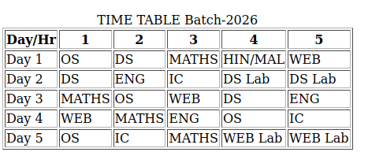

Program 2
Design a web Page for your college containing description of courses, department, faculties, library ect. Using list tags, href tags and anchor tags.

Aim
Design a web Page for your college containing description of courses, department, faculties, library etc. Using list tags, href tags and anchor tags.

Program

<!DOCTYPE html>
<html><head>
<title>College Information</title>
</head>
<body>
<h2 align="center"><u>St.George's College Aruvithura</u></h2><br>

<img src="college.jpg" height="600" width="1100"><br>
<h4>
About :
</h4>
<p>St. George’s College Aruvithura, is a minority educational
institution founded by St. George Forane Church, Aruvithura in 1965.
Pioneered under the patronage of His Excellency Mar Sebastian Vayalil,
the first Bishop of Pala, and cherished by a host of visionaries and
philanthropists like Very Rev. Fr. Thomas Araythinal and Mr T. A.
Thomman (Former Minister), the college, right from its inception,
embarked on an odyssey towards academic pre-eminence. Very Rev. Fr.
Thomas Manakkat, the founding manager and a great visionary, was truly
instrumental in laying the foundations for a great beginning and Very
Rev. Fr. Jacob Thazhathel, who followed him, was equally adept and
insightful in his ideals, guiding the college during the early stages of
its growth. For more than two decades, His Excellency Mar Joseph
Pallickaparampil, the Bishop of Pala, had been the patron of the
college. His Excellency Mar Joseph Kallarangattu is the present patron
of this seat of learning.</p>

<p>Currently, the college offers 17 undergraduate courses, and 5
postgraduate courses and the Department of Chemistry and Physics are
recognized Research Centers under MG University.</p>

<h4>DEPARTMENTS AND FACULITIES : </h4>
<ol>
<li><a href="">Department of Botany and Zoology</a></li>
<li><a href="">Department of Chemistry</a></li>
<li><a href="">Department of Commerce (Aided)</a></li>
<li><a href="">Department of Commerce (SF)</a></li>
<li><a href="">Department of Computer Application (Aided)</a></li>
<li><a href="">Department of Computer Application (SF)</a></li>
<li><a href="">Department of Economics</a></li>
<li><a href="">Department of English (Aided)</a></li>
<li><a href="">Department of English (SF)</a></li>
<li><a href="">Department of Food Science and Technology </a></li>
<li><a href="">Department of Hindi</a></li>
<li><a href="">Department of Malayalam</a></li>
<li><a href="">Department of Physical Education</a></li>
<li><a href="">Department of Mathematics (SF)</a></li>
<li><a href="">Department of Mathemathics and Statistics</a></li>
<li><a href="">Department of Media Studies</a></li>
<li><a href="">Department of Political Science and History</a></li>
</ol>
<h4>Course Details :</h4>
<ul>
<li><u><b>UNDER GRADUATE COURSES</b></u><br></li>
<ul>

<li><h5>AIDED</h5></li>

<ol>
<li>B.Sc (Honours) Mathematics</li>
<li>B.Sc (Honours) Physics</li>
<li>B.Sc (Honours) Chemistry</li>
<li>B.Sc (Honours) Botany</li>
<li>B.A (Honours) Economics</li>
<li>B.A (Honours) Political Science</li>
<li>B A (Honours) English with Specialization in Media Studies &amp; Film Studies </li>
<li>B.Com (Honours) with Specialization in Finance &amp; Taxation</li>
<li>BCA (Honours) with Specialization in Data Science &amp; Full Stack Development</li>
</ol>

<li><h5>SELF-FINANCING</h5></li>

<ol>
<li>B.Com (Honours) with Specialization in Finance &amp; Taxation</li>
<li>B.Com (Honours) with Specialization in Finance and Taxation &amp; Accounting</li>
<li>B.Com (Honours) with Specialization in Finance and Taxation &amp; Marketing</li>
<li>B.Com (Honours) with Specialization in Financial Markets &amp; Logistics Management</li>
<li>B.Com (Honours) with Specialization in Co-Operation &amp; Accounting</li>
<li>B.A (Honours) Journalism &amp; Mass Communication</li>
<li>B.Sc (Honours) Food Science &amp; Quality Control with specialization in Food Saftey</li>
<li>B.Voc Food Technology &amp; Analysis</li>
<li>BCA (Honours) with Specialization in Artificial Intelligence and Machine Learning &amp; Full Stack Devel</li>
</ol>
</ul>

<li><u><b>POST GRADUATE COURSES</b></u><br></li>

<ul>

<li><h5>AIDED</h5></li>

<ol>
<li>M.Sc. Physics</li>
<li>M. Sc. Chemistry</li>
<li>Integrated MA English</li>
</ol><h5>SELF-FINANCING</h5>

<ol>
<li>M.Sc. Food Technology and Quality Assurance</li>
<li>M.Com Finance and Taxation</li>
</ol>
</ul>

<br><li><u><b>CERTIFICATE COURSES</b></u></li><br>

<ol>
<li>Department of Computer Applications (SF) </li>
<ul><li>MS Office</li></ul>
<li>Department of Physical Education</li>
<ul><li>Yoga Education</li></ul>
<li>Department of English (Aided)</li>
<ul><li>Communicate English with Confidence</li></ul>
<li>Department of Economics</li>
<ul><li>Basics Tools For Economics Research</li></ul>
<li>Department of Botany and Zoology</li>
<ul><li>Mushroom Farming Technology</li></ul>
<li>Department of Media Studies</li>
<ul><li>Basics of Adobe Premiere Pro</li></ul>
<li>Department of Mathematics and Statistics</li>
<ul><li>Scientific Writing Tools</li></ul>
<li>Department of Commerce (SF)</li>
<ul>
<li>Certified GST Practitioner</li>
<li>Tally Prime</li>
<li>SAP Finance And Control – SAP FICO</li>
</ul>
<li>Department of Food Science and Technology</li>
<ul><li>Food Safety Management Systems</li></ul>
<li>Department of Chemistry</li>
<ul><li>Chemistry in day-to-day life </li></ul>
<li>Department of Political Science &amp; History</li>
<ul><li>Indian Legal System</li></ul>
<li>Department of Computer Applications (Aided)</li>
<ul><li>Javascript Fundamentals</li></ul>
<li>Department of Physics</li>
<ul><li>Basics of Scientific Data analysis</li></ul>
<li>Department of Commerce (Aided)</li>
<ul><li>Social Skills Development</li></ul>
<li>Department of Malayalam</li>
<ul>
<li>Film Theory (ഫിലിം തിയറി)</li>
</ul>
<li>Library</li>
<ul>
<li>Library science and academic writing</li>
</ul>
</ol>

</ul>

<h4>LIBRARY : </h4>
<p>The library at St. George's College, Aruvithura, has a rich history,
having started functioning in 1965. Over the years, it has undergone
significant upgrades and expansion to become a first-grade library. In
1978, the post of a first-grade Librarian and a IV-grade librarian were
sanctioned, indicating the growing importance of the library as a vital
academic resource.</p>

<p>Today, the library has a vast collection of resources to support the
academic programs of the college. There are 32,330 books available on
various subjects, including literature, science, technology, history,
and philosophy. The library also has 58 periodicals, 250 CDs, and access
to 8 newspapers, providing students and staff with access to the latest
research and developments in their fields of interest.</p>

<p>In addition to the regular collection, the library also provides
resources specifically for academic support programs. 400 books are
allotted for Walk with Scholar Programme and Scholar Support Programme.
The library is a member of the National Digital Library of India (NDLI)
and provides access to the NLIST facility, which provides access to
electronic resources, including books, journals, and databases.</p>

<p>The library is equipped with computers and provides internet access
to students and staff, making it easy for them to search for academic
resources and research materials online. The library also offers
repographic facilities, allowing students to make copies of materials
that they need.</p>

<p>To facilitate easy access to its vast collection, the library uses an
Online Public Access Catalogue (OPAC). Users can search for books,
journals, and other materials using the OPAC, making it easy to locate
and retrieve resources.</p>

<p>At St. George's College, Aruvithura, the library is a valuable
resource for the academic community. Its collection of resources,
including books, journals, and electronic resources, provides a wealth
of knowledge to students and staff. The library's commitment to
providing access to the latest research and developments in different
fields ensures that it remains a vital component of the college's
academic programs.</p>

Online public access catalog (OPAC) at the library holds details of materials held by SGC Library. It can be accessed at <br>

<a href="http://opac.sgcaruvithura.ac.in">Koha Public Access Catalogue..</a><br>
<a href="https://library.sgcaruvithura.ac.in/">Librabry Portal..</a><br>

<br>COLLEGE WEBSITE : <a href="https://sgcaruvithura.ac.in">sgcaruvithura.ac.in</a>

</body></html>

Output
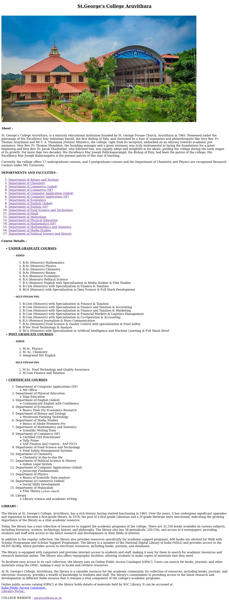
Program 3
Design a web Page for your college containing description of courses, department, faculties, library ect. Using list tags, href tags and anchor tags.

Aim
Design a web Page for your college containing description of courses, department, faculties, library etc. Using list tags, href tags and anchor tags.

Program

