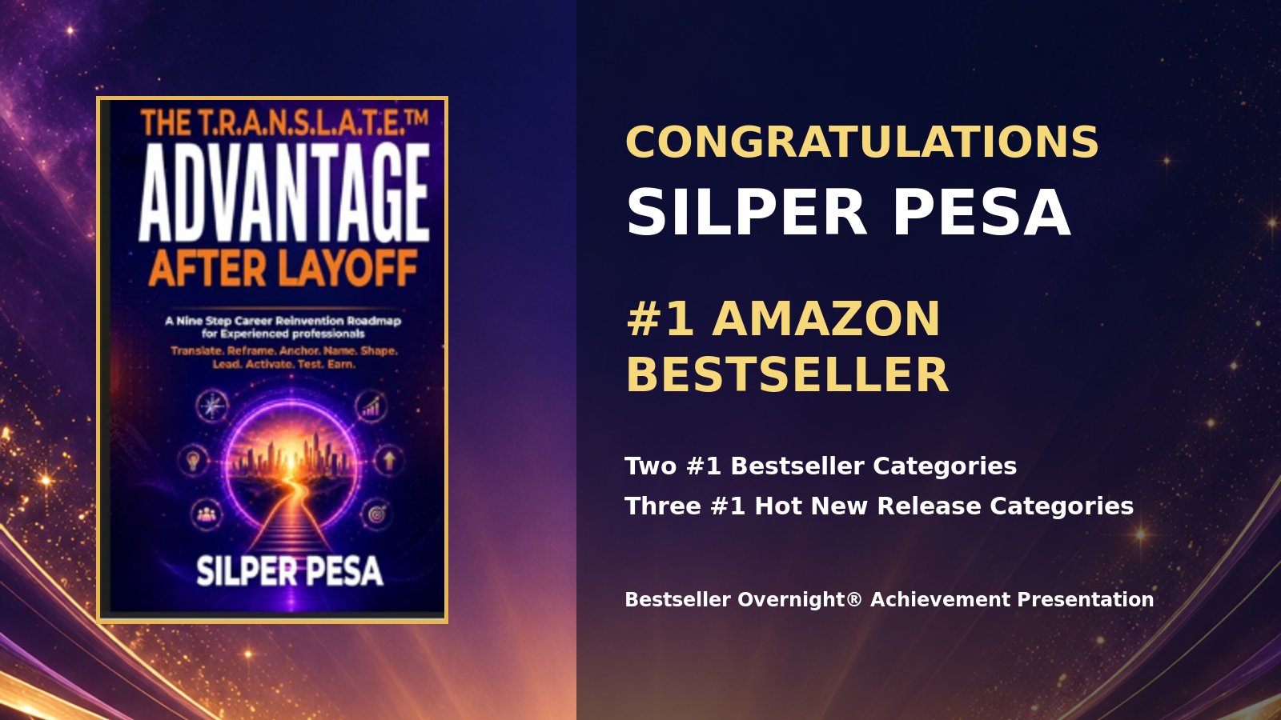

Silper Pesa Amazon Bestseller Achievement Dossier
The T.R.A.N.S.L.A.T.E.™ Advantage After Layoff
Verified Amazon ranking evidence captured September 17, 2026
Prepared by Fred Jones Law Firm LLC and Bestseller Overnight®

Achievement Summary
Conclusion. Amazon displayed Silper Pesa’s Kindle edition as a #1 Best Seller in two paid categories, a #1 Hot New Release in three categories, and #6 in Career Guides. The supplied screenshots also show Amazon’s #1 Best Seller badge on the book’s product page.
Achievement | Rank | Amazon category | Evidence
Best Seller | #1 | 15 Minute Business and Money Short Reads | Screenshot 08
Best Seller | #1 | 15 Minute Self Help Short Reads | Screenshot 06
Best Seller | #6 | Career Guides | Screenshot 02
Hot New Release | #1 | Career Guides | Screenshot 01
Hot New Release | #1 | 15 Minute Self Help Short Reads | Screenshot 04
Hot New Release | #1 | 15 Minute Business and Money Short Reads | Screenshot 07

What the Evidence Establishes
- Amazon’s category pages displayed the book in the numbered positions shown in this dossier.
- The product page displayed a #1 Best Seller badge in 15 Minute Business and Money Short Reads.
- The achievement record reflects the rankings visible at the time of capture. Amazon rankings update frequently and may later change.

Congratulations to Silper Pesa
Coach Silper, congratulations on becoming an Amazon #1 bestselling author with The T.R.A.N.S.L.A.T.E.™ Advantage After Layoff.
Your book reached #1 in two paid bestseller categories and #1 in three Hot New Release categories. It also rose to #6 in Career Guides. These results show that your message connected with readers who need a practical path forward after career disruption.
This achievement gives you more than a ranking. It gives you documented proof that your ideas can compete, connect, and establish authority in the marketplace. Protect the book, the T.R.A.N.S.L.A.T.E.™ framework, and the business opportunities that can grow from them.
I am proud of what you accomplished and honored to support the work. Keep building from this moment.
Dr. Frederick D. Jones Esq.
Fred Jones Law Firm LLC
Bestseller Overnight®

Recommended Authority Assets
- Use the #1 Amazon Bestseller designation with the date and category context when precision matters.
- Save the original screenshots and this dossier as the evidence record for media, speaking, and partnership opportunities.
- Carry the achievement into the book’s author bio, speaker introduction, press materials, and business development conversations.
- Continue the ownership review for the title, framework name, course content, and licensing opportunities.

Evidence 1 Amazon Product Page
Amazon displayed the #1 Best Seller badge in 15 Minute Business and Money Short Reads on the Kindle product page.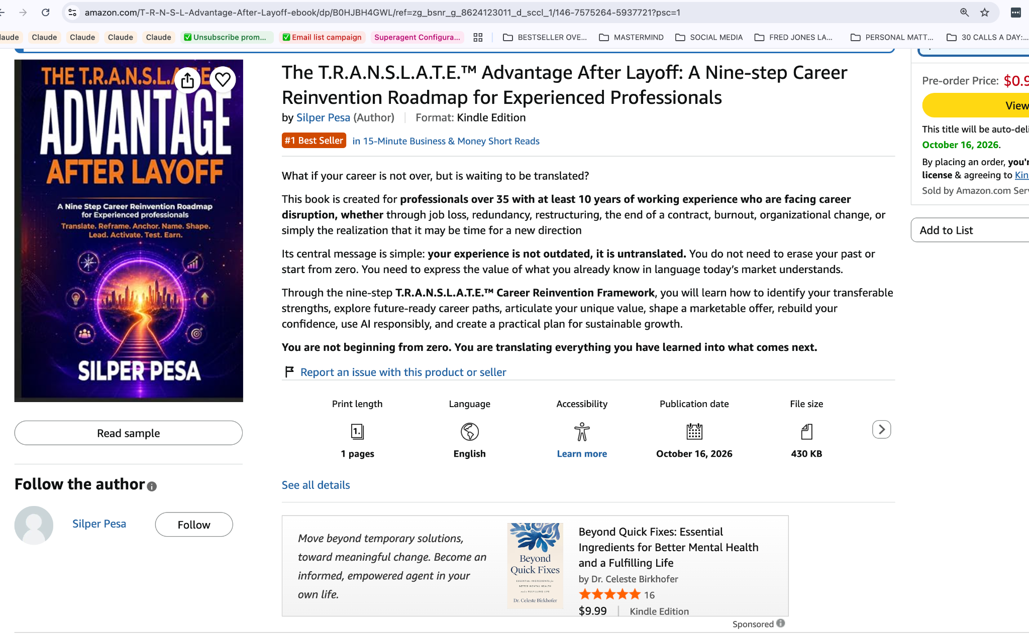
Source: Amazon category or product page screenshot captured September 17, 2026. Rankings can change over time.

Evidence 2 Business and Money Bestseller
The book held the #1 paid position in 15 Minute Business and Money Short Reads.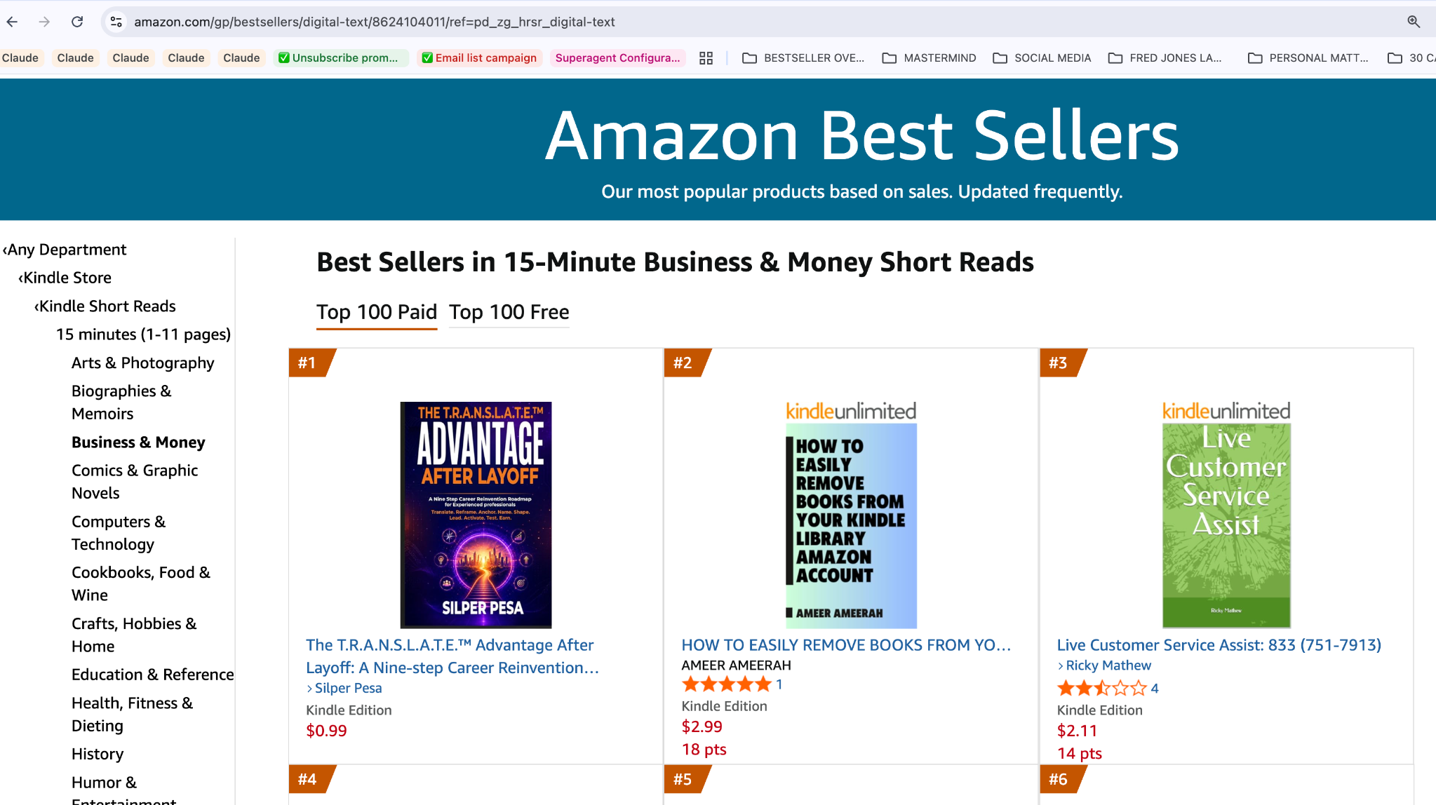
Source: Amazon category or product page screenshot captured September 17, 2026. Rankings can change over time.

Evidence 3 Self Help Bestseller
The book held the #1 paid position in 15 Minute Self Help Short Reads.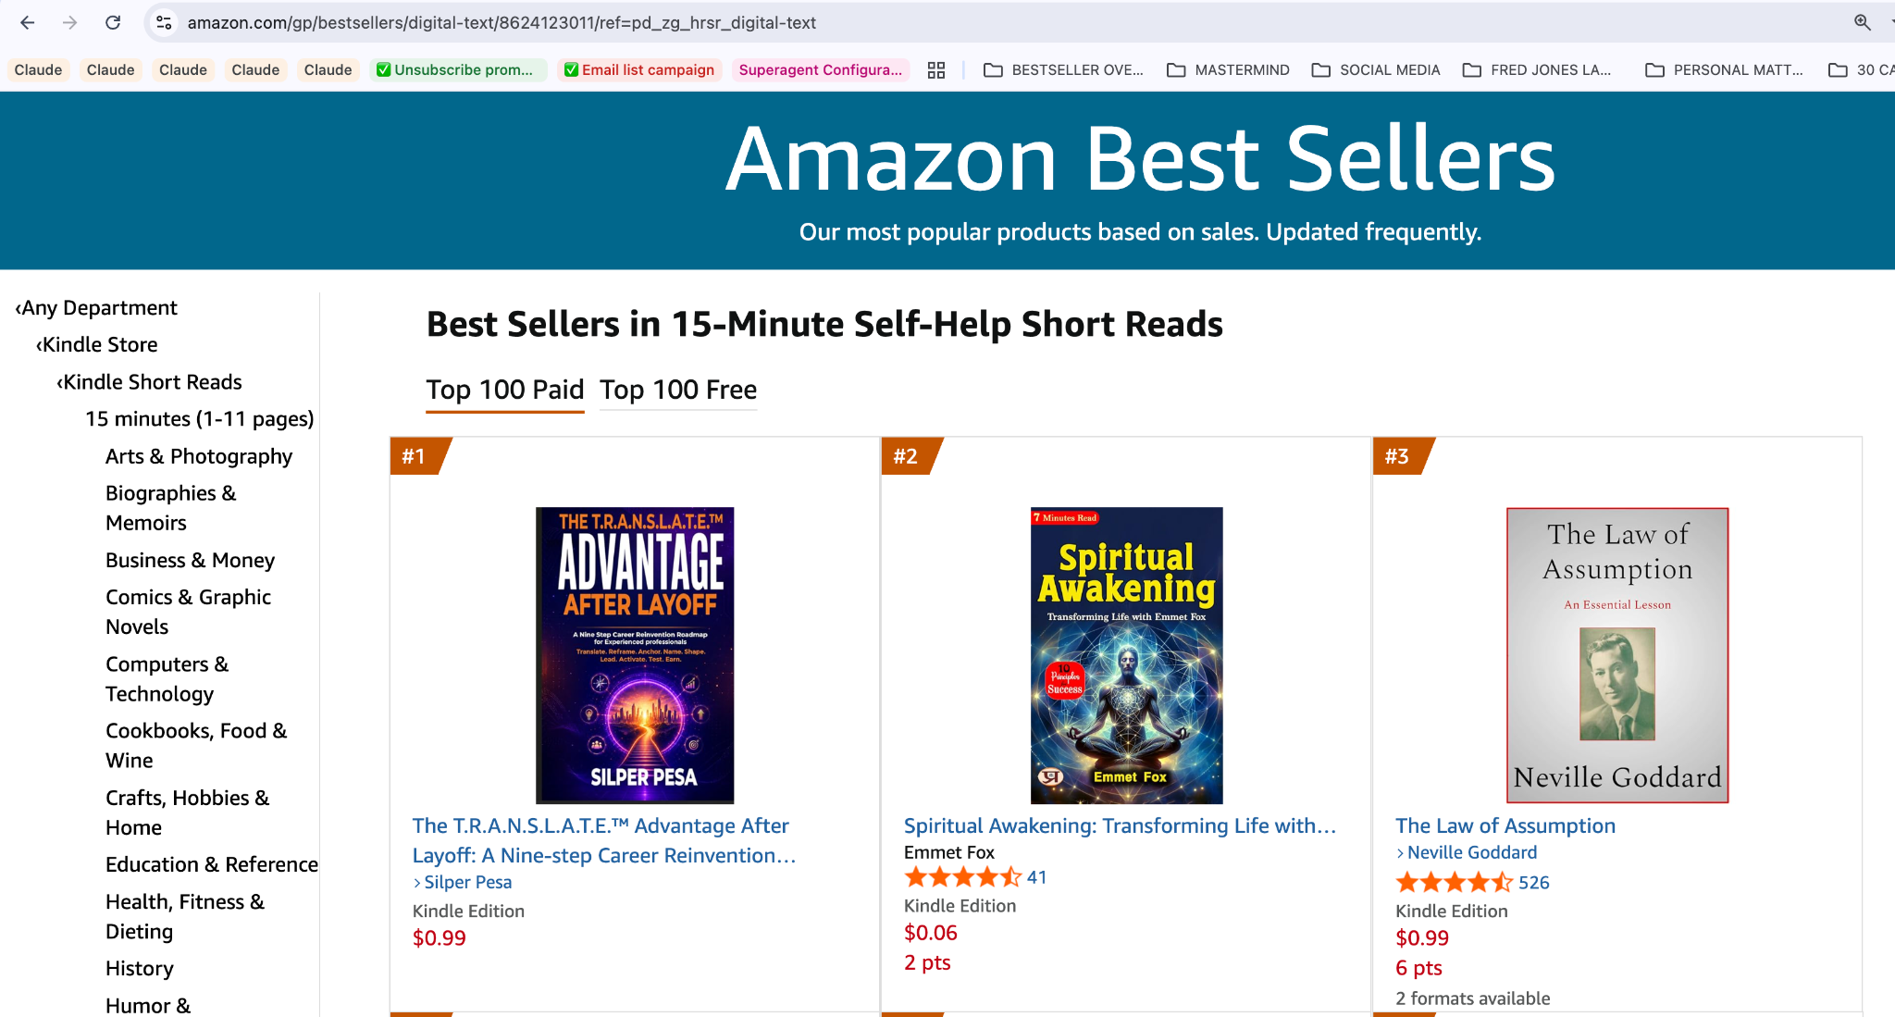
Source: Amazon category or product page screenshot captured September 17, 2026. Rankings can change over time.

Evidence 4 Career Guides Bestseller
The book appeared at #6 on the paid Best Sellers in Career Guides list.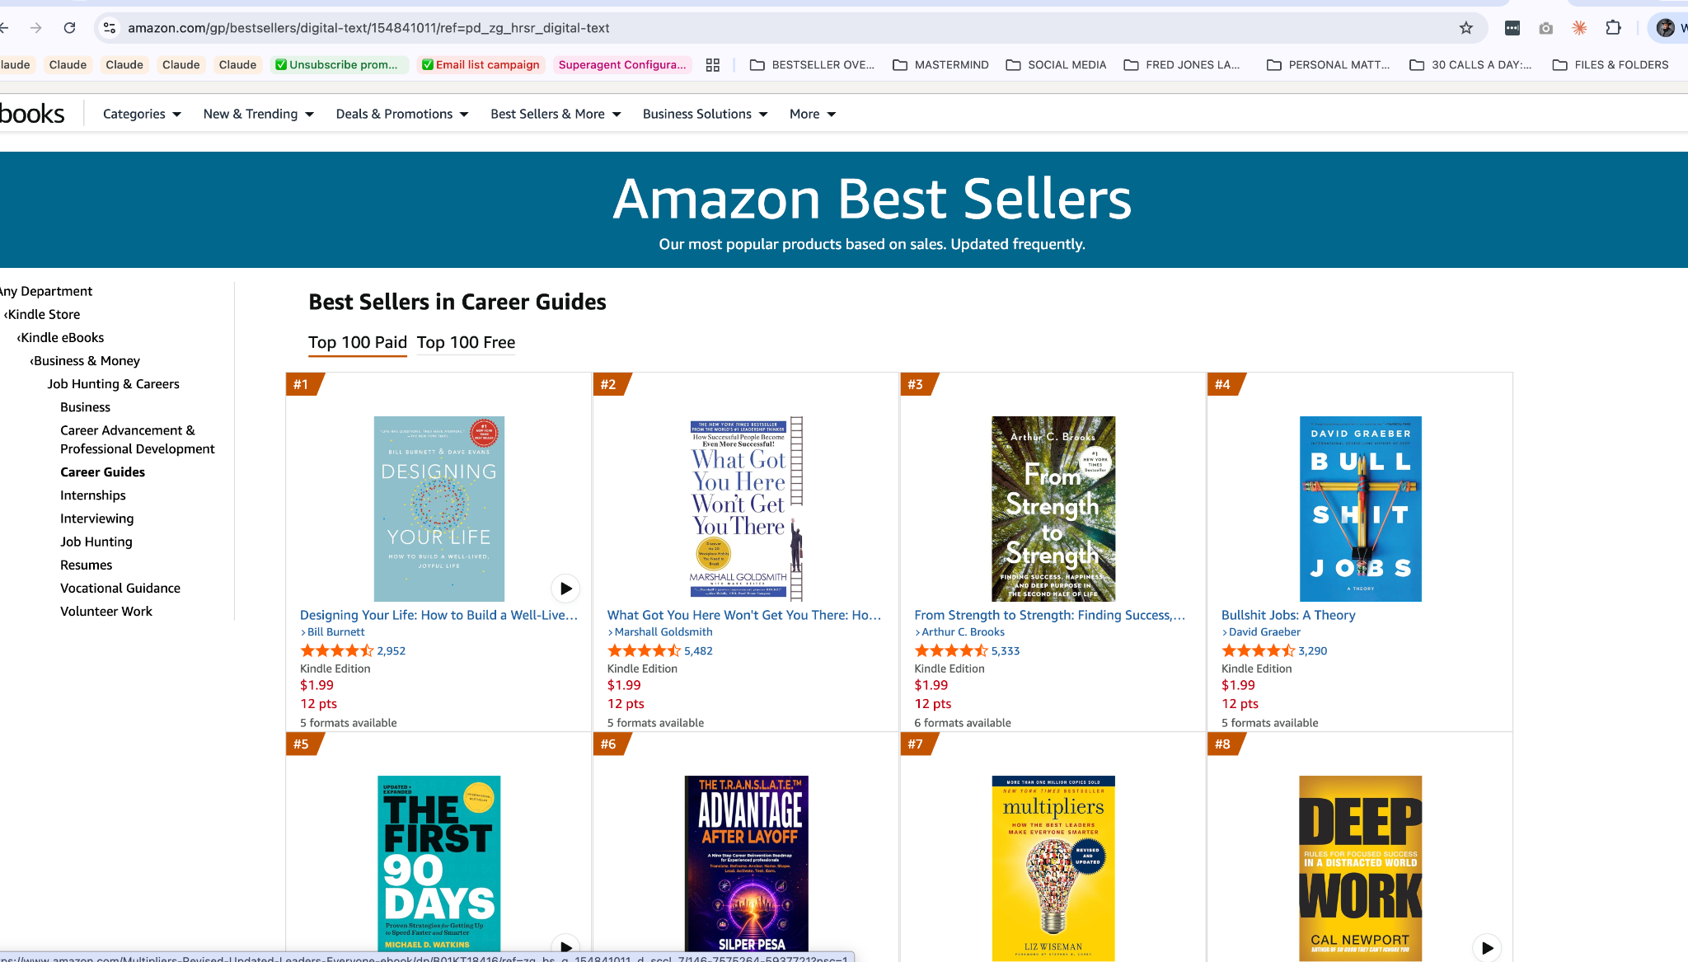
Source: Amazon category or product page screenshot captured September 17, 2026. Rankings can change over time.

Evidence 5 Career Guides Hot New Release
The book held the #1 New Release position in Career Guides.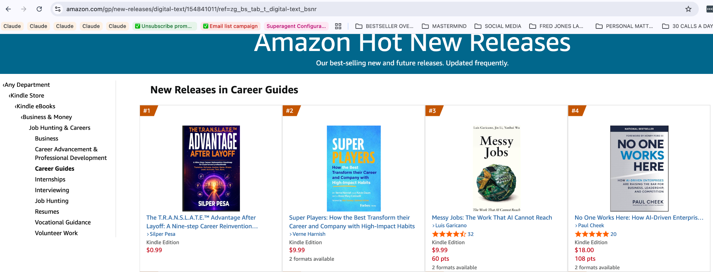
Source: Amazon category or product page screenshot captured September 17, 2026. Rankings can change over time.

Evidence 6 Self Help Hot New Release
The book held the #1 New Release position in 15 Minute Self Help Short Reads.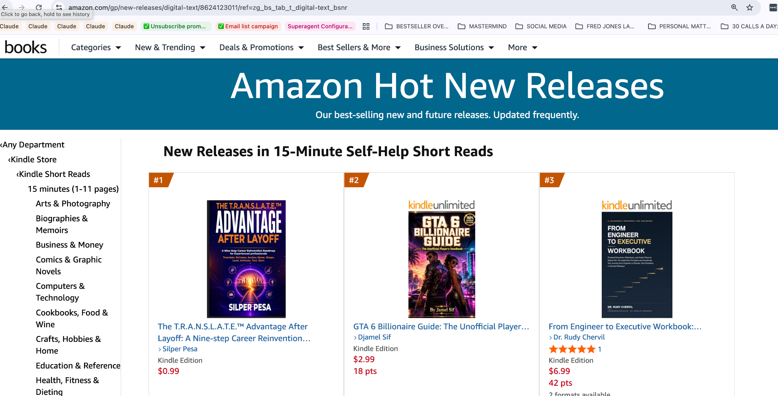
Source: Amazon category or product page screenshot captured September 17, 2026. Rankings can change over time.

Evidence 7 Business and Money Hot New Release
The book held the #1 New Release position in 15 Minute Business and Money Short Reads.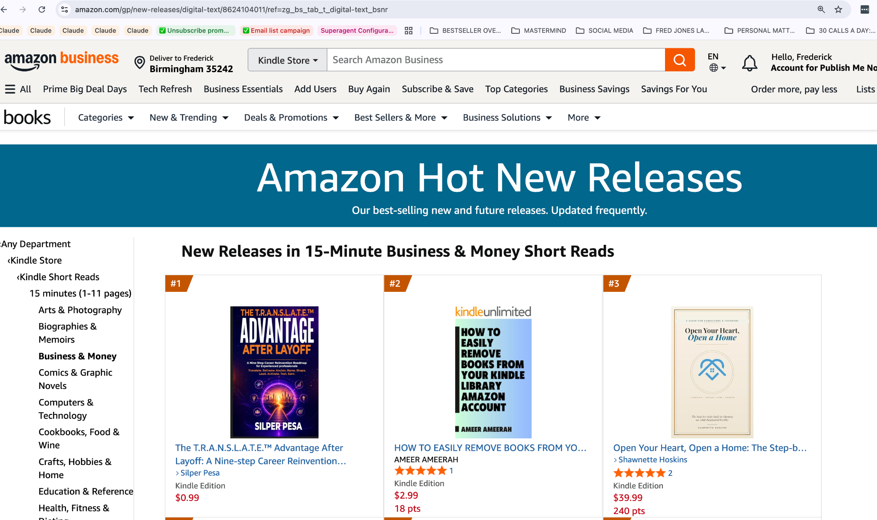
Source: Amazon category or product page screenshot captured September 17, 2026. Rankings can change over time.

Record Notes
Book: The T.R.A.N.S.L.A.T.E.™ Advantage After Layoff: A Nine-step Career Reinvention Roadmap for Experienced Professionals
Author: Silper Pesa
Format reviewed: Kindle edition
Evidence date: September 17, 2026
Amazon Standard Identification Number shown in the product URL: B0HJBH4GWL
The screenshots document the Amazon pages visible at the time of capture. Amazon rankings change frequently, so this dossier records a historical achievement rather than a permanent current ranking. Bestseller designations should be used accurately and with appropriate category and date context.

