
Vault
Enterprise Document Management
PLATFORM OVERVIEW · USER GUIDE
The single source of truth for every ZBFH document.
Capture, approve, find and govern corporate, customer and transactional records across the Group, in one secure place.
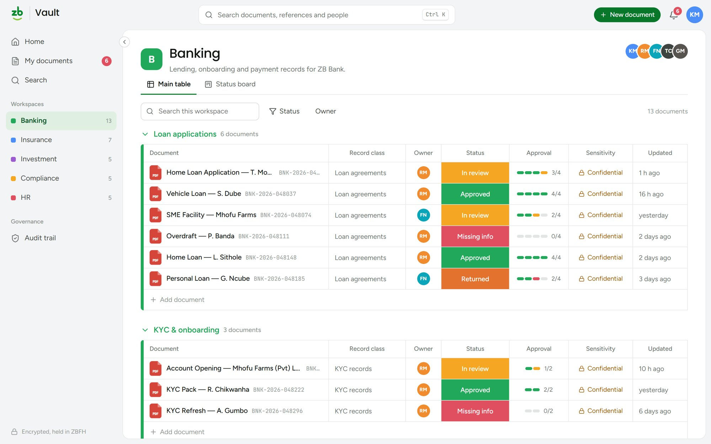
ZB Financial Holdings | October 2026

OVERVIEW

What ZB Vault does
ZB Vault is the Group's single home for corporate, customer and transactional records. It brings capture, approval, retention and audit into one place, so every document has an owner, a status and a full history from the day it is filed to the day it is disposed of.
01  Capture  Upload documents into the right workspace and record class, with tags and sensitivity set at the point of filing. | 02  Approve  Route documents through the approval steps for their record class. Each approver signs off or returns with a comment.
03  Find  Search every document, reference and person you have access to from anywhere with Ctrl K. | 04  Retain  Retention schedules work out when each record can be destroyed. Legal holds stop disposal while a case is open.
05  Audit  Every sign-in, view, change, approval and download is written to a tamper-evident, hash-chained audit trail. | 06  Secure  Encrypted with AES-256 and TLS 1.3, MFA at sign-in, and access limited to the workspaces each person needs.
HOW IT IS ORGANISED

Workspaces, groups and record classes
Documents live in workspaces that mirror the business. Inside each one, groups keep related records together, and the record class decides how long a document is kept and who must approve it.
Workspaces | One per business area: Banking, Insurance, Investment, Compliance and HR. People see only the workspaces they belong to.
Groups | Sections inside a workspace, such as Loan applications or KYC & onboarding.
Record classes | Decide how long a document is kept and which approval route it follows.
Statuses | Filed, In review, Missing info, Returned, Approved and Archived show where each document stands.

Document statuses
Filed | Stored, with no approval needed | In review | Waiting on an approver
Missing info | Something required is missing | Returned | Sent back to the owner for changes
Approved | Every approval step is complete | Archived | Held in archive storage

Inside this guide
01 Sign in | 02 Home: records and retention
03 Work in a workspace | 04 Track progress on the status board
05 File a new document | 06 My documents and approvals
07 Review and approve | 08 Find anything quickly
09 Audit trail
STEP 01

Sign in
Open ZB Vault and sign in with your ZBFH network account, then confirm the 6-digit code from your authenticator app.
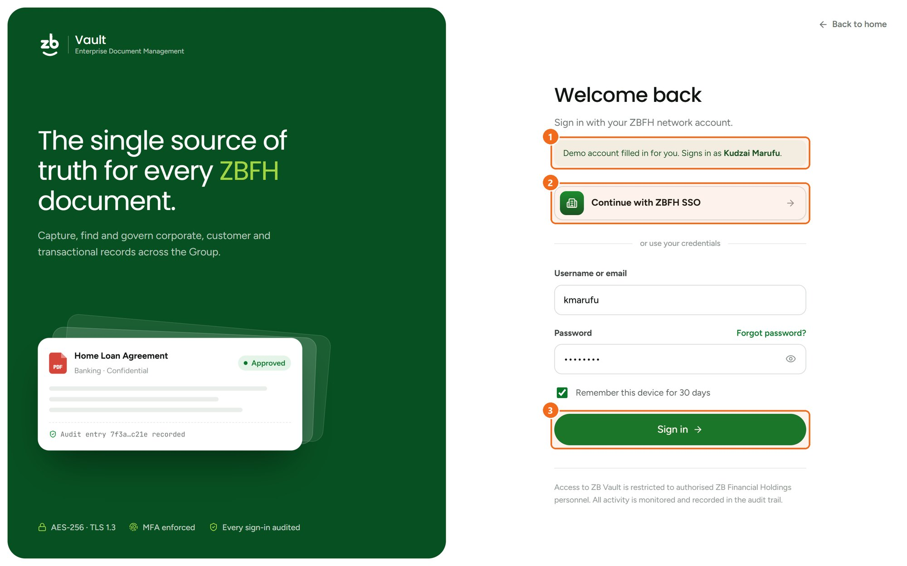
1 | Demo account  The demo opens with Kudzai Marufu's details filled in, so you can explore straight away. | 2 | Single sign-on  Use Continue with ZBFH SSO to sign in with your network account.
3 | Sign in  Or enter your username and password, then verify the one-time code.
STEP 02

Home: records and retention
Home gives records managers a live view of what the Group holds and what needs action.
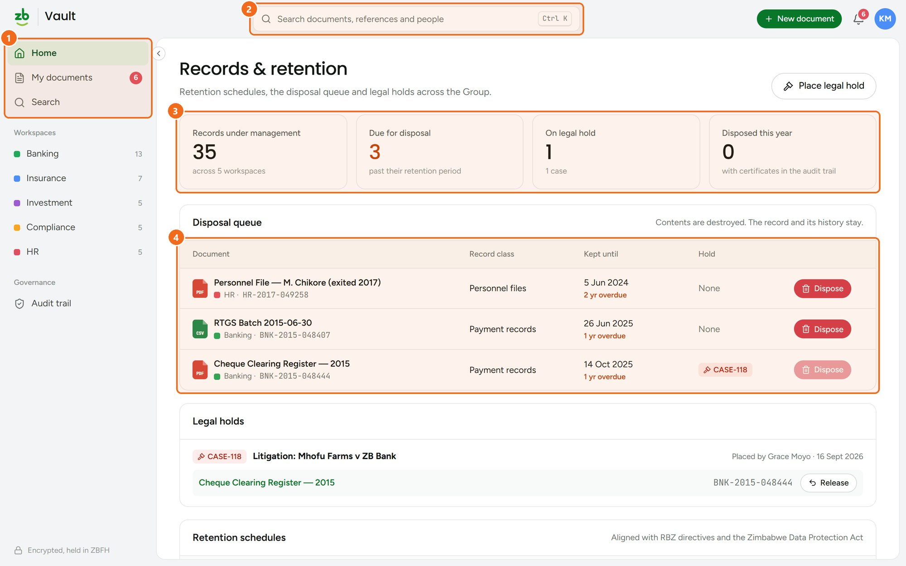
1 | Navigation  Home, My documents and Search sit at the top of the sidebar, with your workspaces below. | 2 | Search anywhere  Search documents, references and people. Press Ctrl K from any page.
3 | At a glance  Records under management, items due for disposal, legal holds and certificates issued this year. | 4 | Disposal queue  Records past their retention period. Dispose destroys the content but keeps the record and its history. Items on legal hold cannot be disposed of.
STEP 03

Work in a workspace
Each workspace lists its documents by group, with status, approval progress, sensitivity and last update.
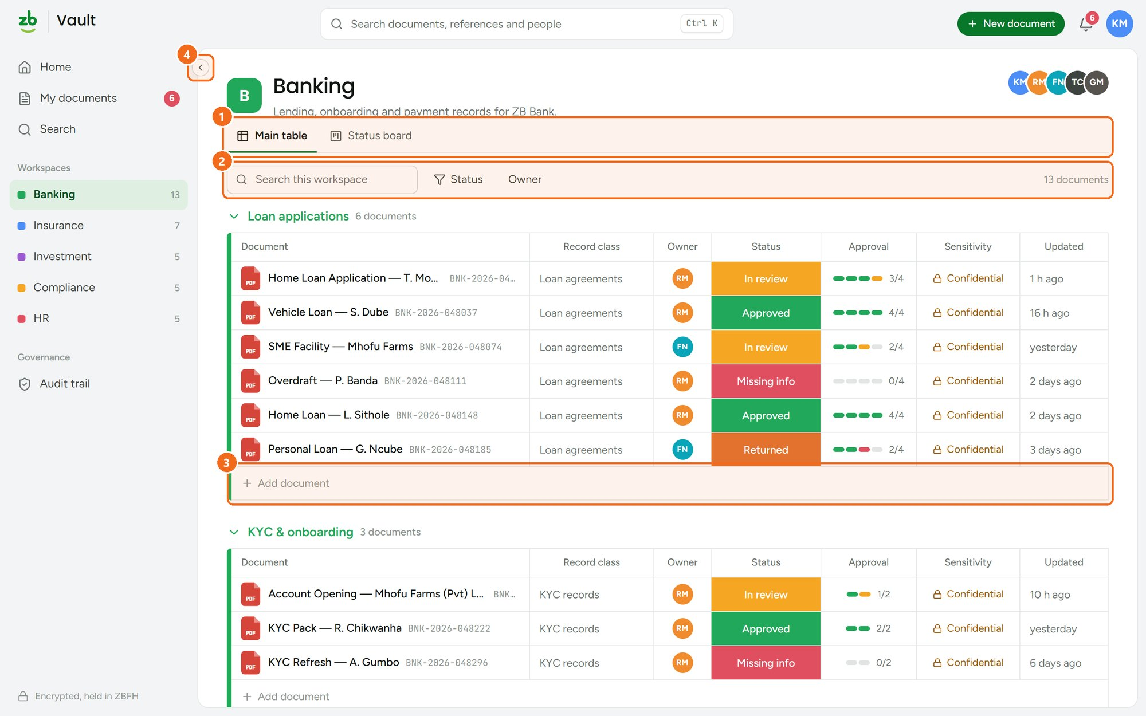
1 | Two views  Switch between the Main table and the Status board. | 2 | Filter  Search inside the workspace, or filter by status and owner.
3 | Add a document  Add document files straight into that group. | 4 | More room  Collapse the sidebar to icons with the arrow on its edge.
STEP 04

Track progress on the status board
The status board shows the same documents as cards in columns, from Filed through to Approved, so you can see where work is stuck.
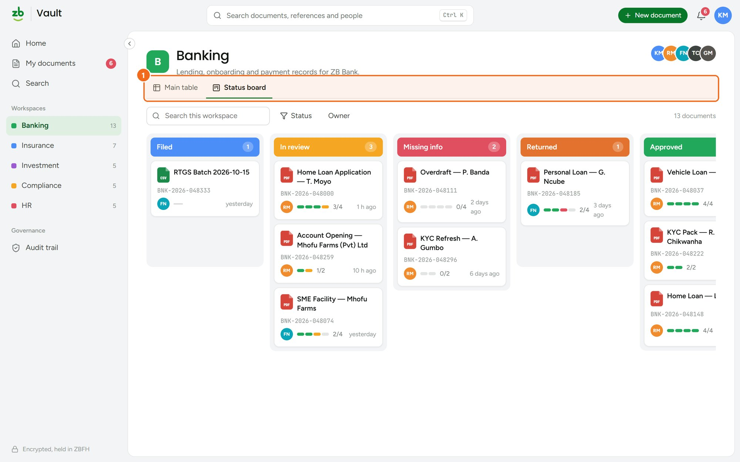
1 | Switch views  Use the tabs to move between the table and the board. Your filters carry over.
STEP 05

File a new document
Use New document at the top of any page, or Add document inside a group.
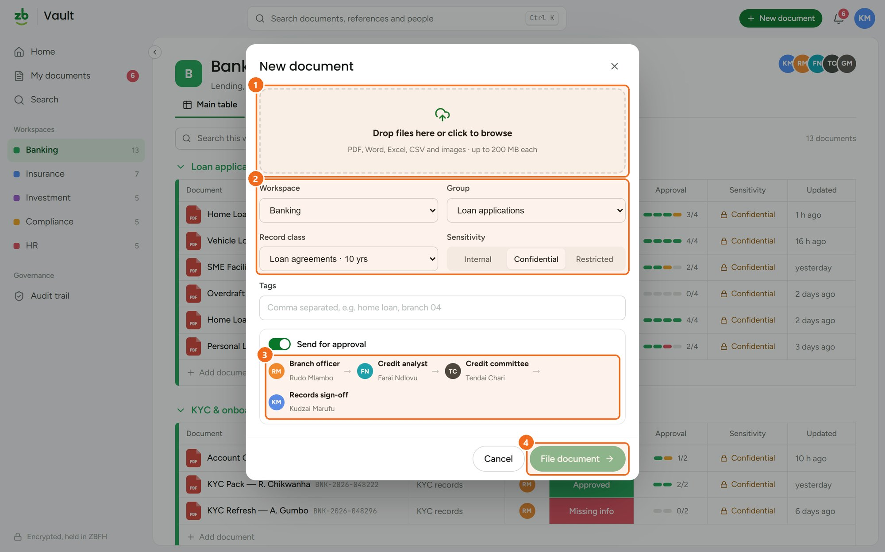
1 | Add files  Drop files in, or click to browse. PDF, Word, Excel, CSV and images up to 200 MB each. | 2 | Classify  Choose the workspace, group and record class, and set the sensitivity: Internal, Confidential or Restricted.
3 | Approval route  The record class sets who approves and in what order. Turn off Send for approval to file without one. | 4 | File it  File document saves it and notifies the first approver.
STEP 06

My documents and approvals
My documents collects everything you have uploaded and every document waiting for your decision.
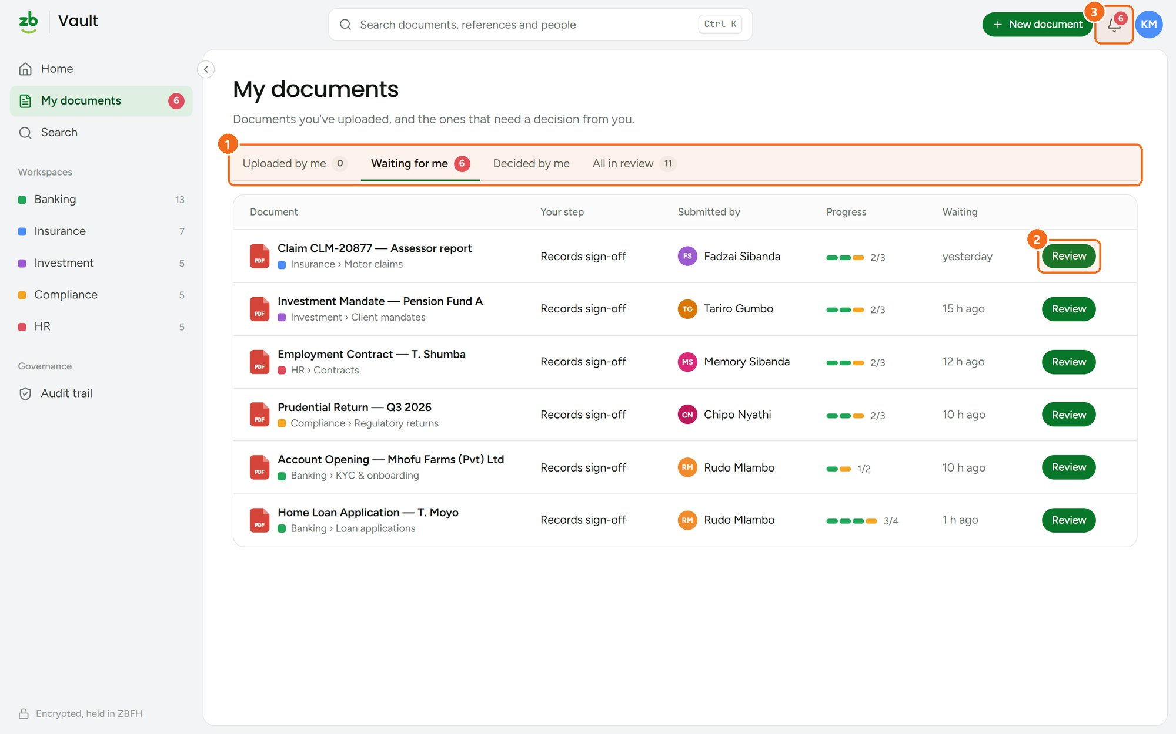
1 | Tabs  Uploaded by me, Waiting for me, Decided by me and All in review. | 2 | Review  Open a document to review it and make your decision.
3 | Notifications  The bell shows how many approvals are waiting for you.
STEP 07

Review and approve
Opening a document shows a preview next to its details, approval route, activity and versions.
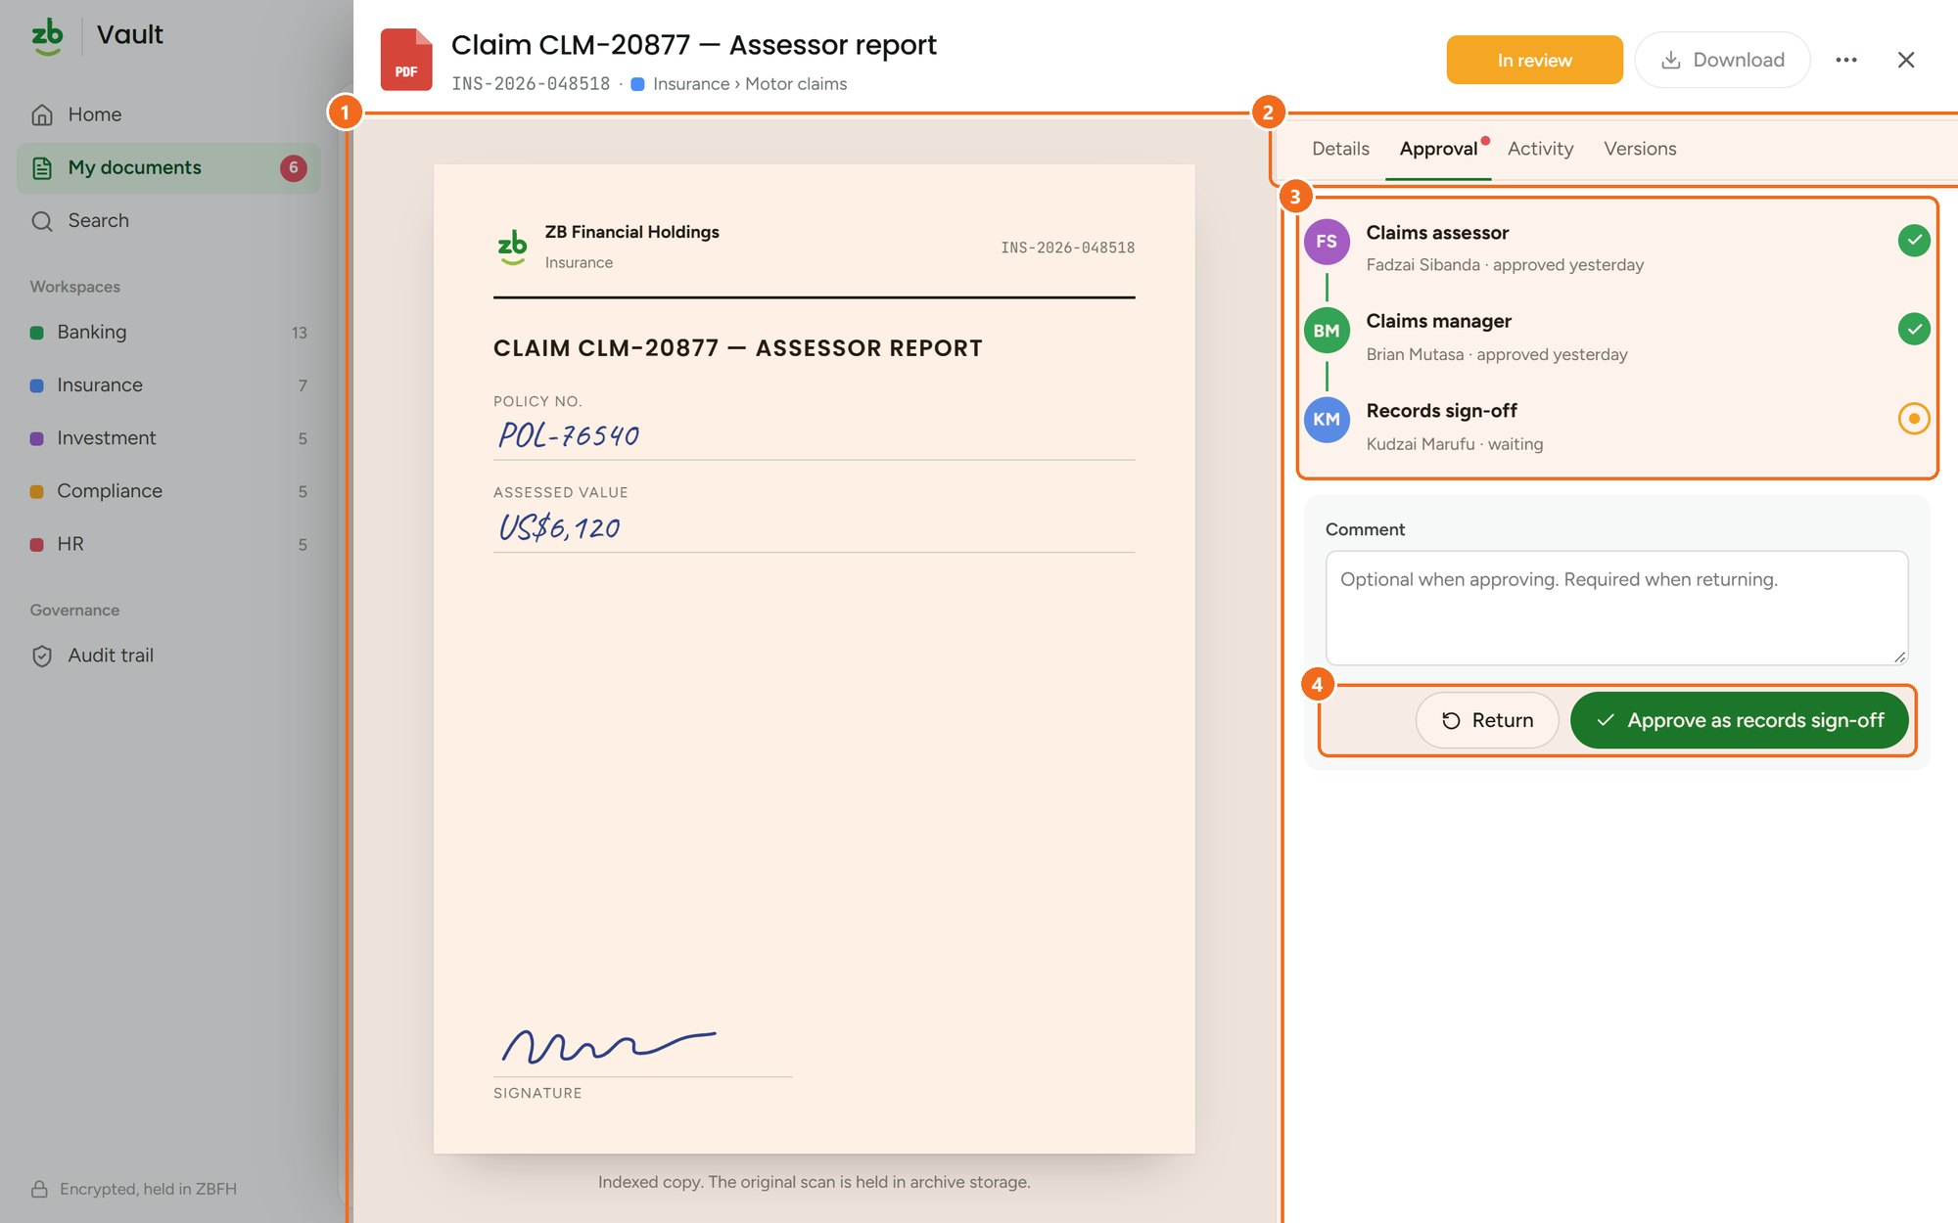
1 | Preview  Read the indexed copy. The original scan stays in archive storage. | 2 | Tabs  Details, Approval, Activity and Versions.
3 | Approval route  Each step shows who approved and when, and whose turn it is now. | 4 | Decide  Approve as your step, or Return with a comment so the owner can upload a corrected version.
STEP 08

Find anything quickly
Press Ctrl K anywhere to open search. Results update as you type.
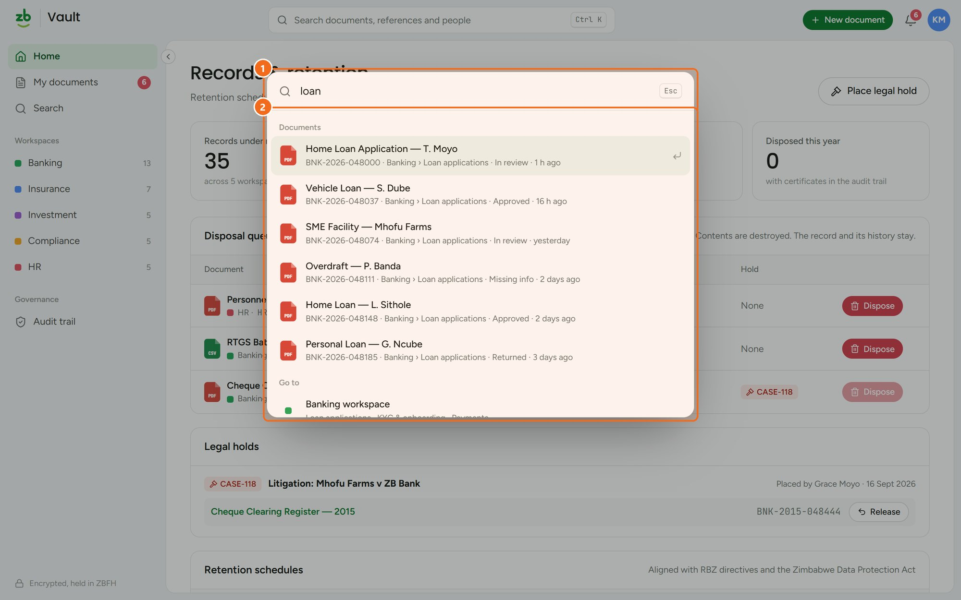
1 | Type to search  Search by title, reference number, person or tag. | 2 | Jump straight there  Results cover documents, pages, workspaces and actions. Press Enter to open one.
STEP 09

Audit trail
Governance roles can see every action taken in ZB Vault, in order, with the person, time and detail.
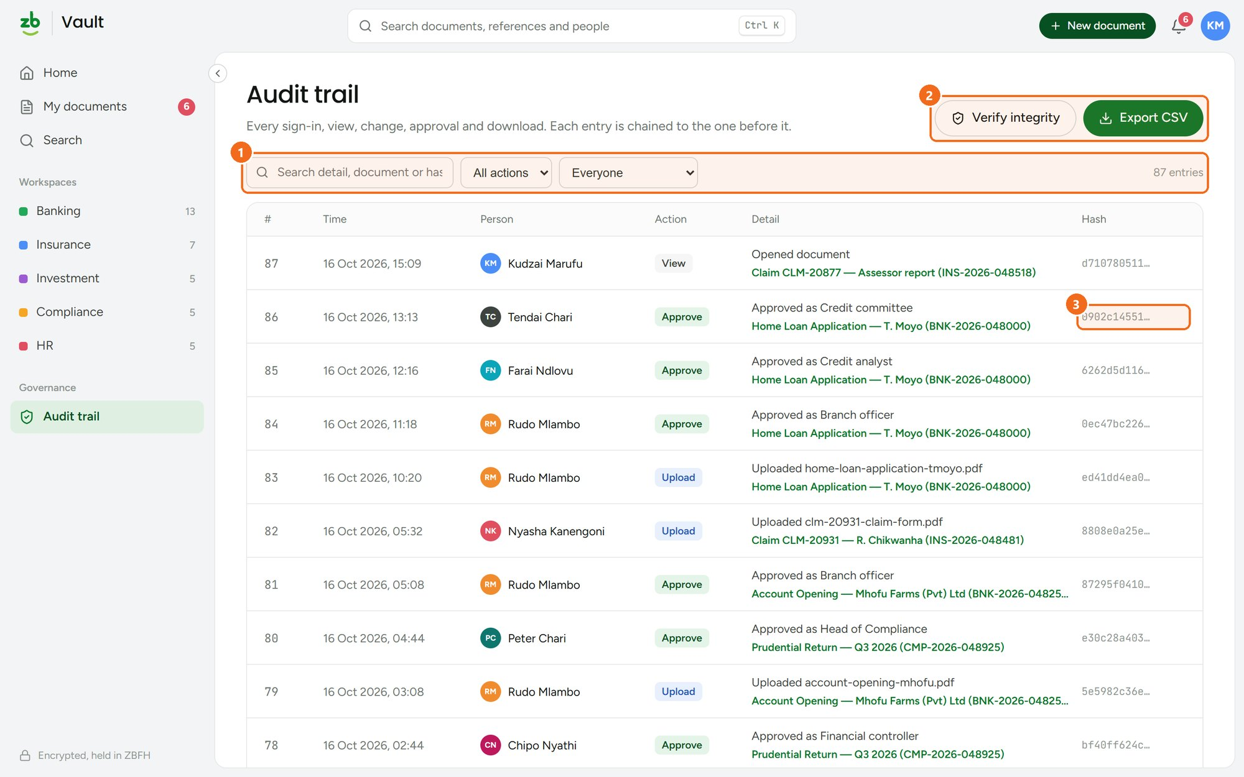
1 | Filter  Search the detail, document or hash, and filter by action or person. | 2 | Verify and export  Verify integrity re-checks the whole chain. Export CSV for auditors and regulators.
3 | Tamper-evident  Each entry's hash covers the entry before it, so any edit breaks the chain.
QUICK REFERENCE

Shortcuts and tips

Ctrl K Open search from any page | Esc Close a document, dialog or search
New document Top right on every page | Sidebar arrow Collapse or expand the sidebar

Security and compliance
All content is encrypted at rest (AES-256) and in transit (TLS 1.3). Every sign-in uses multi-factor authentication, and every action is recorded in the audit trail. Access to ZB Vault is restricted to authorised ZB Financial Holdings personnel.

