SPECIALIST DIPLOMA IN EMBODIED AI · DATA ACQUISITION & POLICY LEARNING
Reinforcement Learning I
Learning by trial and reward
Lesson 5 · Learner notes for self-study
HOW TO USE THESE NOTES
These notes follow the Lesson 5 slides one by one. Each section shows a small picture of the slide, explains it step by step, and ends with key points and a question to check yourself.
Work through them in order: later slides build on earlier ones. Try each question before looking at the answers in Appendix A.
All numbers come from the real SO-101 Reach task (Isaac-SO-ARM101-Reach-v0) that you train in Lab 6.

Contents
If page numbers are missing, right-click the table and choose Update Field.

Introduction

Slide 1 · Reinforcement Learning I: learning by trial and reward

WHAT THIS SLIDE IS ABOUT
This lesson introduces a second way to teach a robot. Until now the SO-101 only copied a person's movements from the leader arm. Reinforcement learning (RL) lets the robot discover the movements itself, by trying and being scored.

By the end of these notes you should be able to explain how an RL policy is trained in Isaac Lab, read the reward of the SO-101 Reach task line by line, and predict what happens when that reward is changed.
- Before you start: you should know what an observation and an action are (Lesson 1) and what domain randomisation and reset events are (Lessons 3–4).
- You do not need any calculus. Every formula in these notes is explained with a worked number.
- The task used throughout is Isaac-SO-ARM101-Reach-v0 from the isaac_so_arm101 project. You will train it yourself in Lab 6.
KEY POINTS
RL = learning from a score, not from examples.
Everything in these notes is tied to one real task you will run in Lab 6.

Slide 2 · Where we are: Block C · reinforcement learning in simulation
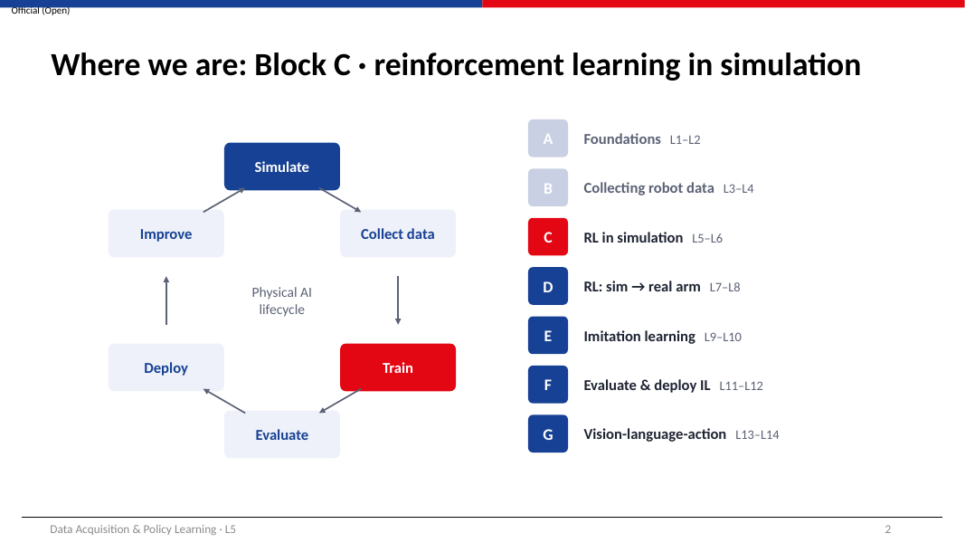
WHAT THIS SLIDE IS ABOUT
This slide places the lesson on the course map: the six-stage lifecycle and the seven blocks of the course.

- In Blocks A and B the main data came from people: you recorded demonstrations with the leader arm.
- In Block C two stages light up together: Simulate and Train. RL needs no recorded dataset. The robot creates its own experience inside the simulator while it trains.
- The domain randomisation you set up in Lab 4 becomes part of the world the robot practises in, so the policy learns to cope with variation.
- In Block D (Lessons 7–8) the policy trained in Lab 6 is moved onto the real SO-101. That is where the reality gap from Lesson 3 is tested.
KEY POINTS
RL in this course happens in simulation; no demonstrations are needed.
The output of Lab 6 is used again in Lab 8.

Slide 3 · Entry check: three questions on Lessons 3–4
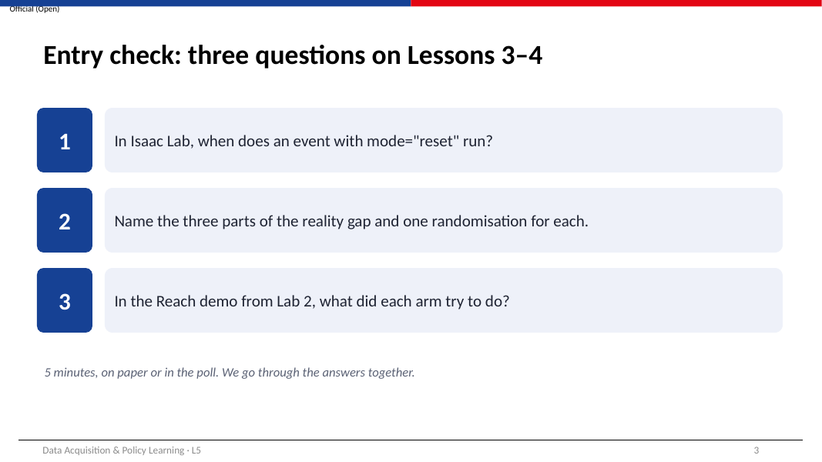
WHAT THIS SLIDE IS ABOUT
These questions check that you remember the parts of Lessons 3–4 that RL depends on.

- Event modes. An Isaac Lab event with mode="reset" runs at the start of every episode (for example, placing the cube at a new random spot). mode="startup" runs once when the simulation starts. mode="interval" runs every few seconds during an episode.
- The three parts of the reality gap. Dynamics (how things move: mass, friction, motor response) — randomise mass or friction. Appearance (how things look: colours, textures, lighting) — randomise colours. Sensing (how measurements behave: noise, offsets, delays) — add noise to joint readings.
- The Reach demo. In Lab 2 you watched many simulated arms each move the gripper to a target marker that kept jumping to new positions. That trained policy is exactly what this lesson explains.
TIP
If you could not answer one of these, re-read the matching section of the Lesson 3 notes before continuing. RL uses reset events and noise directly.

KEY POINTS
Reset events and observation noise are part of every RL task in Isaac Lab.

Slide 4 · Learning outcomes
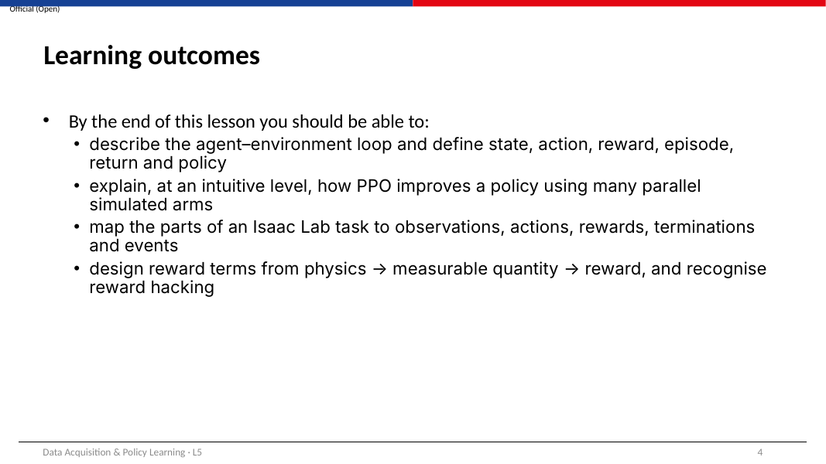
WHAT THIS SLIDE IS ABOUT
These are the four things you should be able to do after this lesson. The exit ticket (slide 24) tests them.

- Describe the agent–environment loop and define state, action, reward, episode, return and policy (slides 6–10).
- Explain at an intuitive level how PPO improves a policy using many parallel simulated arms (slides 12–16).
- Map the parts of an Isaac Lab task to observations, actions, rewards, terminations and events (slide 18).
- Design reward terms from physics → measurable quantity → reward, and recognise reward hacking (slides 19–22).
KEY POINTS
Use this list as a checklist when you revise for Test 1.

Part 1 · The RL idea

Slide 5 · Part 1 · The RL idea
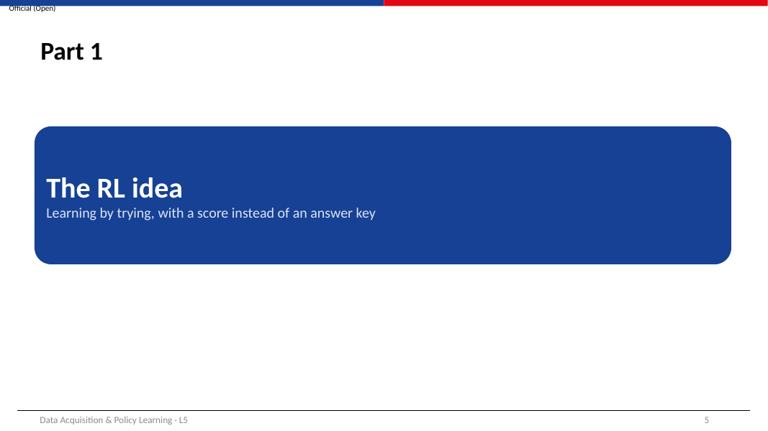
WHAT THIS SLIDE IS ABOUT
Part 1 builds the core idea of reinforcement learning using only addition and a few definitions.

Keep one question in mind through Part 1: if nobody tells the robot the correct action, how can it ever learn what to do?

Slide 6 · Learning a trick: the agent–environment loop
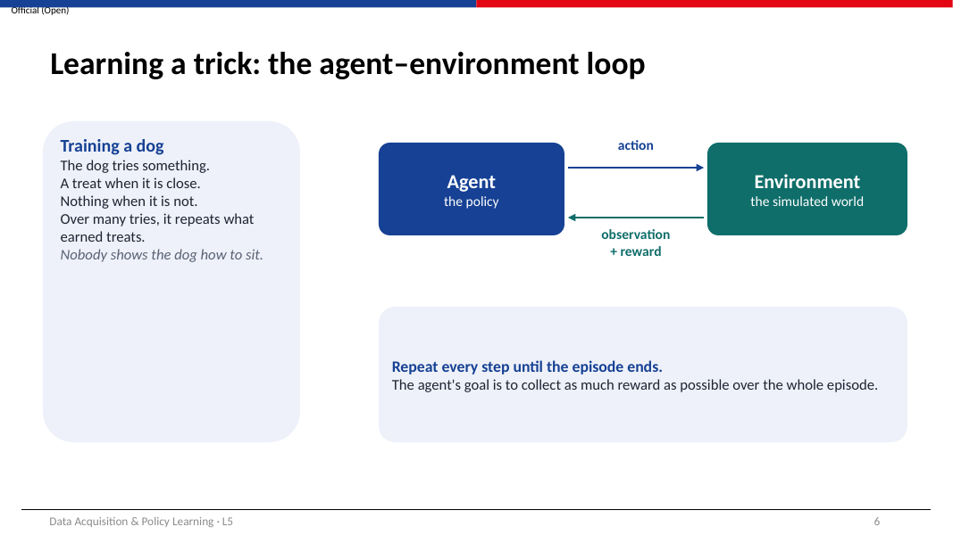
WHAT THIS SLIDE IS ABOUT
Reinforcement learning is a loop between two parts: the agent, which decides, and the environment, which responds.

The dog analogy: you do not move a dog's legs to teach it to sit. You wait for it to try something, give a treat when it gets closer, and over many tries it repeats what earned treats. The robot learns the same way, except the treat is a number called the reward.
One step of the loop, written with the time index t:
- The agent receives an observation of the current situation, written s_t (for example the joint angles and where the target is).
- The agent's policy chooses an action a_t (for example six joint targets).
- The environment (the simulator) applies the action and moves the world forward by one control step.
- The environment returns a reward r_t (one number: how good that step was) and the next observation s_t+1.
- Repeat from step 1 until the episode ends (time runs out, or a failure such as dropping an object).
The agent's goal is not to get the biggest reward on the next step. It is to collect the most reward over the whole episode. This is why a robot can learn to accept a small penalty now (moving its arm) to earn a larger reward later (reaching the target).
KEY POINTS
Agent = the policy. Environment = the simulated world.
Each step: observe → act → receive reward and next observation.
The goal is total reward over the episode, not the next reward.

CHECK YOURSELF
In the loop, which part produces the reward: the agent or the environment?

Slide 7 · RL vocabulary on the SO-101 Reach task
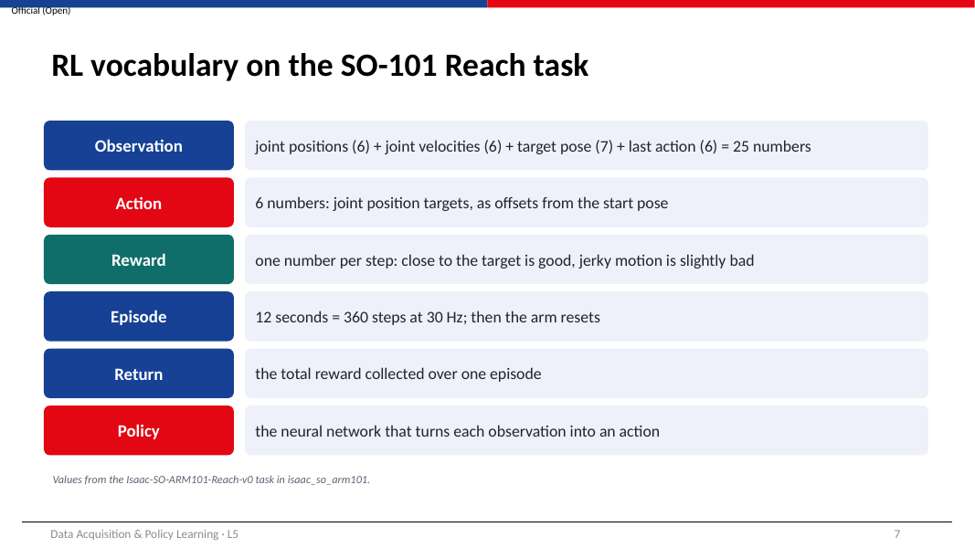
WHAT THIS SLIDE IS ABOUT
The general words from slide 6, filled in with the real numbers from Isaac-SO-ARM101-Reach-v0.

Term | Meaning in the Reach task
Observation | 25 numbers each step: 6 joint positions + 6 joint velocities + 7 numbers for the target pose (x, y, z position and a 4-number rotation called a quaternion) + the 6 numbers of the previous action.
Action | 6 numbers, one per joint (5 arm joints + gripper). Each is turned into a joint target: target = start angle + 0.5 × action.
Reward | 1 number per step, built from several terms (slide 20).
Episode | 12 seconds. The policy acts 30 times per second, so 12 × 30 = 360 steps. The target moves to a new random place every 5 seconds.
Return | The total reward collected over one episode.
Policy | The neural network that maps the 25 observation numbers to the 6 action numbers.

Three details worth understanding:
- Joint positions are relative. The observation is each joint's angle minus its start angle (Isaac Lab calls this joint_pos_rel). A value of 0 means "at the start pose".
- Where 30 Hz comes from. The physics runs at 60 steps per second (dt = 1/60 s). The policy acts every 2 physics steps (decimation = 2), so 60 ÷ 2 = 30 decisions per second.
- Readings are noisy on purpose. Uniform noise of ±0.01 is added to the joint position and velocity observations. This is the sensing randomisation from Lesson 3.
WORKED EXAMPLE: FROM ACTION TO JOINT TARGET
The policy outputs 0.4 for shoulder_lift. Its start angle is 0.0 rad.
target = 0.0 + 0.5 × 0.4 = 0.2 rad (about 11.5°).
The joint motor then drives towards 0.2 rad. Next step a new action gives a new target.

KEY POINTS
Observation 25 numbers, action 6 numbers, 360 steps per episode.
Actions are offsets from the start pose, scaled by 0.5.

CHECK YOURSELF
a) Why does the observation include the previous action?
b) How many steps would a 12 s episode have if the policy ran at 50 Hz?

Slide 8 · Worked example: the reward and the return
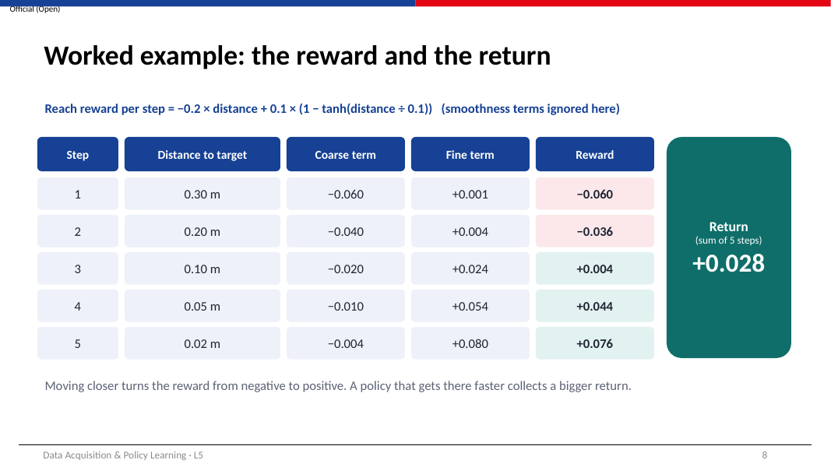
WHAT THIS SLIDE IS ABOUT
This slide adds up real reward numbers to show how a score, with no answer key, can still tell good behaviour from bad.

The two main parts of the Reach reward depend on d, the distance in metres between the gripper and the target:
reward per step ≈ −0.2 × d + 0.1 × (1 − tanh(d ÷ 0.1))

- The first part (coarse term) is always negative and grows with distance. It pushes the arm towards the target from anywhere.
- The second part (fine term) uses tanh, a function that rises from 0 and flattens out at 1. tanh(d ÷ 0.1) is close to 1 when d is more than about 0.2 m, so (1 − tanh) is close to 0 far away and close to 1 when d is tiny. It only pays out near the target.
- The smoothness penalties (slide 20) are ignored here because they are tiny at the start of training.
STEP BY STEP FOR ROW 4 (D = 0.05 M)
Coarse term: −0.2 × 0.05 = −0.010
d ÷ 0.1 = 0.5; tanh(0.5) = 0.462; 1 − 0.462 = 0.538
Fine term: 0.1 × 0.538 = +0.054
Reward: −0.010 + 0.054 = +0.044

Doing the same for all five steps (0.30, 0.20, 0.10, 0.05, 0.02 m) gives rewards −0.060, −0.036, +0.004, +0.044, +0.076. The return is their sum: +0.028. A policy that gets close sooner spends more of its 360 steps in the positive region, so its return is larger. That is the whole learning signal.
Two refinements you will meet in the real software:
- Discounting. PPO actually adds future rewards with a discount factor γ (gamma). For Reach γ = 0.99, so a reward k steps in the future counts 0.99^k as much. For the five steps above the discounted return is +0.024 instead of +0.028. With γ = 0.99 the policy mostly cares about roughly the next 1 ÷ (1 − 0.99) = 100 steps, about 3.3 seconds.
- Time scaling. Isaac Lab multiplies every reward term by the step time (1/30 s) before adding it up. The numbers you see in TensorBoard are therefore 30 times smaller than in this example. This does not change which behaviour is better.
KEY POINTS
The reward is a number per step; the return is the (discounted) sum over the episode.
Coarse term gives direction everywhere; fine term rewards precision near the target.

CHECK YOURSELF
a) Calculate the reward at d = 0.10 m and check it against the table.
b) Why is the fine term almost zero at d = 0.30 m?

Slide 9 · RL vs supervised learning: who provides the answer?
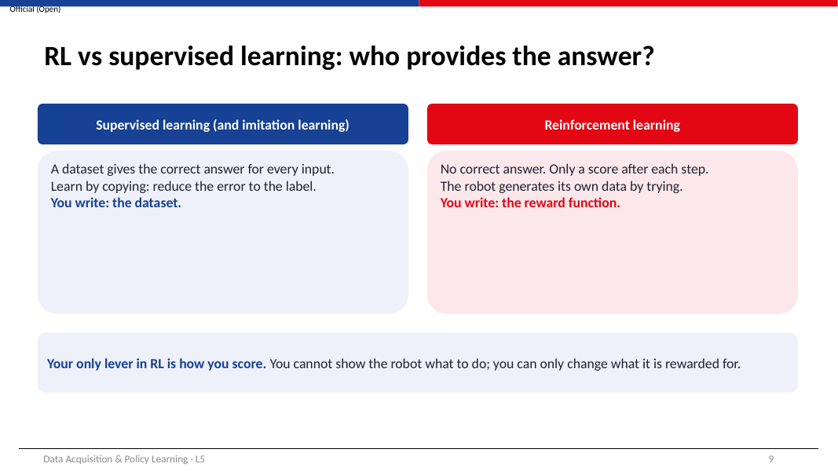
WHAT THIS SLIDE IS ABOUT
You already know supervised learning. This slide shows exactly what changes in RL.

 | Supervised / imitation learning | Reinforcement learning
What you provide | A dataset with the correct answer for every input | A reward function that scores each step
Where the data comes from | Collected before training (e.g. leader-arm demos) | Generated during training by the robot itself
What training minimises or maximises | Error between prediction and label | Expected (discounted) return
Does the data change during training? | No, the dataset is fixed | Yes: a better policy visits new situations, so the data changes

- In supervised learning the dataset tells the model the right answer, so the model only has to copy it.
- In RL there is no right answer for any step. The robot must try actions and discover, from the reward, which ones lead to more return.
- Because the robot creates its own data, the data keeps changing as the policy improves. This makes RL training less stable than supervised training, which is why PPO takes small, careful steps (slide 12).
- Practical consequence: your only control over what the robot learns is the reward function. If the behaviour is wrong, you change the reward, not the data.
KEY POINTS
Supervised: you write the dataset. RL: you write the reward.
RL data changes as the policy changes.

CHECK YOURSELF
In imitation learning (Block E), what plays the role of the 'correct answer'?

Slide 10 · Exploration vs exploitation
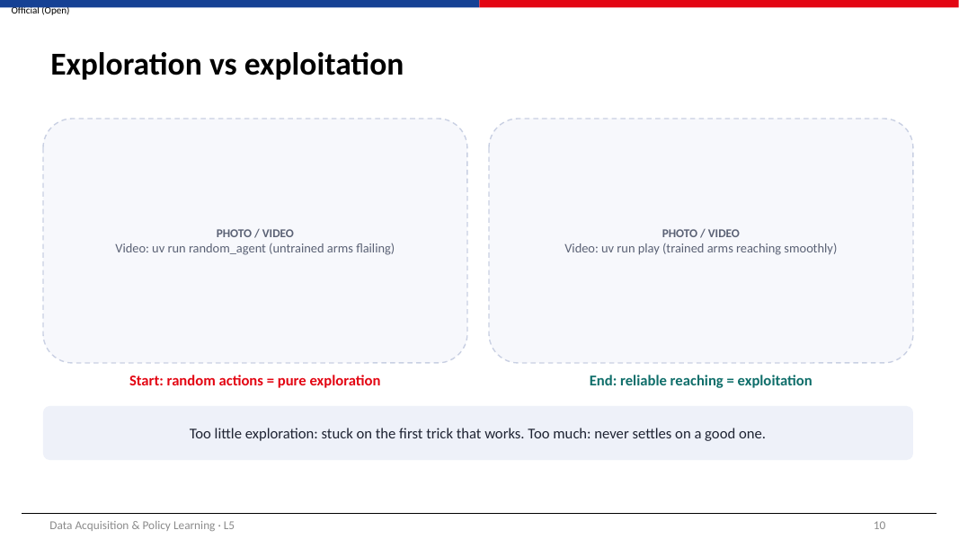
WHAT THIS SLIDE IS ABOUT
A policy can only learn about actions it has tried. This slide explains how it balances trying new things against using what already works.

How the policy produces random actions: the network outputs a mean value for each of the 6 actions, and the action actually sent is drawn from a bell-shaped (Gaussian) distribution around that mean. The width of the bell is the standard deviation, or noise.
- At the start of training the noise is large (it starts at 1.0 for Reach). Actions are nearly random: the arms flail. This is exploration.
- Some random movements happen to bring the gripper closer to the target and earn more reward. PPO makes those movements more likely.
- As learning continues the noise shrinks and the mean becomes more accurate. The arm reaches smoothly. This is exploitation of what has been learned.
- A small entropy bonus (entropy_coef = 0.001 for Reach) rewards the policy for keeping a little randomness, so it does not stop exploring too early.
- When you play a trained policy, Isaac Lab uses the mean action only (no noise), so playback is smoother than training.
TIP
In TensorBoard, the tag Policy/mean_noise_std shows the noise. It should fall steadily during training. If it collapses to almost zero very early, the policy may be stuck on its first trick.

KEY POINTS
Exploration = trying varied actions (high noise). Exploitation = using the best known action (low noise).
PPO shrinks the noise as the policy improves.

CHECK YOURSELF
What would happen if the noise were set to zero from the very beginning?

Part 2 · How the robot learns in simulation

Slide 11 · Part 2 · How the robot learns in simulation
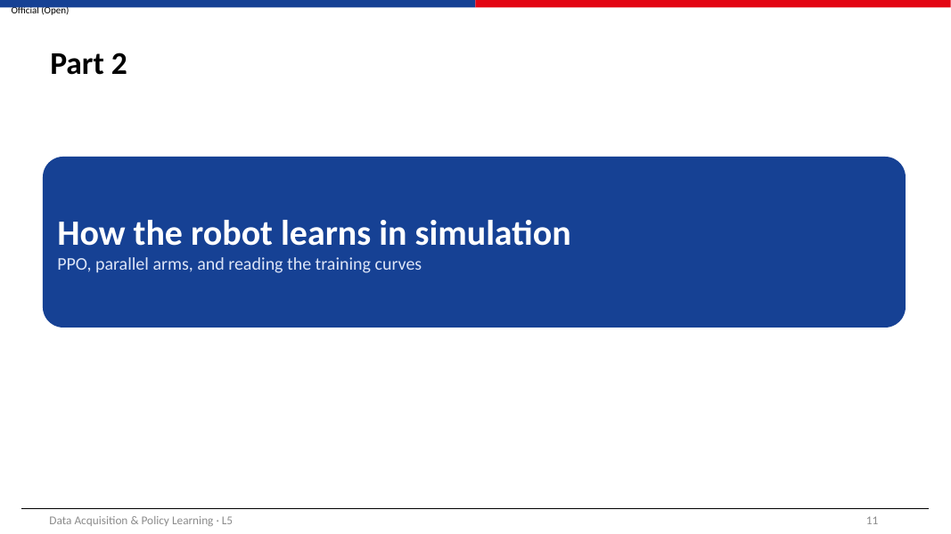
WHAT THIS SLIDE IS ABOUT
Part 2 explains the training algorithm (PPO), its two networks, and why simulation is essential.

Keep the Reach numbers from slide 7 in mind: 25 observation numbers in, 6 action numbers out, 30 decisions per second.

Slide 12 · PPO in one picture
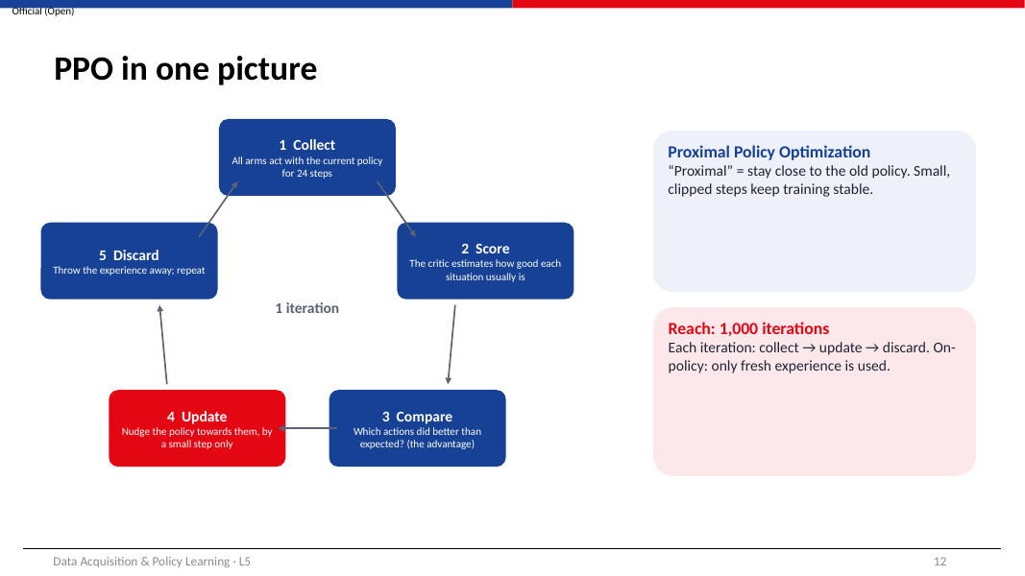
WHAT THIS SLIDE IS ABOUT
PPO (Proximal Policy Optimization) is the algorithm Isaac Lab uses through the RSL-RL library. One training iteration is a five-step cycle.

- Collect. Every simulated arm runs the current policy for 24 steps (num_steps_per_env = 24), recording observation, action and reward at each step.
- Score. A second network, the critic, estimates for each recorded situation how much return usually follows from there (its value).
- Compare. For each action, PPO compares what actually happened afterwards with what the critic expected. The difference is the advantage. A positive advantage means the action turned out better than usual.
- Update. The policy is changed so that actions with positive advantage become more likely and those with negative advantage less likely. The data is reused for 8 passes (num_learning_epochs = 8), split into 4 mini-batches each time.
- Discard. All the collected experience is thrown away and the next iteration starts with the improved policy. Because PPO only learns from experience made by the current policy, it is called on-policy.
Why “proximal” (close)? If the policy changes too much in one update, it can suddenly become much worse and never recover. PPO measures how much more or less likely each action has become:
ratio = (probability of the action under the new policy) ÷ (probability under the old policy)

and stops rewarding any change once the ratio leaves the range 0.8 to 1.2 (clip_param = 0.2). The learning rate also adapts so that the policy does not drift too far per iteration (desired_kl = 0.01).
EXAMPLE OF CLIPPING
An action had probability 0.10 under the old policy and a positive advantage.
After an update it has probability 0.13: ratio = 1.3, above 1.2.
PPO treats it as if the ratio were 1.2: no extra credit for pushing it further this iteration.

The Reach task runs 1,000 iterations (max_iterations = 1000).
KEY POINTS
One iteration: collect → score → compare → update → discard.
Updates are clipped so the policy changes only a little each time.

CHECK YOURSELF
Why does PPO throw away its experience after each update instead of keeping it?

Slide 13 · Two networks: the actor and the critic
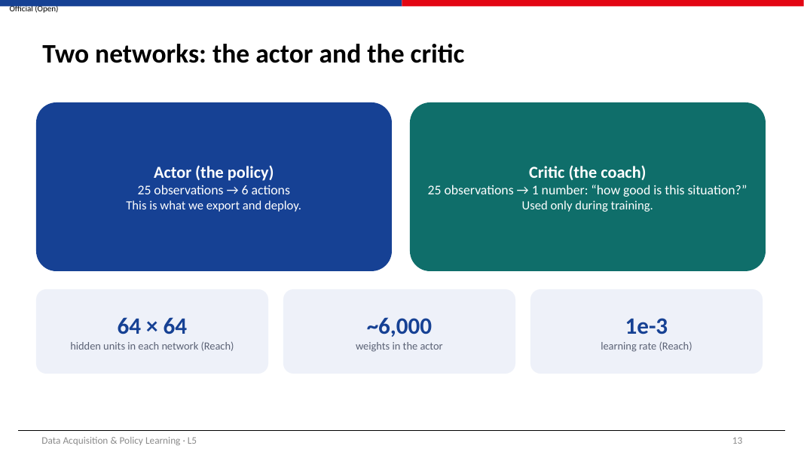
WHAT THIS SLIDE IS ABOUT
PPO trains two small neural networks side by side.

 | Actor (policy) | Critic (value function)
Input | 25 observation numbers | the same 25 numbers
Output | 6 action means (plus a learned noise level) | 1 number: expected return from this situation
Hidden layers (Reach) | 64 → 64, ELU activation | 64 → 64, ELU activation
Used when | training and deployment | training only

COUNTING THE ACTOR'S WEIGHTS
Layer 1: 25 inputs × 64 + 64 biases = 1,664
Layer 2: 64 × 64 + 64 = 4,160
Output: 64 × 6 + 6 = 390
Total ≈ 6,214 weights. An image classifier like ResNet-18 has about 11 million.

- The actor is what you export (policy.pt / policy.onnx) and later run on the real arm.
- The critic acts like a coach. Without it, PPO could only tell that an episode was good or bad overall. With it, PPO can judge each individual action: did things go better or worse than the critic predicted from that situation?
- Isaac Lab estimates advantages with a method called GAE (generalised advantage estimation, λ = 0.95), which blends short- and long-term information. You do not need its formula for this course.
KEY POINTS
Actor = decides; critic = judges. Only the actor is deployed.
Robot RL networks are tiny compared with vision models.

CHECK YOURSELF
Why is the critic not needed when the policy runs on the real arm?

Slide 14 · Thousands of arms in parallel
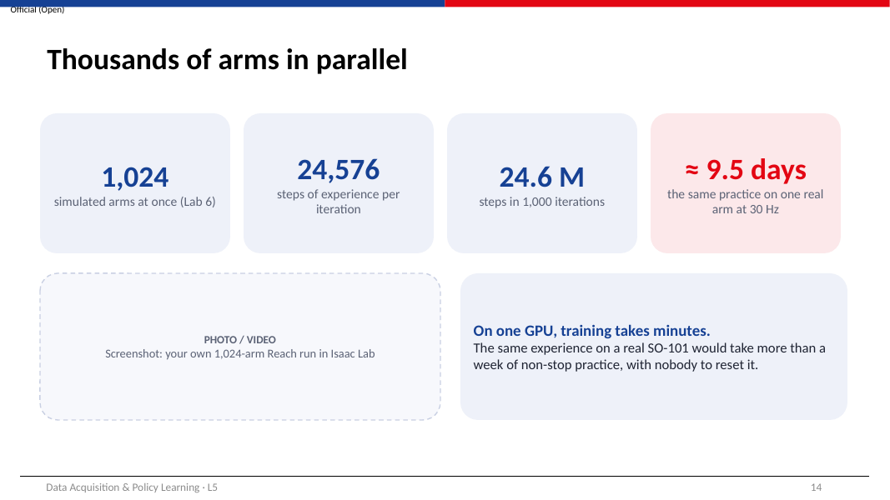
WHAT THIS SLIDE IS ABOUT
RL needs millions of tries. This slide shows, with arithmetic, why a simulator is the only practical way to get them.

HOW MUCH EXPERIENCE DOES TRAINING USE?
Arms running at once in Lab 6: 1,024
Steps per arm per iteration: 24
Experience per iteration: 1,024 × 24 = 24,576 steps
Iterations: 1,000 → 24,576 × 1,000 = 24,576,000 steps (24.6 million)
Time on one real arm at 30 steps per second: 24,576,000 ÷ 30 = 819,200 s
819,200 ÷ 3,600 ≈ 228 hours ≈ 9.5 days, non-stop, with someone resetting the arm every 12 seconds

- In Isaac Lab all 1,024 arms are simulated together on one graphics card, each in its own copy of the scene.
- Each arm has its own random start pose and target, so one iteration covers many different situations.
- The simulation also runs faster than real time, so the whole training takes minutes, not days.
- This is the main reason RL for robots is done in simulation first, and why the reality gap (Lessons 3 and 7) matters so much.
KEY POINTS
24.6 million steps of practice ≈ 9.5 days on one real arm.
Parallel simulation turns that into minutes.

CHECK YOURSELF
If your GPU can only run 512 arms, how many steps of experience does one iteration produce?

Slide 15 · Where the compute goes
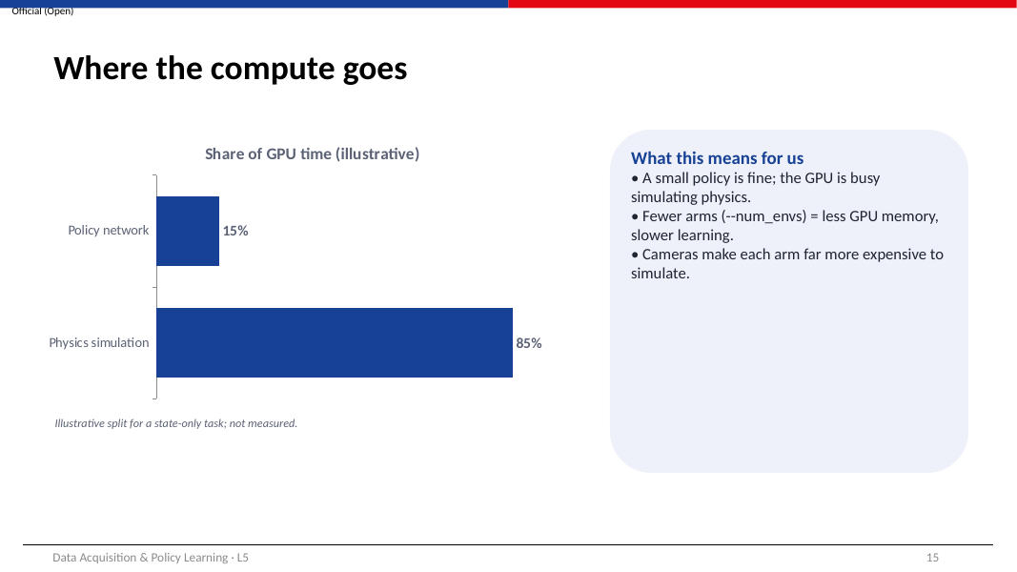
WHAT THIS SLIDE IS ABOUT
In image classification the network does most of the work. In robot RL it is usually the opposite.

- Each step, the simulator must compute contacts, joint forces and motion for every link of all 1,024 arms. This is heavy physics work.
- The policy network is tiny (about 6,000 weights), so running it for 1,024 arms is cheap.
- So most of the GPU time goes to simulation. The split on the slide (85 % / 15 %) is illustrative, not measured, but the direction is right for state-only tasks such as Reach.
What this means in practice:
- A small network is enough; making it bigger rarely helps a task like Reach.
- If you run out of GPU memory, lower the number of arms with --num_envs (for example 512). Learning becomes a little slower per iteration but still works.
- Tasks with cameras must render an image for every arm at every step, which is far more expensive. That is why camera-based training uses tens of arms, not thousands.
- Always train with --headless: drawing the scene on screen wastes GPU time.
KEY POINTS
In robot RL the simulator, not the network, uses most of the GPU.
--num_envs is the main knob for GPU memory.

CHECK YOURSELF
Why would adding a camera observation make training much slower?

Slide 16 · Reading the training curves
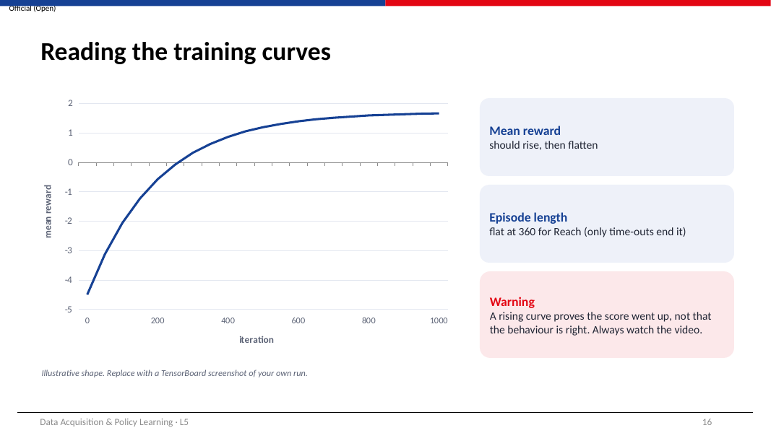
WHAT THIS SLIDE IS ABOUT
During training you monitor progress in TensorBoard. This slide explains what the main curves should look like.

TensorBoard tag | What it shows | Healthy pattern for Reach
Train/mean_reward | Average return of recent episodes | Rises, then flattens
Train/mean_episode_length | Average episode length in steps | Flat at about 360 (only time-outs end an episode)
Episode_Reward/<term> | Each reward term separately | Position penalty shrinks towards 0; fine term rises
Policy/mean_noise_std | Exploration noise | Falls steadily
Loss/value_function | How wrong the critic is | Falls, may stay noisy

- Start TensorBoard on the log folder (Lab 6 shows the command) and open it in a browser.
- First check Train/mean_reward. A curve that rises and levels off means learning is happening.
- Then open the per-term curves to see which part of the reward is improving.
- Finally, and always, play the policy and watch the video.
TIP
A rising reward curve only proves that the number went up. It does not prove the robot does what you intended. Slide 22 shows how a robot can raise its reward while behaving badly. In tasks where failures end episodes early (such as dropping a cube), episode length becomes an important curve too.

KEY POINTS
Read mean reward first, then the per-term curves, then watch the video.
For Reach, episode length stays at 360.

CHECK YOURSELF
Why does episode length not change during Reach training?

Part 3 · Designing the task and its reward

Slide 17 · Part 3 · Designing the task and its reward
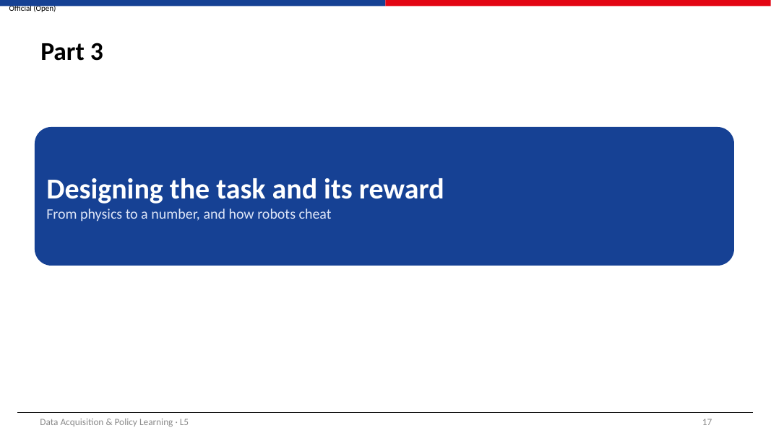
WHAT THIS SLIDE IS ABOUT
Part 3 opens the task configuration and shows how a reward is designed, and how it can go wrong.

Have the isaac_so_arm101 source available if you can: the file tasks/reach/reach_env_cfg.py contains everything shown in Part 3.

Slide 18 · Anatomy of an Isaac Lab task
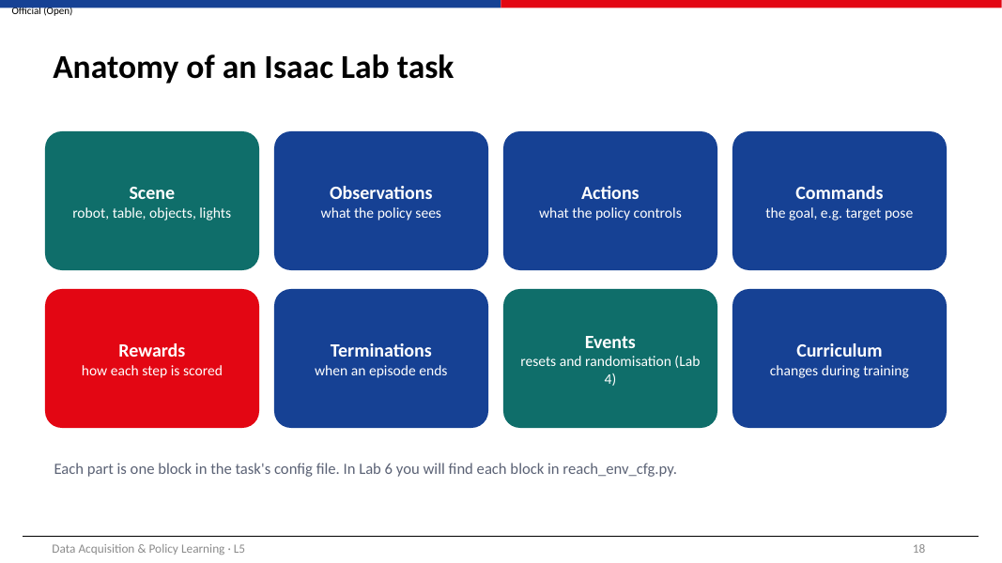
WHAT THIS SLIDE IS ABOUT
An Isaac Lab task is a Python configuration made of eight parts called managers. Each part is one block in the config file.

Part | What it defines | In the Reach task
Scene | Robot, table, objects, lights | SO-101 on a table, light, ground
Observations | What the policy sees | joint_pos_rel, joint_vel_rel, pose_command, last action
Actions | What the policy controls | Joint position targets for 6 joints, scale 0.5
Commands | The goal given to the robot | Random target pose, new one every 5 s
Rewards | How each step is scored | 5 terms (slide 20)
Terminations | When an episode ends | Time-out after 12 s
Events | Resets and randomisation | Joint angles reset to 0.5–1.5 × their start values
Curriculum | Changes during training | Smoothness penalties raised after 4,500 steps

- When training starts, Isaac Lab builds the scene from these settings; a task is not a saved scene file.
- It prints a table of the active terms of each manager in the terminal. Reading that table is a quick way to check what the policy really sees and is rewarded for.
- In Lab 6 your first activity is to find each of the eight blocks in reach_env_cfg.py.
KEY POINTS
Eight parts: scene, observations, actions, commands, rewards, terminations, events, curriculum.

CHECK YOURSELF
Which part would you change to make the target appear in a smaller area?

Slide 19 · Reward design: physics → measurable quantity → reward term
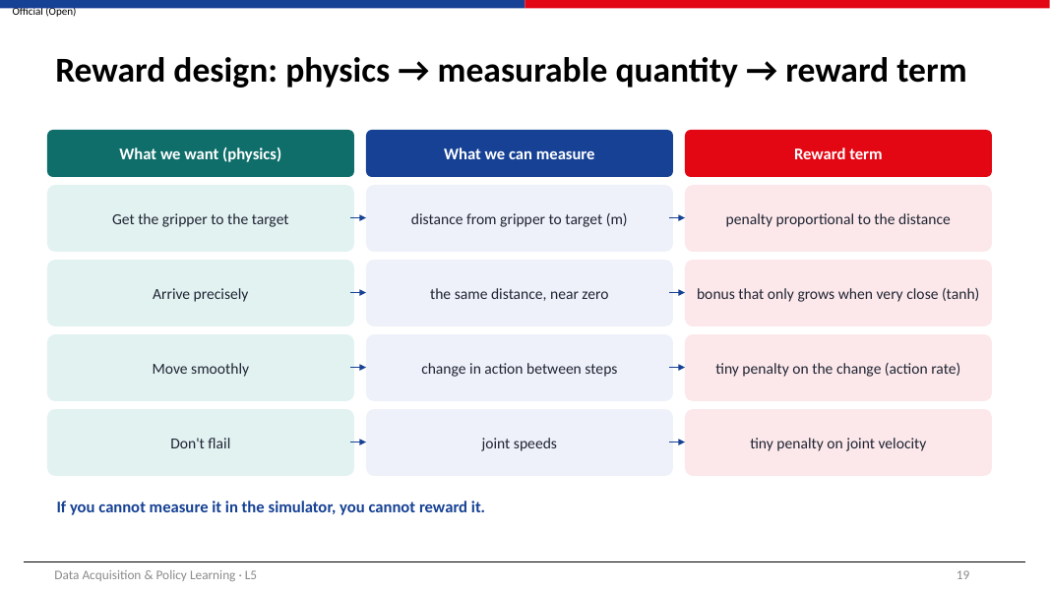
WHAT THIS SLIDE IS ABOUT
A three-step method for turning what you want the robot to do into numbers the simulator can compute.

- Say what you want in physical terms (for example, “get the gripper to the target”).
- Find a quantity the simulator can measure that captures it (the distance from gripper to target, in metres).
- Turn the quantity into a reward term with a sign and a size (a penalty proportional to the distance, weight −0.2).
Want | Measure | Reward term
Reach the target | Distance gripper–target (m) | Penalty ∝ distance
Arrive precisely | Same distance, near zero | Bonus that grows only when very close (tanh)
Move smoothly | Change in action between steps | Small penalty on that change
Don't flail | Joint speeds | Small penalty on joint speed

Dense vs sparse rewards. A sparse reward pays only at success (for example +1 when the gripper is within 1 cm). A random arm almost never gets there, so it almost never sees a reward and learns very slowly. A dense reward, like the distance penalty, gives a signal at every step. Adding helpful dense terms is called reward shaping. Shaping speeds up learning but creates more ways for the robot to exploit the reward (slide 22).
TIP
If the simulator cannot measure something, you cannot reward it. This becomes important on the real arm, where many quantities that are free in simulation (such as an object's exact position) are not available.

KEY POINTS
Want → measure → reward term.
Dense rewards learn faster; every extra term is a possible loophole.

CHECK YOURSELF
Use the method to design a term for “keep the gripper above the table”.

Slide 20 · The real SO-101 Reach reward
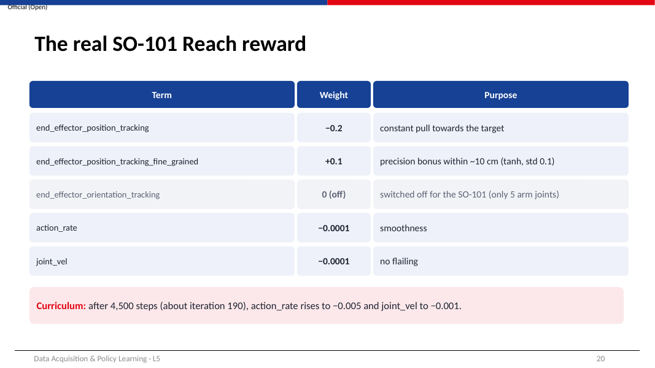
WHAT THIS SLIDE IS ABOUT
The actual reward of Isaac-SO-ARM101-Reach-v0, term by term.

Term (Isaac Lab function) | What it computes | Weight
end_effector_position_tracking (position_command_error) | Straight-line distance d between gripper and target, in metres | −0.2
…_fine_grained (position_command_error_tanh) | 1 − tanh(d ÷ 0.1): near 1 when very close, near 0 far away | +0.1
end_effector_orientation_tracking | Angle between gripper and target orientation | 0 (switched off for the SO-101)
action_rate (action_rate_l2) | Sum over joints of (action now − action last step)² | −0.0001
joint_vel (joint_vel_l2) | Sum over joints of (joint speed)² | −0.0001

- Each step, Isaac Lab computes each term, multiplies it by its weight (and by the step time), and adds them up to get the reward.
- The orientation term exists in the shared Reach config, but the SO-101 version sets its weight to 0. With only five arm joints, the gripper cannot reach every target orientation, so rewarding orientation would ask for the impossible.
- The curriculum raises the two smoothness weights after 4,500 environment steps: action_rate to −0.005 (50 times larger) and joint_vel to −0.001 (10 times larger).
HOW BIG ARE THE PENALTIES COMPARED WITH THE PULL?
Suppose every joint's action changes by 0.5 between steps: action_rate = 6 × 0.5² = 1.5
At the start: 1.5 × −0.0001 = −0.00015
Position term at d = 0.1 m: 0.1 × −0.2 = −0.02, which is 133 times larger
After the curriculum: 1.5 × −0.005 = −0.0075, now about a third of the position term
So jerky motion barely matters early on, and matters a lot once the arm can already reach

KEY POINTS
Two terms pull the arm to the target; two tiny terms keep it smooth; orientation is off for the SO-101.
The curriculum makes smoothness matter later in training.

CHECK YOURSELF
After the curriculum, which term grew by the larger factor?

Slide 21 · Why the weights look so different
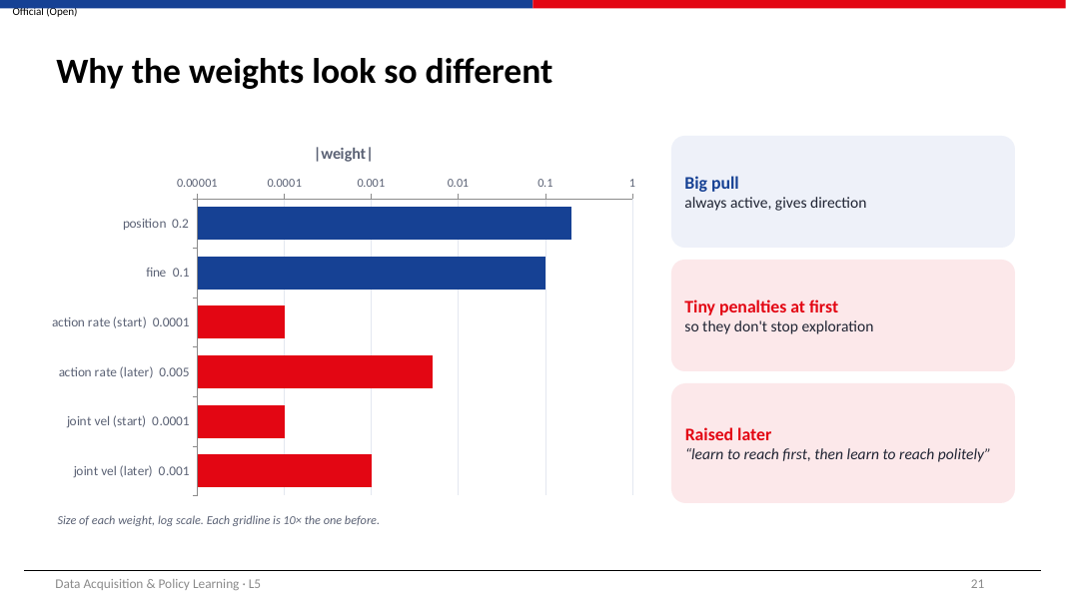
WHAT THIS SLIDE IS ABOUT
The weights range from 0.2 down to 0.0001. This slide explains why such different sizes are deliberate.

How to read the chart: the horizontal axis is a log scale, so each gridline is 10 times the one before. Bars that look one gridline apart differ by a factor of 10.
- The position term (0.2) is the largest because it must give the robot a direction from anywhere in the workspace, from the very first iteration.
- The fine term (0.1) is similar in size but only matters near the target, so it adds precision without dominating far away.
- The smoothness penalties start 2,000 times smaller (0.0001). If they were large from the beginning, a random policy would find that moving at all is costly; the safest strategy would be to stay still, and it would never discover reaching.
- After 4,500 environment steps the curriculum raises them. With 24 steps per iteration that is about iteration 4,500 ÷ 24 ≈ 188, early in the 1,000-iteration run. By then the arm can reach, so it can afford to learn to reach smoothly.
Learn to reach first, then learn to reach politely.

KEY POINTS
Relative size of weights matters more than their absolute values.
Curriculum = change the reward once the basic skill exists.

CHECK YOURSELF
What do you expect to see in the action_rate curve in TensorBoard around iteration 190?

Slide 22 · Reward hacking: it optimises what you wrote
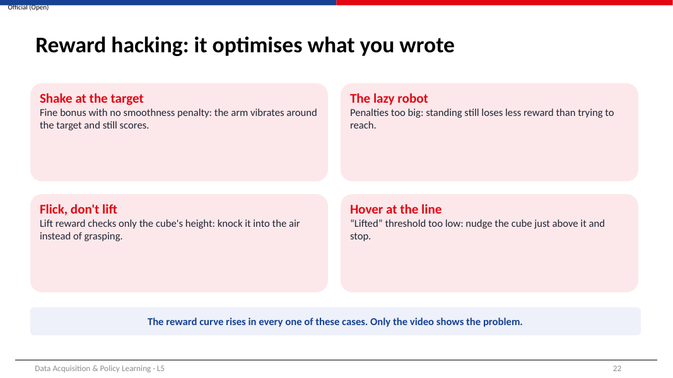
WHAT THIS SLIDE IS ABOUT
Reward hacking is when the policy finds a way to score well that is not what the designer intended. It is not a bug in PPO: PPO does exactly its job, which is to maximise the number you wrote.

Example | What went wrong | Fix
Shake at the target | No smoothness penalty: vibrating near the target still collects the fine bonus | Keep the action_rate / joint_vel penalties
The lazy robot | Penalties too big: standing still loses the least reward | Start penalties small; use a curriculum
Flick, don't lift | Lift reward only checks cube height: knocking it upwards counts | Require the gripper to be near the cube, or holding it
Hover at the line | “Lifted” threshold too low: a nudge just over the line scores | Set the threshold clearly above the resting height

- In every case the reward curve rises, because the policy really is collecting more reward.
- The only reliable way to catch hacking is to watch the policy (play it, record video) and to check task metrics that are separate from the reward, such as the position error of the gripper.
- When you find hacking, ask: which missing or wrongly sized term allowed this behaviour? Then change that term and retrain.
KEY POINTS
The robot optimises the reward you wrote, not the one you meant.
Always watch the video and check task metrics.

CHECK YOURSELF
Suggest one reward-hacking behaviour that could appear in the Reach task if the fine term had a very large weight.

Activity, exit ticket and next steps

Slide 23 · Activity: predict the behaviour
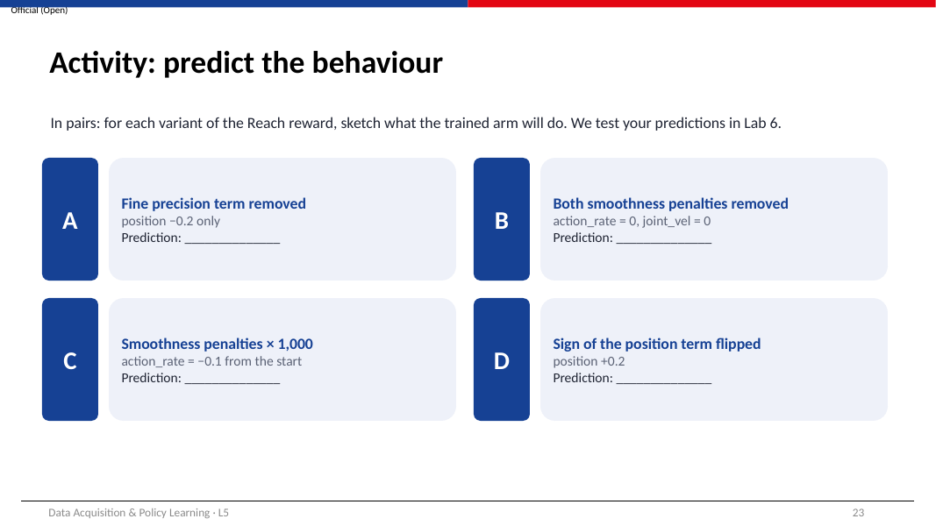
WHAT THIS SLIDE IS ABOUT
Four changes to the Reach reward. Predict what the trained arm will do before you test them in Lab 6.

How to reason about each variant:
- Write down which terms remain and their signs.
- Ask: for a random arm, which behaviour now earns the most reward?
- Ask: once the arm can reach, what extra behaviour is rewarded or no longer punished?
- Write your prediction in one sentence. Compare it with the video in Lab 6.
Variant | Change
A | Fine precision term removed (position −0.2 only)
B | Both smoothness penalties removed
C | Smoothness penalties × 1,000 (action_rate −0.1 from the start)
D | Sign of the position term flipped (+0.2)

TIP
Suggested answers are in Appendix A. Try the activity first.

KEY POINTS
Predict, then test: this is how reward designers work.

Slide 24 · Exit ticket
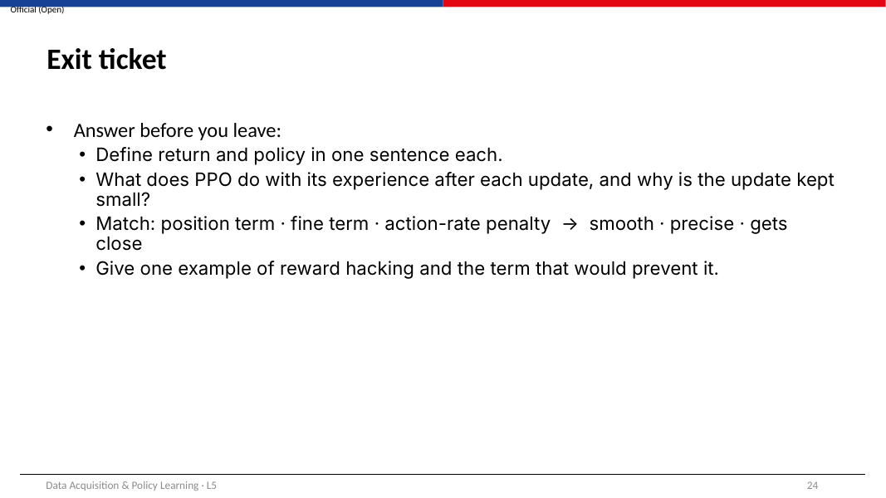
WHAT THIS SLIDE IS ABOUT
Four questions that test the learning outcomes. Answer them without looking back, then check Appendix A.

- Define return and policy in one sentence each.
- What does PPO do with its experience after each update, and why is the update kept small?
- Match: position term · fine term · action-rate penalty → smooth · precise · gets close.
- Give one example of reward hacking and the term that would prevent it.

Slide 25 · Next week: L6 lab · Train a Reach policy in Isaac Lab
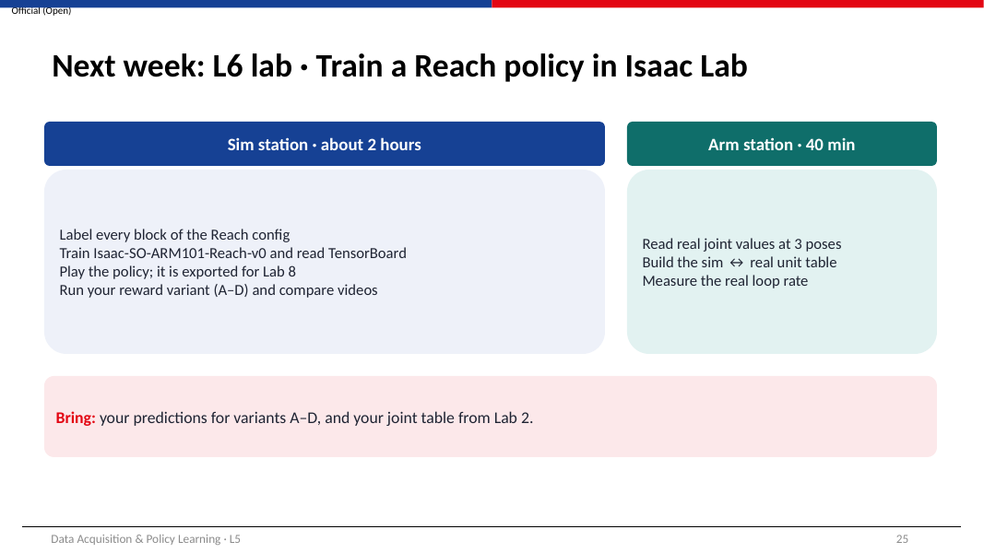
WHAT THIS SLIDE IS ABOUT
What you will do in Lab 6 and how to prepare.

- Sim station (about 2 hours): label every block of the Reach config; train Isaac-SO-ARM101-Reach-v0 and read TensorBoard; play the policy (this also exports policy.pt and policy.onnx for Lab 8); train your reward variant (A–D) and compare it with your prediction.
- Arm station (about 40 minutes): read the real joint values at three poses, build the table that converts simulator angles (radians) to the real arm's readings, and measure the real control rate.
- Bring your predictions for variants A–D and your joint table from Lab 2.
- Revise slides 7, 16 and 20 of these notes: you will use them directly in the lab.
KEY POINTS
Lab 6 produces the exported policy used on the real arm in Lab 8.

Slide 26 · References and further reading
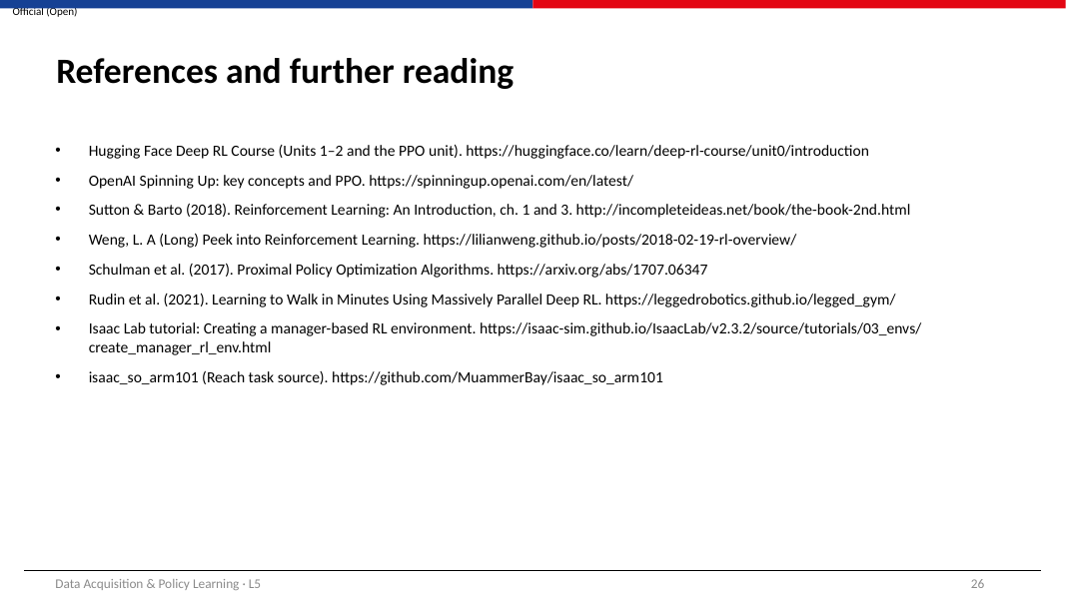
WHAT THIS SLIDE IS ABOUT
Where to go next, in a suggested order.

Resource | Use it for
Hugging Face Deep RL Course — https://huggingface.co/learn/deep-rl-course/unit0/introduction | Units 1–2 for the basics, then the PPO unit. Free, hands-on.
OpenAI Spinning Up — https://spinningup.openai.com/en/latest/ | Short, precise explanations of key concepts and PPO.
Sutton & Barto, Reinforcement Learning: An Introduction — http://incompleteideas.net/book/the-book-2nd.html | The standard textbook. Chapters 1 and 3.
Lilian Weng, A (Long) Peek into Reinforcement Learning — https://lilianweng.github.io/posts/2018-02-19-rl-overview/ | A readable map of RL terms.
Schulman et al. (2017), PPO — https://arxiv.org/abs/1707.06347 | The original PPO paper (for reference).
Rudin et al. (2021), legged_gym — https://leggedrobotics.github.io/legged_gym/ | Videos of thousands of robots training in parallel.
Isaac Lab tutorial: manager-based RL environment — https://isaac-sim.github.io/IsaacLab/v2.3.2/source/tutorials/03_envs/create_manager_rl_env.html | How rewards and terminations are written.
isaac_so_arm101 — https://github.com/MuammerBay/isaac_so_arm101 | The Reach task source used in these notes.

Appendix A · Answers
Answers to the “Check yourself” questions (by slide number), the activity on slide 23 and the exit ticket on slide 24.
Slide | Answer
6 | The environment. The agent only chooses actions; the simulator computes the reward from the new state.
7 (a) | The policy only sees one moment at a time. Including the previous action tells it what it just commanded, which helps it move smoothly and lets it relate its own command to the joints' motion.
7 (b) | 12 × 50 = 600 steps.
8 (a) | Coarse: −0.2 × 0.10 = −0.020. tanh(1.0) = 0.762, so fine = 0.1 × (1 − 0.762) = +0.024. Reward = +0.004, as in the table.
8 (b) | At 0.30 m, d ÷ 0.1 = 3 and tanh(3) = 0.995, so 1 − tanh is 0.005 and the fine term is only 0.0005.
9 | The recorded human action (the leader-arm command) at each frame.
10 | Every action would be the network's current mean, which at the start is almost the same everywhere. The arm would barely vary its movement, rarely discover higher-reward behaviour, and learn very slowly or not at all.
12 | PPO is on-policy: its update assumes the data came from the current policy. After an update the policy has changed, so old data no longer represents what the policy would do. Small updates keep that assumption approximately true and avoid sudden collapses in performance.
13 | The critic only judges actions during training. At deployment the robot just needs to choose actions, which is the actor's job.
14 | 512 × 24 = 12,288 steps per iteration.
15 | Every arm would need an image rendered every step, and the network would have to process images, which costs far more GPU time and memory than 25 numbers.
16 | Reach has no failure condition that ends an episode early; every episode ends at the 12-second time-out (360 steps).
18 | Commands: the ranges of the target pose (pos_x, pos_y, pos_z).
19 | Want: gripper above the table. Measure: gripper height minus table height (m). Term: a penalty when that height is below a small margin, e.g. −1 × max(0, 0.02 − height).
20 | action_rate: × 50 (−0.0001 → −0.005). joint_vel: × 10 (−0.0001 → −0.001).
21 | A visible change: the action_rate term (Episode_Reward/action_rate) becomes much more negative at first, then shrinks again as the policy learns to move more smoothly.
22 | The arm could rush to the target and oscillate tightly around it, or ignore smoothness entirely, because a large fine bonus would outweigh the small penalties.
23 A | The arm still moves towards the target, but stops less precisely: there is no extra reward for the last few centimetres.
23 B | The arm reaches, but with jerky, buzzing motion and possible oscillation at the target.
23 C | The lazy robot: the arm barely moves or moves very slowly, because any motion is heavily penalised before it has learned to reach.
23 D | The reward now pays for being far from the target, so the arm moves its gripper as far away from the target as it can.
24.1 | Return: the (discounted) total reward collected over an episode. Policy: the network that maps each observation to an action.
24.2 | It discards the experience (PPO is on-policy) and keeps updates small (clipped) so training stays stable.
24.3 | Position term → gets close; fine term → precise; action-rate penalty → smooth.
24.4 | Any example from slide 22 with its fix, e.g. shaking at the target → keep the action_rate penalty.

Appendix B · Glossary
Term | Meaning
Action | What the policy outputs each step; for Reach, 6 joint position offsets.
Advantage | How much better an action turned out than the critic expected.
Agent | The decision maker; here, the policy.
Critic (value function) | Network that predicts the expected return from a situation; used only in training.
Curriculum | Changing the task or reward during training, usually from easy to hard.
Decimation | Number of physics steps per policy step (2 for Reach).
Discount factor (γ) | How much future rewards count; 0.99 for Reach.
Entropy bonus | Small reward for keeping some randomness in actions, to keep exploring.
Environment | The simulated world that responds to actions with observations and rewards.
Episode | One attempt from reset to end; 12 s (360 steps) for Reach.
Exploration / exploitation | Trying varied actions / using the best known action.
Iteration | One PPO cycle of collecting experience and updating the policy.
Observation | What the policy sees each step; 25 numbers for Reach.
On-policy | Learns only from experience made by the current policy.
Policy (actor) | Network mapping observations to actions; the part that is deployed.
PPO | Proximal Policy Optimization: improves the policy in small, clipped steps.
Return | Total (discounted) reward over an episode.
Reward | Number given each step that scores what just happened.
Reward hacking | Scoring well in a way the designer did not intend.
Reward shaping | Adding dense intermediate reward terms to guide learning.

Appendix C · Formula and number sheet
Quantity | Value / formula
Reach observation size | 6 + 6 + 7 + 6 = 25 numbers
Policy rate | physics 60 Hz ÷ decimation 2 = 30 Hz
Episode length | 12 s × 30 Hz = 360 steps
Action to joint target | target = start angle + 0.5 × action
Coarse reward term | −0.2 × d (d = gripper–target distance, m)
Fine reward term | +0.1 × (1 − tanh(d ÷ 0.1))
Smoothness terms | action_rate: −0.0001 × Σ(Δaction)²; joint_vel: −0.0001 × Σ(joint speed)² → −0.005 / −0.001 after 4,500 steps
Return | G = r₁ + γ r₂ + γ² r₃ + …, γ = 0.99
Effective horizon | 1 ÷ (1 − γ) = 100 steps ≈ 3.3 s
PPO clip range | ratio kept within 0.8 – 1.2
Experience per iteration | num_envs × 24 (1,024 × 24 = 24,576)
Total experience | 24,576 × 1,000 iterations = 24.6 million steps ≈ 9.5 days at 30 Hz
Actor size | 25×64+64 + 64×64+64 + 64×6+6 = 6,214 weights

