
Date: 8 November 2026 · Diwali (Lakshmi Puja)
Dear Valued Customer,
As a million diyas flicker to life across the country tonight, we at ElectricalSkart.com wish you and your family a very Happy Diwali — may your celebrations sparkle with joy, prosperity and togetherness.
Diwali is the festival of lights, and lights are what we know best. Whether you are shopping for a glittering new chandelier for the living room, festive fairy lights for your balcony, an energy-efficient fan, smart switches, or ISI-marked wiring for a safer home — we are just a click away at www.ElectricalSkart.com.
Thank you for trusting us with the light in your home. Your support powers everything we do, and we promise to keep delivering genuine products, honest prices and warm, friendly service — today, tomorrow and every day of the year.
May Goddess Lakshmi bless your home with prosperity, may Lord Ganesha remove every obstacle from your path, and may your life shine brighter than ever — this Diwali, and always.
Warm regards & sparklers,
Team ElectricalSkart
ELECTRICALSKART.COM
www.ElectricalSkart.com
P.S. While you light the diyas, do take a moment to check your home's wiring and MCBs — safety is the spark behind every happy Diwali.
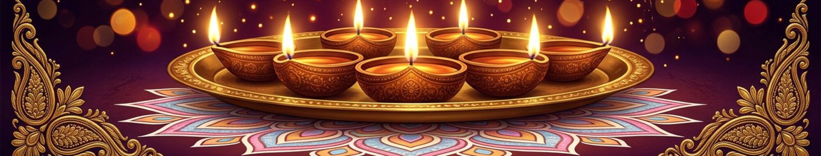
ELECTRICALSKART.COM · www.ElectricalSkart.com · શુભ દિવાળી ૨૦૨૬

