GHANSHYAM ELECTRICALS
441-The Galleria, Yogi Chowk, Surat, Gujarat - 395006
Mobile: +91 92655-60638 | Email: ghanshyamelectricals101@gmail.com
ELECTRICAL WORKS QUOTATION
Prepared from the approved electrical layout drawings (Ceiling Plan, Light Dimension Layout & Electric Wiring Layout)
Project | JANKI HEIGHT’S, B-Building, 9th Floor, Flat No. 901 | Client Name | ________________________
Scope | Interior Electrical Works – Flat 901 (as per drawing) | Contact No. | ________________________
Drawing Ref. | BULD-B 901_JANKI HEIGHTS_electric plan.dwg | Site Address | ________________________
Quotation No. | GE-874 (Rev. 1) | Date: 15/08/2026 | Valid: 10 days | Ceiling Area | 458.64 sq.ft + 46.79 sq.ft (toilet)

Note: This quotation is prepared after a systematic reading of the client-supplied electrical layout. The drawing contains three sheets of Flat 901 – (1) Ceiling Plan (light/fan/exhaust/geyser points), (2) Light Dimension Layout (same ceiling scope, dimensioned), and (3) Electric Wiring Layout (switch boards, plug points, A.C. points and circuit annotations). Quantities below are counted point-by-point from these sheets.
1. ELECTRICAL LAYOUT – ROOM-WISE POINT SCHEDULE (FLAT 901)
Summary of every electrical point counted from the drawing, room by room:
Room | Ceiling  Light | Fan | Wall  Light | Stripe  Light | 5A  Socket | 15A  Point | Switch  Board | Geyser | Exhaust | Others
Living | 4 | 2 | 1 | 1 | – | – | – | – | – | Pooja light – 1, A.C. O.D.U. – 1
Kitchen | 6 | 1 | – | – | – | – | 1 | – | – | Chimney – 1, Water filter – 1
Bedroom 1 | 4 | 1 | – | 1 | 3 | 1 | 2* | – | – | Split A.C. point – 1, O.D.U. – 1
Bedroom 2 | 4 | 1 | 1 | 2 | 2 | 1 | 2 | – | – | –
A. Toilet | 1 | – | 1 | – | – | – | 3 | 1 | 1 | –
C. Toilet | 2 | – | 1 | – | – | 2 | 3 | 1 | 1 | –
Passage | 1 | – | – | – | – | – | – | – | – | Bell – 1
Entry | – | – | – | – | – | – | 2 | – | – | –
Wash / Utility | – | – | 1 | – | – | 2 | 2 | – | – | Internet point – 1
Store / Utility wall | – | – | – | – | – | – | – | 1 | – | –
TOTAL | 22 | 5 | 4 | 4 | 5 | 6 | 15 | 3 | 2 | 9 misc. points
* Bedroom switch boards include bed-panel boards at 3′-0″ / 2′-6″ height as per the drawing’s switch-board height schedule.
Additional scope noted on the drawing: 2 Nos. A.C. Outdoor Units (living + bedroom, above/below), pooja-light point in living furniture, chimney & water-filter points in kitchen, and one-way / two-way ceiling circuit lines (~99 m drawn length). Ceiling areas: living etc. 458.64 sq.ft + toilet 46.79 sq.ft (total 505.43 sq.ft ≈ 47.0 m²).
2. PRICING – BOQ (QUANTITIES FROM DRAWING, RATES INDICATIVE)
Rates include standard/ISI-marked material and labour. GST extra. Final quantities shall be confirmed on-site before commencement.
Sr. | Description of Work | Unit | Qty. | Rate – Material + Labour (₹) | Amount (₹) | Labour Only (₹)
A. Distribution & Panel Work
A1 | Distribution Board (SDB) with MCB + RCCB set, supply & installation | Set | 1 | 12,500 | 12,500 | 2,000
A2 | MCB / RCCB fitting & circuit connection | Per pole | 12 | 850 | 10,200 | 150
A3 | Switch board installation & circuit wiring (standard, 4′-6″ height) | Per board | 11 | 1,250 | 13,750 | 450
A4 | Switch board @ 3′-0″ / 2′-6″ (bed panel / geyser boards) | Per board | 4 | 1,250 | 5,000 | 450
A5 | Panel labelling & circuit identification | Lot | 1 | 1,500 | 1,500 | 500
B. Light & Power Wiring
B1 | Ceiling light point (false-ceiling / downlight) – concealed wiring | Per point | 22 | 950 | 20,900 | 300
B2 | Wall light point at 7′-0″ | Per point | 4 | 1,100 | 4,400 | 350
B3 | Stripe / profile LED light point | Per point | 4 | 1,300 | 5,200 | 400
B4 | Pooja light point (in furniture) | Per point | 1 | 950 | 950 | 300
B5 | Fan point with regulator connection | Per point | 5 | 1,450 | 7,250 | 400
B6 | 5A socket (plug) point | Per point | 5 | 900 | 4,500 | 300
B7 | 15A power point | Per point | 6 | 1,200 | 7,200 | 350
B8 | Split A.C. point (indoor unit, 4 sq.mm wiring + isolator) | Per point | 2 | 2,600 | 5,200 | 600
B9 | A.C. outdoor unit (O.D.U.) point | Per point | 2 | 1,800 | 3,600 | 450
B10 | Geyser / water heater point | Per point | 3 | 2,100 | 6,300 | 450
B11 | Exhaust fan point | Per point | 2 | 1,200 | 2,400 | 350
B12 | Call bell point | Per point | 1 | 1,100 | 1,100 | 350
B13 | Chimney point | Per point | 1 | 1,800 | 1,800 | 450
B14 | Water filter / RO point | Per point | 1 | 1,100 | 1,100 | 350
C. Cabling & Conduit
C1 | Main power cable laying (floor riser to flat DB) | Per meter | 15 | 420 | 6,300 | 80
C2 | Sub-circuit cable laying – 2.5 / 4 sq.mm FR (approx.) | Per meter | 750 | 72 | 54,000 | 20
C3 | ISI concealed conduit fitting & laying (approx.) | Per meter | 700 | 48 | 33,600 | 18
C4 | Junction box / pull box fitting | Per unit | 8 | 250 | 2,000 | 60
C5 | Earthing cable laying & connection | Per meter | 10 | 180 | 1,800 | 30
D. Data & Communication
D1 | CAT 6 network cable laying (approx.) | Per meter | 40 | 38 | 1,520 | 12
D2 | Network patch panel / jack installation | Per unit | 1 | 1,200 | 1,200 | 300
G. Special & Miscellaneous
G1 | Testing, commissioning & handover | Lump sum | 1 | 4,500 | 4,500 | 1,500
G2 | Any other work as per site requirement | As agreed | – | – | – | –
 | GRAND TOTAL |  |  |  | ₹ 219,770 | ₹ 63,710

Grand Total – With Material & Labour: ₹ 219,770 | Grand Total – Labour Only: ₹ 63,710
GST @ 18% and any other applicable taxes extra. Rates are indicative market rates for standard/ISI material; contractor’s final rates to apply before issue.
3. ASSUMPTIONS & NOTES ON QUANTITIES
1. Quantities are counted point-by-point from the client-supplied drawing “BULD-B 901_JANKI HEIGHTS_electric plan.dwg” (Ceiling Plan, Light Dimension Layout and Electric Wiring Layout of Flat 901, B-Building, 9th Floor, Janki Height’s).
2. The ceiling plan and light-dimension layout represent the same physical points; they have been counted once (22 ceiling lights, 5 fans, 3 geyser points).
3. Conduit & sub-circuit cable quantities are estimated on a per-point basis (~11–12 m per point) plus ~99 m of one-way/two-way ceiling circuit lines measured on the drawing. Final running-meter quantities to be measured on site.
4. Fire alarm, CCTV, access control, audio-visual and automation items are not shown on this interior electrical drawing and are therefore quoted as “Not Applicable – on request”.
5. Earth pit is assumed existing; if a new pit is required it shall be quoted separately.
6. The drawing is an interior-design-purpose plan (Architects: Ar. Tirth Radadiya / Ar. Raj Modi). Any deviation from the approved layout requires written approval.
4. TERMS & CONDITIONS (CONDENSED – FULL VERSION AS PER GE-874)
Payment: 50% advance before commencement; 25% on 50% work completion; balance 25% within 3 days of completion. 2% per month interest on overdue amounts.
Materials: ISI-marked/standard quality only. Material substitution only with prior written client approval.
Warranty: 1 year on workmanship; material warranty as per manufacturer.
Work hours: Mon–Sat, 9:00 AM–6:00 PM. As-built drawings, test reports and completion certificate on handover.
Confidentiality: All drawings, data and pricing remain confidential under the NDA (valid during project + 2 years thereafter).
Jurisdiction: Indian Electricity Act 2003 / IS / IEC standards; disputes subject to Surat, Gujarat courts.

Client / Customer  Signature: ______________  Name & Date: ______________ | Quotation Accepted  (Yes / No): ______________  Date: ______________ | For Ghanshyam Electricals  Signature: ______________  Name & Date: ______________

ANNEXURE A – ELECTRICAL LAYOUT REFERENCE (EXTRACTED FROM CLIENT DWG)
The figure below reproduces the electrical layout of Flat 901 (three sheets + legend) as read from the supplied DWG file.
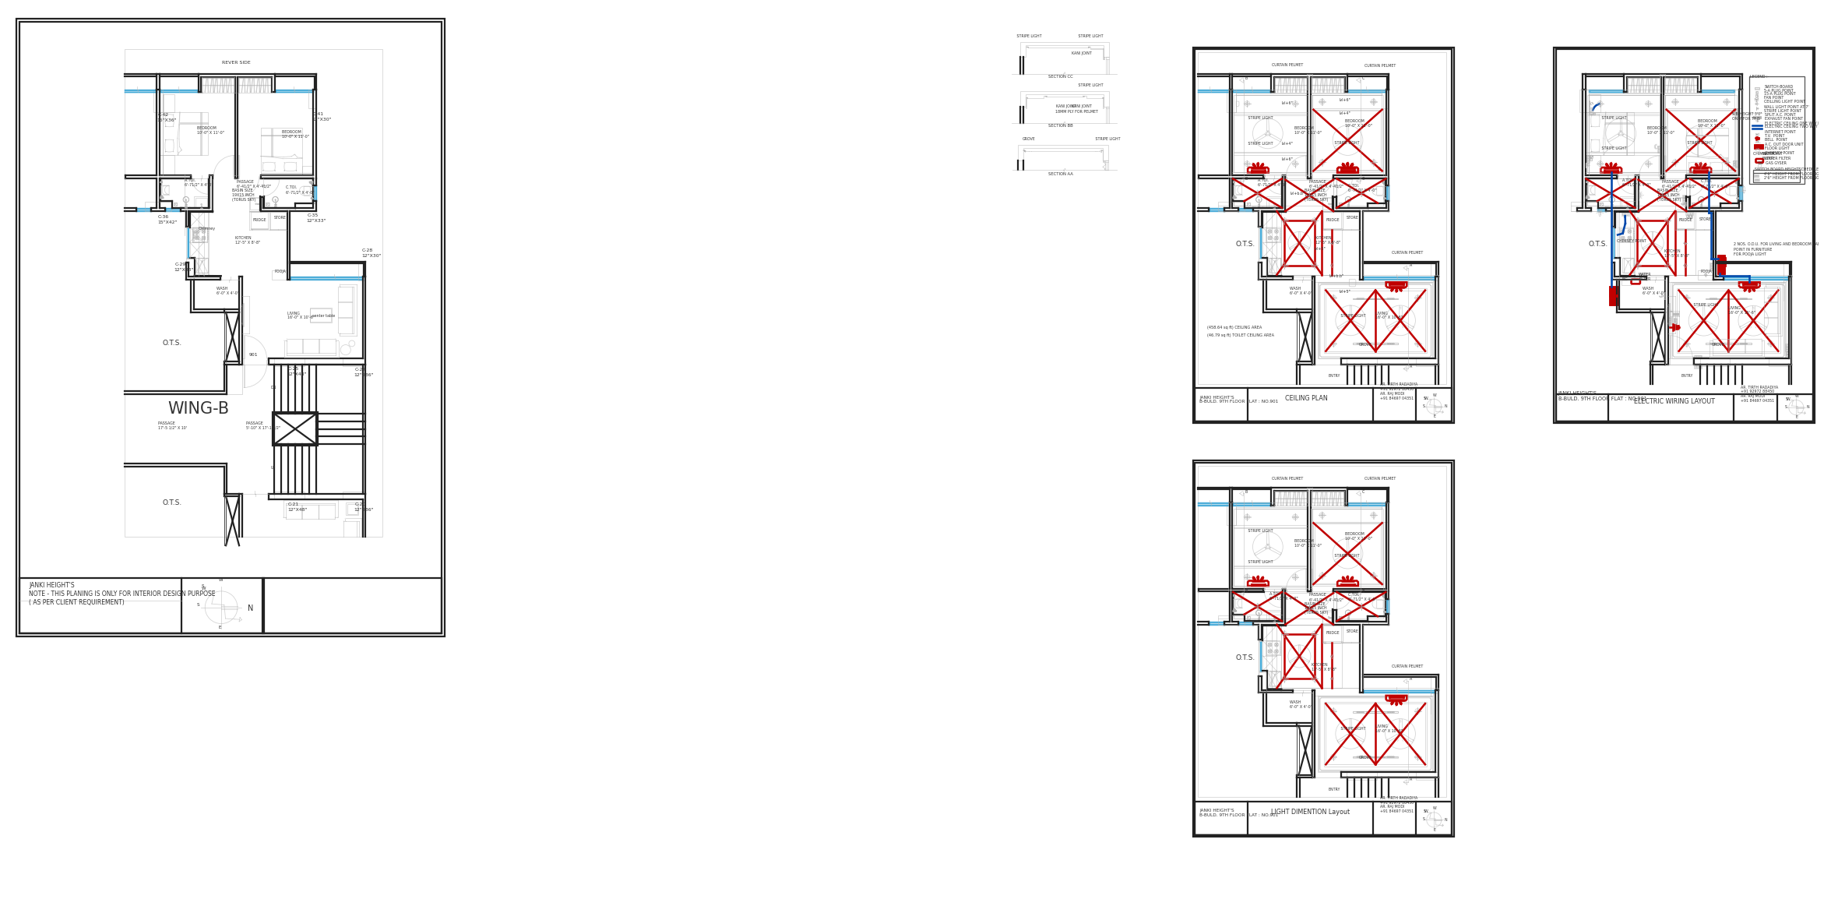
This document is confidential and intended solely for the named client. Unauthorized reproduction or distribution is strictly prohibited.

