Phase-Based Syntax: Theoretical Motivations and Empirical Proposals

Hania Kedzierska and Ryan Kelley

ETHEL Program, University of Wroclaw

June 2016

**Table of Contents**

1. Introduction: 3

2. Theoretical Motivations for Phases: 10

2.1: The Syntax-Phonology Interface 10

2.2: Information Structure 17

2.3: Verb Phrase Ellipsis and Phases 19

3. Motivation for our proposed study: 22

3.1: Island effects in empirical research: 22

4. Proposed study: Design 27

4.1. Methodology: 27

4.2. Materials: 30

5. Discussion: 32

6. Conclusion: 34

References: 35

Appendix 1: Sample stimuli for experiment design 37

## 1. Introduction:

In the early 1980s, Noam Chomsky introduced his theory of Principles and Parameters (in the context of Government and Binding Theory) with the intent of creating a framework for use in studying generative grammar. Principles and Parameters itself rose out of Chomsky's previously proposed Universal Grammar, or UG – the notion that human language capability is innate and “reflexive” (Chomsky, 1998, p. 89), and can be likened to an organ, similar to the visual system or the immune system. “Like other organs,” Chomsky writes, “FL [language faculty] has an 'initial state' S0 that is an expression of the genes [which]...undergoes state changes under triggering and shaping influences of the environment” (Chomsky, 1998, p. 90); under that assumption, the question then becomes: what is the exact nature of those “triggering and shaping influences”? With the introduction of generative grammar, Chomsky writes, the age-old goals of descriptive adequacy versus explanatory adequacy were set in contrast: “the search for descriptive adequacy seems to lead to ever greater complexity of rule systems, varying among grammatical constructions and across languages, whereas the search for explanatory adequacy leads to the conclusion that language structure is largely invariant” (Chomsky, 1998, p. 92). Nevertheless, Chomsky's Principles and Parameters was an early attempt to introduce a device to explain how a particular languages “values” are “set”, thereby providing an arena in which to discuss such issues.

With a provisional general theory thus provided, new vistas of inquiry opened up. Chomsky's Minimalist Program subsequently sought to investigate the optimality of the “design” of language. Chomsky assumed that FL has access to a cognitive system which stores information about sound, meaning, and how language structures are organized. He also assumed that there are “levels of representation” through which this information is presented to the “performance systems”: sensorimotor systems (PHON, for short) and “systems of thought” (SEM) (Chomsky, 1998, p. 90). In other words, all of the information which is necessary for language to be processed must be translated through PHON and SEM in order to be produced and/or understood.

Given this assumption, Chomsky then put forward the question of “how well is language designed?”; in other words, is this system of “translation” optimal in human language? If not, how close is it? (Chomsky, 1998, p. 92). What are the minimal design specifications which can yield perfection? The Minimalist Program suggests that the minimal condition is *legibility*; that is, the ability of the system to provide representations which can be interpreted by the interface levels PHON and SEM (Chomsky, 1998). The flip side of this assertion is that no elements which are introduced to the interfaces can be *illegible* – that is, no features which are not interpretable by either PHON or SEM can pass through to the interfaces, since this would lead to a crash in the derivation. Therefore, an optimal design must both provide a way to distinguish between legible features (here called “interpretable features”, since they can be interpreted by the performance systems) and illegible (“uninterpretable”) features, and must also be able to ensure that only interpretable features are presented to the interfaces; somehow, all of the uninterpretable features which are inaccessible to the interfaces must be identified deleted to avoid crashing. The term “convergence” is used to refer to the event of the legibility condition being met at all interface levels (Chomsky, 1998, p. 95). Chomsky's assumption is that language indeed *approaches* an optimal solution to this need for convergence, although may not perfectly achieve this goal in fact; the Strongest Minimalist Thesis (SMT) is that “language design may really be optimal in some respects, approaching a 'perfect solution' to minimal design specifications” (Chomsky, 1998, p. 93). However, with the assumption that the SMT is true, questions concerning the biology and “design” of such a system become paramount: “a new problem arises: how did the structure of the brain and the course of evolution happen to yield the [SMT]? ...Issues relating to the interface become of central concern. The problem of discovering whether, and if so how, considerations of economy enter into language design also gains new prominence” (Chomsky, 1998, p. 96)

How would a language system operate under the SMT? In other words, what does a perfect system look like, and what are the principles governing it? Chomsky assumes a derivational approach, consisting of a “step-by-step procedure for constructing EXPs [expressions]” (Chomsky, 1998, p. 98). With this assumption, operational complexity can be brought into focus; the goal becomes to reduce complexity and to maximize optimization. “Least effort” conditions dictate the elimination of any unnecessary elements, such that all elements must be legible and all operations must be motivated (Chomsky, 1998). Similarly, Chomsky incorporates the notion of “search space reduction”. Both ideas will become important later on; the overall drive to reduce computational effort as much as possible is a major motivation for the notion of phases in general.

With these two conditions combined, Chomsky pursued possible avenues for complexity reduction. One immediate arena for consideration was the question of access to the lexicon. Unfettered access was quickly discarded in favor of “lexical arrays” (LAs), which reduce computational load by presenting only necessary items to the derivation. Each lexical item represents a set of both interpretable and uninterpretable features, and the eventual structure presented to the interfaces is determined through the operations Merge and Agree (Citko, 2014). So far, so good. However, empirical problems begin to arise with this basic assumption, particularly a problem which was named Merge Over Move (MOM).

The Merge Over Move problem emerges when considering the economy of the basic syntactic operations Merge and Move. Hornstein, Nunes and Grohmann give the following examples:

1) There seems to be someone here.

2) *There seems someone to be here. (Hornstein, Nunes and Grohmann, 2005, p. 335)

As Hornstein, Nunes and Grohmann explain, both sentences begin with the same numeration:

N0 = {there1, T1, seem1, to1, be1, someone1, here1}

The derivations of both sentences progress equally until {to be someone here} has been formed. In sentence 1), the expletive is merged to check the EPP feature on *to*. The remaining features are also selected and merged until the numeration has been emptied. The matrix EPP-feature still needs checking, so the expletive *there* moves to check it. This yields a well-formed sentence in English.

However, its mate, sentence 2), is derived differently and, for some reason, is not well-formed. In short, “someone” moves to check the EPP feature of T, and the other elements in the numeration are merged until the numeration is exhausted. The explanation is that, as Citko summarizes, “all things being equal, Merge is preferred over Move” as the less costly and therefore default option (Citko, 2014, p. 23). This rule neatly rules out the incorrect option.

Unfortunately, this preference does not explain the grammaticality of more complex sentences, and so must be reconsidered. Citko gives the example:

3) There is a strong likelihood that many parrots will be at the clay lick right now. (Citko, 2014, p. 27)

MOM predicts that this sentence should be ungrammatical for the same reason as 2) is; namely, that *there* should be merged in [spec, TP] after {will be many parrots be at the clay lick right now}, since it is less costly to merge the expletive than to move *many parrots*. However, doing this would yield the ungrammatical sentence,

4)*There is a strong likelihood that *ti* will be many parrots at the clay lick right now.

To get around this obstacle, Chomsky expanded on the LA theory and proposed the concept of lexical *subarrays*, which would further divide the lexical items selected from the lexicon and counted in the numeration. The acceptability of sentences like 3) and 4) could therefore be explained by proposing that *there* and *many parrots* were in different subarrays, and therefore the only option for checking the EPP feature is to move *many parrots* because *there* is not yet made available to the derivation (Citko, 2014, p. 28).

This brings us neatly to Chomsky's introduction of *phases*: “A phase of a derivation is a syntactic object derived...by choice of LA” (Chomsky [2000], cited in Citko, 2014, p. 29). This definition, especially when seen in terms of the notion of lexical subarraysalready implies a kind of 'cyclicity' in lexical access, as the subarraysare, in fact, accessed one by one. As Chomsky explains: “at each stage of a derivation a subset LAi is extracted [and] placed in active memory (…) and submitted to the procedure L. When LAi is exhausted, the computation may proceed if possible” (Chomsky [2000], cited in Citko, 2014, p. 28).

Which syntactic objects can be then classified as phases? Initially, Chomsky defined as phases only those constituents which contain external arguments (i.e. CP, and transitive and unergative vP): “[he] took phases to be semantically complete units, 'either a verb in which all theta-roles are assigned or a full clause involving tense and force...A phase is CP or vP, but not TP or a verbal phase headed by H lacking phi-features and therefore not entering into case/agreement checking: neither finite TP nor unaccusative/passive verbal phrase is a phase” (Chomsky, 1998, p. 106-107). In other words, the original definition excludes TP, as well as unaccusative and passive vPs from being considered phases. However, strong empirical evidence has been provided since 2000 against this division; for instance, Legate's (2003) detailed discussion of primary stress placement in English in terms of Nuclear Stress Rule (NSR) (see section 2.1 Syntax-Phonology Interface for further details) constitutes a valuable piece of evidence that both passives and unaccusatives should be treated as phases. Citko also displays a certain kind of skepticism towards the classification based on the presence of external arguments and demonstrates that, for instance, unergatives “are not complete in their argumental structure,” as they sometimes may lack internal arguments (p. 30). The same type of inconsistency could be ascribed to transitives, as they often take double objects: for example, in the sentence *John baked Mary a cake* (Citko, 2014).

Chomsky responded to Legate's argument by introducing the division of phases between strong and weak ones. According to him, Strong and weak phases: only strong phases can have EPP features and trigger transfer. Weak phases can still be used for reconstruction effects as in Legate. But at the same time, Boeckx wonders what the point of having weak phases is if only strong phases exhibit the exemplary properties of phasehood (PIC and Spell-Out sites) (Boeckx, 2007)?

One more thing worth stressing here is the status of DP as a phase. Although Citko (2014) mainly focuses on the controversies which arose around the dispute whether DP can contain other phases, she also emphasizes the existence of many similarities between DPs and CPs and, following Matushansky (2005), applies various tests of phonological and interpretation independence of DPs, e.g. checks whether DPs can be considered a domain of feature valuation, locus of uninterpretable features, or determiners of Spell-Out, to mention just a few (Citko, p. 123). The majority (if not all) of those tests confirm the phasal status of DPs, which seems to be acknowledged in the field by the majority of researchers (for instance, Adger (2007) bases his analysis of stress pattern in English in terms of phasal syntax on the assumption that not only CPs and vPs but also DPs are phases).

Interestingly, T is also sometimes assumed to have phase-like properties, for instance by Gallego (2010). He focuses mainly on Null-Subject languages (NSLs), such as Romance or Slavic languages, in which, as the name suggests, it is possible to create a sentence without a subject, which capability is said to be motivated by the pro-drop parameter. Gallego describes the dependencies between C, T, and v in NSLs; more specifically, he wants to “offer a formalization of the idea that T can manifest phase-like properties in NSLs after *v\**-to-T movement, and defend the hypothesis 'uninterpretable features (uFF) signal phase boundaries'” (Gallego, 2010, p. 51) His proposal, then, is that NSLs have different phase systems from English due to the notion that T has phase-like properties in NSLs but not in English. This approach is based on the idea that uninterpretable morphology (in the case of NSLs associated with the subject) “must be valued and deleted when the relevant chunks of structure are transferred to the interfaces” (Gallego, 2010, p. 51).

This leads us to an important question: why should phases differ cross-linguistically, assuming UG? Is it some kind of parametric variation? If so, what is the nature of this variation? Gallego argues that in NSLs (Romance languages in particular), that T is not actually a phase in itself, but that it acquires phase effects due to *Phasal Sliding*, which means that it actually derives its effects from a complex sort of combination with v*. So, by this theory, C, v* and P are still the only phases. T just acquires some of the features through head movement.

Perhaps the most important property of phases, and the property which most influences the motivations described below, is that they determine points of transfer of syntactic information to PHON and SEM. This feature is sometimes strictly connected with the notion of so-called Multiple Spell-Out, and means that during the derivation, syntax can “'communicate' with phonology and semantics” more than once (Citko, 2014, p. 30), which, according to Citko, is one of the biggest advantages the phase-based approach has over the previous ones (e.g. the Minimalist Approach).

At this point, the undoubted importance of phase heads should be stressed. As stated by Citko, (2014), “phases are the loci of uninterpretable features” (p. 30). And, as it is the head that contains uninterpretable features, it is, consequently, the only phasal element able to trigger syntactic operations, with Move and Agree being the most prominent ones. However, thanks to the phenomenon of Feature Inheritance, non-phasal heads can 'inherit' features from phasal heads (Citko, 2014, p. 46). To illustrate this process, T (a non-phasal head) is widely acknowledged to possess a set of ɸ-features, which, in fact, make subject-verb agreement possible (Adger, 2002). This set of features, however, is said to originate in C which can be visible, as exemplified in Citko (2014), in such languages as, for instance, Polish, in which ɸ-features are visible on the complementizers, as in 5.

5) Chciałam, żebyście skończyli.

want-PST-fem that-2-Pl finish-PST

*I wanted you to finish.*

That is why Feature Inheritance is not always considered obligatory (Citko, 2014). Also, two types of Feature Inheritance may, in fact, be distinguished, i.e. Feature Inheritance From Above (as in the example of ɸ-features transfer from C to T) and Feature Inheritance From Below, whose existence, though disputed, may be observed, for instance, in Exceptional Case Marking structures (Citko, 2014).

Yet another basic notion strictly connected with phases is the phase edge, which is the term used to describe the phase head, its specifiers, and its adjuncts. In the most general terms, it is assumed that at some point, only the edge of the phase is accessible to operations outside the phase (Citko, 2014). When exactly does the phase become “closed”? This question brings us to the two definitions of the Phase Impenetrability Condition (hereinafter referred to as PIC): the strong (PIC1), and the weak (PIC2) versions of this condition. The main difference between them could be briefly summarized as follows: according to PIC1, the phase becomes inaccessible for further operations (such as Agree) right after it is complete, while according to PIC2, the next phase has to be merged for the previous one to be permanently “closed”. Citko provides an argument in favor of PIC2 from the Polish language, and more specifically, from the “quirky nominative objects”, i.e. objects which take the nominative case, as in:

7) Marii podobała się książka. (Citko, 2014, p. 35)

Mary-DAT like-PST the book-NOM

*Mary liked the book.*

In sentences of this kind, the Agree operation between T and the object takes place after the first phase (vP) is closed. One could then conclude that not only vP but also the rest of the phase is accessible for T after vP is complete and before C (the next phase's head) is merged, which is exactly what PIC2 states.

There are some problems with PIC, though; the most prominent ones come perhaps form Boškoviƒ (2007). He describes the phenomenon of Long-Distance Agreement in such languages as, for example, Chukchee, where Agree can take place between the embedded object and matrix verb; in other words, across the phase boundary. Does this necessarily prove that PIC is wrong? Citko suggests that there are alternatives: Long-Distance Agreement can either be caused by some kind of parametric variation, or could be motivated by delayed transfer to PHON (Citko, 2014, p. 41).

Not only is the exact existence of PIC controversial, but many other problems have also been connected with phases so far. For instance, Boeckx and Grohmann (2007) express hesitations concerning the reduction of computational load, one of the major factors which motivated phases for Chomsky in the first place. According to Boeckx: “interfaces appear to examine the internal content of full representations for specific processes. For example, the semantic component needs to see multiple spelled-out chunks for pronominal binding” (Boeckx and Grohmann, 2007, p. 48). In other words, where is the benefit in “packing things in boxes” (phases) if you just have to “open the boxes” again to re-access the information? Additionally, “recombination cannot amount to the cumulative outcome of cyclic Spell-Out because syntactic derivations proceed in parallel. Some algorithm will therefore have to be found, and more importantly, justified” (Boeckx, as quoted in Gallego, p. 71). To illustrate the point, cyclic Spell-Out can't even provide the same outcome precisely because of the simultaneity that is supposed to provide the computational efficiency that motivates it. In order to find out how reconstitution happens, yet another mechanism has to be found and motivated which is, undoubtedly, not an easy task in terms of the Strong Minimalist Thesis.

Although Boeckx's argument indeed seems to be a strong one, the list of evidence which supports a phase-based theory is, on the other hand, fairly extensive. Chomsky (as quoted in Gallego, p. 75) provided a whole list of empirical evidence for phases. To mention just a few, arguments from Merge over Move Principle, SEM effects at edges, Valuation of uFF, Featural Opacity, and SEM and PHON independence all suggest that the notion of “phase” is a necessary contribution to the Minimalist Syntax approach. In the following sections of this work, we will focus on phases at PH and LF and discuss some significant pieces of both theoretical and empirical evidence in favor of the existence of phases.

## **2. Theoretical Motivations for Phases:**

### 2.1: The Syntax-Phonology Interface

2.1.1: Primary stress in English

We would like to start our discussion about the relation between phases and PF with evidence provided by Julie Anne Legate in her article, “Some Interface Properties of the Phase” (Legate, 2003). Legate provides evidence for the existence of more strong phases, i.e., she states that, apart from transitive vPs and CPs, passive and unaccusative VPs are phases as well (p. 506). To prove this assertion, she applies the Nuclear Stress Rule (NSR), a phasehood test of vPs at PF level, to English sentences of various types.

To explain what the NSR is, Legate follows Clinque's (1993) definition of the NSR as the rules which assigns primary stress in English to “the final stress-bearing element in the VP” (Legate, 2003, p. 511). It is crucial here that NSR is said to apply in cycles (Bresnan, 1972). That is why, in sentences containing relative clauses, such as *Mary liked the proposal that John left* (Legate, 2003, p. 511), it is the word *proposal,* not the word *left* which receives the main stress. It happens this way because during the first cycle, when the DP (*the proposal)* occupied the position of verb complement, it was also the final stress-bearing VP element. Then, in the next step of the derivation, it was moved outside the embedded clause, but the movement took place after the primary stress had already been assigned[1].

However, Legate observes that if an element is moved within a phase it does not, in fact, receive the primary stress. To illustrate the assumption, one could focus on English phrasal verbs' nominal complements which, in contrast to their pronominal counterparts, display a certain kind of flexibility when it comes to their position in the phrase, i.e., they can either appear after the preposition (*put away the dishes*), or, after having undergone an object-shift, they can also appear between the verb and the preposition (*put the dishes away*). And that is where the problem starts to become visible as, according to Legate, prepositions (although they are, in general, considered to be a non-stress-bearing word category) can receive the primary stress in such sentences as: *Please, put the dishes away* (Legate, 2003, p. 512). How should this be possible if, as in the above-mentioned example of object movement (*Mary liked the proposal that John left*) the last element remains unstressed?

Legate notes that this phenomenon could be attributed to the fact that, in the case of phrasal verbs, the object, though shifted, remains in the same phase. In the case of the embedded sentences, however, the object crosses the CP boundary and thus moves across phases. According to Legate, “the operation that deletes (non-initial) copies in a chain treats the phase as a separate unit” (Legate, 2003, p. 512). That is why, in the case of sentences containing relative clauses, the shifted object cannot be deleted before the NSR applies as it, in fact, contains only one copy of the object. In the case of phrasal verbs, however, there are two occurrences of the object within one phase and, consequently, the lower one is deleted before it is assigned the nuclear stress. Subsequently, the preposition becomes the final element in the VP and is assigned stress, following the NSR.

Legate uses this mechanism to prove that both unaccusative as well as passive VPs are phases. This is because in passive sentences, the object also undergoes movement: it is assumed to be moved from the VP-complement position to the subject position. The same applies to unaccusatives. Assuming that passive VPs are not phases, this movement should be classified as movement within one phase and, exactly like as in the case of phrasal verbs with nominal complements discussed above, the object should not be stressed. In such sentences as “My bike was stolen” (passive) or “The train arrived” (unaccusatives), it is, however, stressed (at least in neutral contexts) (Legate, 2003, p. 513).

To conclude, Legate's argument from NSR not only provides evidence that phases exist, but also introduces a significant argument that unaccusative and passive VPs should also be classified as phases, along with vPs and Cps, whose phasal status has always been undeniable.

What perhaps could be treated as a kind of partial response towards Legate's arguments is Adger's (2007) “Stress and Phasal Syntax”. Adger also examines Bresnan's assumption (described above) about the cyclicity of stress assignment, and shows the advantages of the Multiple Spell-Out Model in which "there is no S-structure but rather phonological rules apply, interspersed with syntactic rules in some principled way" (Adger, 2007, p. 2) over Clinque's model of stress assignment.

Clinque (1993) described the connection between the syntactic structure and nuclear stress assignment on the basis of general assumption that that the most deeply embedded element receives the highest stress (Adger, 2007). Although the mechanism seems to work well in the majority of cases, some problems are apparent; for instance, when the focus articulation interferes and it is the focus which receives the most prominent stress, or, in DPs such as "the man of Philadelphia's hat,” where it is the word “hat” which receives nuclear stress although it is neither the most deeply embedded element, nor focus (Clinque 1993, cited in: Adger, 2007, p. 6). To account for such problems, Clinque tried to distinguish between major and minor paths of embeddings, so that, in conflicting situations (i.e. when both paths meet), only the major path of embedding would project stress. In essence, the most important consequence of the postulated existence of major and minor paths is that such a solution prevents the specifiers of functional categories from projecting stress.

However, even assuming that the major and minor paths solution is well-justified and accurate enough, Adger observes that Clinque's pattern of stress assignment fails to explain the distinction between unergative and unaccusative VPs. To illustrate the well-known problem, in context-neutral sentences (answering such questions as "what happened?”) there is a difference in the behavior of unaccusatives and unergatives. With unaccusatives, one has to place stress on the subject (*The 'train arrived./*The train 'arrived*), while in the case unergatives it is possible to place stress on either the verb or the subject (*'The girl is dancing./The girl is 'dancing*).

Adger elaborates on Legate's assumption (presented above) and also tests the behaviour of transitive, unaccusative and unergative verbs in English with the aid of NSR. Then, he proposes yet another solution of the unaccusative vs. unergative verbs problem. Having introduced the notion of the grid[2] and assuming that “phrasal stress assignment in such a phase-based syntax would be that each phase receive a single stress marking: that is, the grid is constructed on the basis of phasal status” (Adger, 2007, p. 7), he develops a system in which the most prominent stress is projected to the next line of such a grid. However, the elements which are at the edge of the phase do not project as, obviously, the phase's head is not sent into Spell-Out. That is why, unaccusative sentences which are derived in terms of subject-raising are obligatorily stressed on the subject (i.e. the subject, within the derivation, is never at the phase edge so it can project stress to the next grid line; see: Grid 1). When it comes to unergatives, however, the subject DP is not raised but merged and, consequently, it appears at the DP edge at the moment in which the merge occurs. It cannot project stress, then. As a result, the following metrical grid (Grid 2) is created. Adger assumes that “since [stress marks] are equal, either will do, predicting the optionality that is found” (p. 10).

x

x x x

x x x x

the boy arrived the boy ran

*Grid 1: unaccusative Grid 2: unergative*

As one could easily see, Adger's explanation of nuclear stress assignment phenomena does not differ strikingly from what Legate's earlier proposal. In our opinion, however, Adger's metrical system has a few advantages over Legate's proposal. First, it can explain the unusual stress-assignment in unaccusative and passive constructions without the necessity of postulating phasal status for such elements as unaccusative and passive vPs. Moreover, it can be used to accurately explain some phenomena from Scottish Gaelic, which had previously been considered mysterious.

Scottish Gaelic is a VSO language (in which verb raising takes place). Adger provides the following set of most important rules connected with stress assignment in this language (Adger, 2007, p. 11). First, functional categories are inherently unstressed. Second, if there is only the verb in a sentence, it receives the primary stress. If there is DP and a verb, however, it is the DP that receives the primary stress, and the verb, secondary stress. In the case of two DPs (both subject and object present), the object (rightmost) receives primary stress, and the subject, secondary stress. To conclude, any kind of straightforward stress assignment pattern is difficult to find. Adger first checks how Clinque's 'embeddings' model justifies these results (it incorrectly predicts primary stress on both the subject and object). Adger's MSO approach[3], on the other hand, provides a correct description of what happens (object receives primary stress).

Similarity, the MSO model can be useful to explain the behavior of adjectives which, in Gaelic, follow nouns and receive stress. Adger proposes that, in Gaelic, nouns are base-generated in exactly the same position as in the right-head languages, like English, and are then moved past the AP(s) (Adger, 2007, p. 13). Again, Adger first checks how Clinque's model would explain this pattern of stress assignment, the result of which is slightly inaccurate (but definitely not as strikingly as in the case of the two DPs constructions discussed above; still, it is not entirely acceptable). As one could expect, the MSO model successfully predicts the placement of the major stress on the rightmost adjective.

To sum up, Adger's contribution to the discussion of primary stress assignment in phasal syntax could be viewed in terms of ascribing particular (and previously neglected) importance to the phase edge: “the reason that phase edges exist is that they allow the system to get by without a structure changing process, by simply not parsing (i.e, Spelling-out) the edge” (Adger, 2007, p. 19).

2.1.2: Pitch accent in German:

Angelika Kratzer and Elisabeth Selkirk (2007) provide a strong theoretical evidence for phases on the basis of pitch accents in German. Phrase stress can be determined by a number of factors, such as the distinction between new and given information, or so-called “contrastive focus” (Kratzer and Selkirk, 2007, p. 97). However, the authors decide to focus mainly on the neutral accent, which in German can be: optional (when the transitive verb is in medial position); forbidden (with the transitive verb in final position); or, and this is the case they discuss in great detail, necessary (with verbal arguments in any position) (Kratzer and Selkirk, 2007, p. 95). Interestingly, intransitive verbs also do not exhibit uniform accent pattern. The differences seem to stem from the well-known division between eventives, such as *ertrinken* (“to sink”), which have no pitch accent on the verb, and statives, e.g. *stinken* (“to be crazy”), which possess an obligatory pitch accent on the verb. The general assumption is that major phrase stress[4] is determined by phase-based Spell-Out rules. The idea is motivated with the fact that, as specified in Chomsky (2000), at the end of the phase, the material is sent to Spell-Out, and, consequently, that should be the time when phonological form appears.

Having provided some basic information about possible stress patterns in German, Kratzer and Selkirk allude to a more universal, and frequently discussed (Ishihara 2007, Kahnemuyipour 2004) problem of stress assignment in all-new sentences; specifically, regardless of the position of the direct object, it is cross-linguistically stressed in such sentences. Why should it be the case, if both verb and object are in the same domain? This is, in fact, a puzzle, as one would rather expect the mechanism to assign stress automatically either to the leftmost or rightmost placed constituent. Various explanations of the phenomenon have been provided, with one of the most famous ones proposed by Kahnemuiypour (2004), who claimed it was only the highest constituent with respect to which the phrase stress should be assigned (p. 105). Kratzer and Selkirk criticize this solution, claiming that, even in English, it fails to provide an accurate explanation of stress-assignment in all-new sentences, as it is, in fact, the unstressed verb which is higher in the structure. However, a slight modification in terms of terminology seems to be enough to re-formulate Kahnemuyipour's proposal. Kratzer and Selkirk's suggestion is to use the word “phrase” instead of “constituent” (Kratzer and Selkirk, 2007, p. 106).

This solution, indeed, seems to be well-motivated. First of all, it is based on the assumption that direct objects are phrasal, whereas verbs are not. Also, it correctly predicts the stress-assignment in German, for instance, with respect to the VP-internal prepositional phrases (which lack stress if the direct object is present but are stressed in there is no such object), and the major phrase stress in all-new transitive sentences (Kratzer and Selkirk, 2007, p. 109). The line of argumentation the authors use to account for the latter case is based on the assumption that stress is assigned in every Spell-Out domain (phase), so the conclusion should be that the number of major stresses is the same as the number of phases. That is why, in all-new sentences in German both the subject (the specifier of T which belongs to the separate phase) and the direct object are stressed.

The next possibility Kratzer and Selkirk (2007) discuss is connected with the direct object being “ineligible” to receive phrase stress (p. 109). The situation may occur when, for instance, the object is not phrasal but pronominal. What happens then? If there is a prepositional phrase (PP) following the object, it is the PP that receives major stress. Otherwise, the final verb is stressed. Of course, this evidence provides yet another argument in favour of the authors' idea to use the word “phrase” instead of “constituent” in Kahnemuyipour's proposal. They admit, however, that some elements which could be potentially defined as phases (i.e. silent, or pronominal) are not “allowed” to receive the stress (Kratzer and Selkirk, 2007, p. 110). When it comes to the G-marked (given) direct objects, they are stressed due to the information-structure related reasons and, whenever adjacent to a verb, prevent those verb from receiving stress. The dependency is formulated by the authors with the aid of a kind of Economy Principle: “skip the prosodic Spell-Out on a phase if possible” (Kratzer and Selkirk, 2007, p. 120).

What follows is a detailed discussion of intransitive verbs in terms of pitch stress assignment. As mentioned at the beginning, the behavior of statives and eventives differs in this dimension. Kratzer and Selkirk try to account for these differences in terms of Jaeger's claim that eventives possess unpronounced locative or temporal pronoun which can serve as a topic (p. 114). Consequently, topic phrase (TopP) (which is obligatory in German) is filled with a default PRO element and the highest phrase eligible to receive pitch stress is the direct object. The verb does not receive stress, then. In eventives, however, topic cannot be expressed in terms of some PRO-element, mainly for semantic reasons (states rarely possess specific location and do not seem to occur at some specific time). As a consequence, if there is no PP which could serve as a topic, the subject has to move to TopP and is spelled out within the CP phase. That is why, both the direct object and the verb receive stress (Kratzer and Selkirk, 2007, p. 116).

This provides yet another explanation of the primary-stress assignment phenomenon, in which, similarly to the solutions proposed earlier by Legate and Adger, the notion of phase plays an important role. Kratzer and Selkirk, however, have presented the problem from a slightly different angle: in particular, the information structure dependencies, which were not analysed in such a great detail in Adger (2007), seem to be one of the most prominent focuses of the analysis here.

2.1.3: High Tone Anticipation (HTA) in Luganda:

Not only stress-assignment, but also such phenomena as High Tone Anticipation are explained in terms of phase-based syntax. Pak (2008) discusses this phenomenon in Luganda, which is a Niger-Congo (more specifically, Bantu) language spoken in Ganda and Southern Uganda by around 5 million speakers. It is a tonal language and the H-Tone Anticipation (HTA) applies there when “a H L word is preceded by a word that ends with at least one toneless mora; the H tone (underlined in the examples below) spreads leftward through a potentially indefinite string of toneless moras, stopping short of the first mora of the domain (Pak, 2008, p. 13). In other words, HTA is a phenomenon in which high tone (marked in bold, sentence 1a) can spread leftwards until it meets a clause boundary, the result of which is the structure in (1b):

1a) omulenzi a-gul-ir-a Mukasa **ka´aw´**a`

1.boy sbj1-buy-appl-ind 1.Mukasa 1a.coffee

‘The boy is buying Mukasa some coffee.’

1b) (om` ul` enz ` `ı) ag`**u´l´ıra´** M**u´ka´sa´** **ka´a´**wa`)

(Pak, 2008, p. 15, cited in: Citko, 2014, p. 197).

Pak's analysis of this phenomenon is based on the assumption that “syntactic structures are computed in phases, and that phonological rules deal directly with the output of each phase” (Pak, 2008, p. 6). Consequently, for such rules like HTA, phonological domains have to be equivalent to Spell-Out domains. As the example presented above is a monoclausal structure, its analysis is fairly simple: the sentences consists of two domains, one of which is created by the verb, and verbal arguments (plus, possibly, some modifiers, which are not present here), and the other domain is formed by the pre-verbal subject.

What should be mentioned here is an atypical syntactic structure of clauses in Lagunda: “matrix-clause pre-verbal subjects, objects, and adverbs obligatorily occupy Spec, CP” (Pak, 2008, p. 15) which Pak discusses in detail in one of the following parts of his dissertation. In short, the motivation for placing the pre-verbal elements in SpecCP comes, inter alia, from the fact they can precede complementizers, as in (2).

(2) omuntu nga t-a-nna-fun-a maka t-a-kul-a

1.person comp neg-sbj1-not.yet-get-ind 6.home neg-sbj1-be.mature

‘If a person doesn’t have their own home yet, they’re not grown up.’

(Ashton et al., 1954, p. 446, cited in: Pak, 2008, p. 139)

When it comes to HTA, then, the subject ('omulenzi' in (1a-b)), being at the phase edge, is simply “invisible at the point when the H-tone on the direct object spreads leftward” (Pak, 2008, p. 18). This provides yet another piece of evidence for the importance of phases in PF; this one being, in our opinion, particularly interesting due to its distinctiveness from the prototypical stress-related arguments discussed in the first sections of this chapter.

### **2.2: Information Structure**

The introduction of phases as an interpretive mechanism has changed the way that researchers and scholars think about how language is processed at the interfaces. In particular, the field of inquiry concerning information structure (IS) has undergone rapid change and development as a result of the introduction of phases. It is important to highlight the importance of syntax, and therefore syntactic structures, for information structure; “[the] language-specific phenomena concerning information structuring, such as focus, topic, and intonation...can only be adequately described according to a specific theoretical framework or model of grammar” (Schwabe and Winkler, 2007, p. 1). Syntax is a key ingredient of information structure, since “information structure involves a computation that maps a syntactic structure onto a state of affairs in the speaker's mind” (Lopez, 2014, p. 22). In other words, syntax is the necessary process of assembly which allows for various expressions to be uttered which enable and mediate the passing of information between participants in a conversation. Any changes to the way in which syntax is analyzed must therefore also have implications for analysis of information structure. Consequently, the introduction of phases has completely changed the way in which information structure is analyzed, which in turn has led to changes in approach for other related areas, such as ellipsis, on which more will be said shortly. First, however, a short introduction to IS is in order.

Krifka describes IS, using Chafe's 1976 definition, as “a phenomenon of information packaging that responds to the immediate communicative needs of interlocutors” (Krifka, 2008, p. 243); among the key notions implicit in IS is “common ground” (CG), which can be initially defined as “a way to model the information that is mutually known to be shared and that is continuously modified in communication” (Krifka, 2008, p. 244). For example, of the two sentences 1) and 2), our intuition tells us that 1) is acceptable but 2) is not:

1) I have a cat, and I had to bring my cat to the vet.

2) # I had to bring my cat to the vet, and I have a cat. (Krifka,2008, p. 245)

At first glance, there is no good reason why this should be so; sentence 2 is well-formed syntactically, and semantically there is no problem with the idea of owning cats or bringing them to vets if they are ill. However, the pragmatic acceptability and unacceptability of 1) and 2) arises from the order in which the information is introduced. In 1), we have a natural progression: first, the speaker informs us that he or she has a cat, and then further information about that cat is given (that it had to go to the vet). In 2), a cat is introduced and the presupposition given all at once in the first clause, which renders the second clause irrelevant (Krifka, 2008). This is further illustrated by the acceptability of 3), below:

3) I had to bring my cat to the vet.

Even without the explicit statement that the speaker owns a cat (*I have a cat*), this information is implied in the clause (***my*** *cat*) and so does not need repeating. This “common ground” information is not limited to facts, but is also grounded in discourse coherence; that is, it can also include elements which happen to be true or familiar in a specific context as opposed elements which must be true universally. For example, anaphoric and pronominal referents fall under the umbrella of common ground management, since their use is governed by the context in which they appear: “the choice of anaphoric expression depends on the recency of the antecedent, again a notion that falls squarely within Chafe's notion of [information] packaging” (Krifka, 2008, p. 246).

Central to IS are *topic* and *focus*; Schabe and Winkler illustrate these concepts with the question and answer set in 4):

4) (What did John bring to the party?) He brought PAELLA to the party. (Schwabe and Winkler, 2007, p. 2)

In the answer, “paella” is the “constituent that corresponds to the *wh*-phrase in [the question], providing the missing information in the answer. This constituent, which is intonationally highlighted by the main accent, is generally referred to...as the Focus of the sentence” (Schwabe and Winkler, 2007, p. 2). *Topic*, on the other hand, is represented by “he” or “John” in 4); “a sentence-initial constituent about which something is predicated” (Schwabe and Winkler, 2007, p. 2). Topic and focus structures in a sentence are reflected in different ways across languages; in English, intonation is a key way to distinguish the two, which is also true of many other European languages. Other languages, such as Hungarian, have a syntactically-designated “identificational focus” position, while Japanese and Korean, for example, mark topic and focus constituents with special morphology (Schwabe and Winkler, 2007, p. 3-4). We have seen in the phonology section, above, that focus plays a role not only in semantics, but in phonology.

Although various strategies for marking topic and focus exist, it is clear that topic and focus are “universally represented...which therefore requires a unified explanation” (Schwabe and Winkler, 2007, p. 4). Chomsky himself took a feature-based approach to information structure, in which a formal focus feature is responsible for triggering movement to “the specifier of a corresponding functional focus head” (Schwabe and Winkler, 2007, p. 6). From here, we can ask, where exactly are topic and focus positions located?

Chafe first introduced the idea of information packaging in 1976, which was well before the introduction of phases by Chomsky. Subsequently, the initial models which attempted to describe IS were built on the assumption that “interpretation – including information structure, took place at the sentence level: syntax would construct full sentences, which were then fed to the interpretive mechanisms” (Lopez, 2014, p. 1). However, the question of topic and focus location inside those sentences was left unanswered. More recently, two main areas have been identified as topic and focus locations in sentences across languages: CP and vP; Chomsky's phase heads. It turns out that phase theory provides a solid explanation for topic and focus movement; Fox and Chomsky found evidence which suggests that “dislocation is always leftward, either to the left edge of the sentence or to the left edge of the predicate phrase...Informational structures must occur both at the left edge of the smaller vP-phase and at the left edge of the clausal phase” (Schwabe and Winkler, 2007, p. 10). This solves the problem of locating possible dislocation sites, relegating that responsibility to phase heads.

Information structure has many other phonological and semantic phenomena affected by or reliant on its behavior. Indeed, looking at other specific, related phenomena, it is possible to observe phase-based behavior there, as well, which further motivates the notion of information structure being reliant on phases. In the following section, ellipsis is proposed as a specific extension of the phase-based approach to information structure.

### 2.3: Verb Phrase Ellipsis and Phases

Verb phrase ellipsis (VPE) has long been a puzzle for linguists; somehow, language users are able to create sentence with seemingly vital information missing, and these sentences are well-formed enough to be understood by their hearers. How is it that language users are able to eliminate entire phrases and still be understood? What are the rules which allow speakers to do so? Information structure

To illustrate the phenomenon, Winkler notes Ladd's comparison to actors on a stage: “if we shine the spotlight on one actor, everything else on stage is in shadow in comparison” (Ladd 1979: 111 in Winkler, 2005, p. 1) To give an example:

1) John took a cookie from the jar, but Betty *did not take a cookie from the jar*.

2) John took a cookie from the jar, but Betty *didn't*.

In both 1) and 2) above, *John* and *Betty* are the “highlighted” elements due to their being contrasted. To borrow from Ladd's metaphor, they are the actors on the stage. The VP *take a cookie from the jar* is not the primary focus; it is “set dressing”, and so can be “shadowed”. To put it another way, the foregrounding and backgrounding of information can be done in various ways, one of which (word stress) has already been discussed, and of which VPE is another example; in fact, the two seem to be closely related due to their reliance on information structure. Winkler gives an intuitive initial hypothesis regarding their relation:

Whatever is backgrounded via deaccentuation (spoken without audible pitch accents) in a sentence can be deleted. (Winkler, p. 7)

However, this hypothesis is soon shown to have some issues. There are clearly other elements at play which restrict deletion: “deaccentuation is a necessary, but not a sufficient condition for deletion” (p. 8). Deletion is, then, rule-governed. Winkler suggests that “an answer will have to be sought in the maximally economic cognitive organization of the mind....Focusing on the language system, the answer lies in the most economic division of labor between the interfaces” (Winkler, 2005, p. 9). This notion neatly mirrors Chomsky's assertions in *Minimalist Inquiries*, and Winkler in fact goes on to use the Minimalist Program to derive a “theory of ellipsis from a syntactic theory of focus and thereby [clarify] the function and interaction of the interfaces” (Winkler, 2005, p. 13).

Given that ellipsis is primarily an issue concerning activity at the interfaces, the question then becomes, “exactly at which stage the syntactic derivation must be handed over to the interfaces” (Winkler, 2005, p. 22). Either syntactically completed material is deleted, ellipsis is the result of movement or another syntactic process, or semantic factors license reconstruction according to discourse context (Winkler, 2005, p. 22). Although researchers have variously supported one or another of these paradigms, the initial problem with all three paradigms is that the place of divergence and the place of deletion are not the same; this is a fundamental issue which must be solved before moving forward with analysis. However, Winkler proposes that cyclical processing – phases – can neatly solve this problem.

“The notion of a phase as a unit that functions independently at the interfaces (can be independently manipulated, forms a phonological constituent and a sense unit) is crucial for the theory of focus,” writes Winkler; the IS notion of focus, in turn, is itself critical for the explanation of ellipsis (Winkler, 2005, p. 23). Winkler puts forward a Parallel Computation Account (PCA), which proposes that syntax, semantics and phonology are processed in parallel. “The PCA is a natural consequence of the derivational conception of grammar in the Minimalist Program that computes syntax and semantics cyclically, or in phases...Thereby, it is possible to collapse both the location of deletion and the interpretation of ellipsis with the effect of causing silence at PF” (Winkler, 2005, p. 54). This is done by phases being interpreted before they are processed at PF; as a result, phases are separated according to whether they have unchecked features or not, which yields information focus. “The idea is that the result of the interpretation (topic/focus readings...etc.) is marked in the form of features on the respective phase that is sent to PF. PF derives phonological structures, phase by phase, and in the case of ellipsis, silence” (Winkler, 2005, p. 45). Winkler gives the following example to explain how information focus is derived using phases:

3) A: What's going to happen next?

B: Someone is eating a COOKIE.

4) is [α someone eating a cookie].

α is the vP of B in 3). α is spelled out. The second cycle, Winkler writes, first checks if α contains uninterpretable features. If it does not, α, the vP, is assigned information focus. “Information focus [IF] is defined by three parameters: its domain of application, its interpretation and its phonological realization....The domain of information focus is the smallest phase...; the smallest phase is vP.” (Winkler, 2005, p. 30). The cyclical processing afforded by phases is the key element which allows information focus to be assigned, and therefore makes ellipsis possible.

This view is also supported by Rouveret (2012), who assumes that “since ellipsis is a syntactic process, involving an operation occurring in the syntactic component, namely the marking of a phrase as being a potential target for deletion/non-pronunciation, we expect phase heads to be natural candidates to perform this operation, in effect the only candidates” (Rouveret, 2012, p. 913).

Though theorists seem to be largely in agreement that phases play an integral role in ellipsis, different approaches relating phases to ellipsis have been put forth. Rouveret suggests an overall *phasal approach to ellipsis* consisting of three assumptions:

A. Only phase heads can license PF-deletion of their complement.

B. Ellipsis is deletion at PF of a fully articulated syntactic structure.

C. The domain of ellipsis coincides with the Spell-Out domain of a phase head. (Rouveret, 2012, p. 915)

Rouveret's main aim in his paper is “to establish that a further dimension, the morphosyntactic requirements of v heads and the derivational history of morphologically complex verbal forms, must be referred to in the statement on the licensing condition on VPE” (Rouveret, 2012, p. 899); he goes on to add the condition,

D. VPE is available in a given structure if, and only if, v's uninterpretable [tense] feature is valued at the v-level.

This is important because it allows for linguistic variation. Languages which do not allow for VPE can now be explained due to variance of the degree to which the [tense] feature on v is valued (Rouveret, 2012, p. 899). Rouveret goes on to analyze ellipses in not only English, but also in Welsh and Portuguese, that support this phasal approach.

Although Winkler and Rouveret differ somewhat in their approaches to ellipsis, particularly VPE, phase-based theory is critical to both of their accounts to explain how ellipsis is possible. Without the cyclical processing afforded by phase heads, it would be impossible for ellipsis to occur; the “domain” of ellipsis is coincident with the domain of a phase head, and the multiple Spell-Out mechanism thereby provides the necessary places for processing of divergence and deletion.

## 3. Motivation for our proposed study:

### 3.1: Island effects in empirical research:

3.1.1: What are island effects?

To define the notion of an *island,* one should perhaps explain first what long distance dependencies are. Such sentences as (1), which are full of central embeddings, may be difficult to parse because of the memory-overload effect. They are, though, assumed to be fully grammatical.

1) What does Anna think that John supposes that Kate believes that George saw __?

According to Wagers (2013), the fact they are perceived as unacceptable by the vast majority of native speakers can be explained in terms of limited processing capacity: “the extreme unacceptability of center self-embeddings is believed to stem from how the application or recognition of grammatical rules is constrained by processing capacity” (Wagers, p. 162). They do not involve any syntactic violations, though, being generated in accordance with grammar rules.

Sentences which involve removal from syntactic islands also involve such long dependencies. In contrast to such centrally-embedded sentences as (1), they are not only considered unacceptable by native speakers, but are also ungrammatical, even after long and meticulous examination. The parsing difficulty is not caused by issues involving working memory (as in the case of sentences with multiple central embeddings), but by issues with purely grammatical, syntactic phenomena. Sentence (2) is an example of this:

2) *What did you make [NP the claim that John saw __]?

Why is the above sentence ungrammatical? The reason has to do with the removal of the *wh-* element to the beginning of the sentence. Ross (1967) used the metaphorical term *island* to refer to such structures as the NP in (2); the sentence's ungrammaticality illustrates “the idea that the *wh*-word could not move from the gap-position inside the island to the front of the sentence” (Sprouse and Hornstein, 2013, p. 2). The sentence in (2) contains a so-called Complex Noun Phrase Island, or “DP island”, out of which elements are not permitted to move. Adger (2003) distinguishes many other island types, though.

First, there are “*wh-*islands” (Adger, 2003, p. 323), which contain delinked *wh-*expressions and are illustrated in (3a-3b).

3a) I asked who saw what.

3b) *What did you ask who saw?

DP-islands (4a-4b) result in an ungrammatical reading when a *wh-*moving syntactic object attempts to move from its place inside the CP-complements of such nouns as “claim,” “assumption,” “belief,” etc. (i.e., those nouns which are allowed to take CP complements).

4a) Anne believed the claim that Kate saw John.

4b) *Who did Anne believe the claim that Kate saw?

Subject islands also involve extraction from a CP complement; in this case, the CP-phrase is the complement of an adjective and, at the same time, the sentence's subject. Adger (2003) summarizes the phenomenon in this way: “it is impossible to *wh*-move the object of a CP subject. In fact, we can make this claim rather more general, since it is impossible to extract anything from a CP subject” (Adger, p. 328). Not only objects, but also subjects and adjuncts are sensitive to this effect.

5a) That Kate saw John is obvious.

5b) *Who is that Kate saw obvious?

Finally, there are adjunct islands, which demonstrate that one cannot extract from adjunct clauses either (6a-6b).

6a) Anne had seen John before Kate left home.

6b) *What had Anne seen John before Kate left?

Moreover, it is perhaps worth mentioning that, as Phillips (2013) observes, island effects can be observed not only in *wh-*clauses but also in many other constructions, such as relative topicalization (p. 68).

Phase-based syntactic theory has undoubtedly helped us understand island effects more accurately than had been possible before the notion of a 'phase' was introduced. The ungrammaticality of sentences in (3b-6b) can be explained in terms of the Phase Impenetrability Constraint (PIC), which we discussed in the introductory part of our work and which states that “feature checking under C-command reaches no further than the specifier of any embedded phase” (Adger, 2003, p. 333). Thus, the elements which are placed outside the phase edge cannot be moved across phase boundaries. PIC explains why sentences which involve extraction from *wh-*islands and DP-islands are ungrammatical.

When it comes to subject and adjunct islands, Adger explains their unacceptability by the fact that the phases from which the element is extracted are located in a non-θ-assigning-position, i.e. that both subjects and adjuncts are not in surface positions where they are assigned a θ-role by their head. (p. 330). Adger formulates then the following generalization: “The specifier of a phase is only visible to feature matching if the phase is in a position where it is selected by a θ-assigning head” (p. 33).

3.1.2: Island effects and memory:

The issues we are particularly interested in are the differences in the processing of sentences containing island constraints violations and sentences containing long distance dependencies which are those difficult to parse. As Wagers states: "There are several reasons to be skeptical (...) that the retrieval difficulty is severe enough to provide a useful explanation of islandhood” (Wagers, 2013, p. 164). However, the lack of empirical studies which would provide such evidence makes it clear that the exact nature of island effects demands further examination.

Looking at island phenomena from a more diachronic perspective, one notes that the attempt to explain parsing difficulties associated with islands are, in fact, nothing new, though opinions have traditionally varied regarding their origin. Though we have so far discussed a syntactic catalyst for island effects, other empirical studies have made an effort to show that syntax is actually not the culprit. As Phillips states: “there have been a number of attempts to reduce island effects to language comprehension difficulty, eliminating the need for formal grammatical constraints” (Phillips, 2013, p. 80). He calls such proposals: “reductionist accounts” (as opposed to “grammatical accounts”) (p. 80) and distinguishes two types: a resource-based reductionist account, and a semantic and pragmatic account. Although there are many differences between these two points of view, the main tenant of both is the same: one does not need any syntactic constraint to explain the unacceptability of island-constraint violations, because its origin lies in either an overly taxing sentence length and/or comprehension difficulties (resource-based reductionism), or semantic and pragmatic loads (semantic and pragmatic account). The debate between the grammatical and reductionist accounts is still open; the few studies which have been done to try to resolve it have returned mixed results.

To date, little empirical research has been done with respect to both island effect and memory-overload issues. Neville at al. (1991), in their ERP study, observed that *wh*-dependencies violations elicit a P300 effect (Neville et al., p. 151), but the primary focus of their research was not to investigate islands processing but rather to compare the ERP differences in terms of various syntactic and semantic violations. Also, the result does not seem to support either the grammatical or the reductionist account; “(...) resource-based reductionist accounts can equally well explain the correlation [in comparison to a grammatical account], by claiming that the same resource limitations that are responsible for island effects in acceptability judgments constrain on-line dependency formation. In fact, the link between off-line and on-line effects may be more directly predicted by the reductionist account, given the general reluctance of formal syntactic theories to make predictions about real-time phenomena” (Phillips, 2013, p. 85). However, there was no conclusive support provided for the reductionist theory. On the other hand, Hofmeister and Sag's (2010) study of acceptability judgments suggests that slight modifications of *wh*-phrases (e.g., changing a bare *wh*-phrase such as *who* into a specific one like *which*) can influence parsers' judgments to a large extent. Thus, “they argued that these correlations support the view that (i) the island violations in (40) are grammatical, and (ii) their (mild) unacceptability is a consequence of constraints on language processing” (Phillips, 2013, p. 87), which does provide support for the reductionist argument.

However, there are also strong arguments against the reductionist account. Phillips (2013) mentions, for instance, that not all island-sentences are difficult to parse (p. 91). Indeed such sentences as (7) are neither long nor structurally complex, but despite this are judged as unacceptable by the vast majority of native speakers of English.

7) *What did you ask who said?

Moreover, Phillips (2013) highlights the fact that “there is little correlation between individual differences in working memory resources and island effects” and “island structures do not block other types of active dependency formation” (p. 108), which was observed, for instance, in a self-paced reading study of Yoshida et al. (2013) who tested the processing of cataphora. Their assumption was that “if *wh*-dependencies with the licensing element (the verb or preposition) falling inside an island entail an unbearable memory load on the parser, then other dependencies, including cataphora, with a licensing element (the antecedent), falling inside an island, should yield a similar processing difficulty” (Yoshida et al., p. 1). However, no similarity has been found, which suggests the correctness of grammatical accounts over the reductionist ones; this, however, does not constitute strong support for a grammatical account, but is simply further evidence against the reductionist account.

Indeed, Phillips (2013) emphasizes that the grammatical account is also not empirically well-grounded, either. Among the most important difficulties that the supporters of the grammatical accounts have to face, is the problem of “acceptable island violations” and the cross-linguistic variation of island-constraints which suggests they are not an entirely universal phenomena, and thus create an obstacle for first language acquisition (p. 108). There are still many questions to be answered, then, before one could be sure about the predominance of either of the two discussed accounts over the other one. However, given the above motivations to support phase-based theories of processing (as outlined in the Introduction), our intent is to show that the locus for processing difficulty does in fact rise from a syntactic account, i.e., Phillips' “grammatical account”; therefore, we hope to demonstrate a significant behavioral effect which signifies the importance of phase heads in island processing. These expected effects are discussed in more detail in the Discussion section, below.

3.1.3. Eye-tracking as an empirical method in investigating island constraints:

Eye-tracking is, without any doubt, one of the most reliable techniques used in linguistic research. Due to the fact it is an online method, it allows researchers to measure real-time processing of stimuli and thus provides very accurate results, especially when compared to such offline methods as, for instance, grammaticality judgments (which, to the best of our knowledge, have been the most popular method used in both island- and phase-related research so far). Of crucial importance is the fact that the eye-tracking method allows us to monitor participants' automatic reactions to stimuli, which is particularly important when dealing with stimuli which may be difficult to process or which may elicit varying levels of acceptability in participants. Eye-tracking also, critically, enables us to pinpoint and predict the targets of participants' attention. Moreover, the use of eye-tracking in our study would enable us to carefully control what is presented to participants, and thus eliminate the risk of the parsers developing some kind of task-related strategy. Naturally, the method also has its disadvantages: for instance, the necessity of sitting in a stable position while reading is often connected with a certain discomfort; this, however, can be to a large extent reduced by carefully considering the length of the experiment and keeping the total experiment length to a minimum.

Despite this risk, the advantage of using an online, time-sensitive method seems unquestionable in an experiment comparing native speakers' reactions towards island-constraints violations and long-distance dependencies, due to its temporal resolution, ability to process automatic and unconscious behavior, and ability to specify targeted areas of interest for further analysis.

## **4. Proposed study: Design**

### 4.1. Methodology:

Our assumption so far is that, presented with a sentence which contains DP islands, complex DPs, or overloads memory constraints, subjects' attention would naturally return to the phase boundary (in this case, CP) in order to reassess the phrase in question. Given this assumption, we also assume that this tendency would be reflected in eye-tracking studies, and that this tendency would take the form of regressions to areas of interest (AOI) which are centered around CPs.

To test this theory, we propose an experiment which tests participants' processing of the following types of sentences: 40 target sentences which feature DP island violations; 40 sentences which feature complex DPs but which are grammatically correct; 40 sentences which have complex DPs and which also feature a noun/verb agreement violation; and, finally, 80 filler sentences. In total, 200 sentences would be created, split into two sets of 100 sentences for presentation (please see the Materials section, below, for discussion, and Appendix 1 for a sample set of the proposed stimuli).

To perform this experiment, we would gather two groups of 20 native English-speaking participants, preferably university students. This would ensure that participants are of a similar age and education level. Subjects should have normal or corrected-to-normal vision. Half of the subjects would be male and half female. Ideally subjects should not have prior training in linguistics, to avoid strategizing during the experiment. Subjects would be distributed at random into the two participant groups, while maintaining the gender proportions in each groups.

The presentation of the experiment would be written in PsychoPy, which would allow the researchers to collect behavioral data concerning participants' reaction times and accuracy counts for the comprehension questions, in combination with the eye-tracking data. At the time of the experiment, participants would be brought to a quiet room and instructed to sit in a chair in front of the eye-tracking apparatus and to place their chin on the chin-bar to minimize head movement. They would be instructed to look at the corners of the screen to facilitate calibration of the device, and then instructed to follow the instructions on the screen.

First, participants would be presented with a screen welcoming them and explaining the general format of the experiment: first, a fifteen-question training session would give participants the opportunity to encounter stimuli and practice questions similar to those in the trial, and would allow participants to ask any salient questions before the start of the exam. This training is intended to reduce any confusion or unfamiliarity with the procedure which would skew the results; this is especially important since the presentations in this experiment would be timed. Forced timing for both stimulus and question is intended to cut down on the length of time that participants spend answering the questions; especially given the complexity of the sentences we are presenting, we want to avoid any temptation to linger on a particular response, which would both disrupt the timing of the experiment and may lead to “analysis paralysis” on behalf of the participants.

In order to determine an ideal duration for which to present the sentences, we propose running a pretest with a different set of students; the pretest would be in the form of a self-paced reading test to determine the average reading time for the sentences. Should any sentences fall far outside of the average range, these sentences would be discarded. The average reading time as discovered in the pretest would then be used to determine the length of time for which the targets would be presented in the full experiment.

After the instruction screen has been presented and any questions have been answered, participants would then press the spacebar to prompt the beginning of the training session. In the training session, the procedure is the same as in the trial: a fixation cross would be presented for 2 seconds in the center of the screen, at which participants have been instructed to look. Next, a full sentence would be presented on the screen in its entirety for a set period of time.

After the sentence is presented for its duration, it would disappear and one of four things could occur: participants could see an acceptability judgment question, a semantic probe question, both, or neither (in which case the fixation cross for the next sentence is presented immediately). These occurrences would be presented at random, with the acceptability and probe questions randomly distributed across 20% of stimuli. The random distribution ensures that participants are obliged to continue paying attention to the entirety of the sentence in all cases, since they will not know which sentences or which parts of the sentence will be subsequently tested. At the same time, we have chosen a relatively low occurrence of these tasks in order to avoid participant fatigue.

In the case of an acceptability judgment task, the original sentence disappears and is replaced by the question, “CORRECT?”, indicating that participants should choose whether they believe the sentence is grammatically acceptable or not. Participants should press the LEFT or RIGHT arrow key on the keyboard to signal a “yes” or “no” answer, respectively, and the accuracy and response times of their answers are recorded by PsychoPy. Should the participant fail to record a response in 3 seconds, the question will disappear and the next question or the fixation cross for the next sentence is presented. In the semantic probe task, the original sentence disappears and is replaced with an upper-case word which is either identical to or is semantically related to a word which was in the original sentence. The word is displayed with a question mark, indicating that participants should choose whether or not the word was used in the sentence they have just seen. For example, given the original sentence,

In tears, the woman played the film that the writer liked the idea that the director made recently.

participants would then see the question, “GIRL?”, intended to reflect the actual word “woman” used in the sentence. Since the word “girl” did not appear in the sentence, participants should press the RIGHT arrow key to indicate “no”. Similarly to the acceptability judgment task, the question will disappear after 3 seconds regardless of whether the participant has answered or not. The answer keys (← for “yes” and → for “no”) will also be displayed for every question, to ensure that participants do not become confused about which is which. The target word in the original sentence will be drawn from different positions in the sentence to ensure that participants do not get accustomed to focusing on, for example, the end of the sentence, at the expense of paying attention to other sections.

After the training session is complete, another instruction screen will inform participants that the practice section has ended and they should now ask any questions they have before starting the trial. They will once again press the spacebar to trigger the beginning of the trial. Trial questions will be in the same format as in the practice session; participants will see a fixation cross, followed by full sentences, occasionally followed by either a semantic probe question, an acceptability judgment question, or followed immediately by the fixation cross for the next sentence. We had considered scheduling a break in the midst of the trial, but if we had done so, participants would then need to recalibrate the equipment if they moved away from the apparatus, which might either cause the fatigue we were trying to avoid, or break up the “flow” of the experiment (not to mention extending the length of the recording sessions overall, to account for recalibration). Therefore, participants will do all 100 trials in one session. Since each sentence is only presented for 5 seconds and the questions for 3 seconds each, we estimate that the trials should take approximately 15 minutes, depending on how long it takes for the equipment to be calibrated. We do not think that this length will overly tax the participants.

### 4.2. Materials:

As discussed in the Methodology section, the total set of 200 stimuli will be composed of 40 target island sentences, 40 grammatically correct control sentences, 40 grammatically incorrect control sentences, and 80 fillers. The set will be evenly split into two sets of 100, to be presented to two groups of participants. Appendix 1 contains a sample of possible stimuli to be included in these sets.

An example of a target island sentence follows:

With care(a), the mother(b) read(c) the poem(d) that(e) the principal(f) believed(g) the claim(h) that(I) the teacher(j) wrote(k) yesterday(l).

For each target (DP island) sentence, the sentence would feature an initial adverbial phrase (a), in order to ensure that there is a sufficient buffer so that no AOIs fall outside of the testable area (i.e. too far to the left, or off the screen). This would be followed by the matrix subject (b); subjects are all definite human nouns, with half being masculine (e.g., “the father”) and half being feminine (e.g., “the actress”). The matrix verb follows the subject, with all matrix verbs being transitive and all verbs being past tense. The object of the verb would be a definite, inanimate noun (e.g., “the ball”), as well as being an object removed from the DP island which follows it.

The island is composed of a complementizer (e) followed by a definite, gender-neutral, human noun (f), followed by a verb expressing a state of mind or assertion (g). Next, a word like “claim” which expresses belief and which takes a CP follows (h), followed by another complementizer (i), another definite gender-neutral human noun (j), followed by another transitive past verb (k). Finally, to provide another buffer, the sentence is finished with a temporal adverb (l). The temporal adjectives were evenly distributed, as were the types of manner adverbials at the beginning of the sentence (i.e., adverbial phrases beginning with “in”, “with”, “quite” and “very”). Each sentence contains the same number of words (18). Nouns and verbs in each sentence were checked for frequency counts; all words used in the target sentences had a frequency greater than 7,000 instances per million, as found in the Corpus of Contemporary American English (COCA).

For the control sentences, both correct and incorrect sets were constructed in similar fashion; they are intended to introduce both anaphora and long relative clauses on the object that pose a strain to participants' working memory. By comparing the controls to the targets, we intend to examine whether there is a difference in processing between island sentences and those which are simply more cumbersome to process. Examples of correct and incorrect types are as follows:

**Correct**: While he was cleaning(a), the surprised father(b) found(c) the daughter(d) that(e) was counting(f) the money(g) in the wardrobe(h).

**Incorrect, early violation**: While he were cleaning(a), the surprised father(b) found(c) the daughter(d) that(e) was counting(f) the money(g) in the wardrobe(h).

**Incorrect, late violation:** While he was cleaning(a), the surprised father(b) found(c) the daughter(d) that(e) were counting(f) the money(g) in the wardrobe(h).

Each sentence begins with an adverbial phrase (a) consisting of “while [he/she] was [progressive verb]...”. Similarly to the target sentences, the distribution of masculine and feminine pronouns is equal among sentences. Next, the matrix subject appears, which, again, is a definite human animate noun, modified by an adjective (b). A transitive past-tense verb (c) follows, followed by another definite human animate noun (d). A relative clause consisting of “that” (e), a past progressive transitive verb (f), inanimate object (g) and prepositional phrase to denote location (h) modify the object of the matrix clause. In the incorrect variants, the errors were created through noun-verb agreement violations in either the first or the last progressive verbs. This was done to ensure that participants would not expect to always see violations in the same place; the progressive verbs were chosen to avoid any issues with irregular past simple forms which would be more ambiguous.

Finally, the 80 filler sentences would be grammatically correct, but a further test of participants' working memory. The sentences involve triple embedding, which is usually viewed as being technically *grammatically* correct, but which is largely viewed as being unacceptable due to the difficulty of maintaining the relationships between the nouns and verbs while so many phrases are left open. For example:

The detective (a) copied (b) the paper (c) the criminal the informant the woman kissed warned wrote with care.

Filler sentences always begin with a definite human animate noun, followed by a transitive verb in the past tense. The transitive verb is always modified with an adverbial phrase of manner, but the location of that phrase varies; it is either directly after the verb, or comes at the end of the sentence. This variety is meant to ensure that participants are not able to strategize or predict where the modification may occur, as they may perhaps try to do in order to answer the probe question. The object of the transitive verb is always a definite inanimate noun; the noun is modified with three embedded relative clauses all made with null complementizers. The nouns in the embedded phrases are always definite human animate nouns, and the verbs are all transitive verbs in the past tense. As previously noted, in half of the fillers, the sentence will end with the adverbial which modifies the matrix verb; the other half, the sentence ends with the final verb of the relative clause.

## **5. Discussion:**

As this experiment design is simply a proposal, we do not have data available to discuss; instead, we will here outline predictions for the results, and possible outcomes which may confirm or set back those predictions.

Given that we assume phase heads to be loci of analysis, due to the complexity of our target sentences, we expect a pattern of regression to phase heads in order to reanalyze them. Specifically, we assume that participants would look back to the CP boundary expressed by the complementizer of the relative clause which modifies the matrix object; if that area is identified as an area of interest we would expect to see a high rate of activity there in the eye-tracking data. In our example above, “With care(a), the mother(b) read(c) the poem(d) that(e) the principal(f) believed(g) the claim(h) that(I) the teacher(j) wrote(k) yesterday(l)”, we predict that regressions will center around (d). Similarly, for the filler sentences featuring the multiple embedded relative clause, we anticipate that participants' gazes would regress to CP boundaries in order to attempt to “close” the open clauses. Should such patterns be observed, we would interpret this as providing support for the “grammatical” approach and as further evidence to suggest the existence of phases. On the other hand, other possibilities do not preclude such a conclusion; for example, if we instead saw repeated and regular regressions to a different part of the sentence, this does not necessarily indicate that phases do not exist. Instead, we would carefully examine the “new” regression site to investigate whether another phase head might be responsible, especially given the recent proposal that DP, for example, may also represent a phase head.

In terms of the acceptability judgment task, the results for the control sentences should be cleanly split according to whether participants are seeing the correct or incorrect variety; the placement of the errors in the incorrect sentences should not play a role in the acceptability judgment task. We anticipate that the filler sentences will be almost unanimously judged negatively, since although they are grammatically correct, the strain on working memory caused by the multiple embedded relative clauses would cause participants to judge them as unacceptably difficult to process. The acceptability judgments for control and filler sentences should be predictable and regular enough to filter out any participants' responses which deviate from the norm, perhaps indicating a failure to understand the task.

In terms of the acceptability judgment for the target, island sentences, the results are less easy to foresee or predict. In the Motivation section, we have discussed two accounts of island-effect processing: grammatical and reductionist, and our goal is to provide support for a (specifically phase-based) grammatical approach. This is simple enough to do in terms of eye-tracking regressions, as we have detailed above. However, previous studies such as Ross (1967) have demonstrated varying levels of acceptability for island effects which include light verbs and periphrastic phrases such as, “believe the claim that” (and which are also included in our target sentences); Chomsky also wrote,

Some speakers seem to accept such forms as, What did he wonder whether John saw? What crimes did he wonder how they solved? For me, these are unacceptable. It would be possible to add special rules to allow for these examples by a complication of the particular grammar, given the suggested interpretation of the conditions. (Chomsky, 1973, p. 244, in Hofmeister and Sag, 2010).

Hofmeister and Sag add that “the grammars of speakers who allow such tokens are nonoptimal, by implication, since a more complex grammar is necessary to explain their perceptions. Effectively, such speakers (and their associated grammars) do not have to be seriously considered or related to speakers with differing judgments” (Hofmeister and Sag, 2010).

Given that acceptability judgments are subjective according to the participant, and given that previous studies such as Ross (1967) have provided mixed results for phenomena similar to those in our stimuli, it is difficult to give a specific prediction for acceptability judgments of the target sentences in this experiment. We can, however, suggest that participants who judge the sentences to be ungrammatical will show a pattern of regression to the CP boundary, as detailed above and as according to a phase-based grammatical theory. If participants judge these sentences to be acceptable, again, this does not necessarily discount the grammatical account for island processing, but may point to a “suboptimal” grammar which has not yet been accounted for. It would be beyond the scope of this study to suggest a new grammar for such examples, but to mark the possibility of its existence would provide a jumping-off point for further research.

## 6. Conclusion:

This article has attempted to compile numerous theoretical motivations for the existence of phases as proposed by Noam Chomsky in his Minimalist Program, including phonological stress, ellipsis, and information structure. Given the relative profusion of theoretical support for phases since their introduction, there is a surprising paucity of empirical support; our experiment design attempts to suggest a way to close that gap by use of an eye-tracking experiment paired with an acceptability judgment task. The results for this study, in particular the regression data for the eye-tracking experiment, would hopefully provide the basis for further study to be done in an effort to support a phase-based theory of processing.

## References:

Adger, D. (2003). *Core Syntax.* Oxford, UK: Oxford University Press.

Adger, D. (2007). Stress and phasal syntax. *Linguistic Analysis*, *33*(3-4), 238-266.

Boeckx, C. and Grohmann, C. (2007). Remark: Putting Phases in Perspective. *Syntax*

10.2, 204-222.

Boškoviƒ, Ž. (2003). Agree, phases and intervention effect. *Linguistic Analysis* 33, 54-96.

Bresnan, J. (1972). On sentence stress and syntactic transformations. In *Contributions to generative*

*phonology,* ed. by Michael Brame, 73–107. Austin: University of Texas Press.

Chomsky, N (1998). *Minimalist inquiries: The framework*. No. 15. MIT Working Papers in Linguistics,

MIT, Department of Linguistics.

Cinque, G. (1993). A null theory of phrasal and compound stress. *Linguistic Inquiry* 24: 239–

297.

Citko, B. (2014). *Phase theory: An introduction*. Cambridge University Press.

Gallego, Á. (2010). *Phase Theory.* John Benjamins Publishing Company.

Hornstein, N., Nunes, J., and Grohmann, K (2005). *Understanding minimalism*. Cambridge University

Press.

Kratzer, A. and Selkrik, E. (2007). Phase theory and prosodic spell-out: the case of verbs. *The*

*Linguistic Review* 24: 93-135.

Krifka, M. (2008). Basic notions of information structure. *Acta Linguistica Hungarica*, *55*(3-4), 243-

276.

Ishihara, S. (2003). *Intonation and interface conditions*. Doctoral disseration. MIT.

Ishihara, S. (2007). Major phrase, focus intonation, multiple spell-out (MaP, FI, MSO). *The Linguistic*

*Review*, *24*(2- 3), 137-167.

Legate, J. A. (2003). Some interface properties of the phase. *Linguistic inquiry*, *34*(3), 506-515.

López, L. (2014). *A derivational syntax for information structure* (Vol. 23). Oxford University Press,

USA.

Matushansky, O. (2005). Going through a phase. In Martha McGinnis and Norvin Richards

(eds.), *Perspectives on Phases*. *MIT Working Papers in Linguistics 49*. MITWPL.

Neville, H., Nicol, J. L., Barss, A., Forster, K. I., & Garrett, M. F. (1991). Syntactically based sentence

processing classes: Evidence from event-related brain potentials. *Journal of Cognitive*

*Neuroscience*, *3*(2), 151-165.

Pak, M. (2008). *The postsyntactic derivation and its phonological reflexes* (Doctoral dissertation,

University of Pennsylvania).

Phillips, C. (2013).On the nature of island constraints I: Language processing and reductionist

accounts. In J. Sprouse and N. Hornstein (eds.), *Experimental Syntax and Island Effects*, 64.

Cambridge University Press, 2013.

Ross, J. R. (1967). *Constraints on Variables in Syntax*. Cambridge, MA: MIT dissertation.

Rouveret, A. (2012). VP ellipsis, phases and the syntax of morphology. *Natural Language & Linguistic*

*Theory*, *30*(3), 897-963.

Schwabe, K., & Winkler, S. (Eds.). (2007). *On information structure, meaning and form:*

*generalizations across languages* (Vol. 100). John Benjamins Publishing.

Sprouse, J. and Hornstein, N. (eds.) (2013). *Experimental Syntax and Island Effects.* Cambridge

University Press.

Wagers, M. (2013). Memory mechanisms for wh-dependency formation and their implications for

islandhood. *Experimental syntax and island effects*, 161-85.

Winkler, S. (2005). *Ellipsis and focus in generative grammar* (Vol. 81). Walter de Gruyter.

Yoshida, M., Kazanina, N., Pablos, L., & Sturt, P. (2014). On the origin of islands. *Language,*

*Cognition and Neuroscience*, *29*(7), 761-770.

## Appendix 1: Sample stimuli for experiment design

1: Target sentences with DP islands (sample of 20 items out of planned 40):

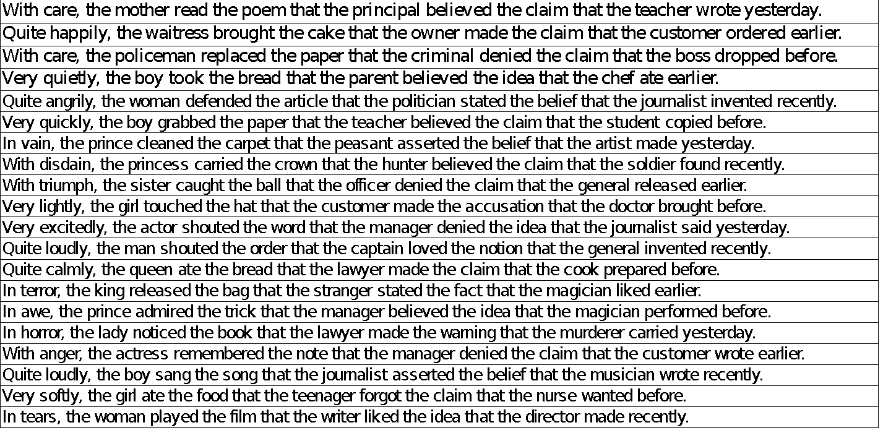

1.1 Probe questions and answers for target questions:

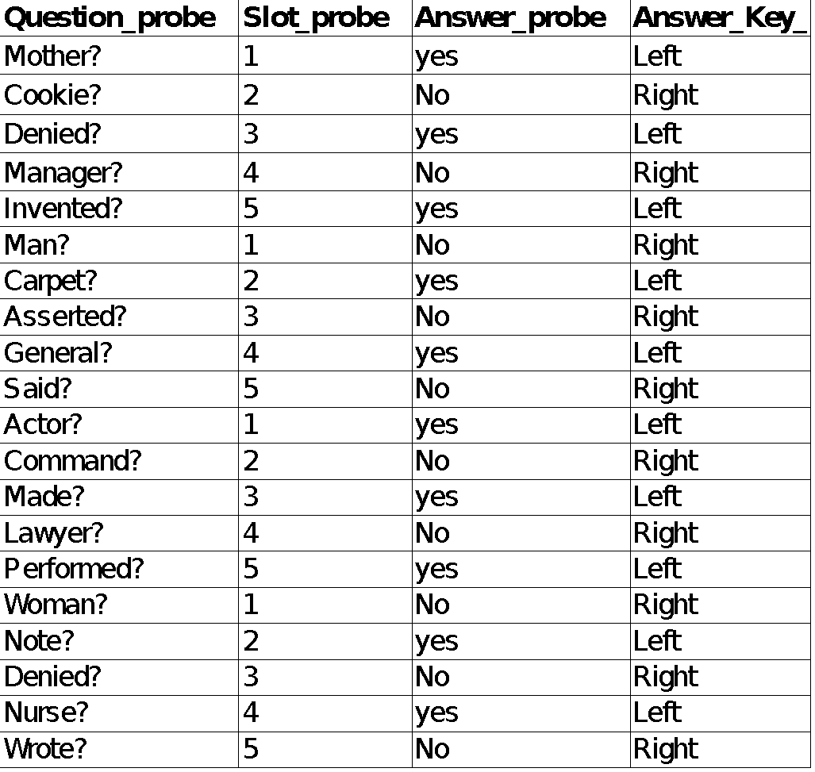

2: Correct control sentences (sample of 20 items out of planned 40):

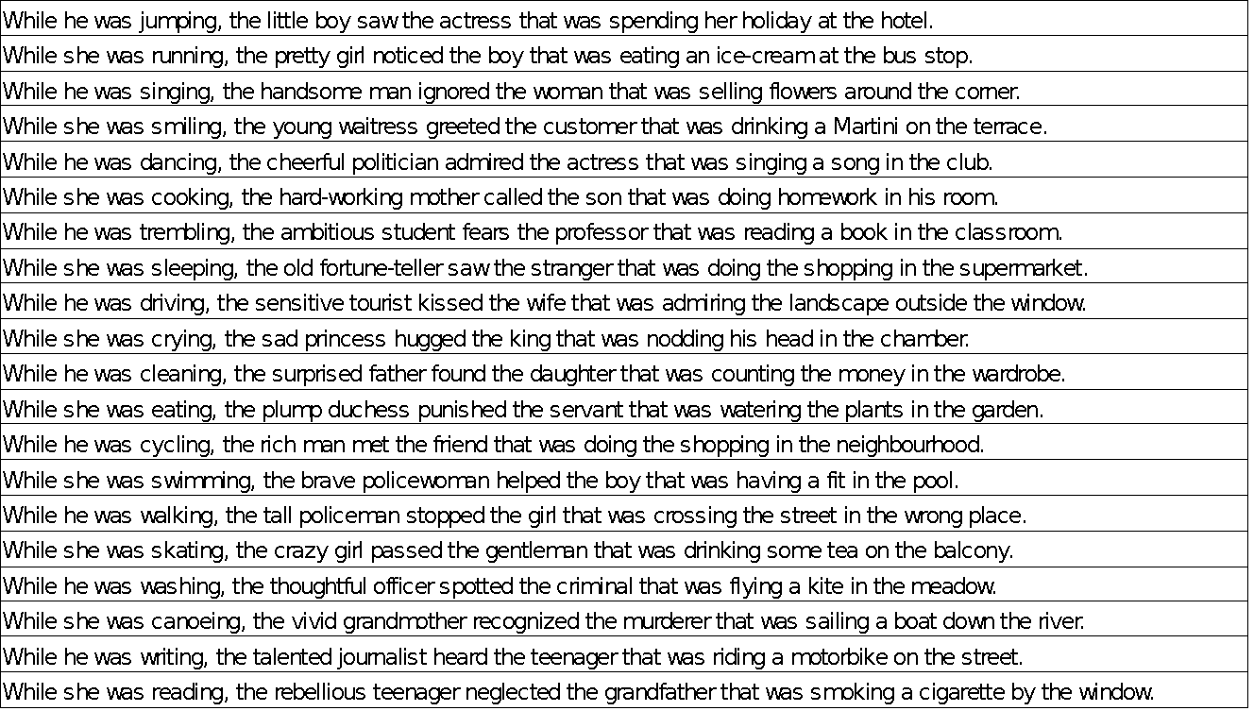

2.1: Probe questions and answers for correct set:

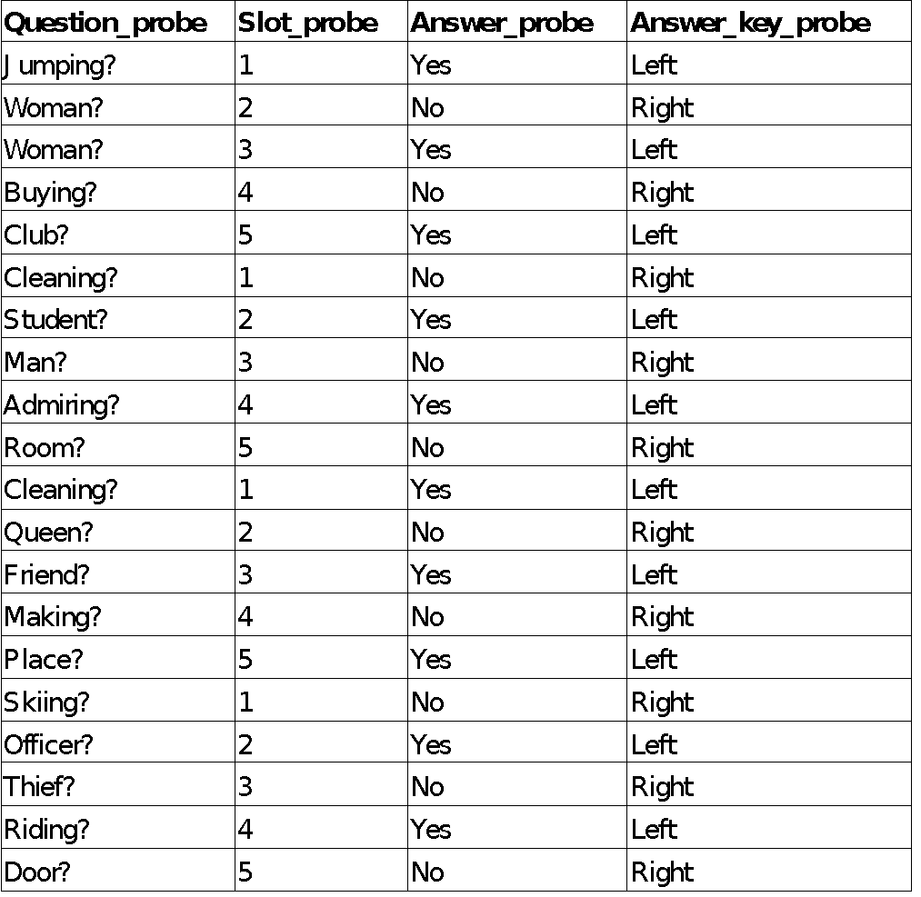

3. Incorrect control sentences (sample of 20 items planned out of 40):

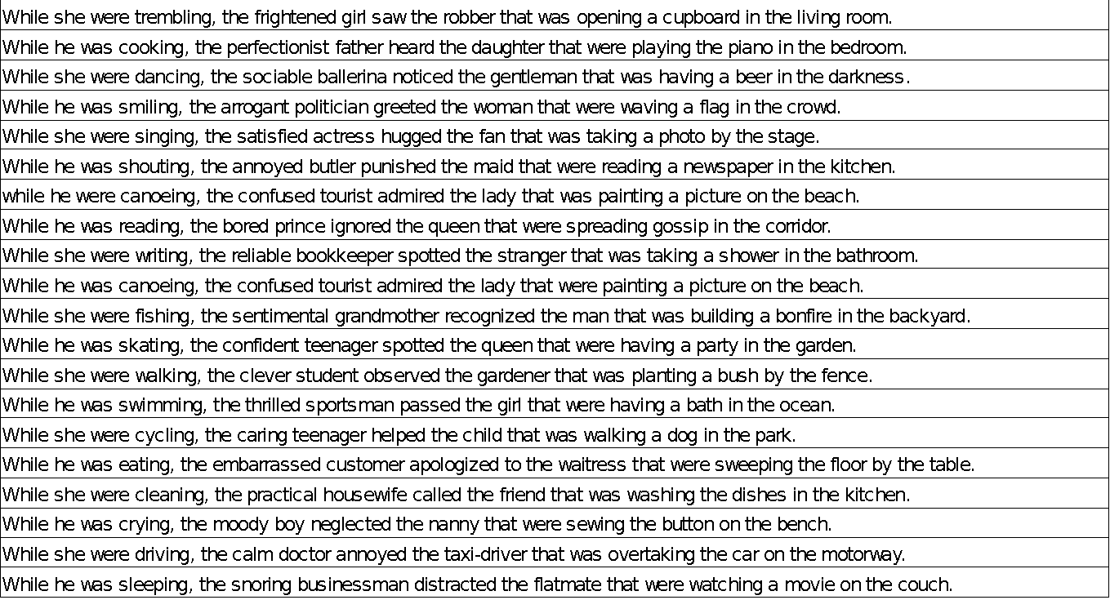

3.1: Probe questions for incorrect set:

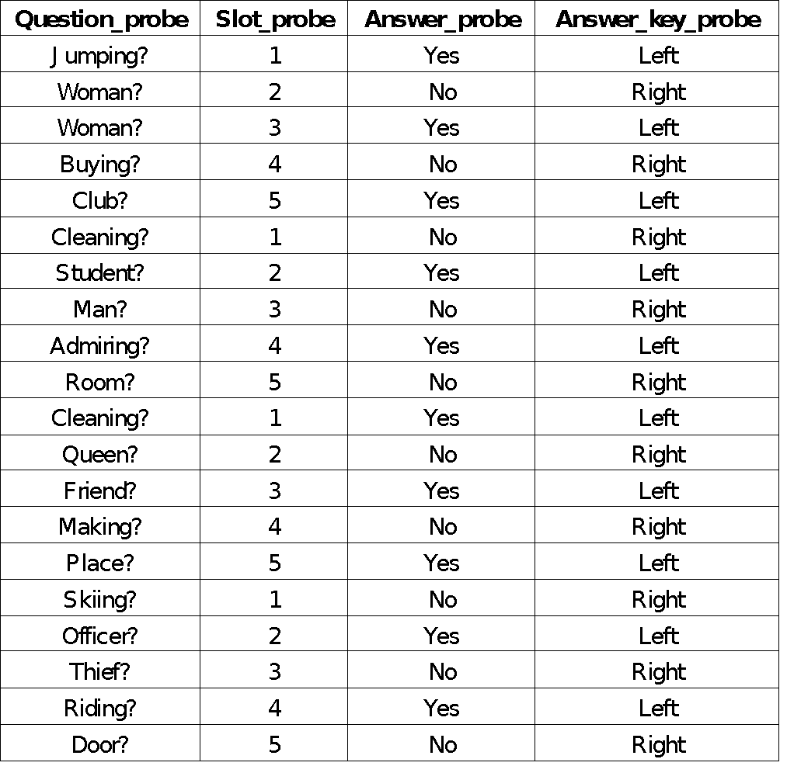

5. Filler sentences (sample of 20 items out of 80 planned):

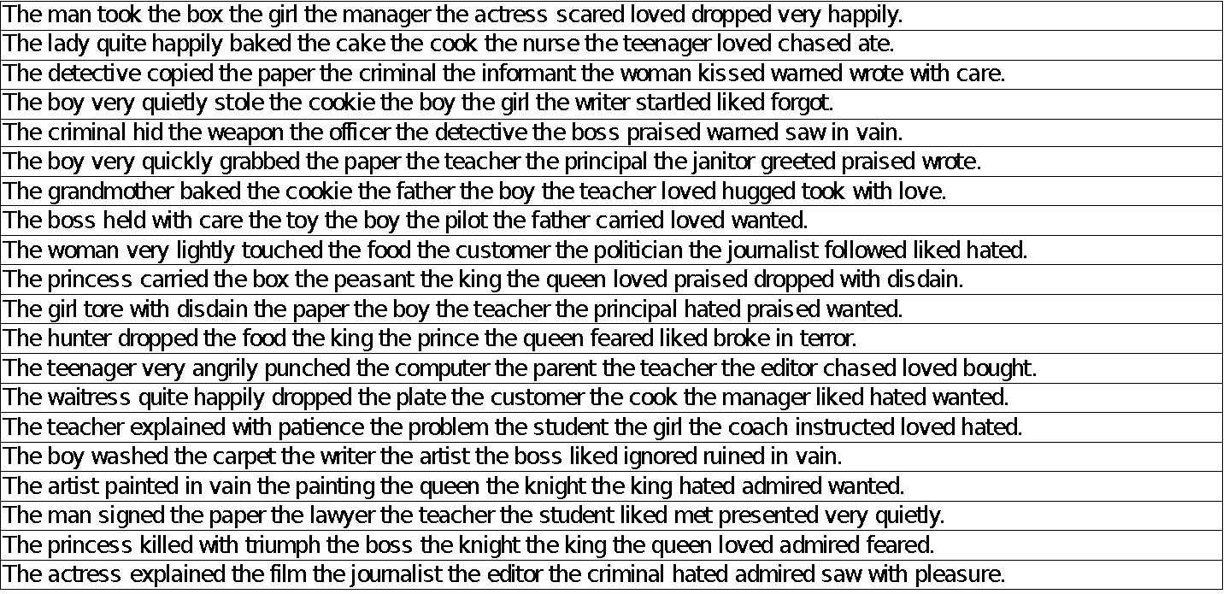

5.1: Probe questions and answers for filler questions:

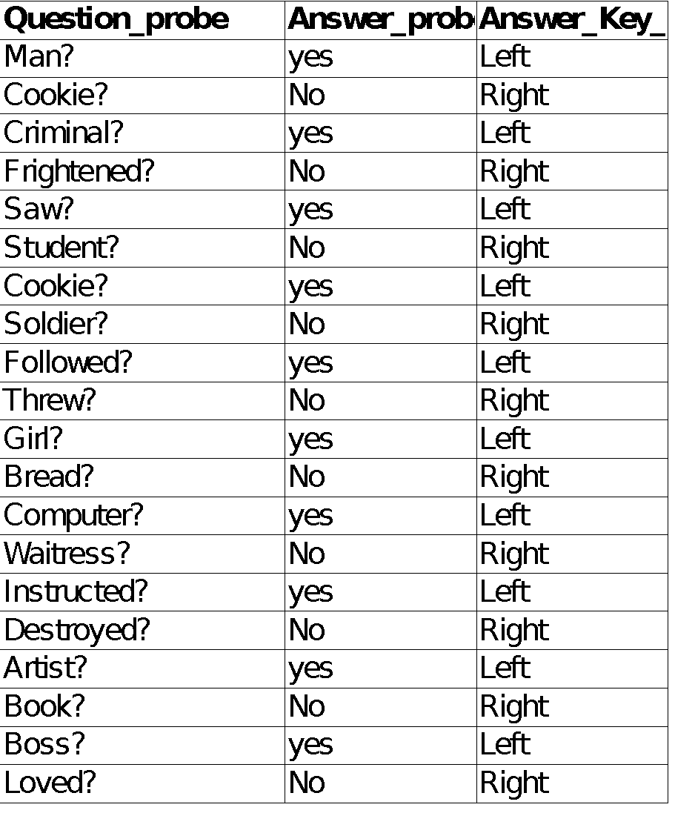

1. The strength of this argument becomes even more noticeable when we compare the sentences to one in which no such movement takes place, for instance, *Mary liked the proposal that John leave,* in which the embedded verb is stressed (p. 511).
2. Also known as the “metrical tree,” could be understood as a way of marking each lexically stressed element.
3. That is the term Adger uses to describe his own model.
4. In contrary to minor phrase stress which depends on the principles of prosodic structure organization (p. 95).