

Ex.NO | DATE | EXPERIMENT NAME | PAGE NO.
01 |  | Monthly Expense Tracker using Python and CSV | 3
2
3
4
5
6
7
8
9
10
11
12
13
14
15
16
17

EXP.NO: 01
AIM

To design and implement a Python-based Monthly Expense Tracker that stores expense records in a CSV file, allows multiple entries, searches expenses by a person's name, searches by category, calculates total spending, and checks spending against a monthly budget.

ALGORITHM

1. Start the program.
2. Check whether the file expenses.csv exists. If it does not exist, create it with the headings Name, Category, Amount and Date.
3. Display the project heading and ask the user for their name and the month being tracked.
4. Ask the user to enter a monthly budget.
5. Display the main menu.
6. If Add Expense is selected, accept name, category, amount and date, then append the record to the CSV file.
7. If Add Multiple Expenses is selected, repeatedly add expenses until the user chooses to stop.
8. If Search Person is selected, read the CSV file using csv.DictReader(), compare the entered name with the Name column, display all matching records and calculate that person's total spending.
9. If Display All Expenses is selected, display every record and calculate total spending.
10. If Search by Category is selected, display matching records and calculate category-wise spending.
11. If Calculate Total Spending is selected, add all amounts in the CSV file.
12. If Check Budget is selected, compare total spending with the monthly budget and display a warning if the budget is exceeded.
13. If Delete All Data is selected and the user confirms, clear all records while retaining the CSV headings.
14. If Exit is selected, display a closing message and terminate the program.
15. Otherwise, display an invalid-choice message and return to the main menu.

FLOWCHART
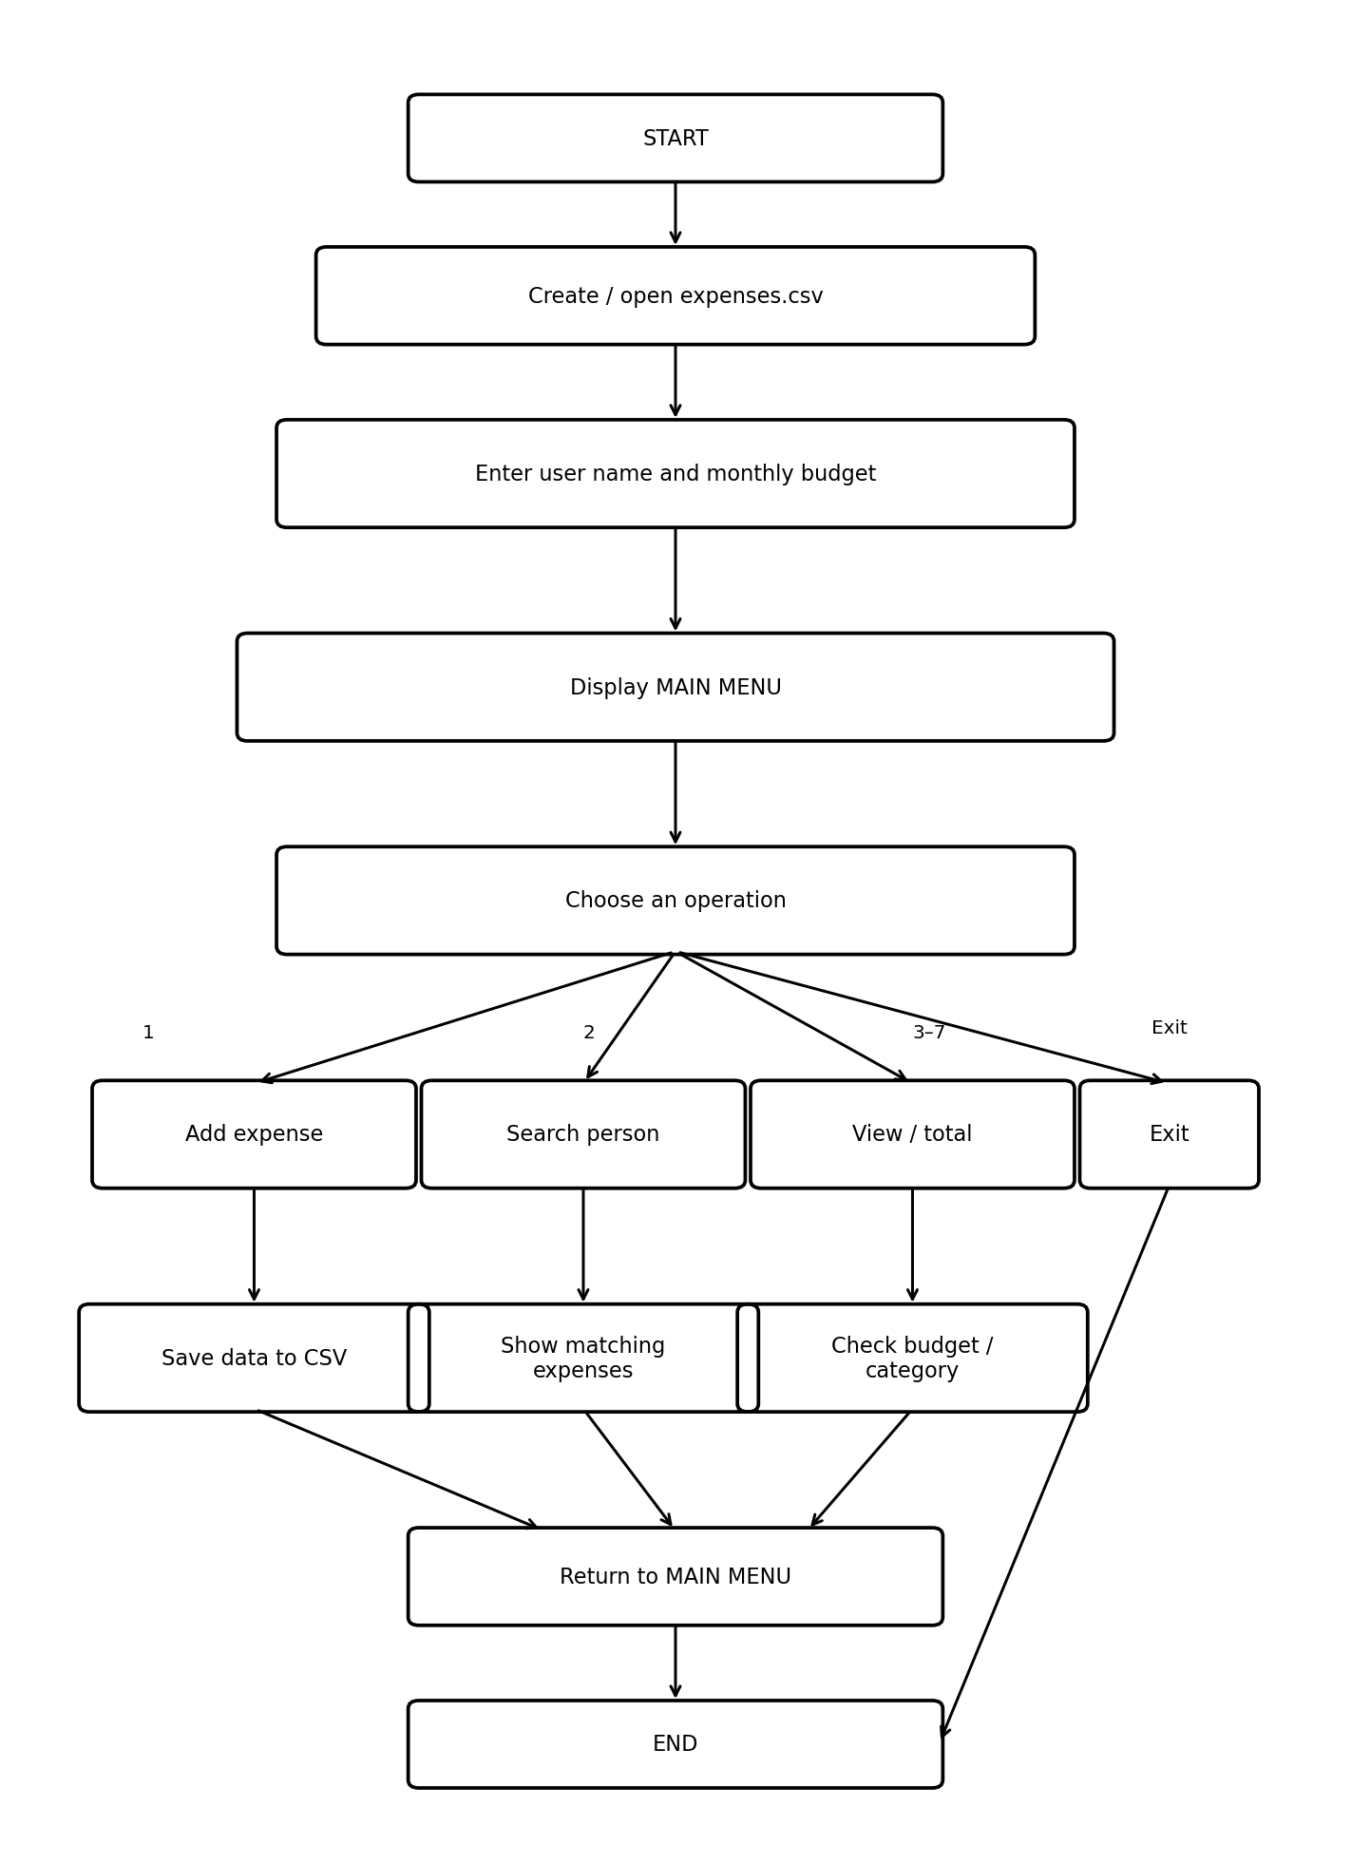

PSEUDO CODE

BEGIN
CREATE expenses.csv if it does not exist
DISPLAY project heading
INPUT user name
INPUT month
INPUT monthly budget

REPEAT
DISPLAY main menu
INPUT choice

IF choice = 1 THEN
INPUT name, category, amount, date
APPEND expense to CSV

ELSE IF choice = 2 THEN
REPEAT
ADD an expense
ASK whether another expense is required
UNTIL user chooses No

ELSE IF choice = 3 THEN
INPUT search name
READ every row from CSV
IF row name matches search name THEN
DISPLAY category, amount and date
ADD amount to person's total
END IF
DISPLAY total and number of expenses

ELSE IF choice = 4 THEN
DISPLAY every CSV record
DISPLAY total spending

ELSE IF choice = 5 THEN
INPUT category
DISPLAY matching records
DISPLAY category total

ELSE IF choice = 6 THEN
CALCULATE and DISPLAY total spending

ELSE IF choice = 7 THEN
CALCULATE total spending
COMPARE total with budget
DISPLAY budget status

ELSE IF choice = 8 THEN
ASK for confirmation
IF confirmed THEN clear CSV records

ELSE IF choice = 9 THEN
DISPLAY goodbye message
STOP

ELSE
DISPLAY invalid choice
END IF
UNTIL choice = 9
END

PROGRAM
import csv
import os

CSV_FILE = "expenses.csv"

def create_csv():
if not os.path.exists(CSV_FILE):
with open(CSV_FILE, "w", newline="") as file:
writer = csv.writer(file)
writer.writerow(["Name", "Category", "Amount", "Date"])

def heading():
print("\n" + "=" * 65)
print(" MONTHLY EXPENSE TRACKER")
print("=" * 65)
print("Welcome to the Monthly Expense Tracker!")
print("This program helps you manage your monthly spending.")

def get_user_details():
print("\n" + "-" * 65)
print(" USER DETAILS")
print("-" * 65)
name = input("Enter your name: ")
month = input("Enter the month you are tracking: ")
print("\nHello,", name + "!")
print("You are tracking expenses for:", month)
return name

def set_budget():
print("\n" + "-" * 65)
print(" BUDGET SETUP")
print("-" * 65)
while True:
try:
budget = float(input("Enter your monthly budget: $"))
if budget <= 0:
print("Budget must be greater than 0.")
else:
print("Monthly budget set to: $", budget)
return budget
except ValueError:
print("Please enter a valid number.")

def add_expense():
print("\n" + "-" * 65)
print(" ADD EXPENSE")
print("-" * 65)

name = input("Enter person's name: ")

print("\nCategories:")
print("1. Food")
print("2. Transport")
print("3. Shopping")
print("4. Entertainment")
print("5. Education")
print("6. Bills")
print("7. Other")

category_choice = input("\nChoose category: ")

categories = {
"1": "Food", "2": "Transport", "3": "Shopping",
"4": "Entertainment", "5": "Education",
"6": "Bills", "7": "Other"
}

category = categories.get(category_choice, "Other")

while True:
try:
amount = float(input("Enter amount: $"))
if amount <= 0:
print("Amount must be greater than 0.")
else:
break
except ValueError:
print("Please enter a valid amount.")

date = input("Enter date (DD-MM-YYYY): ")

with open(CSV_FILE, "a", newline="") as file:
writer = csv.writer(file)
writer.writerow([name, category, amount, date])

print("\nExpense added successfully!")
print("Name :", name)
print("Category :", category)
print("Amount : $", amount)
print("Date :", date)

def add_multiple_expenses():
print("\n" + "-" * 65)
print(" ADD MULTIPLE EXPENSES")
print("-" * 65)

while True:
add_expense()
print("\nDo you want to add another expense?")
print("1. Yes")
print("2. No")
choice = input("Enter choice: ")

if choice == "1":
continue
elif choice == "2":
break
else:
print("Invalid choice.")
break

def search_person():
print("\n" + "=" * 65)
print(" SEARCH PERSON")
print("=" * 65)

search_name = input("Enter person's name: ").strip()
found = False
total = 0
count = 0

print("\nSearching for:", search_name)

with open(CSV_FILE, "r", newline="") as file:
reader = csv.DictReader(file)

for row in reader:
if row["Name"].strip().lower() == search_name.lower():
found = True
count += 1
print("\nExpense", count)
print("Category :", row["Category"])
print("Amount : $", row["Amount"])
print("Date :", row["Date"])
print("-" * 40)
total += float(row["Amount"])

if found:
print("\n" + "=" * 45)
print("PERSON:", search_name)
print("NUMBER OF EXPENSES:", count)
print("TOTAL SPENDING: $", total)
print("=" * 45)
else:
print("\nNo expenses found for", search_name)

def display_all_expenses():
print("\n" + "=" * 65)
print(" ALL EXPENSES")
print("=" * 65)

total = 0
count = 0

with open(CSV_FILE, "r", newline="") as file:
reader = csv.DictReader(file)

for row in reader:
count += 1
print("\nExpense", count)
print("Name :", row["Name"])
print("Category :", row["Category"])
print("Amount : $", row["Amount"])
print("Date :", row["Date"])
print("-" * 40)
total += float(row["Amount"])

if count == 0:
print("No expenses recorded.")

print("\nTotal expenses: $", total)

def calculate_total():
total = 0
with open(CSV_FILE, "r", newline="") as file:
reader = csv.DictReader(file)
for row in reader:
total += float(row["Amount"])
return total

def budget_status(budget):
total = calculate_total()
remaining = budget - total

print("\n" + "=" * 65)
print(" BUDGET STATUS")
print("=" * 65)
print("Monthly Budget : $", budget)
print("Total Spending : $", total)
print("Remaining : $", remaining)

if total > budget:
print("\nWARNING!")
print("You have exceeded your budget by $", total - budget)
elif total == budget:
print("\nYou have reached your monthly budget.")
else:
percentage = (total / budget) * 100
print("\nBudget used:", round(percentage, 2), "%")
print("You are still within your budget.")

def search_category():
print("\n" + "=" * 65)
print(" SEARCH CATEGORY")
print("=" * 65)

category = input("Enter category: ").strip()
total = 0
found = False

with open(CSV_FILE, "r", newline="") as file:
reader = csv.DictReader(file)

for row in reader:
if row["Category"].lower() == category.lower():
found = True
print("\nName :", row["Name"])
print("Amount : $", row["Amount"])
print("Date :", row["Date"])
print("-" * 40)
total += float(row["Amount"])

if found:
print("\nTotal spent on", category, ": $", total)
else:
print("\nNo expenses found in this category.")

def delete_all_data():
print("\nWARNING!")
print("This will delete all expense records.")
choice = input("Are you sure? (yes/no): ")

if choice.lower() == "yes":
with open(CSV_FILE, "w", newline="") as file:
writer = csv.writer(file)
writer.writerow(["Name", "Category", "Amount", "Date"])
print("\nAll expenses have been deleted.")
else:
print("\nNo data was deleted.")

def main():
create_csv()
heading()
name = get_user_details()
budget = set_budget()

while True:
print("\n" + "=" * 65)
print(" MAIN MENU")
print("=" * 65)
print("1. Add Expense")
print("2. Add Multiple Expenses")
print("3. Search Person")
print("4. Display All Expenses")
print("5. Search by Category")
print("6. Calculate Total Spending")
print("7. Check Budget")
print("8. Delete All Data")
print("9. Exit")
print("=" * 65)

choice = input("Enter your choice: ")

if choice == "1":
add_expense()
elif choice == "2":
add_multiple_expenses()
elif choice == "3":
search_person()
elif choice == "4":
display_all_expenses()
elif choice == "5":
search_category()
elif choice == "6":
print("\nTotal spending: $", calculate_total())
elif choice == "7":
budget_status(budget)
elif choice == "8":
delete_all_data()
elif choice == "9":
print("\n" + "=" * 65)
print("Thank you for using the Monthly Expense Tracker!")
print("Goodbye,", name + "!")
print("=" * 65)
break
else:
print("\nInvalid choice.")
print("Please enter a number from 1 to 9.")

main()

OUTPUT
Sample CSV records used for testing:
Name,Category,Amount,Date
Nysa,Food,250,25-09-2026
Nysa,Transport,100,25-09-2026
Nysa,Shopping,500,24-09-2026
Rahul,Food,300,25-09-2026
Rahul,Transport,150,24-09-2026
Priya,Shopping,800,23-09-2026
Priya,Food,200,25-09-2026

Sample execution:

=================================================================
MONTHLY EXPENSE TRACKER
=================================================================
Welcome to the Monthly Expense Tracker!
This program helps you manage your monthly spending.

Enter your name: Nysa
Enter the month you are tracking: September
Hello, Nysa!

Enter your monthly budget: $2000
Monthly budget set to: $ 2000.0

=================================================================
MAIN MENU
=================================================================
1. Add Expense
2. Add Multiple Expenses
3. Search Person
4. Display All Expenses
5. Search by Category
6. Calculate Total Spending
7. Check Budget
8. Delete All Data
9. Exit
=================================================================
Enter your choice: 3

=================================================================
SEARCH PERSON
=================================================================
Enter person's name: Nysa

Searching for: Nysa

Expense 1
Category : Food
Amount : $ 250
Date : 25-09-2026
----------------------------------------

Expense 2
Category : Transport
Amount : $ 100
Date : 25-09-2026
----------------------------------------

Expense 3
Category : Shopping
Amount : $ 500
Date : 24-09-2026
----------------------------------------

=============================================
PERSON: Nysa
NUMBER OF EXPENSES: 3
TOTAL SPENDING: $ 850.0

PROBLEM STATEMENT

The purpose of this project is to develop a Python-based Monthly Expense Tracker that helps users record, manage, search, and analyze their monthly expenses. The system stores expense details such as the person's name, category, amount, and date in a CSV file. It allows users to add single or multiple expenses, search expenses by person or category, calculate total spending, and compare the spending with a predefined monthly budget. The system also provides a warning when the total expenditure exceeds the budget.

FUNCTIONAL STATEMENTS

The system shall provide the following functionalities:
- CSV File Creation – Create an expenses.csv file automatically if it does not already exist.
- User Details – Accept the user's name and the month being tracked.
- Budget Setup – Allow the user to enter a monthly budget.
- Add Expense – Record a person's name, category, amount, and date.
- Add Multiple Expenses – Allow the user to enter multiple expenses continuously.
- Search by Person – Search all expenses belonging to a particular person and calculate their total spending.
- Display All Expenses – Display all records stored in the CSV file and calculate total expenditure.
- Search by Category – Find expenses belonging to a particular category and calculate the category-wise total.
- Calculate Total Spending – Calculate the total amount spent across all records.
- Budget Checking – Compare total spending with the monthly budget and display the remaining amount or a warning if the budget is exceeded.
- Delete All Data – Allow the user to delete all expense records after confirmation while retaining the CSV headings.
- Exit – Exit the program and display a closing message.

NON – FUNCTIONAL REQUIRMENTS

- Usability – The program should have a simple, menu-driven interface that is easy for a beginner to understand and operate.
- Reliability – The program should handle invalid numerical inputs and prevent invalid budget or expense amounts.
- Data Persistence – Expense records should remain stored in the CSV file after the program is closed.
- Accuracy – The system should correctly calculate individual, category-wise, and overall spending.
- Maintainability – The program should be divided into separate functions such as add_expense(), search_person(), calculate_total(), and budget_status() so that individual components can be maintained easily.
- Performance – The program should process the stored expense records efficiently for the intended small-scale monthly expense data.
- Data Integrity – The CSV file should maintain a consistent structure using the fields Name, Category, Amount, and Date
System Architecture
The system follows a simple modular, file-based architecture consisting of the user interface, processing modules, and CSV data storage.

ARCHITECTURAL FLOW
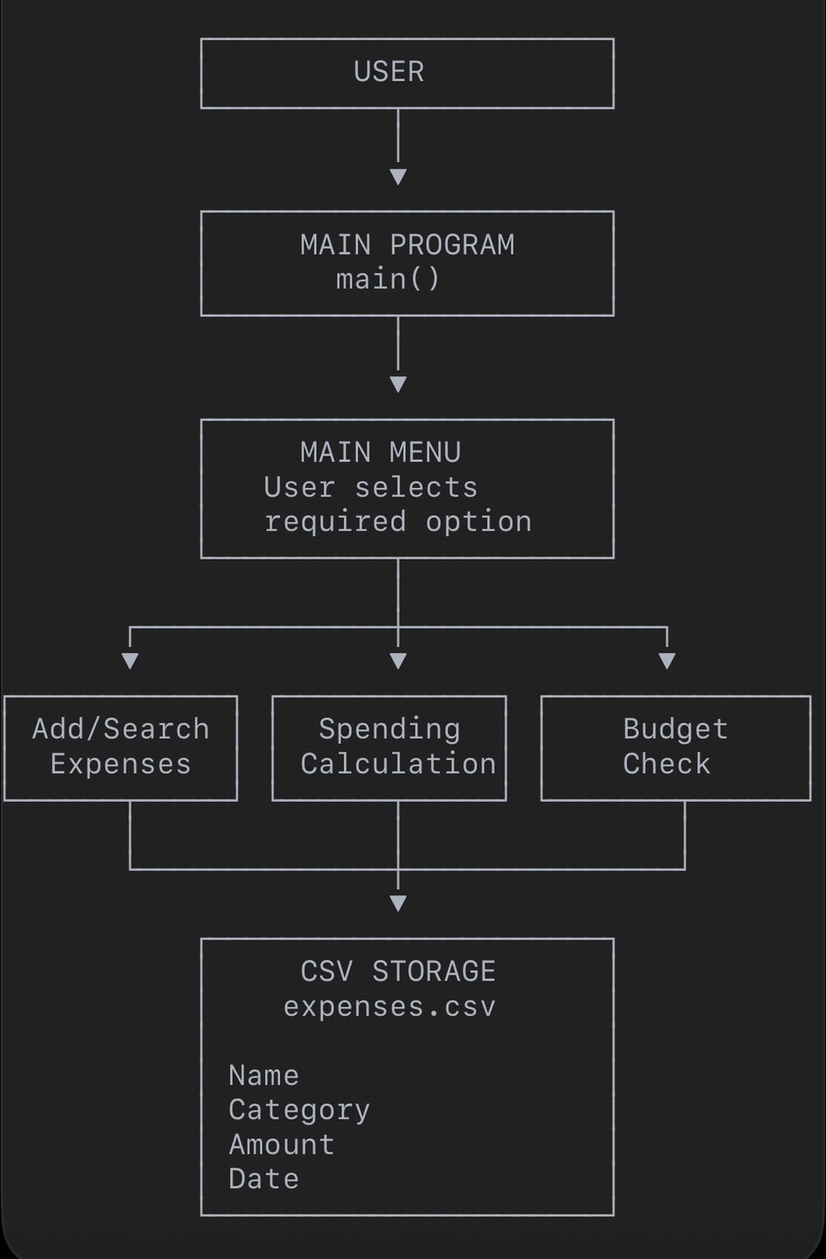

Main components:
- User Interface Layer: Takes the user's name, budget, expense details, and menu choices.
- Main Control Module: The main() function controls the overall execution and repeatedly displays the menu.
- Expense Management Module: Handles adding single/multiple expenses and searching records.
- Calculation Module: Calculates total and category-wise spending.
- Budget Module: Compares total spending with the monthly budget.
- Data Storage Layer: Uses expenses.csv to store and retrieve expense records. The program uses Python's csv module for reading and writing the data.

DESIGN DECISIONS AND RATIONALE

The following design decisions were made while developing the Monthly Expense Tracker:

- CSV File for Data Storage: A CSV file was selected because it is simple, lightweight, and easy to read and modify using Python's csv module.
- Menu-Driven Interface: A numbered main menu was used so that users can easily select operations such as adding expenses, searching records, checking the budget, and deleting data.
- Modular Functions: The program is divided into separate functions such as add_expense(), search_person(), display_all_expenses(), calculate_total(), and budget_status(). This makes the program easier to understand and maintain.
- Input Validation: while loops and try-except blocks are used to handle invalid budget and expense inputs.
- Category Selection: A numbered category system is used for categories such as Food, Transport, Shopping, Entertainment, Education, Bills, and Other.
- Budget Warning: The system automatically compares total spending with the entered monthly budget and displays a warning if the budget is exceeded.
- Confirmation Before Deletion: The program asks the user for confirmation before deleting all stored expense records to prevent accidental deletion.

IMPLEMENTATION DETAILS

The project is implemented in Python using the built-in csv and os modules.
- File Handling: The os.path.exists() function checks whether expenses.csv exists. If it does not, the program creates the file and writes the required headings.
- Adding Expenses: The add_expense() function accepts the person's name, category, amount, and date and stores them as a new CSV record.
- Multiple Entries: The add_multiple_expenses() function uses a while loop to repeatedly call add_expense() until the user chooses to stop.
- Searching: search_person() uses csv.DictReader() to read records and compare the entered name with the Name column.
- Calculations: calculate_total() reads the CSV records and adds the values in the Amount column.
- Budget Management: budget_status() compares total spending with the monthly budget and calculates the remaining amount or exceeded amount.
- Category Search: search_category() searches records based on the selected category.
- Deletion: delete_all_data() clears the stored records while keeping the CSV headings.
- Main Control: The main() function controls the program through a continuous menu loop until the user selects option 9 to exit.

SCREENSHOTS / RESULTS

The program was tested using sample expense records. The sample records included expenses for Nysa, Rahul, and Priya across categories such as Food, Transport, and Shopping.
For Nysa, the program successfully retrieved three expenses:
Category | Amount | Date
Food | 250 | 25-09-2026
Transport | 100 | 25-09-2026
Shopping | 500 | 24-09-2026
The program calculated Nysa's total spending as 850 and displayed the number of expenses as 3.
Screenshots to include in your report:
- Main Menu
- User Details and Budget Setup
- Add Expense
- Add Multiple Expenses
- Search Person
- Display All Expenses
- Search by Category
- Budget Status
- Final Output / Result

Testing Approach

The program was tested using different inputs and menu options to verify that each major functionality works correctly.
Test Case | Input/Action | Expected Result
1 | Start program | CSV file is created if unavailable
2 | Enter valid name and month | User details are accepted
3 | Enter valid budget | Budget is stored successfully
4 | Add an expense | Expense is added to CSV
5 | Add multiple expenses | Multiple records are stored
6 | Search for Nysa | All matching expenses are displayed
7 | Search by category | Matching category records are displayed
8 | Calculate total | Correct total spending is displayed
9 | Spending exceeds budget | Warning is displayed
10 | Delete all data and confirm | Expense records are removed
11 | Enter invalid menu option | Invalid-choice message is displayed
12 | Exit with option 9 | Goodbye message is displayed

The sample execution successfully retrieved three records for Nysa and calculated the total spending as $850, demonstrating that the search and calculation functions worked with the sample data.

CHALLANGES FACED

During the development of the Monthly Expense Tracker, the following challenges were addressed:
- CSV File Management: Ensuring that the CSV file is automatically created when it does not exist.
- Input Validation: Handling invalid budget and expense amounts without causing the program to terminate unexpectedly.
- Multiple Expense Entries: Implementing a loop that allows users to continuously add expenses until they choose to stop.
- Searching Records: Reading CSV data and correctly matching names and categories.
- Accurate Calculations: Converting stored amount values into numerical values before calculating totals.
- Budget Comparison: Calculating remaining budget and identifying when spending exceeds the set budget.
- Data Deletion: Ensuring that all records can be removed while preserving the CSV column headings.
- Menu Control: Maintaining the program flow so that the user returns to the main menu after completing an operation and can exit using the designated option.

LEARNING KEYS AND TAKEAWAYS

Through the development of the Monthly Expense Tracker, the following concepts and skills were learned:
- Learned how to use Python functions to divide a program into smaller and manageable modules.
- Understood the use of loops for repeated operations such as adding multiple expenses and displaying the main menu.
- Learned how to use conditional statements for menu selection, budget checking, and input validation.
- Learned CSV file handling using Python's csv module for storing and retrieving data.
- Understood the importance of input validation and exception handling using try-except.
- Learned how to perform calculations such as total spending, remaining budget, and category-wise expenditure.
- Developed an understanding of how to design a menu-driven application.
- Improved problem-solving skills by breaking the overall problem into smaller functional components.
The project demonstrates how basic Python programming concepts can be combined to create a practical application for managing expenses.

FUTURE ENHANCEMENTS

The Monthly Expense Tracker can be improved further by adding the following features:
- Graphical User Interface (GUI) – Develop a user-friendly interface using a Python GUI framework.
- Monthly Reports – Generate detailed reports showing total and category-wise expenditure for each month.
- Data Visualization – Add pie charts and bar graphs to visually represent spending patterns.
- Expense Editing – Provide an option to edit an existing expense instead of only adding or deleting records.
- Advanced Search and Filters – Allow users to filter expenses by date, amount, category, or person.
- Multiple Budgets – Allow separate budgets for categories such as food, transport, shopping, and entertainment.
- Data Backup – Provide an option to create backups of the expense data.
- Database Integration – Replace CSV storage with a database such as SQLite for handling larger amounts of data.
- Export Reports – Allow users to export monthly expense summaries into PDF or Excel format.
- Recurring Expenses – Add automatic tracking for recurring expenses such as subscriptions and bills.
These enhancements could make the application more suitable for long-term and larger-scale expense management.

REFRENCES

- Python Documentation – Python standard library documentation, particularly the csv and os modules.
- Python csv Module – Used for reading and writing expense records in CSV format.
- Python os Module – Used to check whether the CSV file exists before creating it.
- Course Material – CSA1021: Introduction to Problem Solving and Programming, VIT Bhopal University.
- Project Program and Testing Data – The Python implementation and sample execution used in this project report.
- VIT Bhopal University – School of Computing Science and Engineering, CSA1021 project/record report format.

RESULT
The Monthly Expense Tracker was successfully designed and implemented in Python. The program stores and records in a CSV file, supports multiple expense entries, searches expenses by person and category, calculates total spending, and provides a budget warning when spending exceeds the entered monthly budget. The sample test successfully retrieved all three expense records for Nysa and calculated the total spending as $850.

