WeCare Progress Report

Michael Wu

2024-04-18

## Table of content

## List of figures

## List of tables

**Table** **:** Summary of Enrollment

|  |  |  |  |  |
| --- | --- | --- | --- | --- |
|  | **Harlem** | | **Kings County** | |
| **Age Group** | **12-17** | **18+** | **12-17** | **18+** |
| Number of youth who completed the contact form | 0 | 0 | 4 | 4 |
| Number of youth who completed the eligibility screen | 0 | 0 | 4 | 4 |
| Number of youth who passed the eligibility screen | 0 | 0 | 3 | 4 |
| Number of youth who completed the eligibility survey | 0 | 0 | 3 | 4 |
| Number of youth who passed the eligibility survey | 0 | 0 | 1 | 4 |
| Number of youth who consented | 0 | 0 | 1 | 4 |
| Percent of youth who consented among those who completed the contact form |  |  | 25% | 100% |
| Percent of youth who consented among those who passed the eligibility survey |  |  | 100% | 100% |

**Table** **:** Number of Youths Enrolled during Each One-Week Recruitment Period

|  |  |  |  |  |  |
| --- | --- | --- | --- | --- | --- |
|  | | **Harlem** | | **Kings County** | |
| **Week** | **Date range of report** | **12-17** | **18+** | **12-17** | **18+** |
| 1 | 2024-04-08 ~ 2024-04-14 | 0 | 0 | 1 | 3 |
| 2 | 2024-04-15 ~ 2024-04-21 | 0 | 0 | 0 | 1 |

**Table** **:** Detailed Recruitment Information

|  |  |  |
| --- | --- | --- |
|  | **Harlem** | **Kings County** |
| **General Recruitment Information** |  |  |
| Number of youth who completed the contact form | 0 | 8 |
| Number of youth who passed the eligibility screen | 0 | 7 |
| Number of youth who passed the eligibility survey | 0 | 5 |
| Number of youth who consented | 0 | 5 |
| **Ineligible Based on the First Screen (Information from the Contact Form)** |  |  |
| Number of youth who were NOT willing to hear more about the study | 0 | 0 |
| Number of youth who were NOT willing to be contacted | 0 | 0 |
| Number of caregivers (with youth aged 12-17) who DID NOT consent in the contact form | 0 | 0 |
| Number of youth aged 18+ who DID NOT consent in the contact form | 0 | 0 |
| **Ineligible Based on the Second Screen (Information from Youth Eligibility Screen and Survey)** |  |  |
| Number of youth who were either below 12 or above 19 | 0 | 0 |
| Number of youth aged 12-17 whose caregiver was NOT present | 0 | 0 |
| Number of youth whose race was NOT Black | 0 | 0 |
| Number of youth who DID NOT have a cellphone to receive texts | 0 | 0 |
| Number of youth who were NOT able to speak or read in English | 0 | 0 |
| Number of youth who has sought therapy in the past week | 0 | 1 |
| Number of youth who were currently enrolled in WeCare | 0 | 0 |
| Number of youth who had another youth family member in WeCare | 0 | 0 |
| Number of youth who DID NOT the minimal risk criteria | 0 | 2 |
| *Total number of youth approached* | *0* | *8* |

**Table** **:** Treatment/Control Group Assignment among Enrolled Youths

|  |  |  |  |  |  |  |  |  |
| --- | --- | --- | --- | --- | --- | --- | --- | --- |
|  | **Harlem** | | | | **Kings County** | | | |
| **Treatment Condition** | **Control** | | **Treatment** | | **Control** | | **Treatment** | |
| **Age Group** | **12-17** | **18+** | **12-17** | **18+** | **12-17** | **18+** | **12-17** | **18+** |
| Number of youth who consented | 0 | 0 | 0 | 0 | 0 | 2 | 1 | 2 |
| Number of youth who completed baseline survey | 0 | 0 | 0 | 0 | 0 | 2 | 1 | 2 |
| Number of youth who completed CASSY | 0 | 0 | 0 | 0 | 0 | 0 | 1 | 2 |
| Number of youth who screened positive (> 0.05) on CASSY |  |  |  |  |  | 0 | 0 | 1 |
| Number of youth who received Connections for Safety |  |  |  |  |  | 0 | 0 | 1 |

**Table** **:** Triggered Risk Management Protocol during Baseline

|  |  |  |
| --- | --- | --- |
|  | **Harlem** | **Kings County** |
| Number of youth who verbally disclosed suicide ideation |  | 0 |
| Number of youth who screened positive on CSSRS |  | 0 |
| Number of youth who screened positive on CASSY |  | 1 |

**Table** **:** Demographics of Enrolled Subjects (DSMB Chart)

|  |  |  |  |  |
| --- | --- | --- | --- | --- |
|  | **Harlem** | | **Kings County** | |
| **Treatment** | **Control** | **Treatment** | **Control** | **Treatment** |
| **Age** |  |  |  |  |
| 12-17 |  |  | 0 (0%) | 1 (33.33%) |
| 18-19 |  |  | 2 (100%) | 2 (66.67%) |
| *Total* |  |  | *2 (100%)* | *3 (100%)* |
| **Sex assigned at birth** |  |  |  |  |
| Male |  |  | 0 (0%) | 3 (100%) |
| Female |  |  | 2 (100%) | 0 (0%) |
| *Total* |  |  | *2 (100%)* | *3 (100%)* |
| **Gender** |  |  |  |  |
| Male |  |  | 2 (100%) | 0 (0%) |
| Female |  |  | 0 (0%) | 3 (100%) |
| Nonbinary |  |  | 0 (0%) | 0 (0%) |
| Genderfluid |  |  | 0 (0%) | 0 (0%) |
| Genderqueer |  |  | 0 (0%) | 0 (0%) |
| I am not sure or questioning |  |  | 0 (0%) | 0 (0%) |
| I don't know what this question means |  |  | 0 (0%) | 0 (0%) |
| I do not identify as any of these options |  |  | 0 (0%) | 0 (0%) |
| I do not want to answer |  |  | 0 (0%) | 0 (0%) |
| *Total* |  |  | *2 (100%)* | *3 (100%)* |
| **Race (multiple selection)** |  |  |  |  |
| Black |  |  | 0 (0%) | 0 (0%) |
| Black (African American) |  |  | 0 (0%) | 0 (0%) |
| Black (African) |  |  | 1 (50%) | 2 (66.67%) |
| Black (Caribbean/West Indian) |  |  | 2 (100%) | 2 (66.67%) |
| American Indian/Alaskan Native |  |  | 0 (0%) | 0 (0%) |
| Native Hawaiian Or Other Pacific Islander |  |  | 0 (0%) | 0 (0%) |
| Asian |  |  | 0 (0%) | 0 (0%) |
| White |  |  | 0 (0%) | 0 (0%) |
| Unknown or not reported |  |  | 0 (0%) | 0 (0%) |
| *Total* |  |  | *2 (100%)* | *3 (100%)* |
| **Ethnicity** |  |  |  |  |
| Hispanic origin |  |  | 1 (50%) | 0 (0%) |
| Non-Hispanic Origin |  |  | 1 (50%) | 2 (66.67%) |
| Unknown or not reported |  |  | 0 (0%) | 1 (33.33%) |
| Total |  |  | 2 (100%) | 3 (100%) |

**Table** **:** Enrollment Table: Projected vs. Actual by Time (Cumulative over Time)

| **Monthly Projection** | **Total Target** | **Total Actual** | **Harlem Actual** | **Kings County Actual** |
| --- | --- | --- | --- | --- |
| **YEAR 1 (in grant cycle)** |  |  |  |  |
| 04/2024 | 40 | 5 | 0 | 5 |
| 05/2024 | 85 | 0 | 0 | 0 |
| 06/2024 | 130 | 0 | 0 | 0 |
| 07/2024 | 175 | 0 | 0 | 0 |
| 08/2024 | 220 | 0 | 0 | 0 |
| 09/2024 | 265 | 0 | 0 | 0 |
| 10/2024 | 310 | 0 | 0 | 0 |
| 11/2024 | 355 | 0 | 0 | 0 |
| 12/2024 | 400 | 0 | 0 | 0 |
| **YEAR 2 (in grant cycle)** |  |  |  |  |
| 01/2025 | 445 | 0 | 0 | 0 |
| 02/2025 | 490 | 0 | 0 | 0 |
| 03/2025 | 535 | 0 | 0 | 0 |
| 04/2025 | 580 | 0 | 0 | 0 |
| 05/2025 | 625 | 0 | 0 | 0 |
| 06/2025 | 670 | 0 | 0 | 0 |
| 07/2025 | 715 | 0 | 0 | 0 |
| 08/2025 | 760 | 0 | 0 | 0 |
| 09/2025 | 805 | 0 | 0 | 0 |
| 10/2025 | 850 | 0 | 0 | 0 |
| 11/2025 | 895 | 0 | 0 | 0 |
| 12/2025 | 940 | 0 | 0 | 0 |
| **YEAR 3 (in grant cycle)** |  |  |  |  |
| 01/2026 | 985 | 0 | 0 | 0 |
| 02/2026 | 1,030 | 0 | 0 | 0 |
| 03/2026 | 1,075 | 0 | 0 | 0 |
| 04/2026 | 1,120 | 0 | 0 | 0 |
| 05/2026 | 1,165 | 0 | 0 | 0 |
| 06/2026 | 1,210 | 0 | 0 | 0 |
| 07/2026 | 1,255 | 0 | 0 | 0 |
| 08/2026 | 1,300 | 0 | 0 | 0 |
| 09/2026 | 1,345 | 0 | 0 | 0 |
| 10/2026 | 1,390 | 0 | 0 | 0 |
| 11/2026 | 1,435 | 0 | 0 | 0 |
| 12/2026 | 1,480 | 0 | 0 | 0 |
| **YEAR 4 (in grant cycle)** |  |  |  |  |
| 01/2027 | 1,525 | 0 | 0 | 0 |
| 02/2027 | 1,570 | 0 | 0 | 0 |
| 03/2027 | 1,615 | 0 | 0 | 0 |
| 04/2027 | 1,660 | 0 | 0 | 0 |
| 05/2027 | 1,705 | 0 | 0 | 0 |
| 06/2027 | 1,750 | 0 | 0 | 0 |
| 07/2027 | 1,795 | 0 | 0 | 0 |
| 08/2027 | 1,840 | 0 | 0 | 0 |
| 09/2027 | 1,885 | 0 | 0 | 0 |
| 10/2027 | 1,930 | 0 | 0 | 0 |
| 11/2027 | 1,975 | 0 | 0 | 0 |
| 12/2027 | 2,020 | 0 | 0 | 0 |
| **YEAR 5 (in grant cycle)** |  |  |  |  |
| 01/2028 | 2,065 | 0 | 0 | 0 |
| 02/2028 | 2,110 | 0 | 0 | 0 |
| 03/2028 | 2,155 | 0 | 0 | 0 |
| 04/2028 | 2,200 | 0 | 0 | 0 |

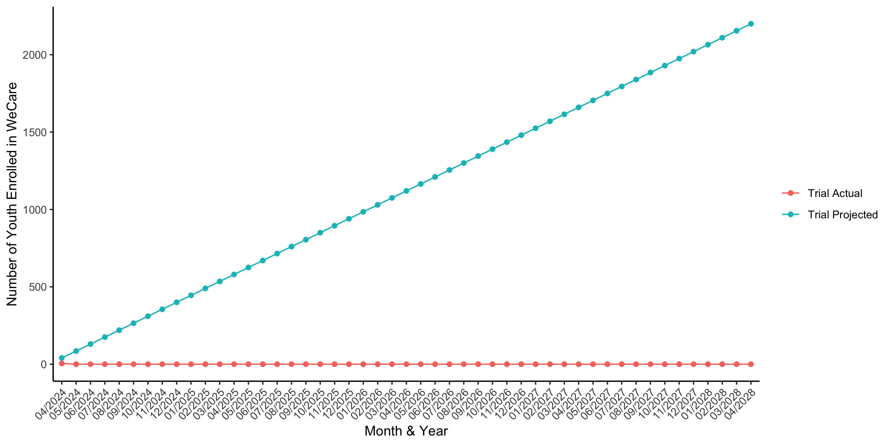

**Figure** **:** Enrollment Graph: Projected vs. Actual by Time (Cumulative over Time)