CSCI222 Assignment 1 Report

Team Number : <B11>

 | Student Number | Name | Email Address
1 | 5217635 | (Team Leader)  Chan Kian Howe | Tel : 8198 6189  Email : ckianhowe@yahoo.com.sg
2 | 5281556 | Yeo Wee Kiat | Tel : 8222 7481  Email : weekiat91@hotmail.com
3 | 5217076 | Ong Ching Hai | Tel : 91476895  Email : b_ong_ching_hai@yahoo.com.sg
4 | 4701677 | Billian Stephanus | Tel : 8122 9882  Email : billian_work@yahoo.com
5

Table of Contents
Project Overview 3
Roles and Responsibility 5
Risk Analysis and Counter Measures 6
Design Artefacts - Use Cases (Iteration 1) 7
Design Artefacts - Use Cases (Iteration 2) 8
Design Artefacts - Activity Workflows (Iteration 1) 9
Design Artefacts - Activity Workflows (Iteration 2) 10
Design Artefacts - Component Diagrams (Iteration 1) 11
Design Artefacts - Component Diagrams (Iteration 2) 12
Design Artefacts - Class Diagrams (Iteration 1) 13
Design Artefacts - Class Diagrams (Iteration 2) 14
Appendix A - Formal Meeting Records 17
Appendix B - Individual Work Diaries 19
Appendix C - Evidence of using VCS (Version Control Software) 21

Project Overview

A brief overview of the project based on information in this assignment specification and details of the actual application.

This overview should not be created by simply cutting and pasting text supplied. It should be written by the members of the group and provide a retrospective view of the project on its completion.

It should be “complete” in the sense that it explains the project to an external assessor who has not seen any of the assignment details.

Examples of relevant information includes:

- "Vision"

- To allow the club member to be able to search and book facilities online with different rates base on the membership ranking they have and allow the club manager to manage the facilities booking and the charges of booking online.

- Initial Use-Case Model

- A "top-most" level use case diagram summarizing the system's interaction with all identified major external entities. Explain

- Project Plan

- Please refer to "Stud_GanttChart_Sample.xls" for planning your system development activities

- Overlay your RUP iterations to Gantt charts timeline (e.g. which phase-iteration relates to which week?

- Also, within each week, what are the development activities, start-end date, duration (no. of man-days), and who is in charge of each activity?)

- If you are pasting screen-shots of your project planning into this sub-section, please ensure all the wordings / text are clearly visible

(i.e. assume anything < Arial Font_Size_10 is NOT easily visible to your company's senior management!)

Roles and Responsibility

A tabular summary of the group structure identifying group members, the roles that they filled, the artefacts that they successfully delivered.

The main roles could be found in Assn 1 Qn Paper, Appendix B, bullet point 6. It is possible to use different roles not found in the Qn Paper, e.g. "Database Implementer", "GUI Designer", etc.

Artefacts refers to any intermediate or final work products which are produced and used during your RUP development activities. Examples could be any program source codes (*.h, *.cpp), documentations (test plan / cases, design diagrams), etc.

Note: this section can span as many pages as necessary

Team Number : <B11>

 | Student Name | Role | Artefacts
1 | Chan Kian Howe | < Manager> | < Activity Workflow Diagram,class diagram,SRS>
2 | Yeo Wee Kiat | <Lead Designer / implementer> | <class diagram, risk analysis and counter measures, SRS>
3 | Ong Ching Hai | <Designer / implementer> | <Used case diagram,class diagram,SRS>
4 | Billian Stephanus | <System integration and testing> | <Component diagram,class diagram>
5

Risk Analysis and Counter Measures

For this section, you are to identify relevant risks and classify them in a table format as shown below. A sample (example) is shown in the first 2 rows.

Column Impact Type -
What is the type of impact affected by the risk?
E.g. Deadline/Budget/Successful Task Completion/etc.

Column Risk Seriousness (%) - how serious the risk affects the project

Column Likelihood of Occurrence (%) - how likely is the risk to happen

Column WBS (affected work/task) - the work/task id(s) in WBS affected by the risk

Column Risk Description - what is nature of the risk

 | Impact Type | Risk Seriousness (%) | Likelihood of Occurrence (%) | WBS  (affected work / task ) | Risk Description
1 | Deadline | 100% | 50% |  | Unable to meet scheduled deadline due to scope creep
2 | Budget | 90% | 50% |  | Insufficient budget due to scope creep
3 | Schedule | 40% | 50% |  | Test team unable to carry out testing due to delay
4 | Deadline | 80% | 20% |  | Some employees are unequipped for coding in required language
5 | System | 80% | 5% |  | Conflict of booked hours for users when booked at same time
6 | System | 70% | 10% |  | Coding language may not support certain functionality required in the system
7 | System | 100% | 2% |  | Breach of user id, password and subsequently details via brute force hacking
8 | Data | 30% | 10% |  | Cloud server used to store user / admin logs are insufficient / too slow / unreliable

Based on the list of risks identified in above table, you are to outline a contingency plan of action to mitigate or eliminate the damage/impact caused by the risk

Column Risk Description - what is nature of the risk

Column Proposed Mgmt Plan - what is your plan(s) to reduce / eliminate the risk

Column (Possible) Reduction in Risk Seriousness (%) -
what is the possible reduction in risk’s impact, if the management plan is carried out?

 | Risk Description | Proposed Mgmt Plan | (Possible) Reduction in Risk Seriousness (%)
1 | Unable to meet scheduled deadline due to scope creep | Plan 1 : Gather initial requirements and stick to the plan | -50%
1 | Unable to meet scheduled deadline due to scope creep | Plan 2 : Hire more employees to finish additional requirements | -40%
2 | Insufficient budget due to scope creep | Plan 1 : Additional milestones / payment required for new functionality | -50%
3 | Test team unable to carry out testing due to delay | Plan 1 : Prepare test team to test modules (part by part) of the entire software | -30%
3 | Test team unable to carry out testing due to delay | Plan 2 : Hire test team at later stage | -50%
4 | Some employees are unequipped for coding in required language | Plan 1 : Hire sufficient employees proficient in coding language to support the team (early stage only) | -10%
4 |  | Plan 2 : Hire employees proficient in coding language | -20%
5 | Conflict of booked hours for users when booked at same time | Plan 1 : Make sure there is a “holding period” reserved for the user when he/she has selected the booking and pending confirmation | -5%
6 | Coding language may not support certain functionality required in the system | Plan 1 : Study requirements carefully to ensure functionality in the language is sufficient to meet needs | -10%
7 | Breach of user id, password and subsequently details via brute force hacking | Plan 1 : Temporarily lock user out of site if username / password combination is entered too many times | -2%
7 |  | Plan 2 : Two factor authentication (via sms) to verify that it's the correct user logging in | -2%
8 | Cloud server used to store user / admin logs are insufficient / too slow / unreliable | Plan 1 : Ensure data type stored can be ported over to another cloud storage provider easily | -10%

Design Artefacts - Use Cases (Iteration 1)

You may use any diagramming tool to develop your use case diagrams for the entire system.

Iteration 1 is based on your team's "INITIAL" understanding of the system.

Note 1 : Your diagram should be developed using standard UML symbols and notations for use case diagrams!

Note 2 : this section can span as many pages as necessary

Note 3 : If you are pasting screen-shots (from your adopted diagramming tool) into this sub- section, please ensure the wordings / text are clearly visible

Design Artefacts - Use Cases (Iteration 2)

You may use any diagramming tool to develop your use case diagrams for the entire system.

Iteration 2 is based on your team's "LATEST" understanding of the system.

In general, the diagrams in later iterations should be more refined, more evolved, capture more details than diagrams developed in earlier iterations

Note 1 : Your diagram should be developed using standard UML symbols and notations for use case diagrams!

Note 2 : this section can span as many pages as necessary

Note 3 : If you are pasting screen-shots (from your adopted diagramming tool) into this sub- section, please ensure the wordings / text are clearly visible

Design Artefacts - Activity Workflows (Iteration 1)

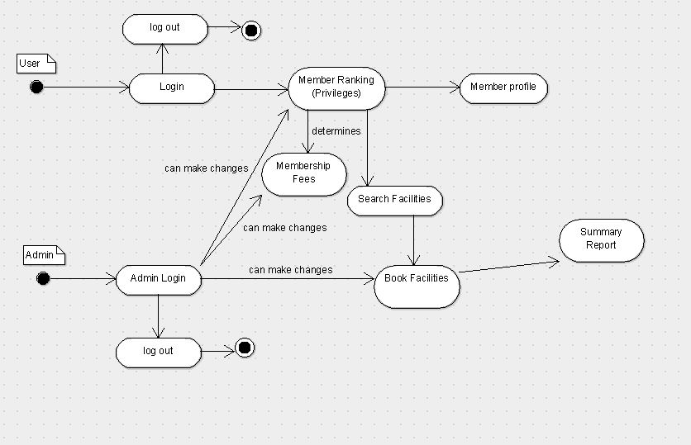

Design Artefacts - Activity Workflows (Iteration 2)

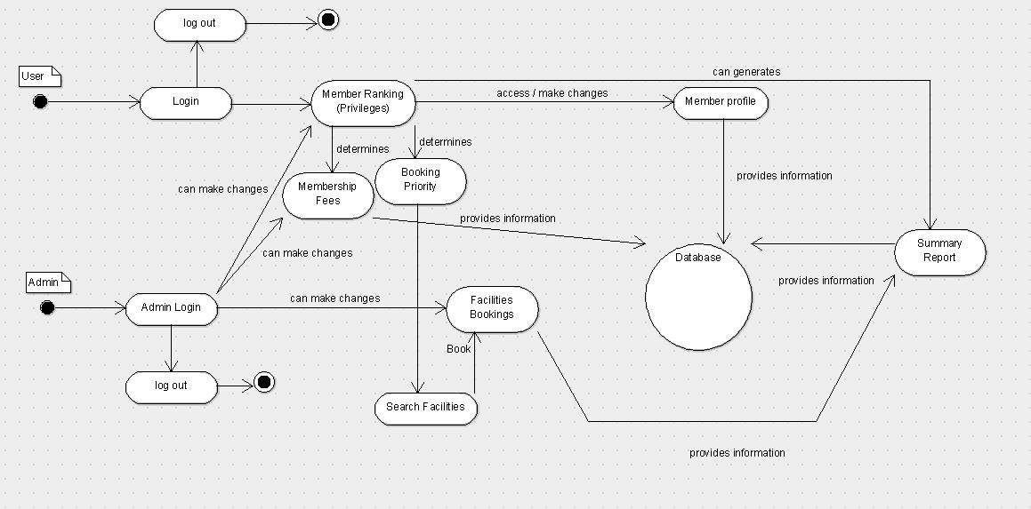

Design Artefacts - Component Diagrams (Iteration 1)

You may use any diagramming tool to develop your component diagrams for the entire system.

Iteration 1 is based on your team's "INITIAL" understanding of the system.

Note 1 : Your diagram should be developed using standard UML symbols and notations for component diagrams!

Note 2 : this section can span as many pages as necessary

Note 3 : If you are pasting screen-shots (from your adopted diagramming tool) into this sub- section, please ensure the wordings / text are clearly visible

Design Artefacts - Component Diagrams (Iteration 2)

You may use any diagramming tool to develop your component diagrams for the entire system.

Iteration 2 is based on your team's "LATEST" understanding of the system.

In general, the diagrams in later iterations should be more refined, more evolved, capture more details than diagrams developed in earlier iterations

Note 1 : Your diagram should be developed using standard UML symbols and notations for component diagrams!

Note 2 : this section can span as many pages as necessary

Note 3 : If you are pasting screen-shots (from your adopted diagramming tool) into this sub- section, please ensure the wordings / text are clearly visible

Design Artefacts - Class Diagrams (Iteration 1)

You may use any diagramming tool to develop your class diagrams for the entire system.

Iteration 1 is based on your team's "INITIAL" understanding of the system.

Note 1 : Your diagram should be developed using standard UML symbols and notations for class diagrams!

Note 2 : this section can span as many pages as necessary

Note 3 : If you are pasting screen-shots (from your adopted diagramming tool) into this sub- section, please ensure the wordings / text are clearly visible

Design Artefacts - Class Diagrams (Iteration 2)

You may use any diagramming tool to develop your class diagrams for the entire system.

Iteration 2 is based on your team's "LATEST" understanding of the system.

In general, the diagrams in later iterations should be more refined, more evolved, capture more details than diagrams developed in earlier iterations

Note 1 : Your diagram should be developed using standard UML symbols and notations for class diagrams!

Note 2 : this section can span as many pages as necessary

Note 3 : If you are pasting screen-shots (from your adopted diagramming tool) into this sub- section, please ensure the wordings / text are clearly visible

Design Artefacts - <Any other diagrams> (Iteration 1)

Depending on your system's software architecture, there may be many other diagrams (e.g. ER-Model, State / Interaction / Activity Diagrams, etc) which are applicable and should be reflected in your Design Artefacts section of your report.

Please "reuse the same structure" you see for the earlier sections on Use Case / Class / Component diagrams, together with 2 iterations version, for your diagrams in this section.

You may use any diagramming tool to develop your diagrams.

Iteration 1 is based on your team's "INITIAL" understanding of the system.

Note 1 : Your diagram should be developed using standard UML symbols and notations that is relevant for that particular type of diagram!

Note 2 : this section can span as many pages as necessary

Note 3 : If you are pasting screen-shots (from your adopted diagramming tool) into this sub- section, please ensure all the wordings / text are clearly visible

Design Artefacts - <Any other diagrams> (Iteration 2)

Depending on your system's software architecture, there may be many other diagrams (e.g. ER-Model, State / Interaction / Activity Diagrams, etc) which are applicable and should be reflected in your Design Artefacts section of your report.

Please "reuse the same structure" you see for the earlier sections on Use Case / Class / Component diagrams, together with 2 iterations version, for your diagrams in this section.

You may use any diagramming tool to develop your diagrams.

Iteration 2 is based on your team's "LATEST" understanding of the system.

In general, the diagrams in later iterations should be more refined, more evolved, capture more details than diagrams developed in earlier iterations

Note 1 : Your diagram should be developed using standard UML symbols and notations that is relevant for that particular type of diagram!

Note 2 : this section can span as many pages as necessary

Note 3 : If you are pasting screen-shots (from your adopted diagramming tool) into this sub- section, please ensure all the wordings / text are clearly visible

Appendix A - Formal Meeting Records

Inception Phase - Iteration 1

- During the meeting, the requirement for the system is being read through by the team and start to interpret what kind of system should be created for the club to use as a online facilities booking system.
- No progress has been made yet as this is the first meeting and the whole meaning to the meeting is to understand and clarify uncertain parts with the other team membership
- It has been decided that each team member will split into different part and do research.
- By the next meeting, which is in one days time, a rough diagram should be created for the team to understand how we the system is going to be like and how is the team going to build the system.
- In the next meeting, everyone has to show their assigned work to each other so we can compile all the ideas together and make it into one.
 | Student Name | Assigned work
1 | Chan Kian Howe | < Activity Workflow Diagram, Class Diagram,SRS>
2 | Yeo Wee Kiat | <Class Diagram, Risk Analysis and Counter Measures, SRS>
3 | Ong Ching Hai | <Used Case Diagram,Class Diagram,SRS>
4 | Billian Stephanus | <Component Diagram, Class Diagram>

Elaboration Phase - Iteration 1

- During the meeting, the team shown each other the rough diagram created from understanding the system requirement by the club.
- Class diagram which is a common diagram is assigned for everyone to make changes on a sharing website, dropbox, as there need to be a standardization. Everyone will have access to the class diagram and can discuss with one another. Since a rough diagram is created, the next step is to improve it and make it more detailed so as to be of some help for the creation of the system.
- The team is expected to finish the detailed version of the diagram before the next meeting in two days time. The SRS (software requirement specification) has to be done as soon as possible as it will clearly show everyone the features and give a rough idea how the design of the system is supposed to take shape.
- Workload for SRS will be shared among the team members and everyone will chip in to complete the SRS. Meanwhile, the detailed version of each diagram the members are assigned to have to be done before next meeting.

- On the next meeting, the team will have to:
- be able to show the detailed version of diagram that is assigned
- compile all the diagrams together and see if it fits what we have in mind
- make amendments if necessary to the diagrams to match with each other

Elaboration Phase - Iteration 2

- Everything that is being done is shown to each other during the meeting and all the different ideas each member has will be compiled and see which will fit the system design that everybody has in mind. A common system design is then decided on and class diagram is finalized.
- Report is then being compiled with all the diagrams and checked for any mistakes.

Appendix B - Individual Work Diaries

Team Member 1 : Chan Kian Howe

Inception Phase - Iteration 1

- 4th February 2016 - 5th February 2016
- about 1 hour is used for the task
- was tasked to do activity workflow diagram and SRS
- research on activity workflow diagram was done so as to understand what the diagram has to show
- after the diagram was done, the diagram was shown to other team members to see if they agree with the diagram and have something to refer to for the flow of the system.
- A bit of SRS is touched on and filled up in the template.
- Requested help from team members as there is a lot to write in SRS.

Elaboration Phase - Iteration 1

- Copy and Paste your formal meeting minutes for Elaboration Phase, iteration 1 here.
- You can refer to Assn 1 Qn Paper, Appendix B, bullet point 5 for a summary of contents to be included.
- Note: this section can span as many pages as necessary

Elaboration Phase - Iteration 2

- Copy and Paste your formal meeting minutes for Elaboration Phase, iteration 2 here.
- You can refer to Assn 1 Qn Paper, Appendix B, bullet point 5 for a summary of contents to be included.
- Note: this section can span as many pages as necessary

Team Member 2 : Yeo Wee Kiat

Inception Phase - Iteration 1

- 4th February 2016 - 5th February 2016
- Spent roughly 2 hours on the basic class diagram
- Was tasked to do class diagram, risk analysis and counter measures, SRS
- Researched on class diagram and the classes / functions needed
- Diagram was shown to other team members for discussion to see if they agreed with the design and flow of the system.
- Certain sections of the SRS was filled in and updated.

Inception Phase - Iteration 2

- 5th February 2016 - 6th February 2016
- Spent roughly 2 hours on basic risk analysis and counter measures.
- Researched on types of risk (resource, technical, scheduling, etc).
- Impact types and risk description was shown to other team members for discussion.
- Certain sections of the SRS was filled in and updated.

Elaboration Phase - Iteration 1

- 8th February 2016 - 9th February 2016
- Spent roughly 2 hours on expanding risk analysis and counter measures.
- Researched on common risk factors, external and internal factors for projects, added counter measures for risk factors.
- Expanded impact types, risk description and counter measures were shown to other team members for discussion. Certain possible risks were discussed.
- More sections of the SRS was expanded on and updated.

Elaboration Phase - Iteration 2

- Copy and Paste your formal meeting minutes for Elaboration Phase, iteration 2 here.
- You can refer to Assn 1 Qn Paper, Appendix B, bullet point 5 for a summary of contents to be included.
- Note: this section can span as many pages as necessary

Team Member 'N' : Xxxx Xxxx

Inception Phase - Iteration 1

- Copy and Paste your formal meeting minutes for Inception Phase, iteration 1 here.
- You can refer to Assn 1 Qn Paper, Appendix B, bullet point 5 for a summary of contents to be included.
- Note: this section can span as many pages as necessary

Inception Phase - Iteration 2 (Optional)

- Copy and Paste your formal meeting minutes for Inception Phase, iteration 2 here.
- You can refer to Assn 1 Qn Paper, Appendix B, bullet point 5 for a summary of contents to be included.
- Note: this section can span as many pages as necessary

Elaboration Phase - Iteration 1

- Copy and Paste your formal meeting minutes for Elaboration Phase, iteration 1 here.
- You can refer to Assn 1 Qn Paper, Appendix B, bullet point 5 for a summary of contents to be included.
- Note: this section can span as many pages as necessary

Elaboration Phase - Iteration 2

- Copy and Paste your formal meeting minutes for Elaboration Phase, iteration 2 here.
- You can refer to Assn 1 Qn Paper, Appendix B, bullet point 5 for a summary of contents to be included.
- Note: this section can span as many pages as necessary

Elaboration Phase - Iteration 3 (Optional)

- Copy and Paste your formal meeting minutes for Elaboration Phase, iteration 3 here.
- You can refer to Assn 1 Qn Paper, Appendix B, bullet point 5 for a summary of contents to be included.
- Note: this section can span as many pages as necessary

Appendix C - Evidence of using VCS (Version Control Software)

Version Control Software used : (E.g. Netbeans subversion, TortiseSVN, etc)

Note 1 : The following screenshots can span as many pages as necessary

Note 2 : Please ensure that all the wordings / text in your screen shots are clearly visible

Screenshot #1 - Contents in the VCS's Root Folder containing all Repository Project Files

< Paste Screenshot #1 image here >

Screenshot #2 - VCS's listing of all the latest source files currently being managed

< Paste Screenshot #2 image here >

Screenshot #3 - Example using VCS's to check-out source files (it may be necessary to do >1 screen capture, depending on the software used)

< Paste Screenshot #3 image(s) here >

Screenshot #4 - Example using VCS's to check-in source files (it may be necessary to do >1 screen capture, depending on the software used)

< Paste Screenshot #4 image(s) here >

Screenshot #5 - Example using VCS's to display the change history / log (it may be necessary to do >1 screen capture, depending on the software used)

< Paste Screenshot #5 image(s) here >

