**ÜCRETSİZ DASHBOARDS**

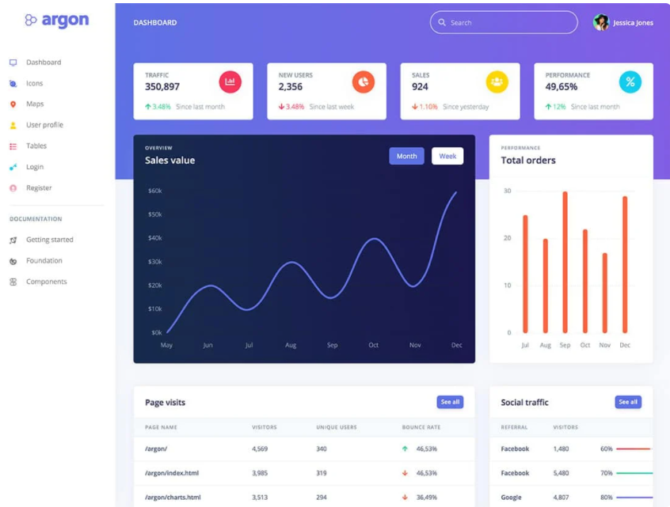<https://www.creative-tim.com/product/argon-dashboard/?partner=49926>

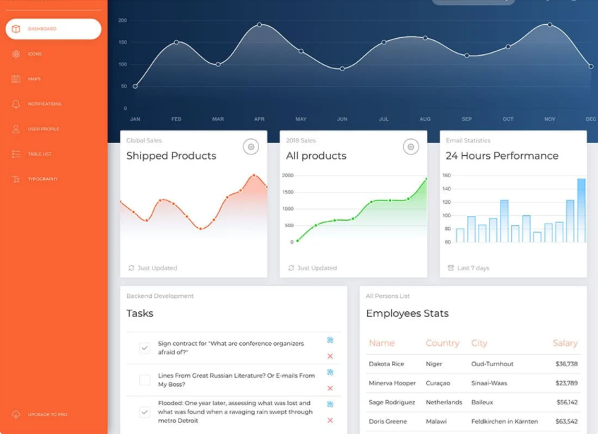

<https://www.creative-tim.com/product/now-ui-dashboard/?partner=49926>

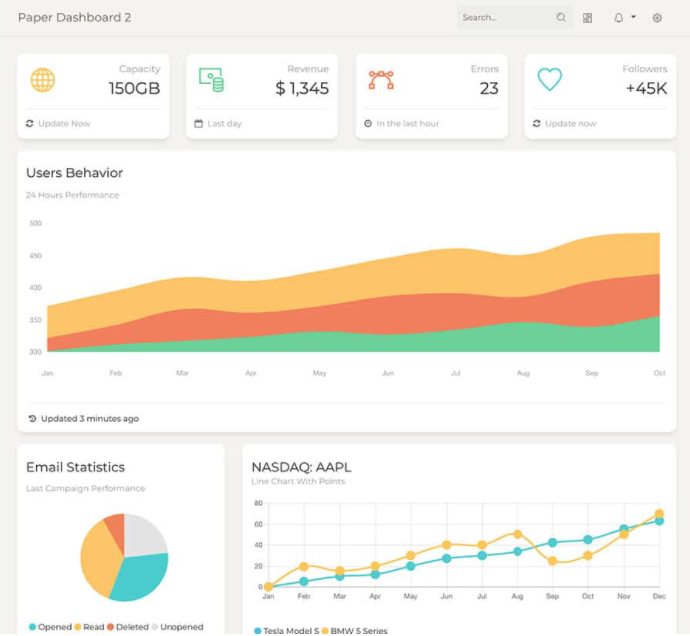

<https://www.creative-tim.com/product/paper-dashboard-2/?partner=49926>

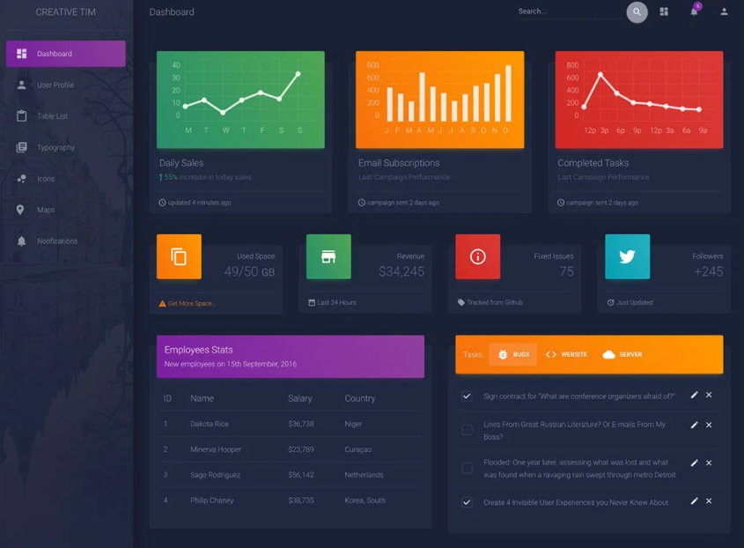

<https://www.creative-tim.com/product/material-dashboard-dark/?partner=49926>

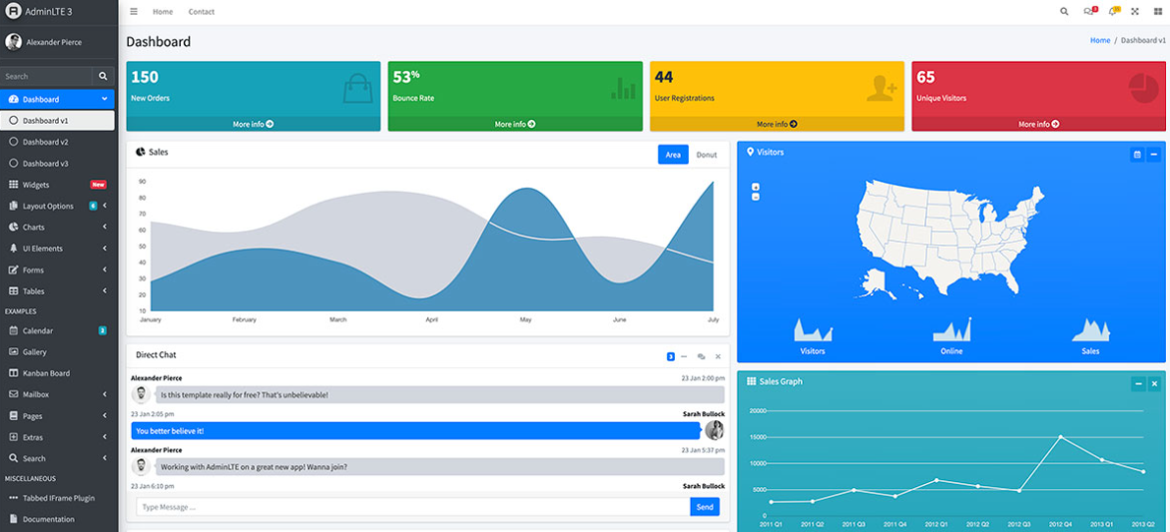

<https://adminlte.io/themes/v3/>

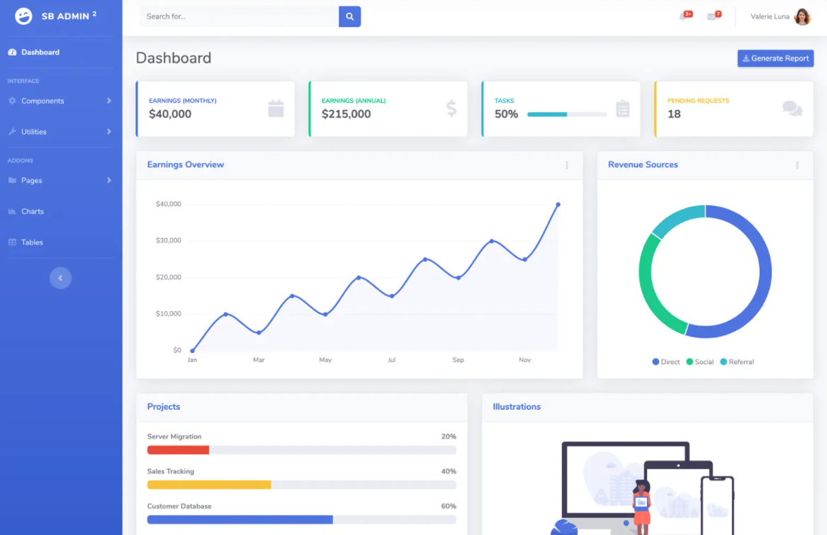

<https://startbootstrap.com/theme/sb-admin-2>

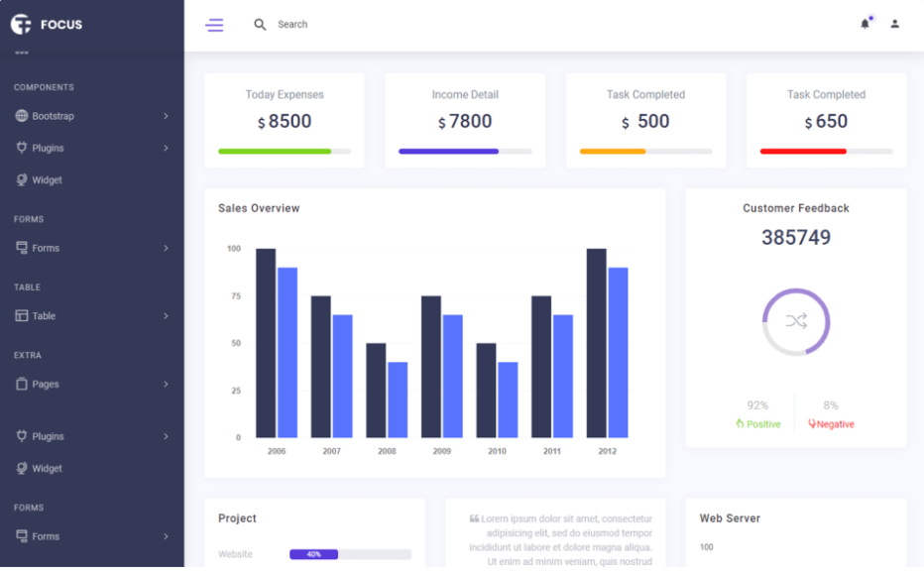

<https://themewagon.com/themes/free-bootstrap-4-html-5-admin-dashboard-website-template-focus/>

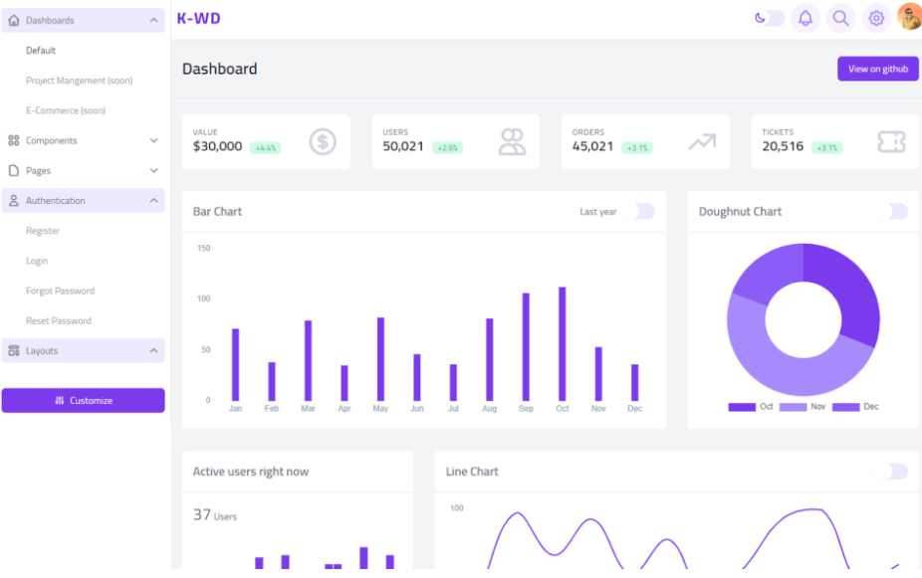

<https://themewagon.com/themes/free-tailwind-css-admin-dashboard-template-k-wd-dashboard/>

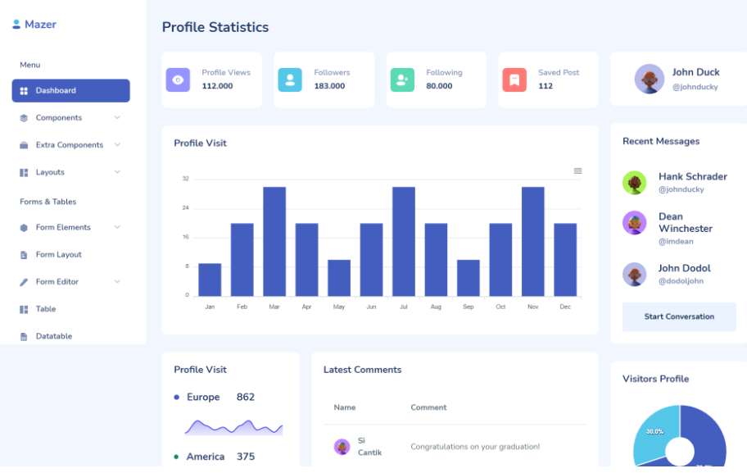

<https://themewagon.com/themes/free-bootstrap-5-html5-admin-dashboard-template-mazer/>