**Need consistent design**

**Messaging Issues**

1. ~~All messages say Missed whether they were missed or not test~~
2. When composing a message you cannot type in the To: box you can only select a name
3. ~~Names to select appear in random order – need to be alphabetized~~
4. ~~Names in list in messaging feature continuously flash between different pictures~~ ***~~Figure A~~***
5. ~~Keyboard makes it difficult to set time for message~~ ***~~Figure B~~***
6. ~~Message is received for a different time then what is sent for~~ ***~~Figure C~~***
7. Timer on messages sometimes doesn’t change time at all, or time elapses very quickly ***Figure D***
8. ~~While reading message user can type under and temporarily edit the sent message~~ ***~~Figure E~~***
9. Once message is read or missed there is no way to delete message – possibly add feature to swipe read/missed messages away?
10. Need button to respond directly to a message
11. ~~When no messages, you leave the tab and come back, there is spinner spinning.~~

**Profile Picture**

1. ~~When profile picture is changed app keeps flashing between former and new picture~~ ***~~Figure F~~***
2. ~~Size of profile picture is not consistent – profile picture appears to be stretched when appearing next to a dwindle~~ ***~~Figure G~~***

**Friend Requests**

1. ~~Requests not request~~ ***~~Figure H~~***
2. ~~Multiple requests from the same person can be sent~~ ***~~Figure I~~***
3. Neither “yes” nor “later” buttons working

**Home Screen**

1. ~~Sometimes a dwindle will be randomly highlighted grey and stay that way~~ ***~~Figure J~~***
2. When refreshing sometimes the screen glitches ***Figure K***
3. ~~Sometimes the revive function disappears for posts that should be revivable~~
4. When selected the settings/filter button sometimes displays one screen and sometimes another ***Figure L***
5. Sometimes a line will temporarily appear through the middle of a dwindle ***Figure M***

**Design**

1. ~~All Icons/buttons should be the theme icons~~ ***~~Figure N~~***
2. Colors used throughout the app do not correspond with the theme colors – wrong shade of blue used
3. ~~Friend request icon appears to be slightly smaller than other icons~~ ***~~Figure O~~***
4. ~~Functionless button on profile page~~
5. Name, time and content of dwindle should be in varying sizes or fonts ***Figure P***

**Miscellaneous**

1. If you do not select “done” on filter the window will stay on the screen even after leaving the home screen ***Figure Q***
2. There is currently no way to view the profiles of the people that you are following
3. Clicking on “following” or “followers” on the profile page should lead to a corresponding list of users
4. Function to like or comment on dwindles is not available
5. Most of the time that the app crashes appear to occur at the same time a dwindle dies

***Figure A***

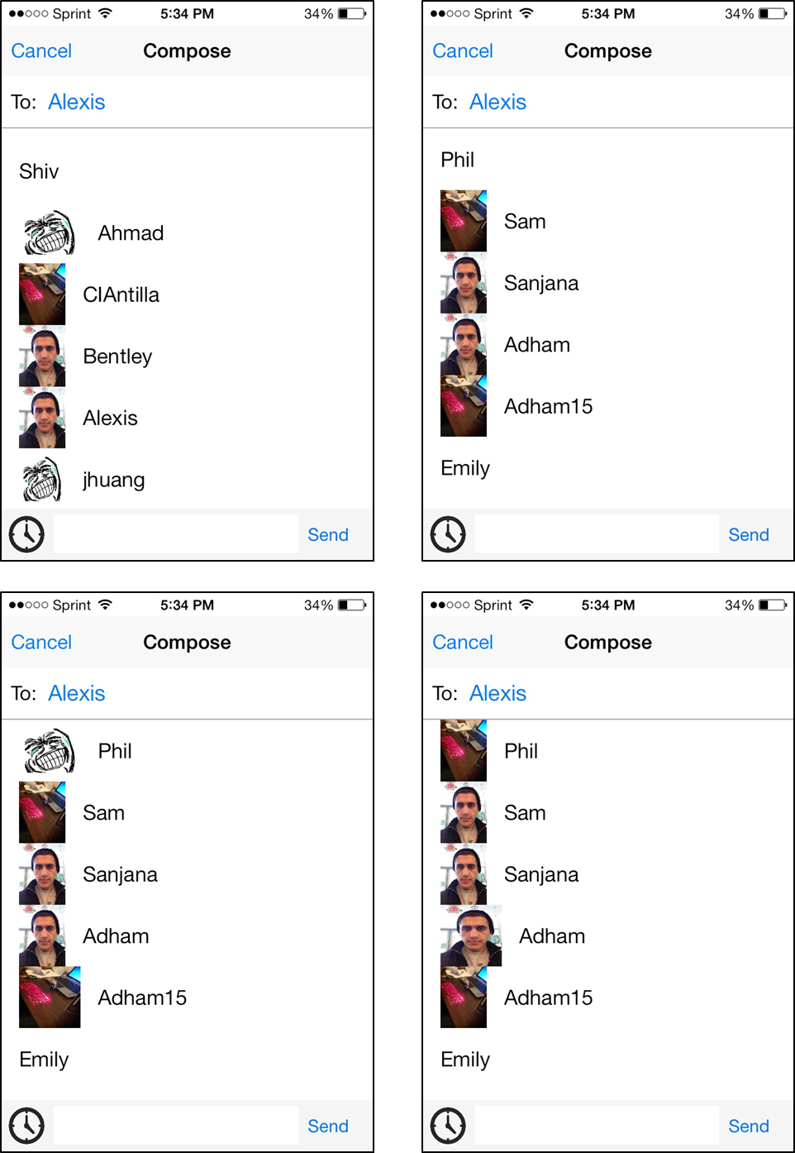

***Figure B***

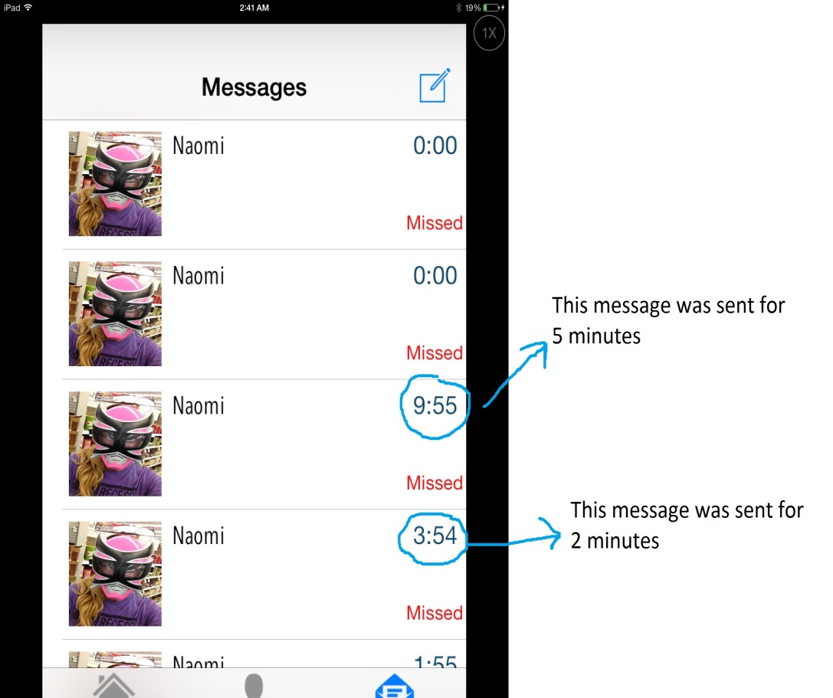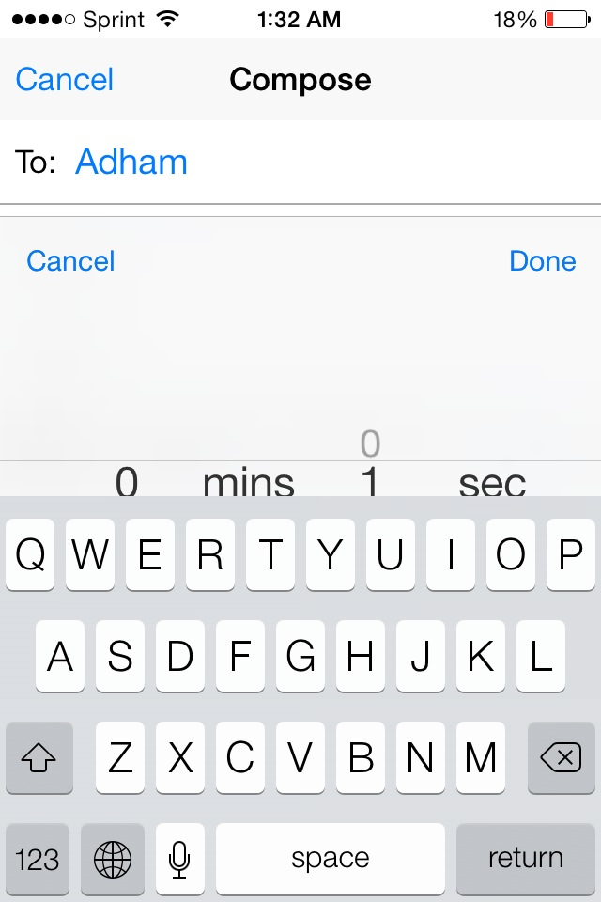

***Figure C***

***Figure D***

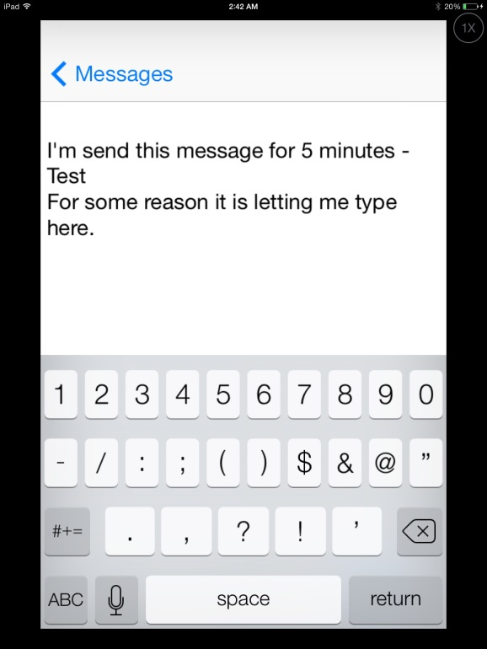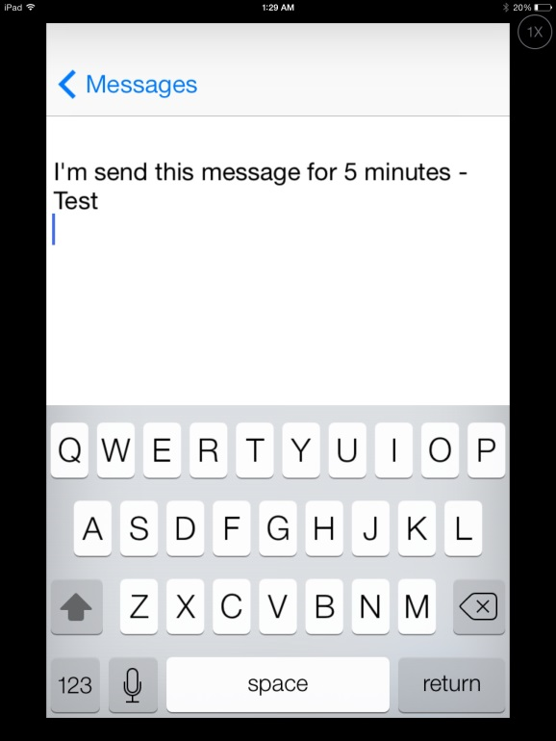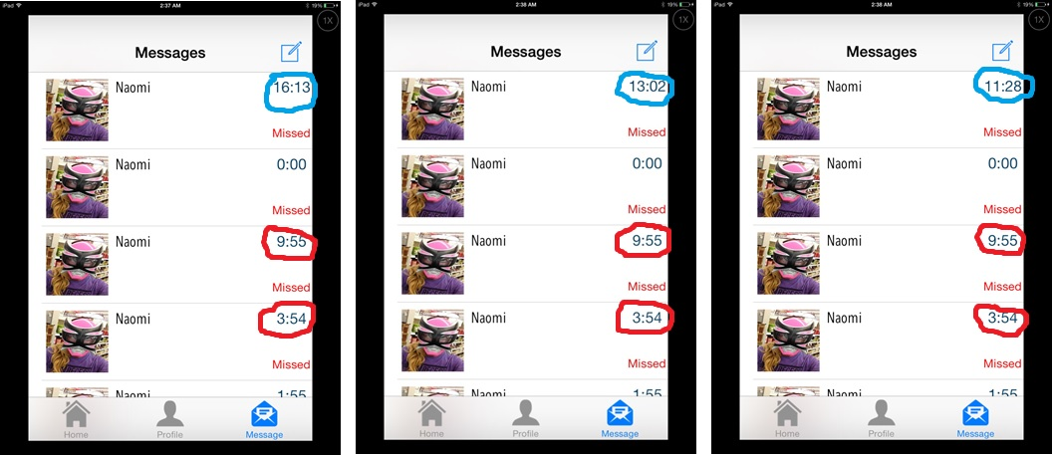

These messages are being viewed by the receiver. If the receiver clicks on the message they were sent the keyboard appears and they can edit and/or add to the message temporarily.

***Figure E***

One minute in real time has lapsed between the first and the third picture. Circled in blue you see a timer that is moving faster than real time. Circled in red you can see that over the course of a minute some timers have not changed at all.

***Figure F***

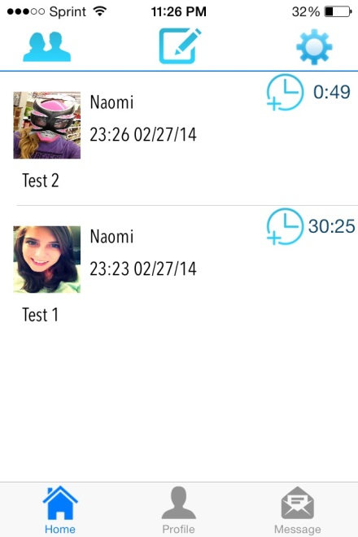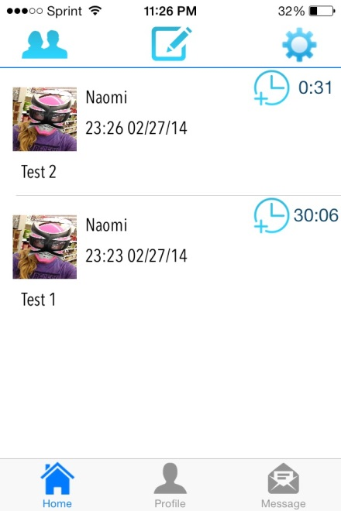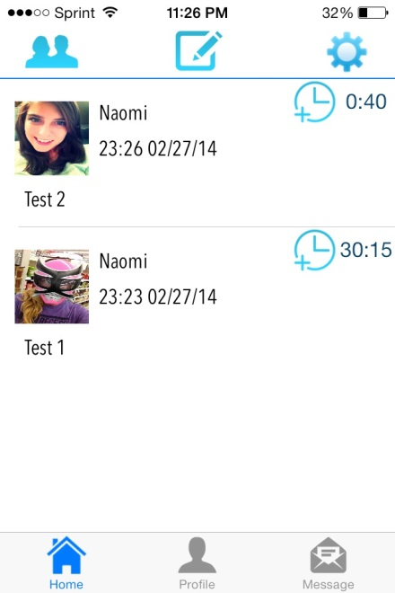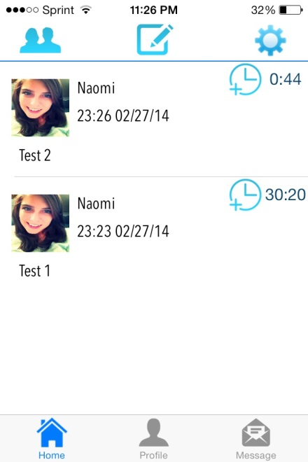

***Figure G***

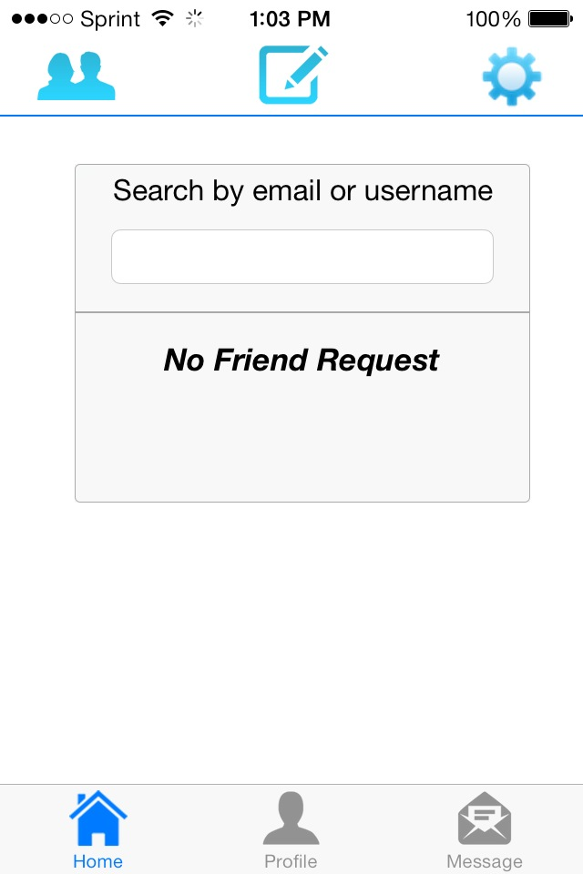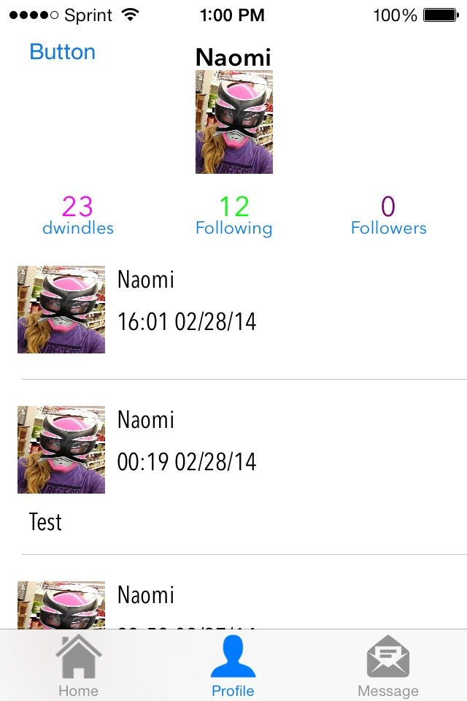

***Figure H***

***Figure I***

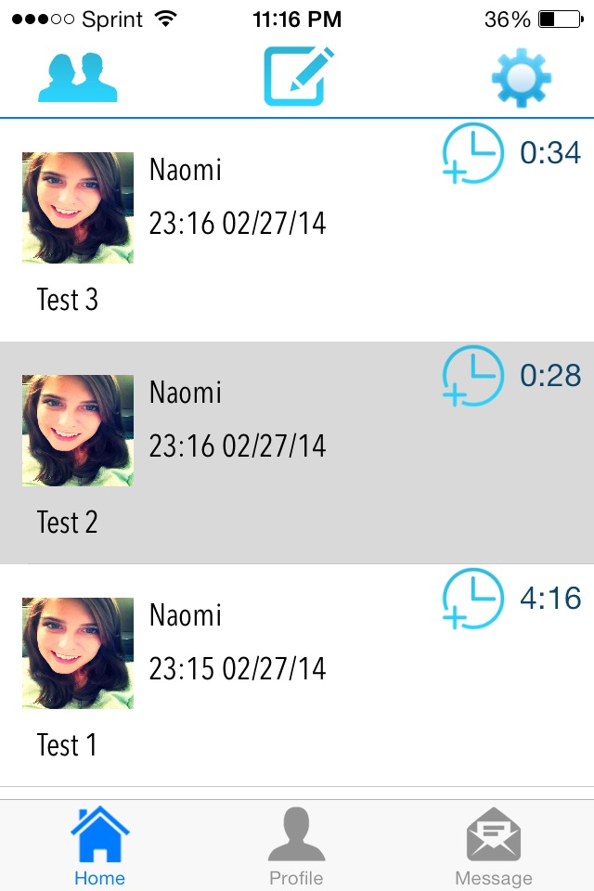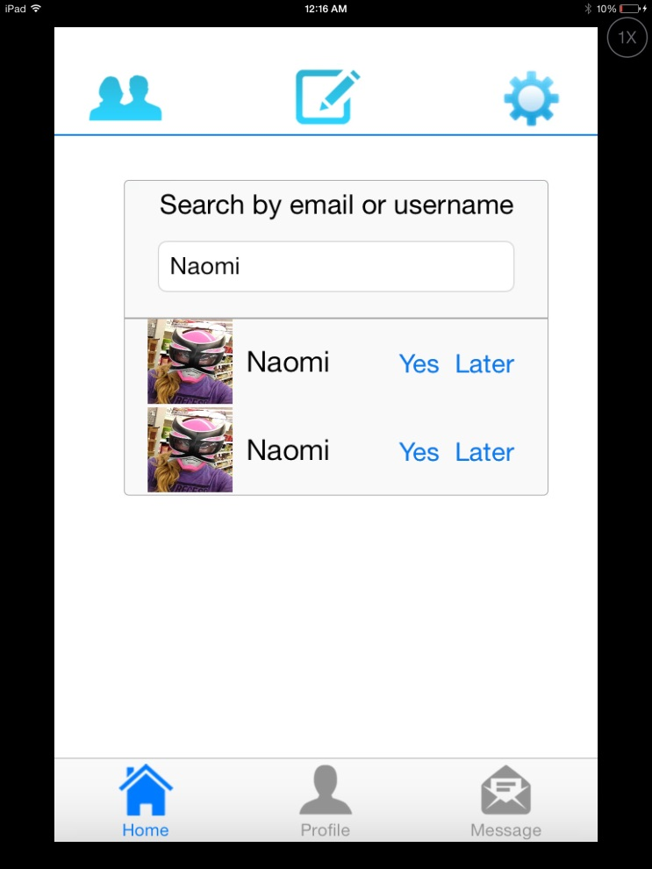

***Figure J***

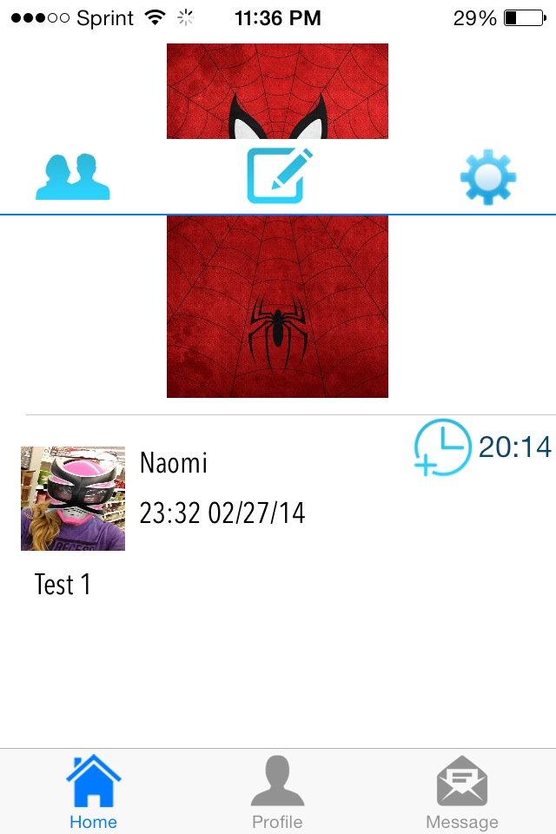***Figure K***

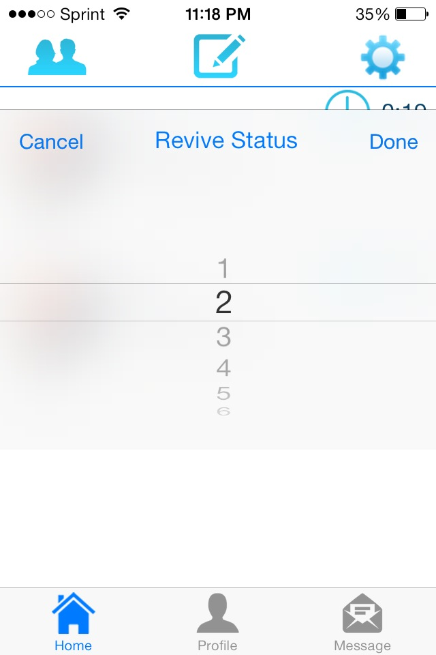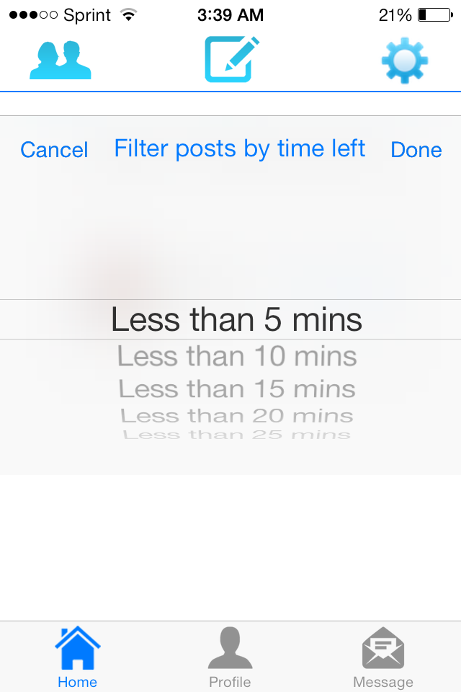

***Figure L***

***Figure M***

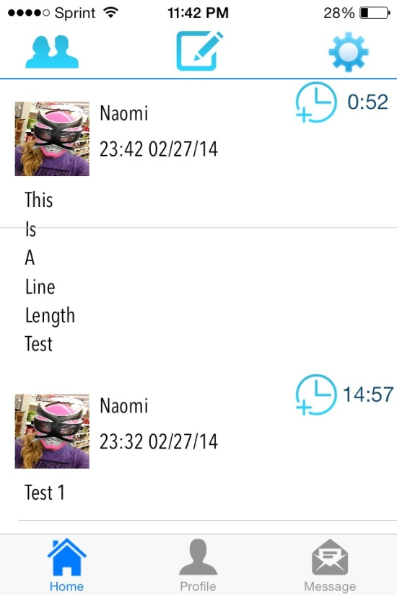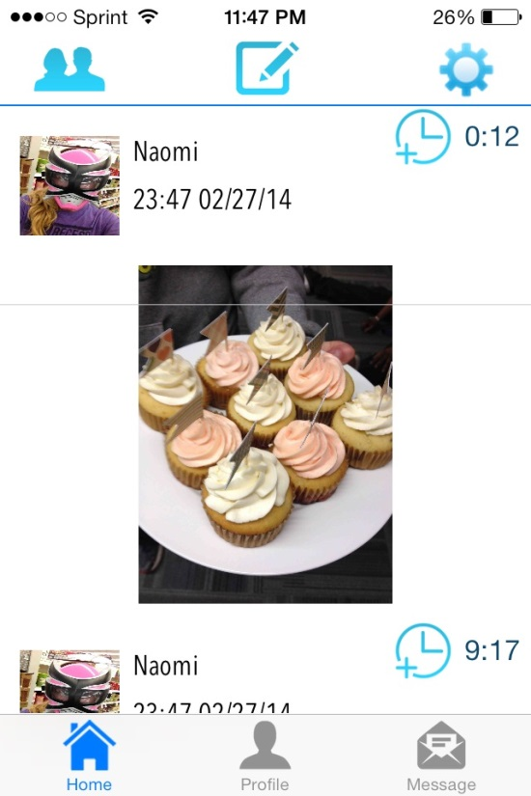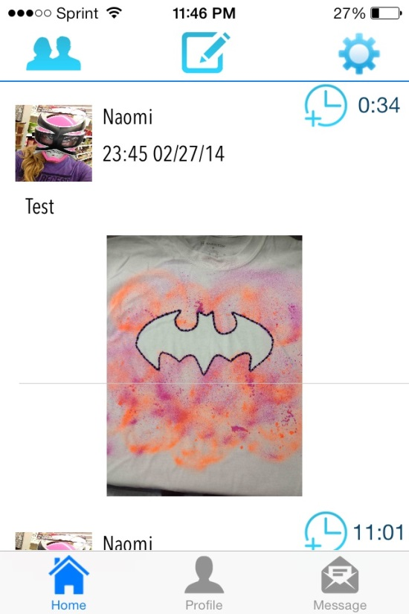

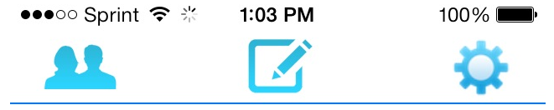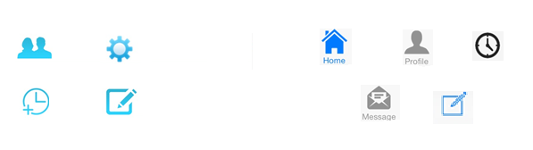

***Figure O***

Icons that are incorrect – need to be changed to theme

Icons that are correct – theme icons

***Figure N***

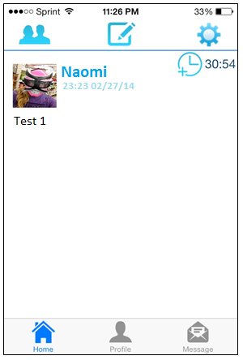***Figure P***

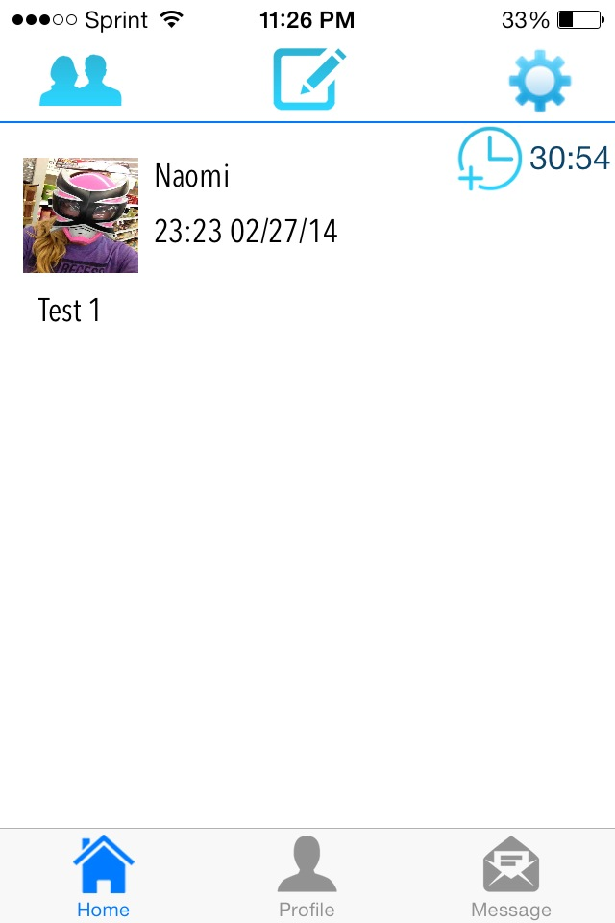

Filter function was left open on home screen so it appears on both profile page and messages page when user leaves home screen.

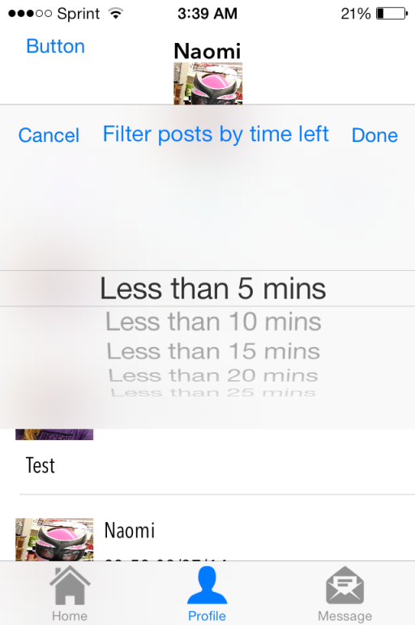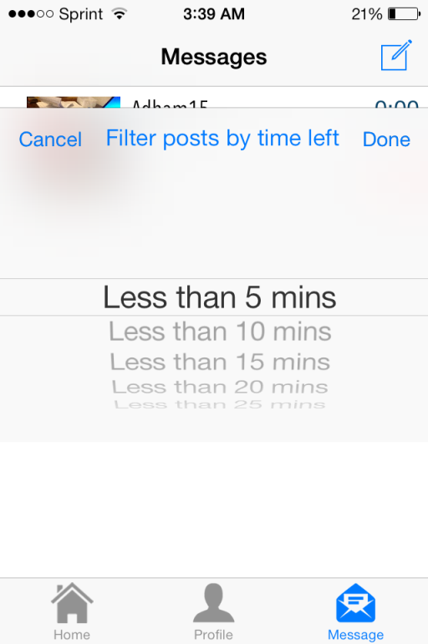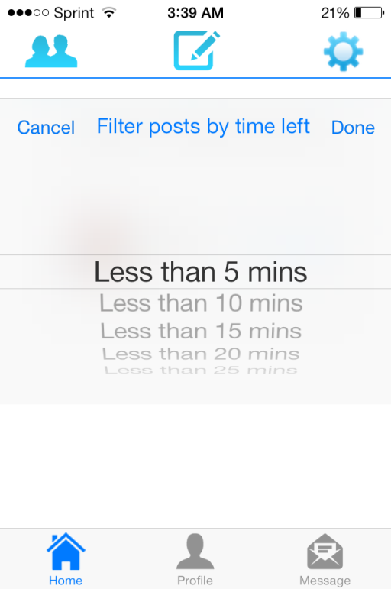

***Figure Q***

Example of a layout with different font sizes and colors

Current layout of dwindle