Screen in the app.
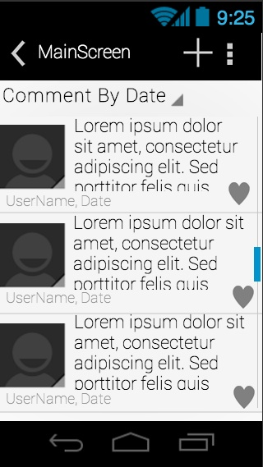

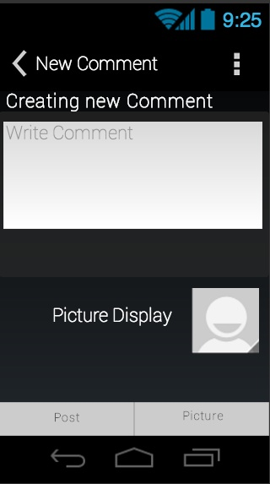
MAINSCREEN

Creating a New comment ( this is use for top level comments as well for replies comments.

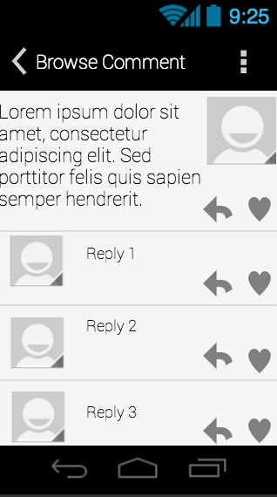

This screen show the top level comment with all its replies.

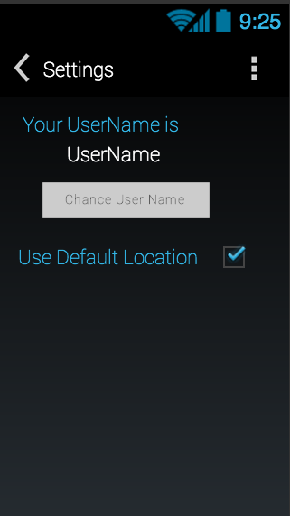

Setting screen where the user can change his or her username, or use the default Location.

Storyboard:
Let say the user use for the first time the app, and decide to browser some top level comments. The user will see a screen like this.

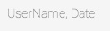
Let say that the user was interesting in one of the top level comment a click on in so he can see the complete top level comment as well as its replies comments. The user will see a screen like this.

So the user decide to reply to the top level comment, the user click on the arrow icon an open this screen. This screen is the same to reply

Now the user go back to the main screen and want to sort the the top level comments by proximity. The user would select the pull down menu and select sort by proximity.

This show a new list of top level comment close to the user.

Now lets say that the user want to create a new Top Level comments

So the user decide to add a picture top his/ her top level comment.

After he or she post a comment, the user notices that he or she has some grammar error or just want to add a picture to his/her comment, the user only have to press to the edit open, only appears in the comment make by this user.

