**SonarQube**

SonarQube contains the following components:

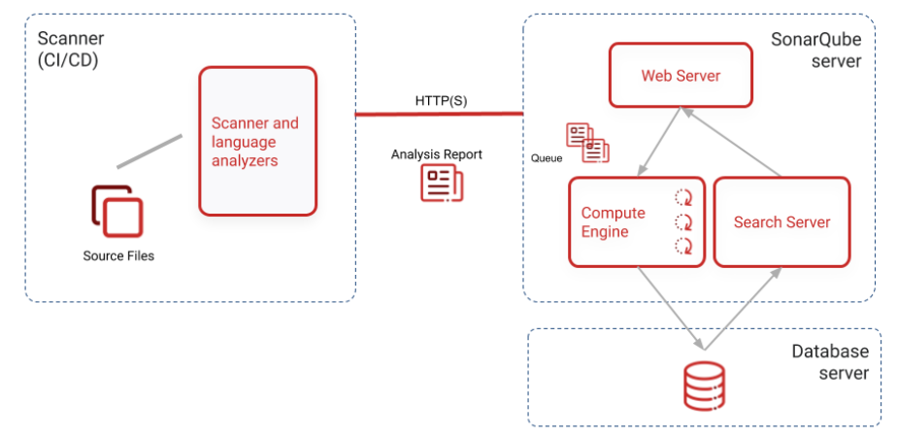

1. The SonarQube server running the following processes:
   * A web server that serves the SonarQube user interface.
   * A search server based on Elasticsearch.
   * The compute engine in charge of processing code analysis reports and saving them in the SonarQube database.
2. The database to store the following:
   * Metrics and issues for code quality and security generated during code scans.
3. The SonarQube instance configuration.
   * One or more scanners running on your build or continuous integration servers to analyze projects.

**Pre-requisite:**

You must be able to install Java (Oracle JRE or OpenJDK) on the machine where you plan to run SonarQube.

**Download Sonarqube**

1. Download [SonarQube](https://www.sonarqube.org/downloads/) from Sonarqube website

         * Download the latest stable version and extract the .zip on to the local system.

2. Extract the sonarqube binaries and navigate to the directly and run the below command

Note: In your case, downloaded versions may differ

D:\DevOps\sonarqube-6.7.3\bin\windows-x86-64  
StartSonar.bat

3. If you get the java error then make sure JAVA_HOME is set properly or manually update the wrapper.conf file which is present under conf folder of sonarqube installation directory to point to your java

wrapper.java.command=C:\Program Files\Java\jdk-14.0.2\bin\java

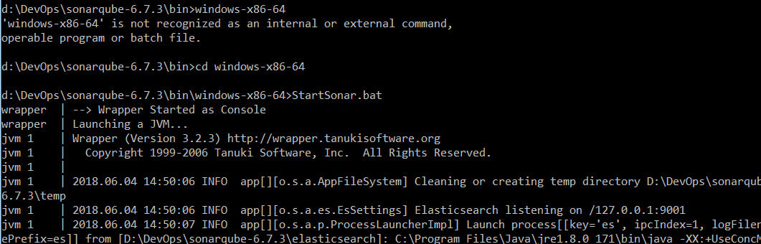

Running SonarQube on command prompt

4. Once the SonarQube is up, go to the browser : [http://localhost:9000](http://localhost:9000/) to access SonarQube dashboard.

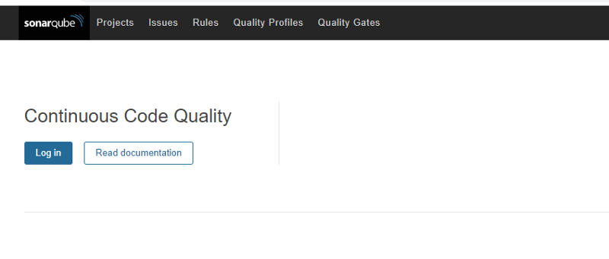

Note: you can also install sonaqube with the separate DataBase as mentioned in the SonaQube Documention

Analyze the Maven Project:

As soon as you are able to access sonarqube at URL, you will then be able to create project.

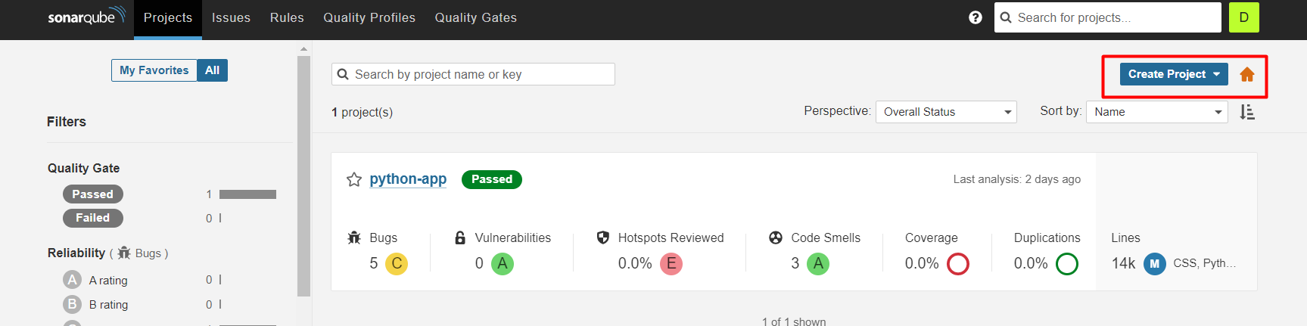

Once you create project along with project key, you will then be able to generate the token which is used for authentication when you use for your scan

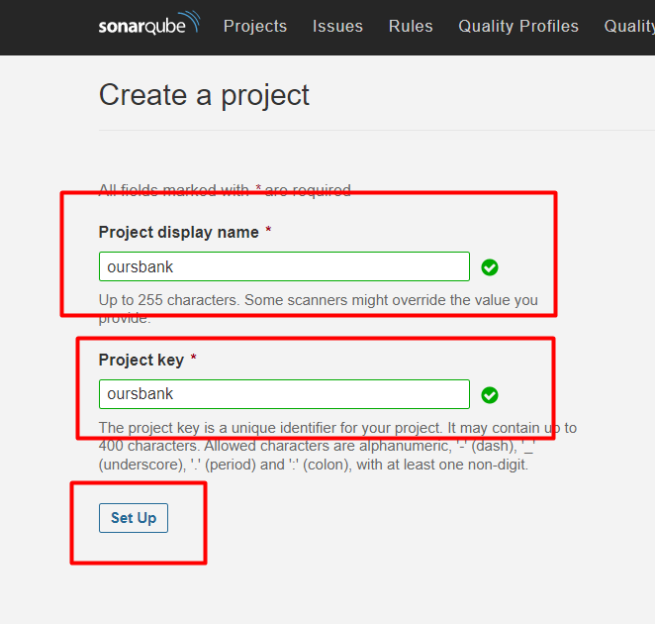

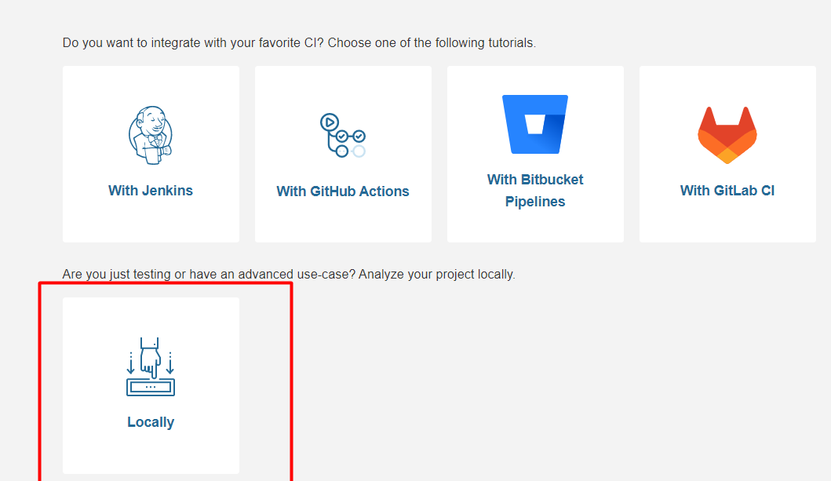

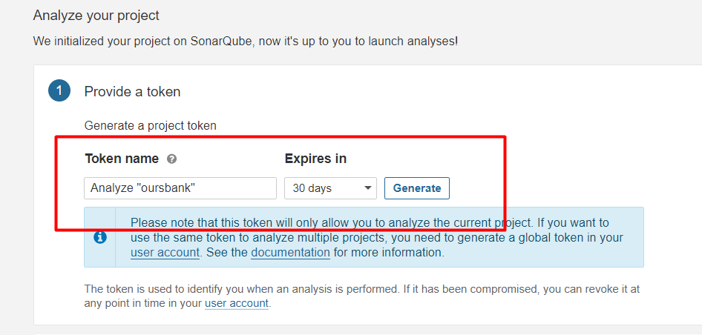

Once you generated the token, you need to select the project type, in our case it is Java project which we build with Maven.

Note:

1. we can also select other project types where you get the instrcture suggested by Sonarqube to run the command.
2. We don’t need anysonarscanner to install for maven project as it downloads automatically as plugin, But for other project, we need to install SonarScanner Seperately.

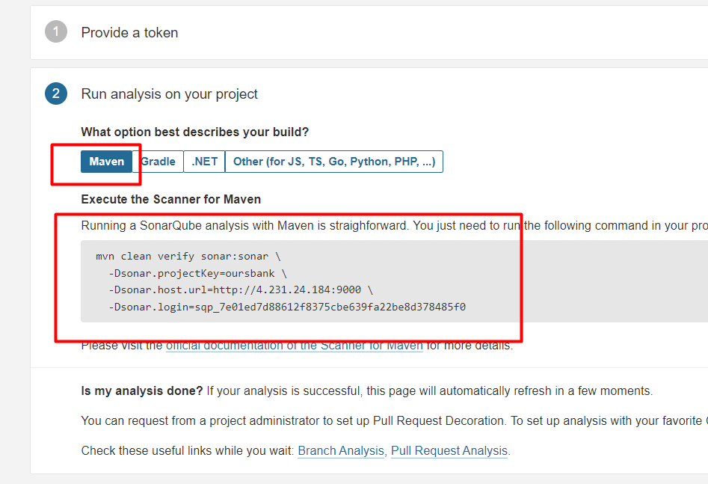

**Install SonarScanner:**

1. Download the sonar scanner from official sonarqube website

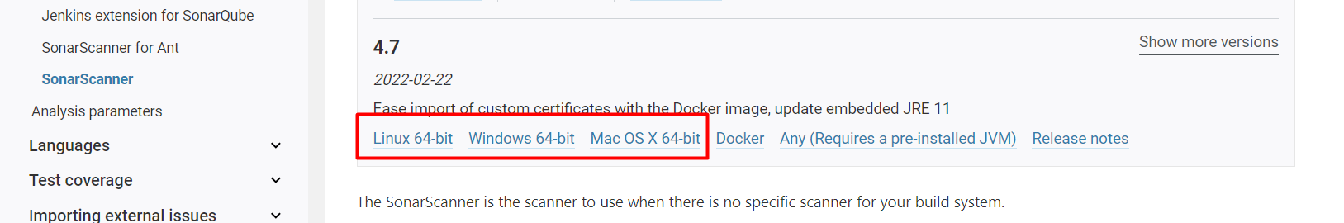

1. Expand the downloaded file into the directory of your choice. We'll refer to it as <INSTALL_DIRECTORY> in the next steps.
2. Update the global settings to point to your SonarQube server by editing $install_directory/conf/sonar-scanner.properties:

#----- Default SonarQube server

#sonar.host.url=http://localhost:9000

1. Add the <INSTALL_DIRECTORY>/bin directory to your path.

Verify your installation by opening a new shell and executing the command sonar-scanner -h (sonar-scanner.bat -h on Windows). You should get output like this:

usage: sonar-scanner [options]

Options:

-D,--define <arg> Define property

-h,--help Display help information

-v,--version Display version information

-X,--debug Produce execution debug output

If you need more debug information, you can add one of the following to your command line: -X, --verbose, or -Dsonar.verbose=true.

Run the following command from the project base directory to launch analysis and pass your authentication token:

sonar-scanner -Dsonar.login=myAuthenticationToken