**Assignment #5. Forms and Validation**

Student: Nurislam Kabash

Group: MT-2402

**Objective:**

The goal of this assignment is to understand how to create user-friendly forms with HTML and style them using Bootstrap form components. Students will also learn how to apply form validation (both HTML5 built-in validation and Bootstrap validation classes).

**Rules for Submission:**

1. The assignment must be completed individually. If you have the same paperwork with other students, you will have 0 to this work.
2. The assignment must be submitted by the deadline which is specified in the lms.astanait.edu.kz. Works submitted after the deadline will not be accepted! To receive a grade, you must submit by deadline and defend your work at practice lesson time.
3. SUBMIT REPORT(DOC FILE) AND YOUR PROJECT FOLDER IN ZIP FORMAT. Ensure that the project runs without errors.

IN REPORT SHOULD BE:

* YOUR NAME, GROUP
* **All parts with screens(write part, task and then add screen)**
* Summary of your work process

**Part 1. Basic HTML Forms**

**Task 0. Simple Contact Form**

* Create a basic contact form with the following fields:
  + Name (text input)
  + Email (email input)
  + Message (textarea)
  + Submit button
* Ensure all fields have proper <label> elements.

**Task 1. Form with HTML5 Validation**

* Add built-in validation attributes (required, type, maxlength, etc.).
* Test how the browser enforces validation (e.g., email format, empty fields).

**Part 2. Bootstrap Forms**

**Task 2. Bootstrap Form Styling**

* Recreate the contact form using **Bootstrap form classes**.
* Use Bootstrap’s grid system to arrange form fields neatly.
* Add placeholders and helper text where appropriate.

**Task 3. Bootstrap Validation Styles**

* Apply Bootstrap’s validation feedback classes (is-valid, is-invalid).
* Show feedback messages below inputs (e.g., “Email is required”, “Looks good!”).
* Test the form by entering valid and invalid data.

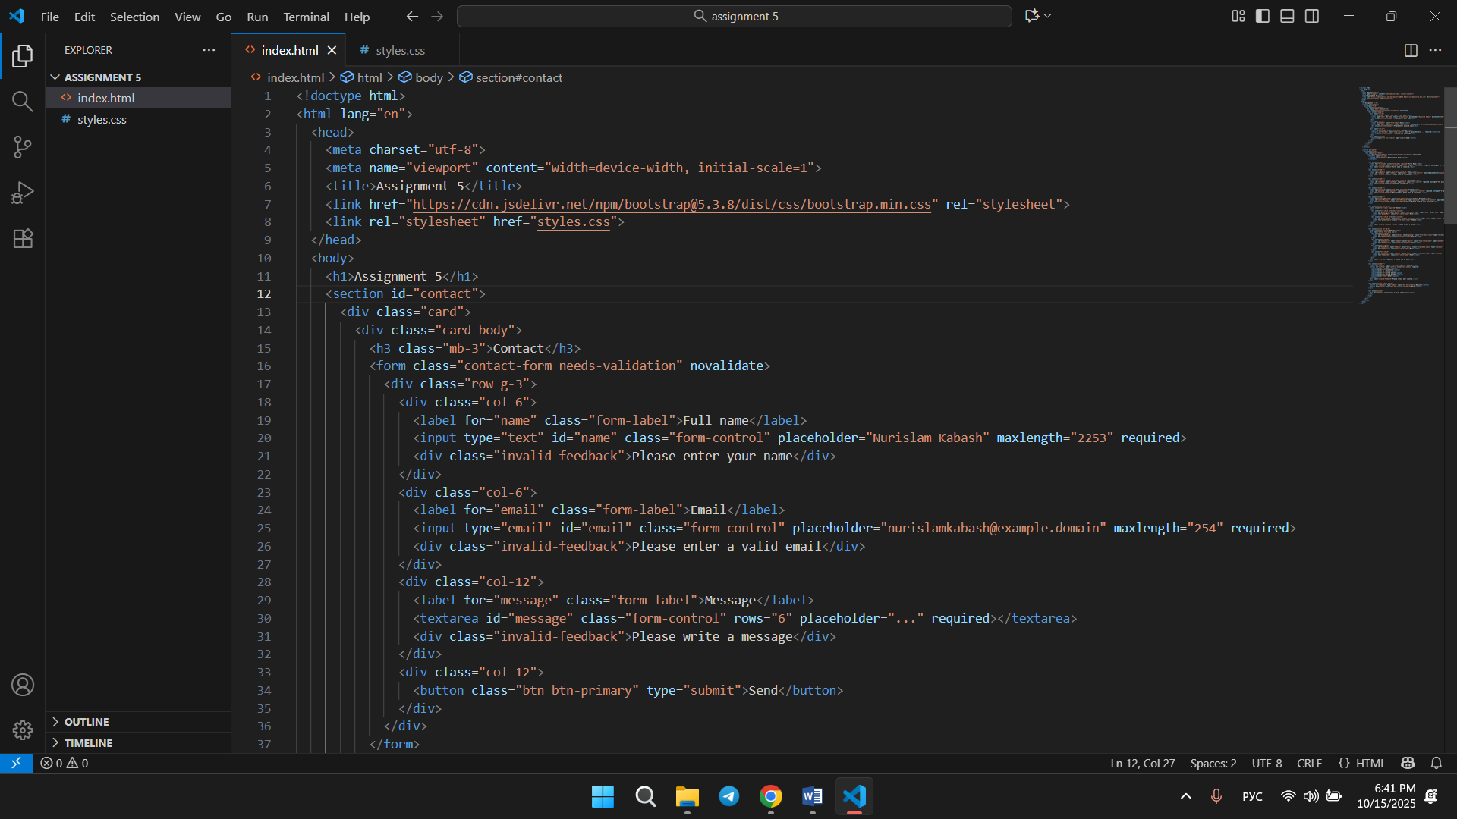

I did all 2 parts in one, used HTML5 and also Bootstrap system.

**Part 3. Advanced Form Project**

**Task 4. Registration Form**

* Create a **registration form** for a website. It should include:
  + First Name, Last Name
  + Email
  + Password + Confirm Password
  + Gender (radio buttons)
  + Hobbies (checkboxes)
  + Country (select dropdown)
  + Submit and Reset buttons
* Style the form with **Bootstrap Grid** so it is responsive.
* Add **HTML5 validation** (e.g., password must have minimum length).
* Add **Bootstrap validation feedback** to display error/success messages.

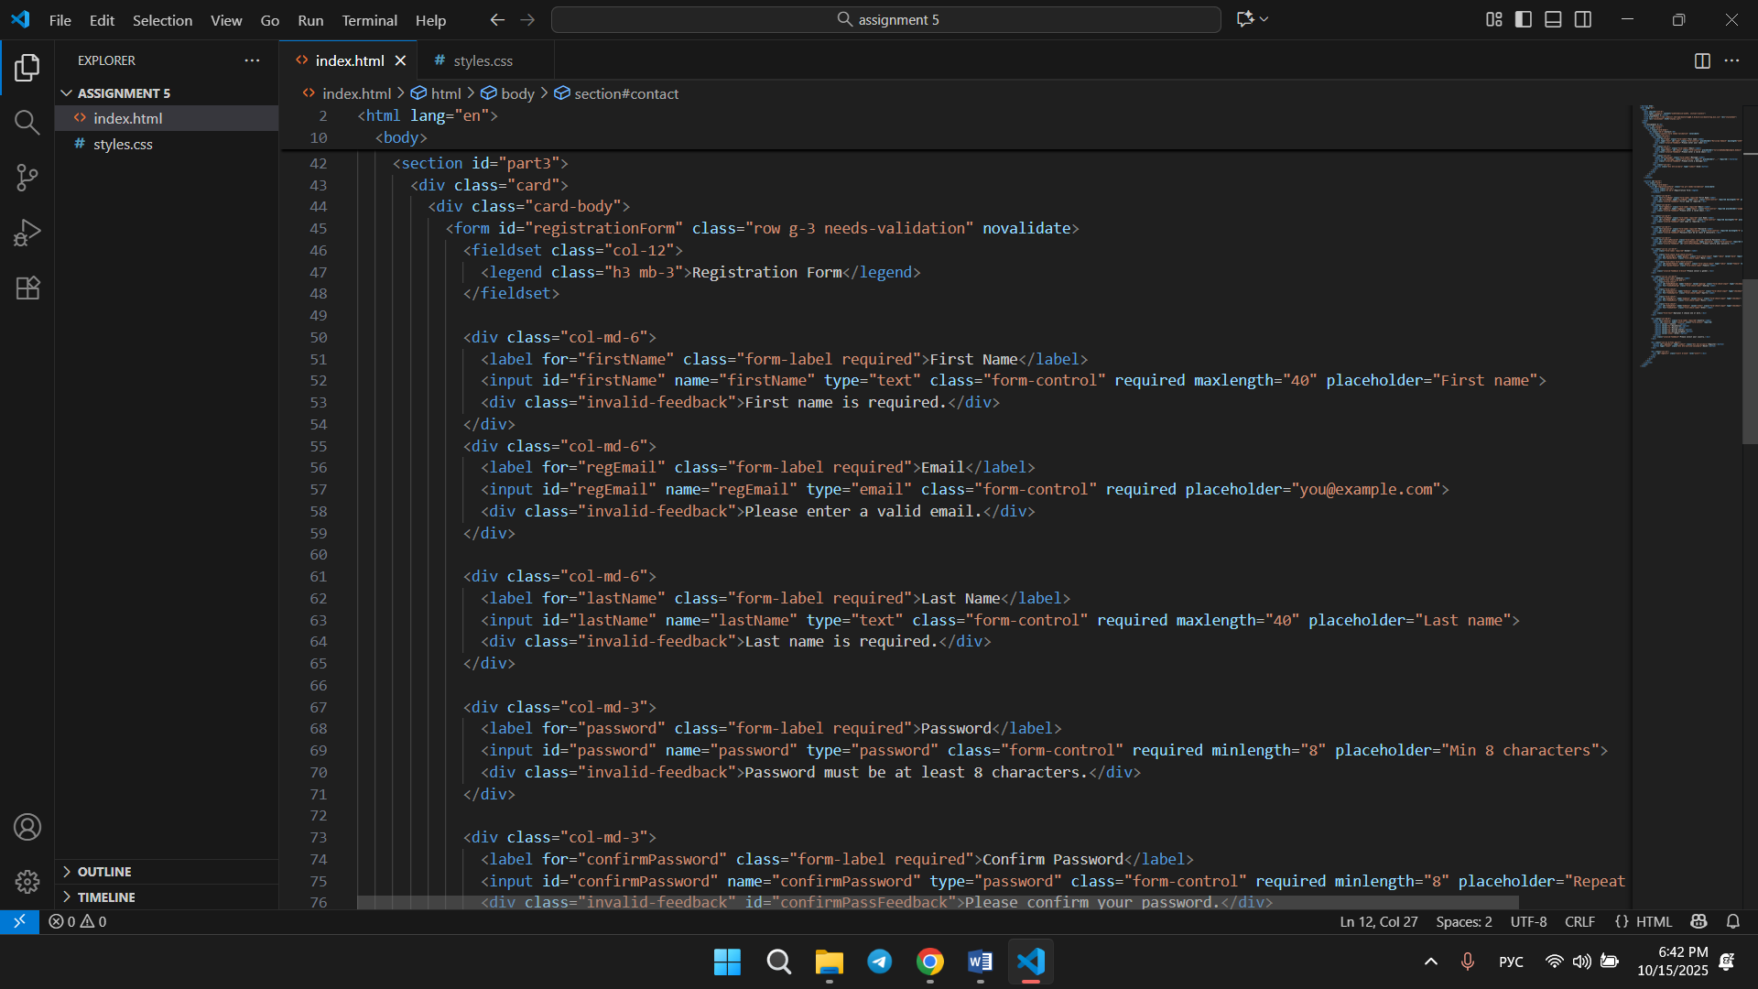

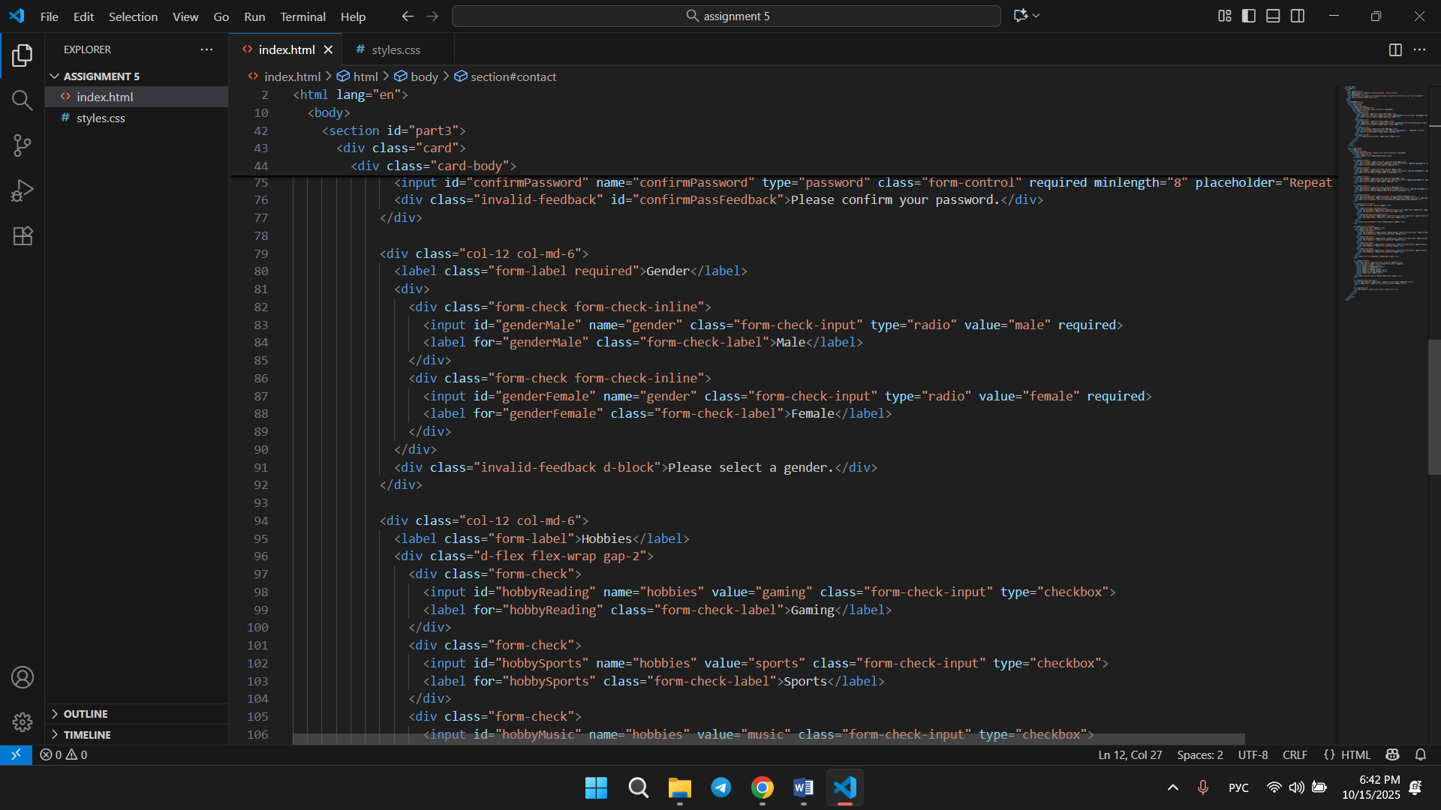

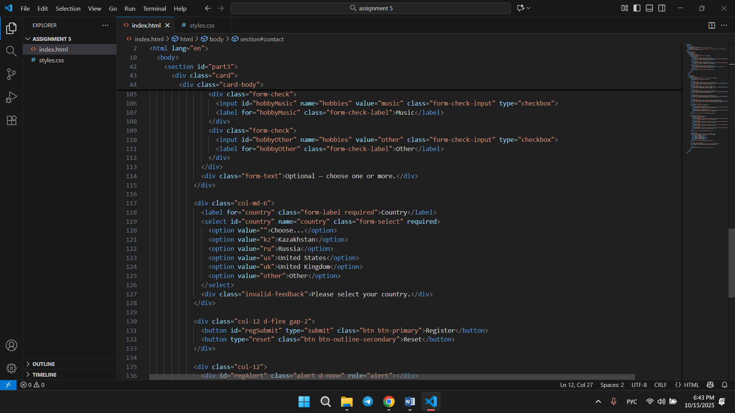

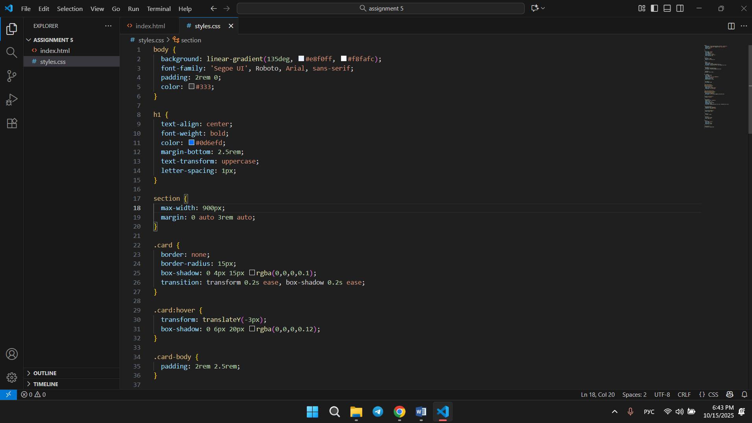

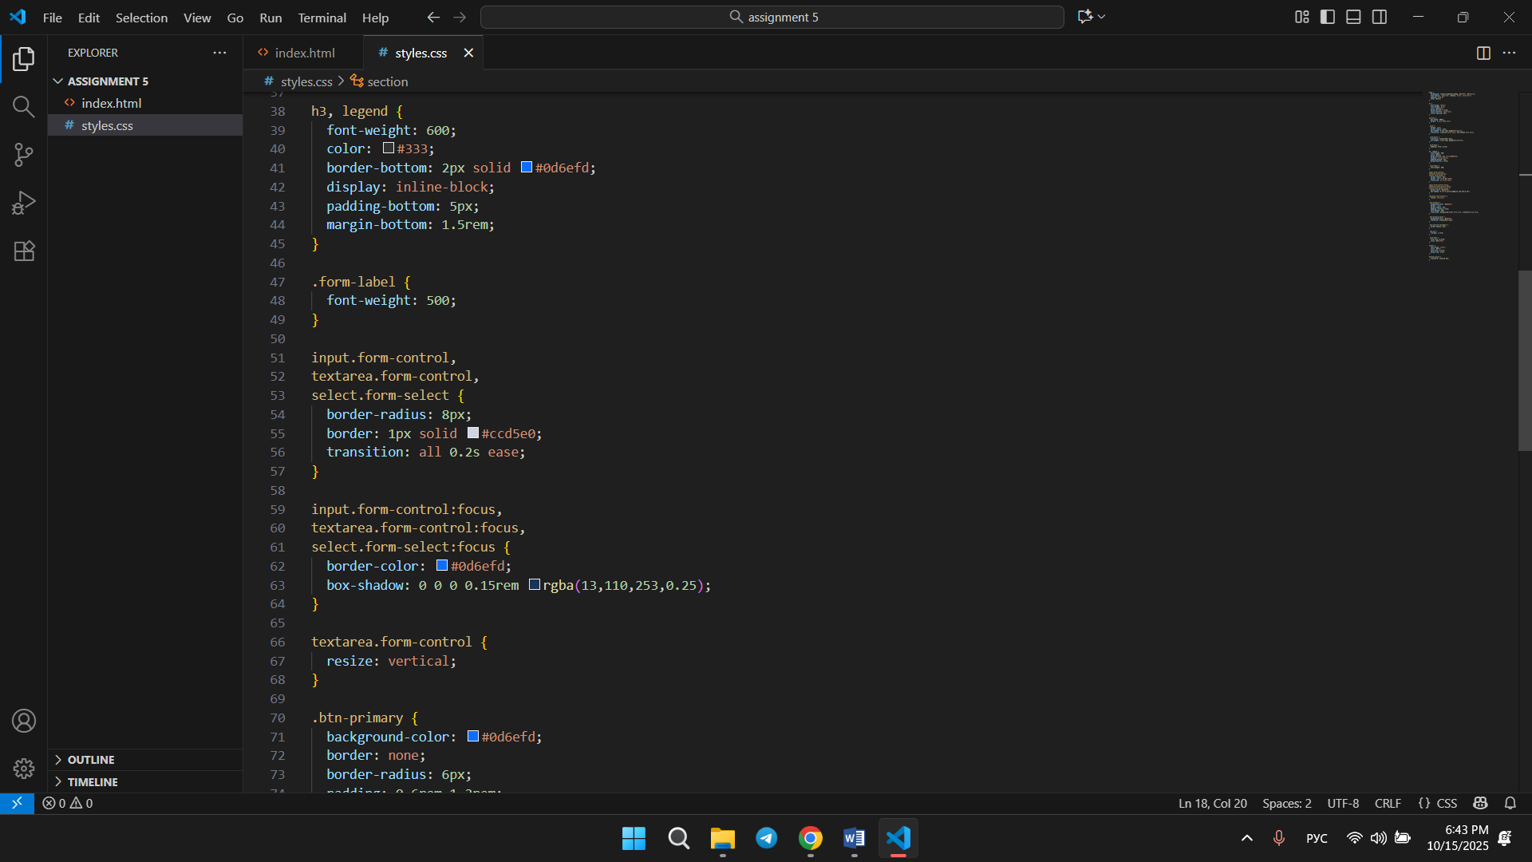

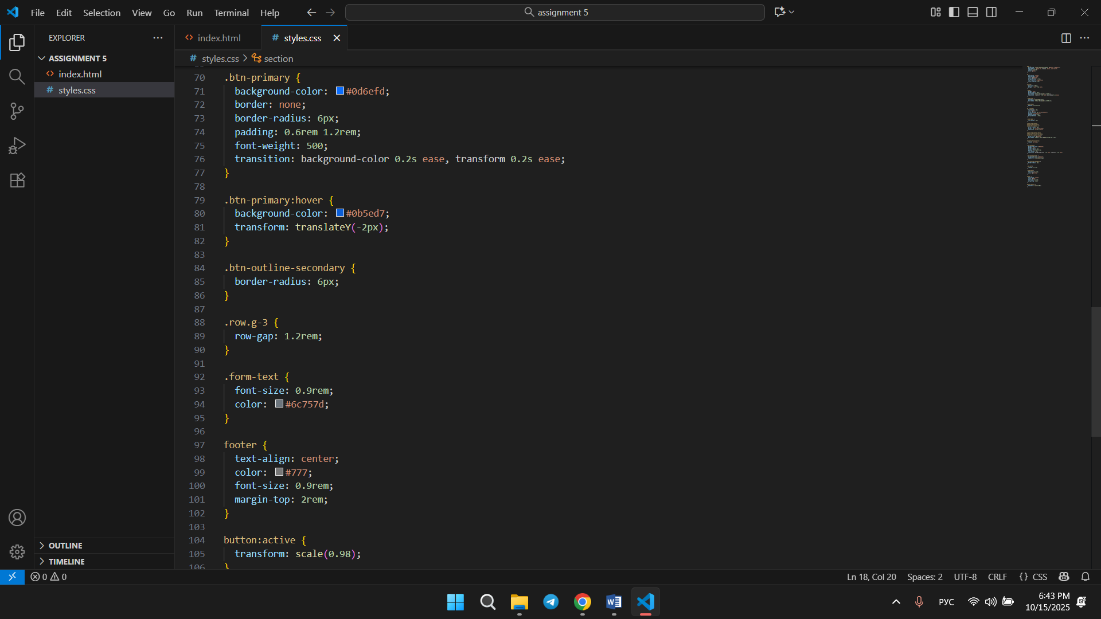

Registration form with all options and good-looking CSS styles

**Evaluation Criteria (100%)**

1. **Basic HTML Form (10%)**

correct structure with labels and inputs

1. **HTML5 Validation (10%)**

correct use of validation attributes

1. **Bootstrap Form Styling (10%)**

proper use of Bootstrap classes and layout

1. **Bootstrap Validation (10%)**

validation feedback works correctly

1. **Registration Form (20%)**

complete, styled, responsive, and validated form

1. **Design & Code Quality (10%)**

neat, readable, semantic HTML and CSS

1. **Defense during Practice Lesson (30%)**

Student explains assignment clearly

Demonstrates understanding of assignment

Answers instructor’s questions correctly

Completes the given task from the instructor correctly

1. **Report (10%)**

well-structured report with all screenshots and summary

**Resources:**

1. Abitova G.A. Web technologies Front-End Development. Part 1 (2022);
2. <https://www.youtube.com/playlist?list=PLPT6CF0r4E3rkvy1rLUKdDHf_HmWZeURW>
3. [*https://getbootstrap.com/docs/5.3/getting-started/introduction/*](https://getbootstrap.com/docs/5.3/getting-started/introduction/)
4. <https://getbootstrap.com/docs/5.3/forms/overview/>
5. <https://developer.mozilla.org/en-US/docs/Learn_web_development/Extensions/Forms>
6. <https://www.w3schools.com/html/html_form_attributes.asp>

***\*\*Questions will be based on the provided resources***

**Good luck!**

**Please remember:** contact hours are **from 9:00 AM to 9:00 PM**. Messages sent outside of this time may not receive an immediate response.