# Literature Review/Problem Area (Research Task)

**Ideas**

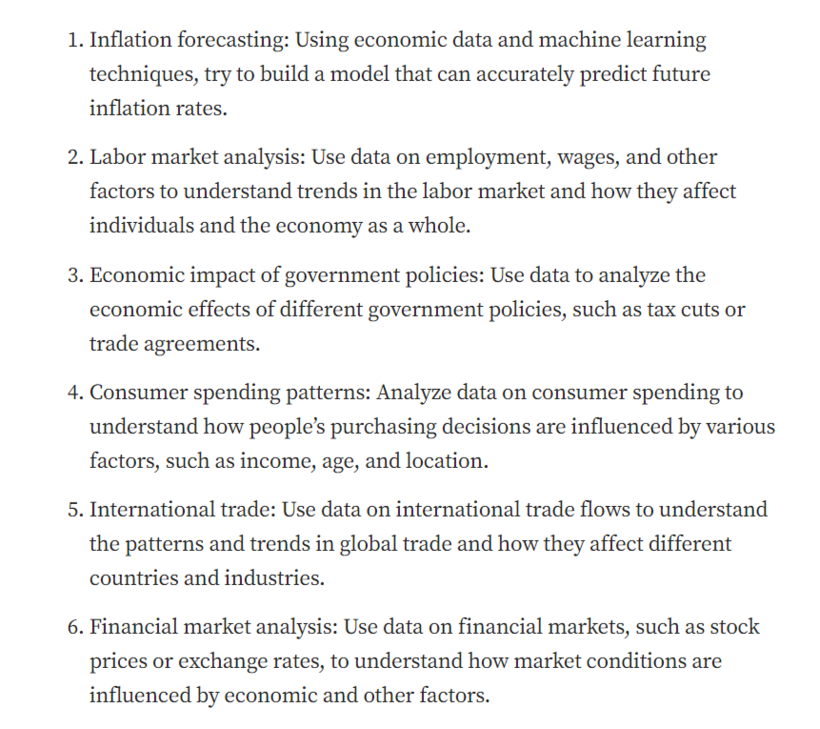

[**https://medium.com/@datafather/data-analytics-projects-for-economic-portfolio-4036ba9147fb**](https://medium.com/@datafather/data-analytics-projects-for-economic-portfolio-4036ba9147fb)