# **Domain-specific area and objectives of the project (200-500 word)**

***Instructions:*** *The first step of the coursework is to identify and describe the domain-specific area. This is an area of industry or science where a linear regression model will contribute. It can be any field which can* ***benefit from machine learning****. Then* ***state and justify the objectives of the project****. Discuss* ***its impact and contribution to the domain-specific area****. State any contribution which the results may make to the challenge addressed. Examples: Housing prices in the UK (United Kingdom). To show how prices were affected by Brexit in London and Manchester. Life expectancy globally. To show the effect of GDP per capita.*

**Resources**

<https://www.finance-monthly.com/2023/01/what-is-retail-sales-why-is-it-important/>

<https://www.dailyfx.com/education/macro-fundamentals/what-are-retail-sales-and-why-is-it-important-to-traders-a-guide.html>

* **Domain Specific Area:**
  + The relationship between weather and retail sales prices in the UK.
  + How does weather influence retail sales in the UK?
* **Why is this important?**
  + Retail sales are an important economic indicator which can give an insight into the overall health of an economy
  + Tells economists about: overall health of the economy – consumer demand for finished products – whether economy is expanding/contracting – likely trends in the unemployment rate – trends in company earnings and stock prices – manufacturing activity levels (<https://finance.yahoo.com/news/retail-sales-mean-economy-110029982.html>)
  + Retail sales are important because consumer spending drives much of the economy (<https://www.thebalancemoney.com/why-retail-sales-are-important-3141223>)
  + Retail sales influence macroeconomic activity, as when consumers increase their spending, this can lead to increased economic output
  + Retail sales constitute a large proportion of a country’s GDP
  + Shareholders are interested in predicting retail sales as an increase leads to higher earnings
  + Retail sales are known for fluctuating based on the seasons, winter months tending to be slower despite increase during Christmas
  + Useful for informed decision-making because consumer spending impacts on GDP growth
  + A **reliable** economic indicator (<https://finance.yahoo.com/news/retail-sales-mean-economy-110029982.html>), GDP is growing and the economy is growing when retail sales are high
  + GBP and retail assets like stocks move if investors react to dips or rises in retail sales figures (<https://admirals.com/financial-events/why-retail-sales-important>)
* **Objectives:**
* **Scope:**
* **Possible Stakeholders/Vested Interests:**
  + Governments measure retail sales to gauge economic health/consumer spending habits, as this indicates how well businesses are doing and consumers’ levels of disposable income 🡪 *increased spending drives foreign investment* (<https://www.dailyfx.com/education/macro-fundamentals/what-are-retail-sales-and-why-is-it-important-to-traders-a-guide.html>) and impacts GDP/inflation/balance of payments
  + For company owners, if hot summers keep repeating and negatively impacting retail sales, might have to invest in building for the heat or extreme weather
  + Central banking institutions, decision making process, whether to adjust interest rates (<https://www.dailyfx.com/education/macro-fundamentals/what-are-retail-sales-and-why-is-it-important-to-traders-a-guide.html>), <https://admirals.com/financial-events/why-retail-sales-important> monetary policy makers by adjusting interest rates and controlling inflation
  + 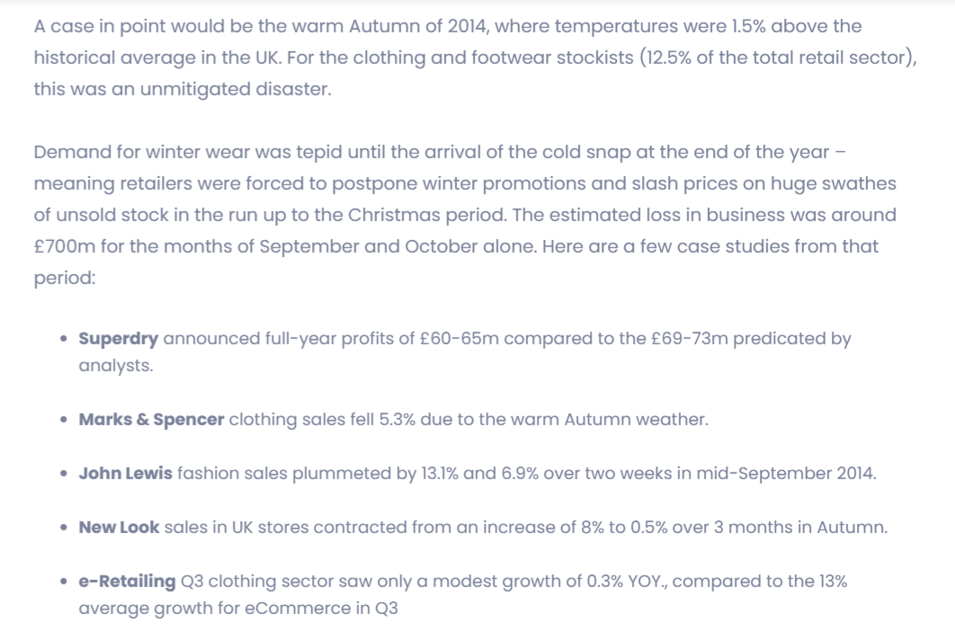Retail companies: for data driven-decision making 🡪 *By syncing product ads to match appropriate weather conditions, retailers can increase conversions and sales of their weather sensitive products, whilst also decreasing ad spend during periods of less favorable weather.* (<https://www.weatherads.io/blog/the-impact-of-weather-on-retail-sector-in-the-uk#:~:text=In%20the%20UK%20%E2%80%93%20a%20country,a%201%25%20fluctuation%20in%20sales>.)
  + <https://www.weatherads.io/blog/the-impact-of-weather-on-retail-sector-in-the-uk#:~:text=In%20the%20UK%20%E2%80%93%20a%20country,a%201%25%20fluctuation%20in%20sales>.
  + Shareholders in retail companies
  + People who might either have agender interest in the health of the economy
  + Investors who want to know when to buy or sell stocks in retail companies
  + Consumers themselves, can help purchasing decisions and when to buy certain products! E.g. after Christmas?
  + Retail sales figures affect everyday customers, as low sales figures indicate less disposable income or consumer confidence, which could reduce GDP
  + Traders (<https://www.dailyfx.com/education/macro-fundamentals/what-are-retail-sales-and-why-is-it-important-to-traders-a-guide.html>) : *retail sales exhibits a positive correlation with stock prices because an increase in sales lends itself to higher company earnings*
  + Bondholders <https://finance.yahoo.com/news/retail-sales-mean-economy-110029982.html> when retail sales are high, inflation rises and bond prices drop, which is not good
* **Factors influencing retail sales:**
  + Weather
  + Holidays
  + Seasonal cycles
* **Challenges:**
  + **Inflation:** it is factored into retail sales figures to account for changes in the **purchasing power of money over time** (https://www.finance-monthly.com/2023/01/what-is-retail-sales-why-is-it-important/) . It considers how much more expensive items might become due to rising labor costs/production material costs. In order to account for the effect of inflation, economists use **price indices** which track the changes in retail prices so that changes in spending/sales can be assessed in **real terms** (i.e. how much has really been purchased). Price indices help economists to compare changes in retail spending in real terms to ensure retailers aren’t **overestimating their revenue** solely to changing prices alone.
  + **Price Index = (Current Price / Base Year Price) * 100**
  + “Current price” = refers to the **current cost of a specific item**/service, the “base year price” is its cost at **some point in history**.
  + By diving a product’s current price by its base year price and * by 100, economists determine how much an item’s **nominal value** has changed due to inflationary pressures
  + *A positive RSI (Retail Sales Index) price once adjusted for CPI inflation can result in a net drop in retail sales* <https://www.dailyfx.com/education/macro-fundamentals/what-are-retail-sales-and-why-is-it-important-to-traders-a-guide.html>
  + As with all econometric analysis, there are always complex factors at play that need to be considered, e.g. after COVID-19 restrictions were lifted, inflation rose to 30-years high <https://admirals.com/financial-events/why-retail-sales-important>
  + Relationship is complex: some articles suggest hot weather to blame for low sales, others suggest cold/rainy weather to blame (<https://www.ft.com/content/833b4ed8-89c8-4388-8f7c-0a24df56e9ba>)

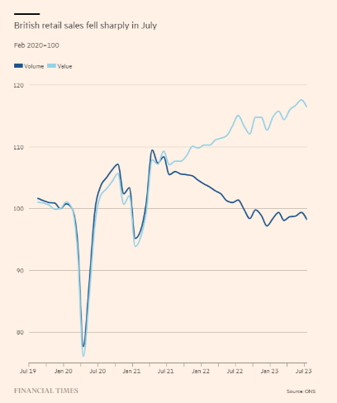

## Research Activity

* Retail sales are an **important** economic metric and macroeconomic indicator (<https://www.investopedia.com/terms/r/retail-sales.asp>). They are important for getting an idea of the general economic health of a country, as consumer spending constitutes a large proportion of a country’s GDP. Furthermore, understanding what factors influence retail sales and making predictions based on these relationships can be of value to shareholders of retail companies because it leads to higher earnings (<https://www.investopedia.com/terms/r/retail-sales.asp>).
* <https://www.finance-monthly.com/2023/01/what-is-retail-sales-why-is-it-important/> 🡪 clothes, electronics account for a significant portion of retail sales growth. In terms of recent growth, **grocery stores have remained stagnant.** **Seasonal tendencies** are typically caused by shifts in consumer demand due to external weather or holidays. E.g. winter months tend to be slower, consumers **usually spend less money during colder temperatures**, but this can depend on industry type and location. Christmas usually sees an uptick in spending. Cycles are an essential role in understanding **how trends influence retail sales performance**. Business **cycles are periods where economic activity fluctuates between expansion and contraction phases over time**; these fluctuations directly **impact consumer confidence levels**, affecting their willingness to purchase products from retailers.
* <https://admirals.com/financial-events/why-retail-sales-important>

“A barometer of economic health”, when jobs are abundant, income growth is strong and cash is flowing into shoppers’ pockets, they are more likely to spend on retail goods. The ONS researches & reports on the volume and value of retail sales figures in the UK, comparing them on a monthly, quarterly and annual basis, making them useful for investors who follow retail stocks and want to understand current and potential trends. **Figures on the UK retail sales sector:** consumer spending accounts for 60% of overall GDP (https://admirals.com/financial-events/why-retail-sales-important) , generates close to 100 billion GBP every year, 3 million jobs in the sector (including grocery shops, clothing, household shops). Huge impact on retail sales sector was COVID-19, as between 2008-2020 UK was slow tof adapt to online shopping, but things changed after 2020, where they drove up to 20% of retail sales. In 2020 UK had highest rate of online shopping compared to other European countries.

## Research on the Relationship between Retail Sales and Weather

**Hot Summers in the UK Increasing**

* 2022 – first time above 40C (<https://www.preventionweb.net/news/met-office-review-uks-record-breaking-summer-2022>)
* *Research in the last few years has continued to add to the evidence base that illustrates that climate change has already made UK summer extremes in temperature more likely and increased the likelihood of extreme heatwave events* (<https://www.preventionweb.net/news/met-office-review-uks-record-breaking-summer-2022>)
* *The highest temperatures recorded in the UK have been*[*increasing at a faster rate*](https://www.nature.com/articles/s41467-020-16834-0)*than the average temperature and in parts of the south-east of England have increased by as much as 1C per decade.* - <https://www.preventionweb.net/news/met-office-review-uks-record-breaking-summer-2022>
* The figure below shows that years in which the temperature failed to exceed 30C used to be a fairly regular occurrence in the past, but has not happened since 1993. - <https://www.preventionweb.net/news/met-office-review-uks-record-breaking-summer-2022>
* National records are also being held for much shorter periods of time. A temperature of 36.7C on 9 August 1911 held the UK high temperature record for 79 years until it was exceeded on 3 August 1990. This record held for 13 years until 2003, which held for 16 years until 2019, which held for just three years until 2022.
* there is also evidence of a general increasing trend in this metric too, with the average number of days above 25 rising from seven days for 1961-1990 to 11 days for 1991-2020. <https://www.preventionweb.net/news/met-office-review-uks-record-breaking-summer-2022>
* The years 2012-2021 [were on average](https://www.metoffice.gov.uk/research/climate/maps-and-data/about/state-of-climate) 1 degree Celsius warmer than the period 1961-1990, and all of the UK’s top 10 warmest years have occurred this century. <https://www.wired.co.uk/article/uk-homes-heat-wave>

**Relationship between weather and retail sales**

* Hot weather or too much rain 🡪 disruption to transport networks e.g. sagging overhead cables on rail networks (<https://www.preventionweb.net/news/met-office-review-uks-record-breaking-summer-2022>)
* **“Weather has had a greater effect [on sales] than economic numbers, we’ve known that** forever” – Andy Street, John Lewis Managing Director, 2014
* *There has been much written about the disruptive effects of extreme weather events on the retail sector. Certainly severe storms, floods, and blizzards – as well as prolonged periods of unseasonably hot and dry weather can have a seismic impact on trade. However, this is only half of the story. Commonplace, daily variations in the weather are equally potent drivers of consumer demand, availability of supply, and ultimately retail profits.* <https://www.weatherads.io/blog/the-impact-of-weather-on-retail-sector-in-the-uk#:~:text=In%20the%20UK%20%E2%80%93%20a%20country,a%201%25%20fluctuation%20in%20sales>.
* *In these cases, it is not just a matter of whether the weather is hot or cold, sunny or cloudy, wet or dry – the critical issue is if the weather is seasonal, with unseasonal spells liable to wreak havoc on the retail trade.*
* *Because retailers report sales quarterly, a bout of unseasonable weather over just two or three consecutive weekends can significantly diminish the quarterly sales figures. For example, following a string of wet weekends over the summer of 2013, B&Q announced a £30m shortfall below first-half projected profits. The unseasonably wet weather inhibited demand for outdoor products such as barbecues and gardening hardware.* <https://www.weatherads.io/blog/the-impact-of-weather-on-retail-sector-in-the-uk#:~:text=In%20the%20UK%20%E2%80%93%20a%20country,a%201%25%20fluctuation%20in%20sales>.
* Some sectors are more weather-sensitive than others.
* *It has been proven that after exposure to sunlight consumers are more willing to self-reward (i.e. make purchases), and are also willing to pay more for goods and services. It has also been shown that when consumers are in a warm environment, their purchase intent increases, and they judge the value of certain items higher. In addition the same study found that warmth leads consumers to be more easily swayed by marketing messages.* <https://www.weatherads.io/blog/the-impact-of-weather-on-retail-sector-in-the-uk#:~:text=In%20the%20UK%20%E2%80%93%20a%20country,a%201%25%20fluctuation%20in%20sales>.
* *just a few days of heavy rainfall can also have an unexpected impact- on your sales.* <https://www.ukpos.com/knowledge-hub/how-weather-affects-sales-in-retail>
* *Cafes and restaurants can benefit from warmer weather patterns by introducing new items to their menu in order to boost interest and increase sales during periods when more people are outside.* <https://www.ukpos.com/knowledge-hub/how-weather-affects-sales-in-retail>
* *According to a 2010 study, exposure to sunlight dramatically increased levels of consumption, as well as the amount spent per item.* <https://www.ukpos.com/knowledge-hub/how-weather-affects-sales-in-retail>
* *While there are seasonal trends in retail - bank holidays, Christmas and regular sales - the weather can also play a large part in sales and even pricing.From hot summers to wet winters, the conditions can determine how consumers buy, what they buy, when retailers introduce new lines and when sales periods start.It’s a fine balancing act for many retailers, with those managing to take advantage of shifts in the weather getting the best results.  Running the right promotions at the right time can lead to a considerable increase in sales and profits. […] One of the biggest influences it has is the introduction of new lines. If weather experts predict an early summer, with good weather in April and May, shops could be convinced to bring in their summer lines earlier. This could mean beach clothing, BBQs or camping equipment, which all sell well when the weather is good.*
* *If the weather gets too cold and the country gets one of its snow storms, it can cause high street retail to ground to a halt, as people don’t want to risk getting into their cars. This causes chaos if it happens either in the run up to Christmas or during the January sales – both periods when retailers are looking to boost their takings.* <https://www.struttandparker.com/knowledge-and-research/how-weather-affects-retail-sales>
* Rain to blame for low sales: <https://www.theguardian.com/business/2023/aug/18/wet-weather-dampens-retail-sales-in-great-britain>
* Hot weather to blame for low sales: <https://www.euronews.com/business/2023/10/20/cost-of-living-and-hot-weather-cause-retail-sales-to-fall-in-uk>
* *Additionally, the warm weather contributed to increased consumer confidence, as evidenced by a 1.6-point rise in the GfK Consumer Confidence Index. This index measures consumers’ perceptions of their financial situation, the general economic climate, their inclination to make major purchases, and their savings intentions. –*
* *In conclusion, the impact of warm weather on the UK retail sector has been a mixed bag. While opportunities emerged, retailers must adapt to evolving consumer preferences and behaviors, while also navigating rising costs and competitive pressures.* <https://medium.com/@wynyardsco/how-the-warm-weather-affects-the-uk-retail-sector-1ee7fa17cccc>
* *British retail sales fell more than expected in September as shoppers delayed buying autumn clothing due to unseasonably warm weather, against the backdrop of broader cost of living pressures, official figures showed on Friday. Retail sales dropped by 0.9% on the month after a 0.4% rise in August, the Office for National Statistics (ONS) said, a bigger decline than the 0.2% fall economists had forecast in a Reuters poll.*
* <https://economictimes.indiatimes.com/news/international/business/uk-retail-sales-slide-in-september-as-warm-weather-hurts-clothing-demand/articleshow/104575529.cms>
* **Research Article:**

*Earning profits in the retail industry is tougher than in other industries (Gaur et al., 1999), and retailers are under pressure to avoid costly mistakes, e.g., over- and/or under-stocking. More accurate forecasts of customer traffic help to improve workforce planning in stores (Mani et al., 2015), price optimization and revenue management (Ferreira et al., 2016), and the inventory planning of stock keeping units (SKUs) (Williams et al., 2014).*

* <https://www.sciencedirect.com/science/article/abs/pii/S0969698919303236>
* **THE ONS SAID "UNSEASONABLY WARM WEATHER" CAUSED NON-FOOD SALES TO FALL BY 1.9%** [*https://www.standard.co.uk/business/leisure-retail/uk-retail-sales-fall-september-weather-autumn-winter-clothes-recession-high-street-b1114795.html*](https://www.standard.co.uk/business/leisure-retail/uk-retail-sales-fall-september-weather-autumn-winter-clothes-recession-high-street-b1114795.html)

## “The Impact of Daily Weather on Retail Sales: An empirical study in brick-and-mortar stores” by Florian Badorf and Kai Hoberg (2020)

* Influence of weather on daily sales for 673 stores
* A **random coefficient model** that **considers non-linear effects** and **seasonal differences** using **different weather parameters**
* “We find that the weather has generally a complex effect on daily sales while the magnitude and the direction of the weather effect depend on the store location and sales theme.”
* The impact of extreme bad/good weather occurrences can be misestimated by traditional models that do not consider non-linear effects.
* We analyze if **weather forecasts can be used to improve the daily sales forecast**.
* Including weather forecast information improves sales forecast accuracy up to seven days ahead.
* The weather’s impact on retail sales has received only limited attention.
* “Weather, such as precipitation (rain and snow) and temperatures significantly influence people’s behavior, although it is unclear how shoppers change their shopping behavior in physical stores because of the weather.”
* Good weather 🡪 might engage in an outdoor activity instead of going inside a shopping mall BUT bad weather might cause shoppers to stay home.
* “Overall, the weather has a significant effect on the economy.”
* Weather accounts for 3.4% of sales variations.
* Helps shop managers plan for the future. Has a big impact on daily decision-making.
* Studies on how weather affects sales have usually focused on the apparel/clothing industry, but weather also affects sales generally, “which has not been studied exhaustively”.
* Earning profit in retail industry is tougher than in other industries and retails are under pressure to avoid costly mistakes. More accurate forecasts of customer traffic help to improve workforce planning in stores, price optimization and revenue management.
* Lots of weather data exists and is widely available, but academic research has not yet thoroughly investigated the impact of weather on retail sales.
* Explanatory power of weather information on daily sales.
* The model can hopefully be used to **improve the accuracy** of sales forecasts.