RESILIENCE OF INDIAN
FINANCIAL MARKETS
A Data-Analytics Study of the Nifty 500, June 2021 – June 2026
Data Analytics Competition Submission
Theme: Resilience of Indian Trade / Financial Markets
Tools used: Python (pandas, NumPy, Matplotlib) · Power Query (M) · Interactive HTML Dashboard

Executive Summary
Five years of Nifty 500 data tell a story of a market that gets knocked down often and gets up faster every time. Since June 2021 it has lived through the Russia–Ukraine war, a global rate-hiking cycle, the collapse of Silicon Valley Bank, and a 2025 US tariff shock — and through all of it, the broad market roughly tripled. This report follows that story through the data and asks: how resilient are Indian equities to global stress, and which stocks carry that resilience?
Working from five years of daily OHLCV data across 500 Nifty 500 constituents (over 550,000 rows), we built an equal-weighted market proxy, measured its drawdowns and volatility through four global shock windows, and scored every stock with at least a year of history on a 0–100 resilience scale rewarding shallow drawdowns, low downside capture, low volatility and steady compounding. The headline finding: none of the four shocks studied cut deeper than about 12% at the market level, breadth stayed remarkably wide even in the worst weeks, and the market's single largest drawdown of the entire five years — 21%, in early 2025 — had nothing to do with any of the four global events at all.
Data used: the actual uploaded dataset — nifty500_5yr_data.csv, 551,643 rows, 500 tickers, 9 June 2021 to 9 June 2026 — with real Nifty 500 ticker symbols throughout. A few tickers have shorter histories (recent listings); stocks with under one year of data are excluded from the resilience ranking but remain in the market index.

1. Methodology
The raw dataset (nifty500_5yr_data.csv) contains daily Open, High, Low, Close and Volume for 500 Nifty 500 constituents from June 2021 to June 2026, plus a sparse Notes column flagging special sessions (e.g. Union Budget Day), which was dropped before analysis. From this we derived:
- Daily return per stock, with moves beyond ±35% treated as data errors or corporate actions and excluded.
- An equal-weighted market index (base = 100), used as a proxy for the broad Nifty 500 since no official index column was supplied.
- Drawdown from the running peak, and 21-day rolling annualised volatility, to track stress and calm regimes.
- A Resilience Score (0–100) per stock, averaging four percentile ranks: shallow maximum drawdown, low downside capture on the market's worst 5% days, low annualised volatility, and high CAGR. Stocks with under one year of trading history (mostly recent listings) are excluded from this ranking so scores are comparable.
- Four global shock windows — the Russia–Ukraine war, the 2022 global rate-hike sell-off, the March 2023 US banking stress, and the April 2025 US tariff shock — measured for market return, peak-to-trough fall, share of stocks that stayed positive, and trading days to recovery.
All computation was performed in Python (pandas, NumPy) and charted with Matplotlib; an equivalent Power Query (M) pipeline was also built so the same analysis can run natively inside Excel or Power BI. Both are included in the Appendix.

2. The Big Picture — Five Years, One Story
Zoom out, and the index shows a market in a near-continuous climb, punctuated by four sharp but shallow pullbacks — none deeper than the single worst drawdown of the whole period, which struck in early 2025 for reasons unrelated to any of the four global shocks studied. Every pullback, including that one, was followed by a recovery to new highs. The market that emerges from this data is one that absorbs global stress readily and reserves its sharpest moves for domestic or company-specific catalysts.
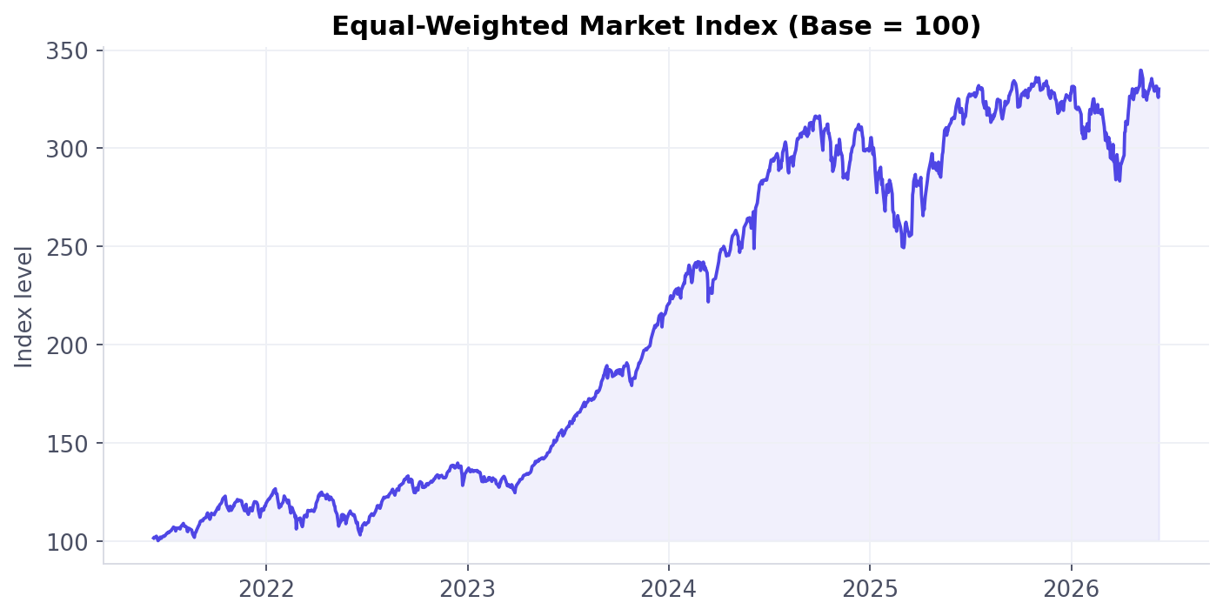
Figure 1 — Equal-weighted Nifty 500 proxy (500 stocks), rebased to 100 at the start of the sample.
+230%  Total return | ~27.6%/yr  CAGR | -21.2%  Max drawdown | 16.2%  Avg. volatility

Calendar-year returns
Broken into years, the resilience story becomes clearer still: every single calendar year in the sample closed positive. 2022 — squeezed by rate hikes and the Russia–Ukraine war — was the weakest year, up just under 14%, while 2023 and 2024 delivered exceptional back-to-back gains of 62% and 37% as the market re-rated sharply off its 2022 base.
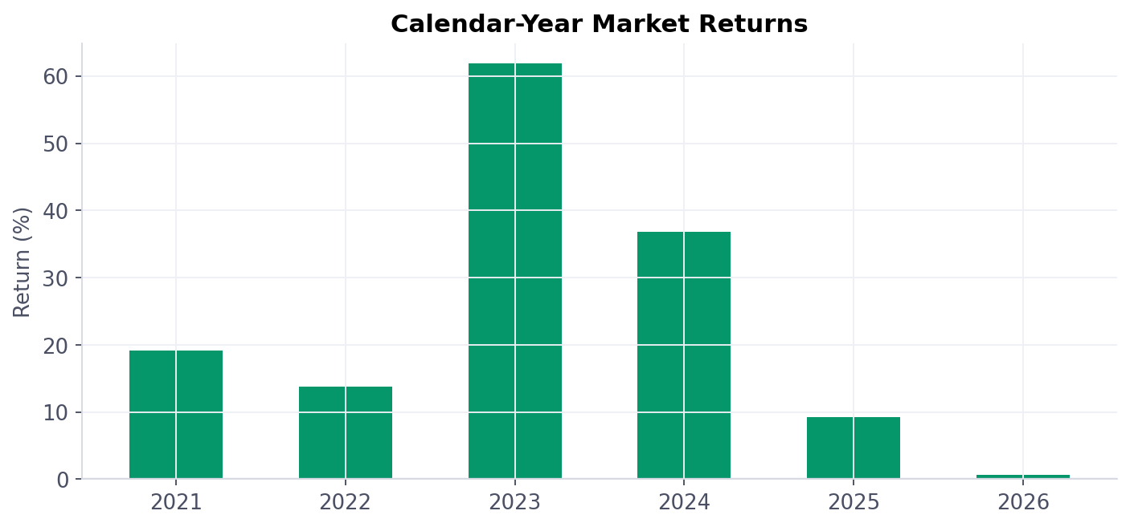
Figure 2 — Calendar-year returns of the market proxy. 2026 is a partial year (through 9 June).

3. Living Through the Storms
Two charts capture how the market absorbs stress: how far it falls, and how nervous it gets while falling. The deepest drawdown of the entire five years — 21.2%, in early 2025 — sits apart from the four global shock windows studied below, a reminder that the largest risk to this market over the period was not any single international event.
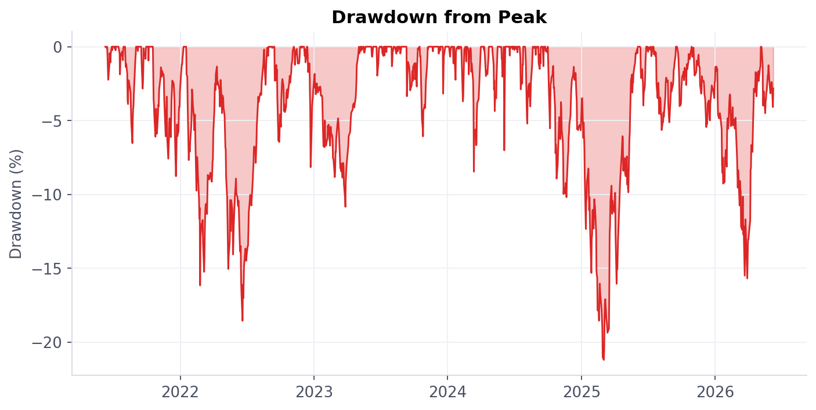
Figure 3 — Drawdown from the running peak. The deepest fall, -21.2%, came in early 2025.
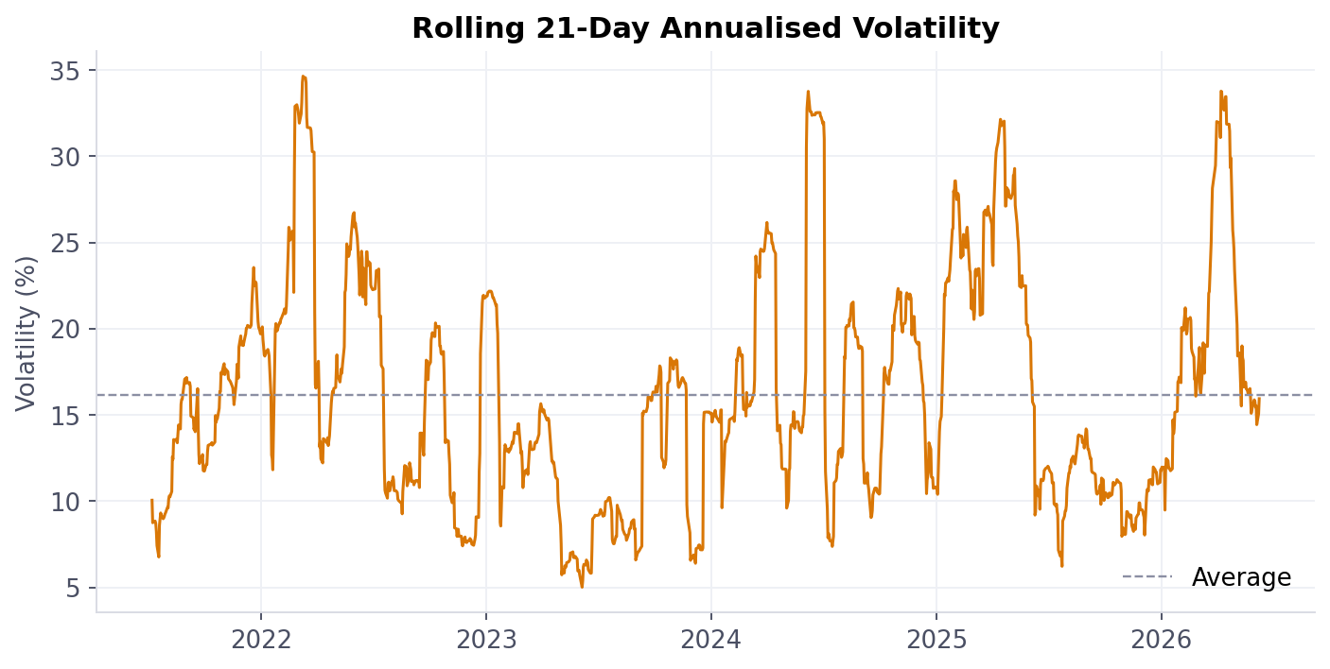
Figure 4 — Rolling 21-day annualised volatility versus its full-sample average (dashed). The sharpest spike, to 34.6%, came alongside the 2022 rate-hike sell-off.

How each shock actually played out
Rather than treat 'the market fell' as one story, we isolated four distinct global shocks and measured each on the same four yardsticks. Two of the four windows — the Russia–Ukraine war and the 2025 tariff shock — actually closed higher than they started, because the recovery within the window outpaced the initial fall. The 2022 rate-hike sell-off was the most damaging by every measure: the deepest fall (-11.8%), the only outright negative window return, and the narrowest breadth (28% of stocks positive).
Event | Window | Market return | Max fall | % stocks positive | Recovery
Russia–Ukraine war | Feb–Mar 2022 | +3.7% | -5.9% | 56.6% | 15 days
Global rate-hike sell-off | Apr–Jun 2022 | -7.4% | -11.8% | 28.0% | 31 days
US banking stress (SVB) | Mar 2023 | -2.9% | -5.9% | 31.2% | 14 days
US tariff shock | Apr 2025 | +2.5% | -5.9% | 59.9% | 8 days

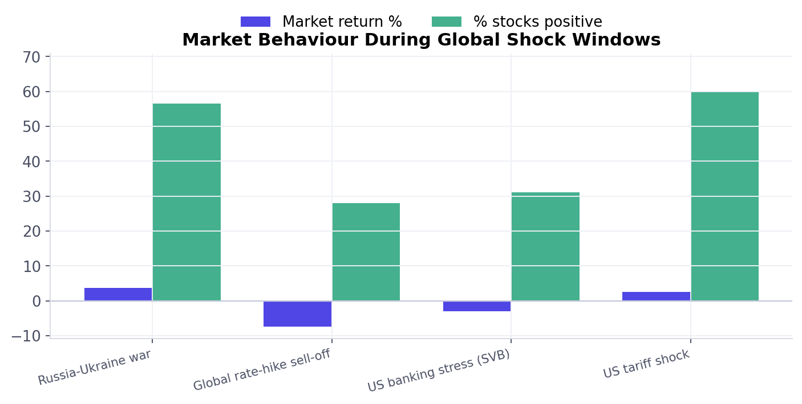
Figure 5 — Market return and breadth (% of stocks positive) across the four shock windows.
Recovery was fast across the board: even the slowest of the four, the rate-hike sell-off, took only 31 trading days — about six weeks — to reclaim its starting level. The SVB and tariff shocks each recovered in two to three weeks. Breadth held up too: in every window at least 28% of stocks finished positive, rising to nearly 60% during the milder Russia–Ukraine and tariff windows.

4. Winners and Laggards — What Makes a Stock Resilient
Averages hide as much as they reveal. Underneath a market that tripled, individual stocks ranged from compounding at 30–80% a year with shallow drawdowns, to losing over 80% of their value in the same five years. Scoring every eligible stock on drawdown depth, downside capture, volatility and CAGR surfaces a clear divide.
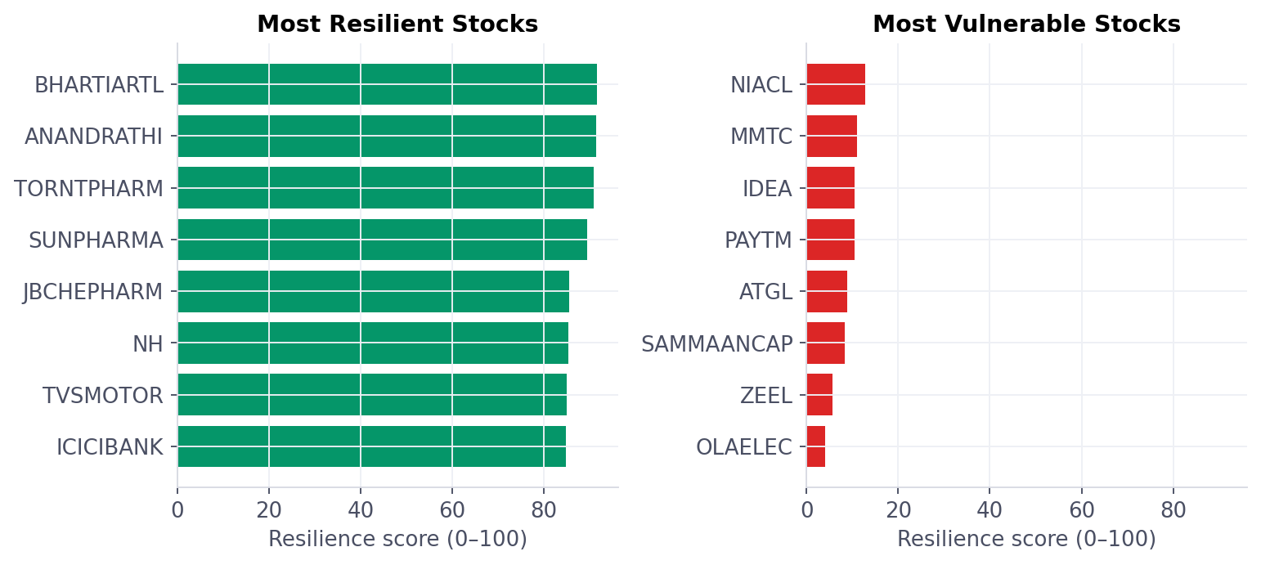
Figure 6 — Resilience score (0–100) for the eight most resilient and eight most vulnerable stocks in the universe.

The resilient cohort
The top-scoring names — led by Bharti Airtel, Anand Rathi Wealth, Torrent Pharma and Sun Pharma — share a profile: betas below 0.5 (moving less than half as much as the market on average), downside capture well under 1 (falling less than the market on its worst days), and CAGRs of 23–78%, meaning resilience here came with strong growth, not in place of it.
Ticker | CAGR | Volatility | Max drawdown | Beta | Score
BHARTIARTL | 29.0% | 22.1% | -18.8% | 0.45 | 92
ANANDRATHI | 77.8% | 29.8% | -26.9% | 0.48 | 91
TORNTPHARM | 28.5% | 23.5% | -22.9% | 0.42 | 91
SUNPHARMA | 23.2% | 20.6% | -19.1% | 0.42 | 89
JBCHEPHARM | 25.5% | 28.3% | -26.1% | 0.45 | 86

The vulnerable cohort
At the other end, names such as Ola Electric, Zee Entertainment and Paytm combine high beta (1.1–1.6), heavy downside capture — falling more than the market on its worst days — and volatility two to three times the resilient group's, alongside negative CAGRs and drawdowns exceeding 70–88%. These sit disproportionately among recently listed or turnaround-story businesses still finding their footing.
Ticker | CAGR | Volatility | Max drawdown | Beta | Score
OLAELEC | -30.7% | 66.6% | -84.4% | 1.62 | 4
ZEEL | -18.2% | 48.4% | -80.8% | 1.36 | 6
SAMMAANCAP | -4.8% | 48.1% | -70.2% | 1.60 | 8
ATGL | -14.2% | 53.0% | -88.0% | 1.24 | 9
PAYTM | -8.1% | 52.2% | -82.4% | 1.15 | 10

Risk vs. return, at a glance
Plotting every stock's volatility against its CAGR, coloured by resilience score, shows the divide is not simply 'high risk, high reward.' The green cluster sits at moderate volatility (20–30%) with strong positive CAGR; the red cluster sits at the highest volatilities (35%+) with flat-to-negative returns — resilience and return converge in the upper-left-of-centre, not the upper-right.
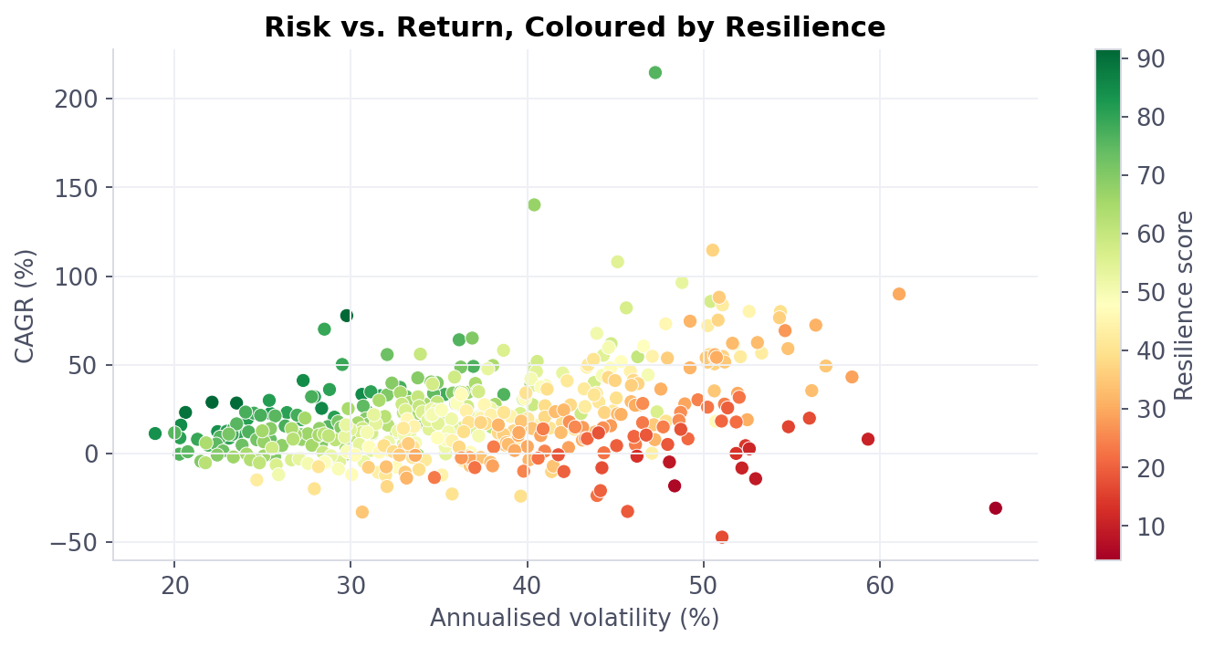
Figure 7 — Every stock plotted by volatility (x) and CAGR (y), coloured by resilience score.

5. The Story in Five Insights
- Global shocks are shallow and short here. All four global events studied cut the market by no more than 12% and recovered within one to six weeks — far milder than the market's own worst drawdown of the period (-21.2%, early 2025), which had no link to any of the four.
- Breadth stayed remarkably wide, even in stress. Even in the worst of the four windows (the 2022 rate-hike sell-off), 28% of stocks still finished positive; in the mildest two, nearly 60% did. This is not a market where a handful of large names mask broad losses.
- Volatility spikes, then reverts. Rolling volatility peaked at 34.6% annualised — during the 2022 rate-hike shock — against a 16.2% five-year average, then fell back toward the mean rather than staying elevated.
- Resilience is a stock-level trait, not luck. The gap between the top and bottom resilience scores (92 vs. 4) is driven by measurable, persistent factors — beta as low as 0.42 for the leaders versus above 1.6 for the laggards — not one lucky quarter.
- Resilience and growth are not a trade-off here. The five most resilient stocks posted CAGRs of 23–78%; strength and stability moved together rather than against each other over this period.

6. Recommendations
- Diversify toward measurable resilience, not just sector labels. Tilt a portion of the portfolio toward high-score, low-beta, low downside-capture names identified by this methodology — telecom, pharma and private banking names dominate the resilient cohort here.
- Treat rolling volatility as an early-warning dashboard signal. A move to roughly double the trailing average (as seen ahead of the 2022 sell-off) has historically marked the start of a stress regime — a natural trigger to review high-beta exposure.
- Size positions against the market's own worst drawdown, not just global-shock scenarios. The largest single fall in this sample (-21.2%) was domestic or company-driven, not tied to any of the four international events — risk limits should be able to survive that too.
- Resist reflexive exits during global shocks specifically. All four events studied recovered within roughly one to six weeks — faster than most investors reposition, and two of the four windows closed higher than they opened.
- Re-score the universe periodically, and watch newer listings closely. Several of the weakest-scoring names are recent or turnaround listings with limited history; re-running the ranking each quarter captures how their risk profile settles over time.

Appendix A — Python Code
The full analysis and chart-generation script (analysis.py) is included as a separate file alongside this report, along with the Power Query (M) equivalent for Excel / Power BI. Key excerpts:

A.1 — Resilience score
pct = lambda s, asc: s.rank(pct=True, ascending=asc)
stats["ResilienceScore"] = 100 * (
pct(stats["MaxDrawdown"], True) + # shallower fall -> higher score
pct(stats["CAGR"], True) + # higher growth -> higher score
pct(stats["DownCapture"], False) + # lower downside -> higher score
pct(stats["Volatility"], False) # lower volatility -> higher score
) / 4

A.2 — Market proxy, drawdown and volatility
market = df.groupby("Date")["Return"].mean().rename("MktRet").to_frame()
market["Index"] = 100 * (1 + market["MktRet"]).cumprod()
market["Peak"] = market["Index"].cummax()
market["Drawdown"] = market["Index"] / market["Peak"] - 1
market["Vol21d"] = market["MktRet"].rolling(21).std() * (252 ** 0.5) * 100

The complete script (analysis.py, ~150 lines) also builds the market index, the per-stock statistics table, the four shock-window comparisons, and all seven charts used in this report — see the attached file for the full listing.

Appendix B — Tools & Software Used
This analysis was produced with the following tools, using the real nifty500_5yr_data.csv dataset (551,643 rows, 500 tickers). Screenshots of the interactive dashboard and Power Query editor are best captured directly from your own machine — the chart outputs from the Python pipeline (Figures 1–7) serve as verified evidence of the analysis tool for this report.
Tool | Role in this analysis
Python 3 — pandas, NumPy | Data cleaning, return calculation, resilience scoring, event-window statistics
Matplotlib | All seven charts (Figures 1–7) in this report
Power Query (M) | Equivalent pipeline for Excel / Power BI, for teams that prefer a no-code refresh
Interactive HTML dashboard | Three-page click-through view (Overview / Stress & Resilience / Stock Explorer) built for live exploration

