Functional Requirement Specification
AFTPS Plagiarism and AI Content Checker

Phase I • Two User Model

Administrator and Instructor Application Roles

Document Control
Item | Details
Document title | Functional Requirement Specification for AFTPS Plagiarism and AI Content Checker Phase I
Version | 1.1
Revision basis | FRS for Plag check Phase I Incomplete
Application users | Administrator and Instructor only
Excluded application actor | Officer Trainee or Officer; report is sent personally to the Instructor outside the application
Deployment | On-premise AFTPS environment accessible through authorised AFNET workstations
Runtime connectivity | No public internet dependency

Revision Summary
Change | Revision applied
User model | Confirmed only two application roles: Administrator and Instructor.
Officer/Trainee flow | Removed application login, upload, dashboard and result access; added official external handoff to Instructor.
Authentication | Removed self-registration concept. Users are pre-provisioned by Administrator or mapped from approved Active Directory groups.
Instructor responsibility | Instructor uploads reports, runs analysis, reviews evidence, compares documents, generates certificate and requests repository storage.
Administrator responsibility | Administrator manages users/configuration/repository, validates save requests and approves or rejects repository ingestion.
Repository workflow | Added explicit Instructor request → Administrator validation → ACTIVE repository sequence.
Functional detail | Completed functional requirements, validation, pipelines, security, audit, offline deployment and acceptance criteria.

Contents
1 Scope
2 Current Scenario
3 System Actors and Use Cases
4 Expected Operational Scenario
5 Role Privileges and Access Control
6 Functional Requirements
7 Document and Analysis Pipeline
8 Repository Management Workflow
9 Data Requirements
10 Non Functional Requirements
11 Validation and Error Handling
12 Audit and Reporting Requirements
13 Phase I Boundaries
14 Acceptance Criteria
15 Traceability Summary
16 Conclusion

1 Scope
The purpose of Phase I is to implement an on-premise plagiarism detection and AI-content indication module for the Air Force Test Pilot School. The application supports debrief reports and other authorised training reports submitted in PDF or DOCX format. It compares reports against the approved local repository, highlights matched content, indicates possible AI-generated or AI-enhanced writing, supports side-by-side comparison and generates an analysis certificate.
Phase I has only two application users: Administrator and Instructor. Officer Trainees and Officers do not log in, upload reports or view results through the application. They send reports personally to the Instructor using the approved organisational communication channel. The Instructor becomes the application user responsible for uploading and processing the report.

1.1 Objectives
- Reduce manual effort required to identify copied or closely paraphrased content.
- Provide explainable percentages and highlighted evidence rather than a single opaque result.
- Maintain a controlled repository of approved historical and newly accepted reports.
- Provide local AI-content indication without depending on public internet APIs.
- Enforce Administrator and Instructor privileges through role-based access control.
- Produce an auditable certificate and decision trail for each analysed report.

1.2 Definitions
Term | Meaning
Administrator | Application user responsible for user management, settings, repository control, approval of save requests, audit and operational management.
Instructor | Application user responsible for uploading reports, running and reviewing analysis, comparing documents, generating certificates and requesting repository storage.
Officer Trainee or Officer | Report author outside the application boundary. Sends the report to the Instructor; has no Phase I account or dashboard.
Master repository | Approved local corpus used for plagiarism comparison.
AI-content indicator | Model score suggesting patterns associated with AI-generated or AI-enhanced text; not proof of misconduct.
Certificate | Generated analysis record containing document identity, scores, evidence summary, versions and authorised reviewer details.

2 Current Scenario
At present, Student Officers submit debrief reports in FTER format after completion of each training phase. Instructors assess the reports manually on technical merit. Manual review makes it difficult to compare every new report against a growing historical collection, identify paraphrased reuse consistently, quantify matched coverage, preserve a reproducible evidence trail and assess possible AI-assisted writing.

2.1 Required Change
The revised system introduces a controlled local analysis workflow. The external report submission to the Instructor remains outside the application. Once the Instructor receives the report, all upload, analysis, evidence review, certificate generation and repository-save request activities occur inside the application. The Administrator retains final control of the master repository.
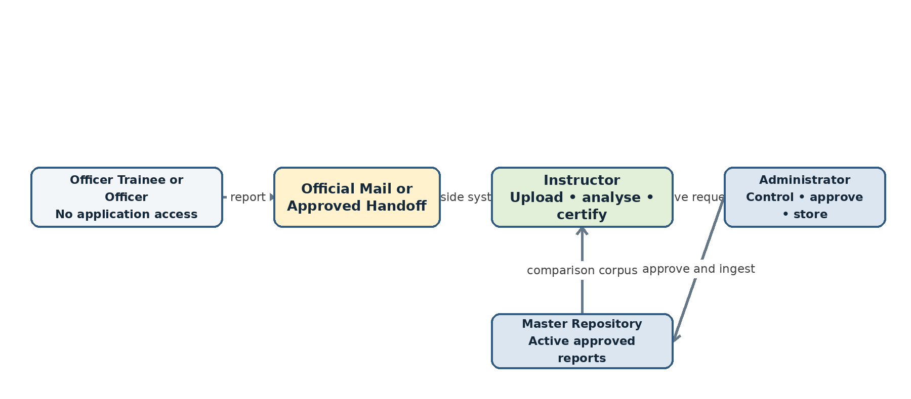
Figure 1 Revised application boundary and two-user context

3 System Actors and Use Cases

3.1 Administrator
- View system dashboard and aggregate usage/score statistics.
- Create, activate, disable or map Instructor and Administrator accounts.
- Manage roles, permitted organisational scope and application settings.
- Import authorised historical reports into the master repository.
- Review Instructor requests to save analysed reports.
- Approve, reject, archive or restore repository records.
- Manage document metadata, course/batch/report-type configuration and retention status.
- Monitor model/index versions, jobs, errors, audit events and backups.
- Delete or purge data only through authorised retention and sanitisation procedures.

3.2 Instructor
- Receive reports from Officer Trainees or Officers outside the application.
- Log in from an authorised AFNET workstation.
- Upload a PDF or DOCX report and enter required metadata.
- Run plagiarism and AI-content analysis and monitor job status.
- View overall plagiarism percentage, exact and semantic components, AI-content indicator and highlighted passages.
- Compare submission and source document content side by side where authorised.
- Generate an analysis certificate.
- Request Administrator approval to save an accepted report in the master repository.
- View previously processed documents and certificate history within assigned scope.

3.3 Officer Trainee or Officer
The Officer Trainee or Officer is not an application user in Phase I. No account, login page, upload function, dashboard, result screen or repository access is provided. The person sends the report personally to the Instructor through the approved official channel. Any feedback or certificate distribution to the author is handled outside the application by the Instructor under organisational procedure.

4 Expected Operational Scenario

4.1 Application Access
The application is deployed on premises and opened from an authorised AFTPS AFNET browser using the approved internal hostname. The final DNS name and certificate are deployment decisions; examples in this document are illustrative and must not be treated as an externally resolvable public URL.

4.2 Login and Account Provisioning
Only Administrator and Instructor identities may log in. Phase I does not provide public or self-service registration. Accounts are created by an Administrator or mapped from approved Active Directory groups. The backend authenticates the user, loads the application role and authorised scope, then opens the corresponding dashboard. Invalid, disabled or unassigned identities are denied and audited.
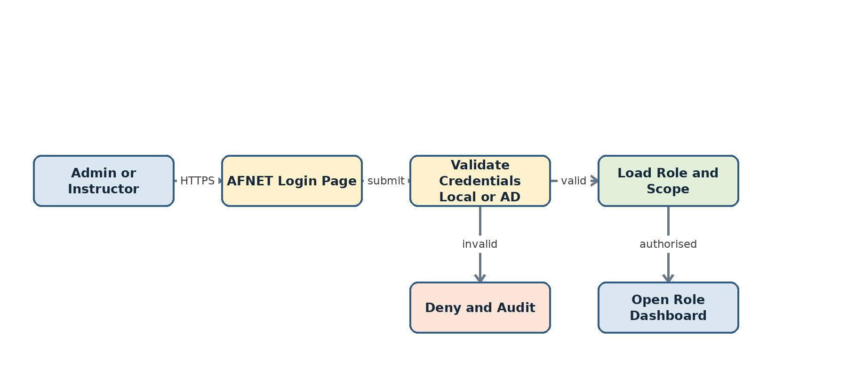
Figure 2 Revised login flow with no self-registration or trainee account

4.3 End to End Scenario
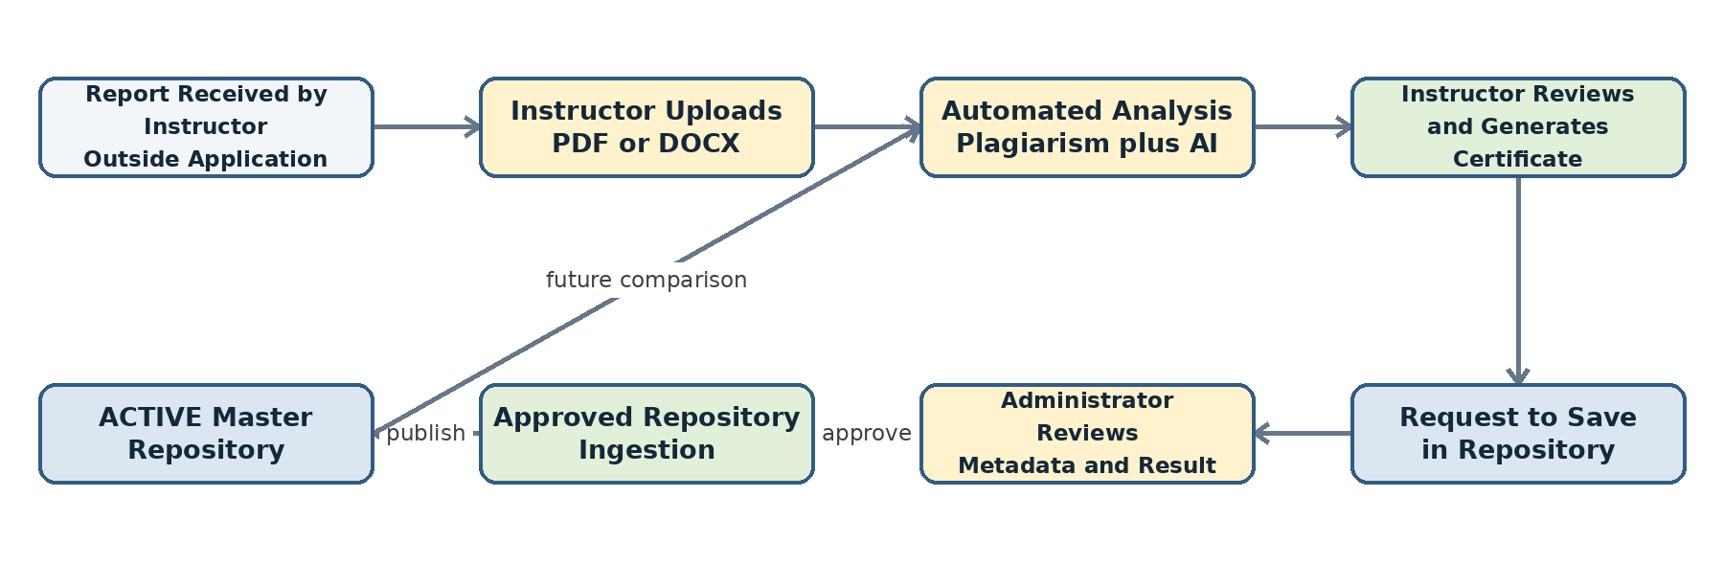
Figure 3 Instructor to Administrator operational workflow
- Officer/Trainee sends the report to the Instructor outside the application.
- Instructor logs in and uploads the report with course, batch, phase, author and report-type metadata.
- System validates, stores and analyses the document.
- Instructor reviews percentages and highlighted evidence, optionally compares source passages and generates a certificate.
- If the report is accepted for future comparison, the Instructor submits a Request to Save in Repository.
- Administrator validates the exact analysed version, metadata, duplicate status and policy compliance.
- On approval, the system generates fingerprints/embeddings, publishes a versioned index and marks the report ACTIVE.
- On rejection, the report is not added and the reason is recorded for the Instructor.

5 Role Privileges and Access Control
Capability | Instructor | Administrator
Login to application | Yes | Yes
Upload report for analysis | Yes | Optional support or bulk import
View analysis and highlighted evidence | Assigned scope | Authorised system scope
Compare two documents | Yes, within scope | Yes, when operationally required
Generate analysis certificate | Yes | View or regenerate with permission
Request save in master repository | Yes | No request needed for authorised historical import
Approve or reject repository save | No | Yes
Manage repository records | View approved scope | Create, archive, restore and authorised purge
Manage users and roles | No | Yes
Configure model/threshold/system settings | No | Yes
View audit logs | Own/limited events | Yes
Run backup/index maintenance | No | Yes

5.1 Authorisation Rules
- Every API request is checked by the backend; hiding a menu item is not security.
- Instructor access is limited to assigned course, batch or organisational scope.
- Instructor cannot directly insert a report into the master repository.
- Administrator can ingest only the exact document version referenced by the save request.
- The same identity may hold both roles only when policy permits; actions remain separately audited.
- A disabled account or revoked directory group loses access at the next request or session refresh.

6 Functional Requirements

6.1 Authentication and Session Requirements
ID | Requirement
FR-AUTH-01 | The system shall authenticate only pre-provisioned Administrator and Instructor identities.
FR-AUTH-02 | The system shall support a local development provider and an approved Active Directory/LDAP provider through one authentication interface.
FR-AUTH-03 | The system shall determine role and authorised scope after authentication.
FR-AUTH-04 | The system shall deny and audit invalid, disabled, unassigned or unauthorised login attempts.
FR-AUTH-05 | The system shall enforce secure session expiry and logout.

6.2 Instructor Requirements
ID | Requirement
FR-INS-01 | The Instructor shall upload PDF and DOCX reports.
FR-INS-02 | The Instructor shall enter or confirm author, course, batch, phase, year and report type.
FR-INS-03 | The Instructor shall start analysis and view QUEUED, PROCESSING, COMPLETED or FAILED status.
FR-INS-04 | The Instructor shall view unique plagiarism coverage and separate exact and semantic values.
FR-INS-05 | The Instructor shall view an AI-content indicator separately from plagiarism.
FR-INS-06 | The Instructor shall view highlighted matched passages and authorised source references.
FR-INS-07 | The Instructor shall compare submission and source content side by side.
FR-INS-08 | The Instructor shall generate and download an analysis certificate.
FR-INS-09 | The Instructor shall submit a request to store an accepted report in the master repository.
FR-INS-10 | The Instructor shall view the status and Administrator reason for each save request.
FR-INS-11 | The Instructor shall access previous analysed reports and certificates within assigned scope.

6.3 Administrator Requirements
ID | Requirement
FR-ADM-01 | The Administrator shall view aggregate document, user, plagiarism, AI-content and job statistics.
FR-ADM-02 | The Administrator shall create, map, activate and disable application users.
FR-ADM-03 | The Administrator shall manage roles, scopes, courses, batches and report types.
FR-ADM-04 | The Administrator shall review Instructor requests for repository storage.
FR-ADM-05 | The Administrator shall approve or reject a request with an auditable reason.
FR-ADM-06 | The Administrator shall import authorised historical reports in controlled batches.
FR-ADM-07 | The Administrator shall archive and restore repository documents.
FR-ADM-08 | The Administrator shall rebuild or activate versioned exact and semantic indexes.
FR-ADM-09 | The Administrator shall view audit logs, failed jobs, model/index versions and backup status.
FR-ADM-10 | The Administrator shall manage approved system configuration without changing historical results.

7 Document and Analysis Pipeline
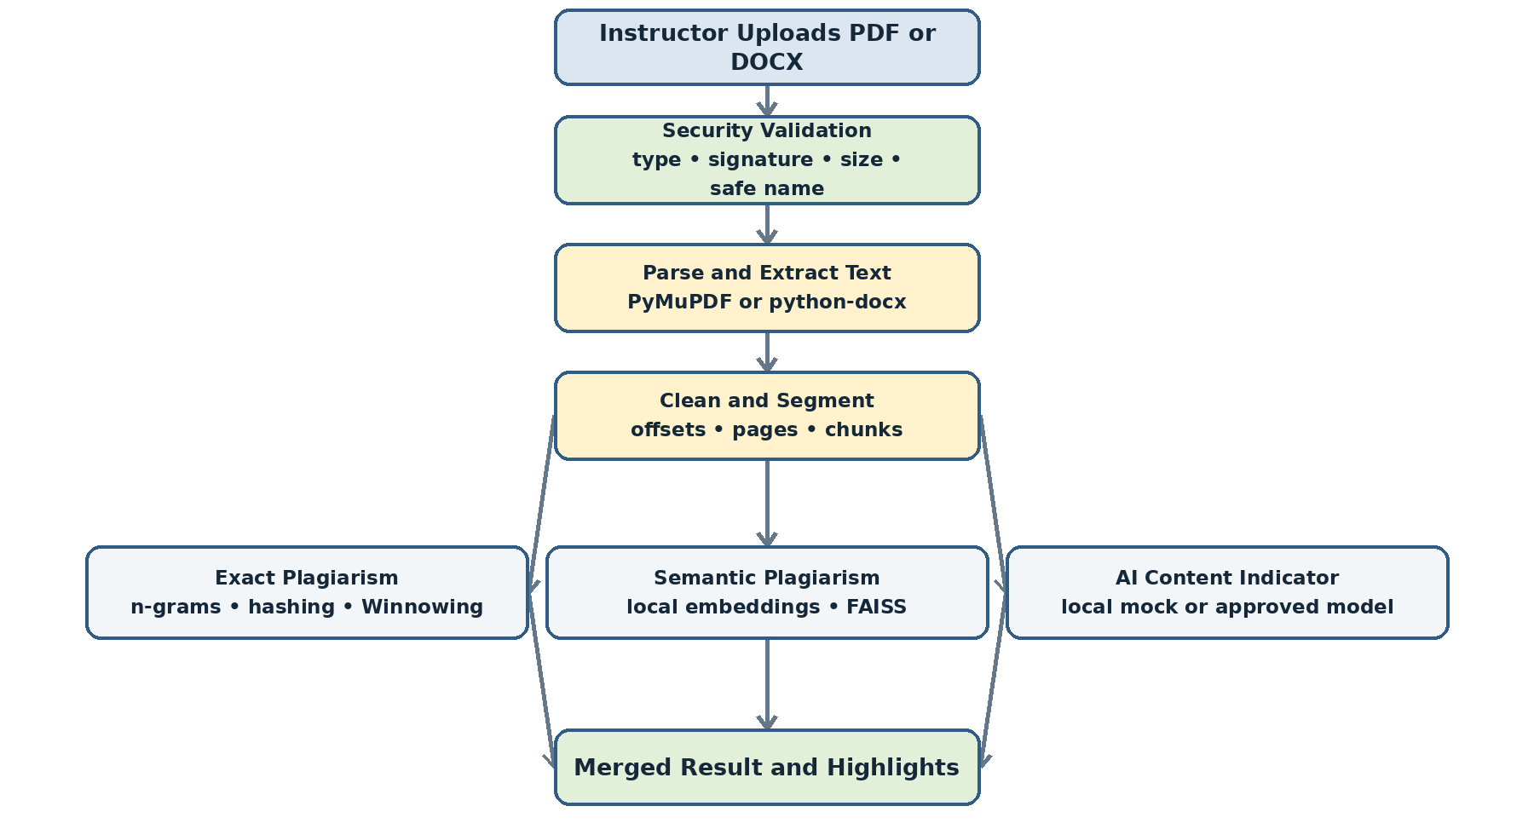
Figure 4 Complete local document and analysis pipeline

7.1 Upload Security
- Validate extension, MIME type and file signature; do not trust filename alone.
- Allow only configured PDF and DOCX limits for Phase I.
- Sanitise display filename and generate a server-side storage identifier.
- Calculate SHA-256 for integrity and byte-identical duplicate detection.
- Reject encrypted, malformed or unsupported files unless an approved workflow exists.
- Store the immutable original and parse a separate controlled working copy.

7.2 Extraction and NLP Preparation
PyMuPDF extracts text, pages and word/block coordinates from text-based PDFs. python-docx extracts paragraphs and tables from Word files. The system normalises Unicode and whitespace, detects repeated headers/footers and page numbers, repairs line-wrap hyphenation, and creates sentence, paragraph and semantic-chunk views. Every processed unit retains original offsets and PDF coordinates for highlighting.

7.3 Plagiarism Analysis
- Exact detection uses n-grams, hashing and Winnowing fingerprints for copied or lightly edited passages.
- Semantic detection uses an approved local BGE/E5-family embedding model and FAISS to retrieve paraphrased candidates.
- Search filters use course, batch, year, report type, repository status and authorised scope.
- Both engines return source-linked offsets; overlapping matches are merged before calculating final unique coverage.
- Exact and semantic percentages are not simply added because one passage may be detected by both engines.

7.4 AI Content Indication
Phase I shall call a stable local detector interface. During development, a local mock provider may return deterministic test values and must label them as MOCK. The future approved model may combine a local transformer classifier and stylometric features. No public ChatGPT or Hugging Face API is required at runtime. The output shall be labelled AI Likelihood Model Score and shall not be described as proof that a person used AI.

7.5 Result and Highlighting
The result shall display final unique plagiarism coverage, exact coverage, semantic coverage, overlap, excluded content, AI-content indicator, processing/model/index versions and matched sources. PDF.js shall use stored page coordinates to highlight the submission. A side panel shall display authorised source document, page/paragraph, match type, similarity and compared text.

8 Repository Management Workflow
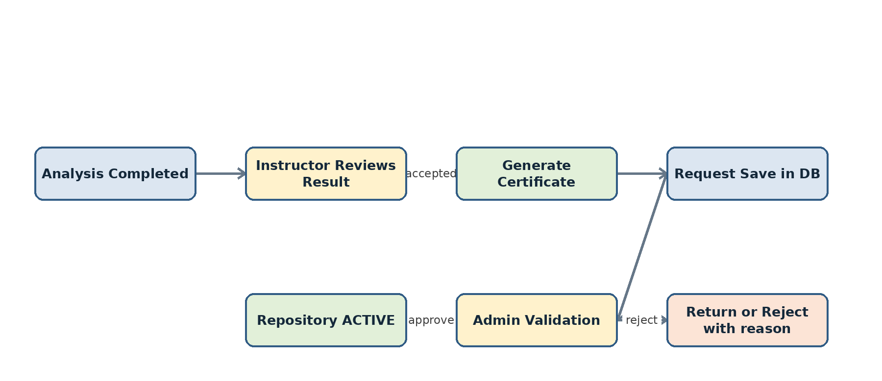
Figure 5 Instructor request and Administrator repository approval

8.1 Save Request
The Instructor save request references one immutable document version, one completed analysis result and the generated certificate. Editing or replacing the file creates a new version and invalidates the earlier request for the changed content.

8.2 Administrator Validation
- Confirm file hash matches the analysed version.
- Confirm mandatory metadata and Instructor identity.
- Check duplicate or conflicting repository records.
- Confirm the analysis completed with valid parser, model and index versions.
- Assign repository classification, scope and retention attributes.
- Approve or reject with a reason.

8.3 Repository Ingestion
On approval, the system stages extracted text, chunks, Winnowing fingerprints, embeddings and metadata. A new versioned FAISS index is built or updated and validated. The report becomes ACTIVE only after successful publication. A failed ingestion leaves the previous index active and records an error; it does not create a partially searchable report.

8.4 Deletion and Archival
Routine removal shall use ARCHIVED status rather than immediate physical deletion. Authorised purge must remove originals, derived text, fingerprints, vectors, certificates and backups according to retention and sanitisation policy. Every action is audited.

9 Data Requirements
Data category | Storage | Content
Identity and access | PostgreSQL | Users, directory mappings, roles, permissions and authorised scope.
Document metadata | PostgreSQL | Submission/version IDs, names, hashes, course, batch, author, year, type and status.
Original reports | Controlled filesystem | Immutable PDF/DOCX addressed by generated storage ID.
Extracted content | PostgreSQL or controlled derived store | Pages, paragraphs, chunks, offsets and coordinate mappings.
Exact index data | PostgreSQL/files | Winnowing fingerprints and source mappings.
Semantic index | FAISS plus PostgreSQL metadata | Vectors in FAISS; vector-to-chunk mapping in PostgreSQL.
Analysis results | PostgreSQL | Summary scores, matches, exclusions, versions and job state.
Certificates | Controlled filesystem plus metadata | Generated certificate file, hash, result link and issuing Instructor.
Audit and settings | PostgreSQL/log store | Events, thresholds, active model/index versions and operational configuration.

9.1 Core Status Values
Object | Representative states
Analysis job | QUEUED, PROCESSING, COMPLETED, FAILED, RETRY_PENDING, CANCELLED
Save request | DRAFT, SUBMITTED, APPROVED, REJECTED, INGESTING, COMPLETED, FAILED
Repository document | STAGED, ACTIVE, ARCHIVED, PURGE_PENDING
User account | ACTIVE, DISABLED, LOCKED or directory-controlled state

10 Non Functional Requirements
Category | Requirement
Deployment | The system shall operate on approved local infrastructure and authorised AFNET workstations.
Connectivity | The runtime shall not require public internet access or external cloud APIs/databases.
Security | Only HTTPS shall be exposed to clients; backend, database and model services remain private.
Database | PostgreSQL shall run locally and be accessed through parameterised raw SQL using psycopg; no ORM is required.
Performance | The UI shall return a job identifier promptly; long analysis shall run in a worker and expose progress.
Scalability | Indexes and jobs shall support growth in repository documents without reinstalling client systems.
Reliability | Worker retries and index publication shall be idempotent and shall not create duplicate records.
Recoverability | Backups shall include PostgreSQL, repository files, active index, model/config manifests and certificates.
Auditability | Security, analysis, certificate and repository actions shall record actor, target, time and outcome.
Maintainability | Authentication and AI detector providers shall be replaceable through stable interfaces.
Usability | Screens shall clearly separate Instructor tasks from Administrator controls.
Accessibility | Text labels, keyboard access, sufficient contrast and non-colour status indicators shall be provided.

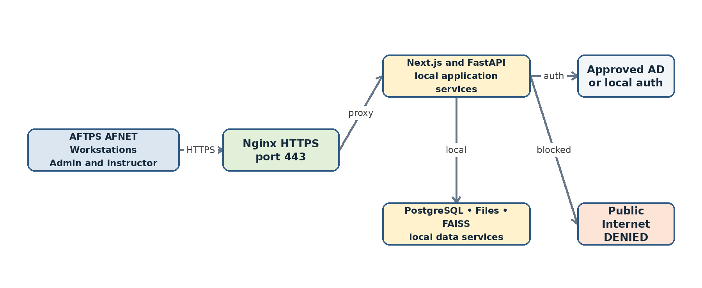
Figure 9 On-premise deployment and network boundary

11 Validation and Error Handling
Condition | Required behaviour
Unsupported or disguised file | Reject before parsing; show supported formats; audit the event.
Oversized or malformed file | Reject or fail safely within configured limits; clean temporary files.
Duplicate hash | Notify Instructor and route according to duplicate policy; do not silently create another repository item.
No extractable text | Mark extraction failure or request approved OCR workflow; do not return misleading zero plagiarism.
Analysis model/index unavailable | Fail the job with a safe message; preserve upload and allow authorised retry.
Unauthorised source evidence | Hide restricted identity/text while retaining internal match accounting.
Save request for altered version | Reject because Instructor request does not match the analysed immutable hash.
Index publication failure | Keep previous active index; mark ingestion FAILED and notify Administrator.
Session expired | Require login again without losing committed job or save-request state.

12 Audit and Reporting Requirements

12.1 Audit Events
- LOGIN_SUCCESS, LOGIN_FAILURE and LOGOUT
- USER_CREATE, USER_DISABLE, ROLE_CHANGE and SCOPE_CHANGE
- DOCUMENT_UPLOAD, DOCUMENT_VIEW and ANALYSIS_RUN
- ANALYSIS_COMPLETE, ANALYSIS_FAILED and RESULT_VIEW
- CERTIFICATE_GENERATE and CERTIFICATE_DOWNLOAD
- REPOSITORY_SAVE_REQUEST, APPROVE, REJECT, INGEST and ARCHIVE
- MODEL_ACTIVATE, INDEX_REBUILD and CONFIG_CHANGE
- BACKUP_START, BACKUP_COMPLETE and RESTORE_TEST

12.2 Certificate Content
- Document title, controlled identifier and SHA-256
- Author/course/batch/phase/report-type metadata
- Analysis date and issuing Instructor
- Final plagiarism coverage with exact, semantic and overlap values
- AI-content indicator with model/provider label and limitation
- Summary of matched sources and excluded content
- Parser, model and index versions
- Certificate identifier, hash and verification status

13 Phase I Boundaries

13.1 In Scope
- Administrator and Instructor accounts only
- Text-based PDF and DOCX upload
- Exact and semantic repository comparison
- Local AI-content indication or clearly labelled local mock provider
- Highlighted evidence and side-by-side comparison
- Certificate generation
- Instructor save request and Administrator repository approval
- Historical repository import, archival, audit and backup

13.2 Out of Scope Unless Separately Approved
- Public internet access or public-facing registration
- Public ChatGPT, Hugging Face, cloud database or other external runtime API
- Automatic disciplinary decision from plagiarism or AI score
- Image-only scanned PDF OCR
- Email sending from the application
- Mobile application
- Direct trainee access to repository sources or certificates

14 Acceptance Criteria
ID | Acceptance criterion
AC-01 | Only Administrator and Instructor can authenticate and receive role-correct dashboards.
AC-02 | No Officer Trainee/Officer application role, page, upload or result access exists.
AC-03 | Instructor can upload valid PDF/DOCX and invalid files are safely rejected.
AC-04 | Completed analysis displays unique plagiarism, exact, semantic and AI indicators separately.
AC-05 | Known copied passages highlight the correct submission location and authorised source.
AC-06 | Instructor can compare content and generate a certificate linked to the immutable result.
AC-07 | Instructor can request repository storage but cannot activate the repository record.
AC-08 | Administrator can approve/reject, and only approval can make a record ACTIVE.
AC-09 | Historical bulk import uses the same validation, integrity and indexing controls.
AC-10 | Application operates with public internet blocked and makes no external model/font/API call.
AC-11 | Direct API tests enforce role, scope, state and object-level permissions.
AC-12 | Backup restore reproduces database, files and active index consistency.
AC-13 | Every login, analysis, certificate and repository decision creates the required audit event.

15 Traceability Summary
Business need | FRS coverage
Two application users only | Sections 3, 4, 5, 6 and AC-01/AC-02
No trainee interaction | Sections 1, 3.3, 4.3, 10.3 and 14
Instructor uploads and analyses | FR-INS-01 through FR-INS-08
Instructor requests database storage | FR-INS-09/10 and Section 8.1
Administrator controls repository | FR-ADM-04 through FR-ADM-08 and Sections 8.2–8.4
Plagiarism percentage and highlights | Sections 7.3 and 7.5; AC-04/AC-05
AI-content detection without internet | Sections 7.4, 11 and AC-10
On-premise AFNET access | Sections 4.1 and 11; Figure 9
Active Directory and RBAC | Sections 4.2, 5 and 6.1
Certificate generation | FR-INS-08 and Section 13.2

16 Conclusion
The Phase I design contains only two application users: Administrator and Instructor. The Officer Trainee or Officer remains outside the application and sends the report personally to the Instructor. The Instructor owns the application-side upload, analysis, evidence review, comparison, certificate and save-request workflow. The Administrator owns identity management, configuration, repository approval, historical import, audit and operational control. This separation keeps the user experience simple while preserving accountability and preventing analysed reports from entering the master comparison repository without administrative validation.

