**A Final Project Report On**

**TREK’S MATE**



Submitted in the Partial Fulfillment of the

Requirements for the Degree of Bachelor of Computer Engineering Awarded by Pokhara University

**Submitted By:**

**Muna Sunar (20070071)**

**Nischal Malla (20070072)**

**Surakshya Adhikari (20070417)**

**Supervisor:**

**Er. Bikash Bhattarai**

**School of Engineering**

**Faculty of Science and Technology**

**POKHARA UNIVERSITY**

**October, 2023**

**A Final Project Report On**

**TREK’S MATE**



Submitted in the Partial Fulfillment of the

Requirements for the Degree of Bachelor of Computer Engineering Awarded by Pokhara University

**Submitted By:**

**Muna Sunar (20070071)**

**Nischal Malla (20070072)**

**Surakshya Adhikari (20070417)**

**Supervisor:**

**Er. Bikash Bhattarai**

**School of Engineering**

**Faculty of Science and Technology**

**POKHARA UNIVERSITY**

**October, 2023**

**COPYRIGHT**

The author has granted authorization to the Pokhara University Central Library and Library of School of Engineering to grant unrestricted access to this report for inspection. Furthermore, the author has agreed to the potential for extensive reproduction of this report for educational purposes by either the supervisors or, in their absence, by the program coordinator wherein the project was done. It is understood that proper acknowledgment will be accorded to both the author of the report and the School of Engineering, Pokhara University in any utilization of the report's contents. Unauthorized copying, publication, or any other form of exploitation of this report for financial gain without explicit consent from the School of Engineering, Pokhara University and the author is strictly prohibited. Requests seeking permission to replicate or employ any segment of the report's content should be directed to:

Program Coordinator

School of Engineering

Pokhara University

**STUDENT’S DECLARATION**

We hereby declare that this project work entitled **TREK’S MATE** is based on our original work. All concepts, data, code, and any other work from external sources have been properly cited and referenced in accordance with the guidelines provided by School of Engineering, Pokhara University.

We owe all the liabilities relating to the authenticity and originality of this project work and project report.

1. Muna Sunar (20070071) ……………………………...
2. Nischal Malla (20070072) ……………………………...
3. Surakshya Adhikari (20070417) ……………………………...

Date:2023-10-09

**SUPERVISOR'S RECOMMENDATION**

This is to certify that this project report entitled **TREK’S MATE** prepared and submitted by the below listed team of students in partial fulfillment of the requirements of the degree of Bachelor of Computer Engineering / Bachelor of Software Engineering awarded by Pokhara University, has been prepared and completed under my supervision.

I hereby recommend the same for acceptance by the School of Engineering, Pokhara University.

1. Muna Sunar (20070071)
2. Nischal Malla (20070072)
3. Surakshya Adhikari (20070417)

…………………………..

**Er. Bikash Bhattarai**

Assistant Professor

School of Engineering

Pokhara University

Date:2023-10-09

**CERTIFICATE**



**School of Engineering**

**POKHARA UNIVERSITY**

The undersigned certified that they have evaluated this project report entitled **TREK’S MATE** submitted by **Muna Sunar, Nischal Malla, Surakshya Adhikari** and their oral presentation for partial fulfillment of the degree of Bachelor of Computer Engineering and recommended to the School of Engineering, Pokhara University for acceptance of this project work/report.

**Project Supervisor: External Examiner:**

**-------------------------- --------------------------**

**Er. Bikash Bhattarai Er. Sushant Paudel**

School of Engineering, PU School of Engineering, PU

Bijaypur, Pokhara Bijaypur, Pokhara

**ACKNOWLEDGEMENT**

I want to thank everyone who helped me finish this report. I want to express my gratitude to our project supervisor **Er. Bikash Bhattarai**, who helped me plan my project by providing stimulating recommendations and encouragement.

In addition, I'd want to express my gratitude to the School of Engineering for allowing us to use all of the necessary equipment to complete the project. Last but not least, I'd like to express my gratitude to my friends for their unwavering support in helping me achieve my goal. Thanks to their comments and recommendations, I have to appreciate the direction provided by other supervisors as well as the panels, particularly in my project.

# 

# ABSTRACT

# Tourism has grown considerable in Nepal in recent years. To ensure a hassle-free, safe and effective travel experience we introduce you to our app Trek’s Mate. In this era of internet, E-tourism is essential for providing tourists with service by improving travel experiences by using user friendly environment which enhances both International and Domestic tourism. Our project ‘Trek’s Mate’ is a web-based application which will recommend the location considering the preference of the tourists. This app offers the features such as General information about the trek (best time, equipment, weather forecast etc.), Route planner that customizes the itinerary based on user’s preferences and time, Detailed description and map of each day’s hike (distance, elevation, difficulty, scenery, etc.), Pack list and tips for water treatment and GPS navigation, Offline navigation with map and GPS and location of lodges, shops, restaurants, etc. This will enable us to develop a systemized tourism framework that will aid travelers in learning about the destinations they want to visit.

# Keywords: *Tourism, E-tourism, GPS, weather forecast, Web Application, Server*.

\

# TABLE OF CONTENTS

ACKNOWLEDGEMENT 5

ABSTRACT 6

TABLE OF CONTENTS 7

List of Figures 9

List of Abbreviations…………………………………………………………….. …10

CHAPTER 1 11

INTRODUCTION 11

1.1 BACKGROUND 11

1.2 PROBLEM STATEMENT 12

1.3 OBJECTIVE 12

1.4 SCOPE AND APPLICATION 12

1.5 REPORT ORGANIZATION 12

CHAPTER 2 13

BACKGROUND STUDY AND LITERATURE REVIEW 13

2.1 BACKGROUND STUDY 13

2.2 LITERATURE REVIEW… 14

CHAPTER 3 15

SYSTEM ANALYSIS AND DESIGN 15

3.1 DEVELOPMENAL METHODOLOGY 15

Software Development Life Cycle (SDLC) 15

Scrum Model…………………………………………………………… …16

3.2 REQUIREMENT ANALYSIS 18

3.2.1 Functional Requirements 18

3.2.2 Non-Functional Requirements 18

3.3 FEASAIBILITY ANALYSIS 19

3.1.3 Technical Feasibility 19

3.1.4 Operational Feasibility 20

3.1.5 Economic Feasibility 20

3.1.6 Schedule Feasibility (Gantt Chart) 21

3.4 SYSTEM DESIGN 22

System Diagram/Architecture 24

CHAPTER 4 27

IMPLEMENTATION AND TESTING 27

4.1 IMPLEMENTATION 27

4.1.1 Tools Used 27

4.1.2 Testing 28

4.1.3 Result Analysis 28

CHAPTER 5 29

CONCLUSION AND FUTURE RECOMMENDATION 29

5.1 CONCLUSION 29

5.2 LIMITATIONS AND RECOMMENDATION 29

REFERENCES 31

APPENDICES…………………………………………………………………… 32

# 

# 

# LIST OF FIGURES

Figure 1 Agile Development Model 15

Figure 2 Scrum Model 16

Figure 3 Gantt Chart 21

Figure 4 System Design Diagram 22

Figure 5 Use Case Diagram 23

Figure 6 Data Flow Diagram 24

Figure 7 System Sequence Diagram 25

Figure 8 ER Diagram 26

**LIST OF ABBREVIATIONS**

1. OS: Operating System
2. HTML: Hypertext Markup Language
3. CSS: Cascading Style Sheet
4. PHP: Hypertext Preprocessor
5. JSX: JavaScript XML
6. XML: Extensible Markup Language
7. IDE: Integrated Development Environment
8. TMS: Trekking Management System

# CHAPTER 1

# INTRODUCTION

## 1.1 Background

Over the years, tourism has continued to gain massive interest at a global scale. Tourism industry boosts the economy of the country, develops infrastructures and shows the diversified culture and natural heritages to the world. Every year roughly a million tourist visit Nepal for trekking and adventure purposes. Nepal is an ideal destination for trekking, attracting thousands of hikers every year. Trekking offers a variety of scenery, culture, and challenges, as it passes through different climatic zones, ethnic villages, and high-altitude passes.

However, trekking is not an easy task. It requires careful planning, preparation, and acclimatization. Trekker’s need to consider the best time to go, the equipment to bring, the altitude sickness prevention, the accommodation options, and the drinking water availability. They also need to choose their itinerary based on their preferences, fitness level, and available time.

According to the data collected from Nepal Tourism Board (NTB) approximately 500,000 foreigner visitors visited Nepal in last 10 months. Compared to the amount in 2020 and 2021 when there was pandemic of The Corona Virus, this is a significant increase. The tourism industry was severely impacted by the COVID-19 pandemic. A little over 230,000 tourists visited the country in 2020, down dramatically by an astounding 81 percent from over 1.9million visitors in 2019 shortly before the epidemic. Similar to 2020, the number of international tourists arriving in 2021 decreased further by 34.4 percent to little over 150,000. [1]

The main purpose of our project ‘Trek’s Mate’ is to help trekkers plan and enjoy their trek on the Trekking Circuit. This app is a comprehensive and user-friendly guide that provides all the information and features that trekkers need to make their trek a memorable experience. This application tries to narrow down the gap between trekkers and their destination by implementing of an intelligent platform that will assist tourists in gaining access to information on trekking locations in Nepal.

## 1.2 Problem Statement

One of the major contributors to the nation’s gross domestic product is the tourism sector. In 2021, the tourism industry contributed about 6.7 percent to Nepal’s GDP, while its total impact was US$2.2 billion.[2] One of the main reason the tourism sector has not grown to its full potential despite the resource Nepal possess is due to the lack of visibility of its tourist destinations. Therefore, the problem of tourism sites obscurity must be addressed in order to keep the flow of tourist and generate more revenue form the industry.

Our project ‘Trek’s Mate’ analyses the psychology of tourists based on their preferred destination. In addition, the project would feature a database that would include both well- known locations and other hidden gem destinations. By advising trekkers to visit specific locations based on their interest and taking reviews of trekker’s, we hope to systematize the country’s tourism industry.

## 1.3 Objective

1. To develop a web application that provides trekkers with reliable and comprehensive information about the trek,
2. To enhance trekker’s experience and satisfaction by making the app user-friendly and updated.

## 1.4 Scope and Application

* + - 1. Trek’s Mate aims to be a one-stop solution for trekker’s who want to explore the most popular and hidden trekking route in Nepal,

2. Trek’s Mate plans to expand to include other cultural and tourism destination of Nepal in the near future.

## 1.5 Report Organization

Trek’s Mate system include following parts:

* Introduction of Trek’s Mate system
* Abstract of Trek’s Mate system
* Scope and limitation of Trek’s Mate system
* Entity Relationship (ER) Diagram of Trek’s Mate

# CHAPTER 2

# BACKGROUND STUDY AND LITERATURE REVIEW

## 2.1 BACKGROUND STUDY

Nepal is well known for its natural beauty, mighty Himalayas, diverse culture and cheerful face of people. These qualities made Nepal a unique place giving high potentialities for the growth of tourism industry. Tourism is not new phenomena, however, making tourism a dynamic sector of economy and accepting it as a vehicle of poverty reduction is certainly relatively new and timely thinking. Nature defined as spectacular Himalayas, the youngest mountain chain on earth, forested hills, fast flowing rivers arising from the Himalayas, broad green valleys, deep gorges an array of flora and fauna, its rich cultural heritage and traditions, art and architecture has made Nepal one of the foremost tourist destinations in the world.

Tourism is the largest industry in Nepal the largest source of foreign exchange and revenue. Nepal is popular for its own beauty consisting of Himalayas, more than 700 species of birds, jumping rivers, wild forest, calm and quite lakes, healthy and peaceful climate and lots of friendly smiles. Nepal has become the center of attraction as a tourist destination due to its natural beauty and world-famous mountain range. Nepal is a hotspot destination for mountaineers, rock climbers and people seeking adventures. It has spectacular Himalayas with the youngest mountain chain on earth, forested hills, broad green valleys, greater range of flora and fauna and its rich cultural heritage and its cold weather has been major source of attraction which has led to an increasing number of tourists from all around the world.

A trekking app in Nepal would address the growing need for accessible and up-to-date information in the country's diverse and often challenging trekking terrain. Such an app could provide trekkers with vital information on trial routes, weather conditions, altitude sickness precautions, emergency contacts, and cultural insights. Additionally, it would promote responsible trekking practices, including Leave No Trace principles, thus helping conserve Nepal's pristine natural beauty. Moreover, with the increasing popularity of trekking in Nepal, a dedicated app could enhance safety by enabling real-time tracking and SOS features, ensuring that trekkers can navigate safely through the breathtaking landscapes while respecting local customs and the environment.

## 2.2 LITERATURE REVIEW

Some earlier studies in our topic that are comparable to our project includes:

**2.1.1 Destination Information Management System for Tourists**

The system was created with travelers in mind, taking Nigeria’s tourism industry into account. This was done to enable intelligent interaction between tourists and residents who share a common interest subject in a virtual community. The system seeks to close the interaction gap that exists between a visitor and local at a given location. The system had the benefits of being interactive, user-friendly, secure and compatible with different web servers but it lacked intelligence in delivering information to tourists, increasing their anxiety while trying to find the information on the system.[3]

**2.1.2 Social Media Based Recommendation System**

Yu et al. (2016) developed a prototype based on location based on social networks. It allows the user to share their location and reviews which can be used for recommending travel packages. This system uses the collaborative filter to suggest a destination to the tourist. It collects information from Location based on social networks (LBSNs). Then evaluate it and suggest a preferred destination to the tourist. It first collects all points of interest considering user preference and then ranks them. Then based on this result, it suggests a destination to the user. This system however had a serious drawback that it was only applicable to social networks.

**2.1.3 The Application of Intelligent Tourism Mobile Client Based on Ontology**

The use of ontology theory to the study of clients for intelligent mobile tourist applications was suggested in this paper. By structuring the information provided to tourists and utilizing an ontology, ambiguity in the information is eliminated. The utilization of an organic combination of the key factors closely related to tourism and their penetration into every part of tourism, which results in an effective, intelligent, and efficient tourism information system, is the basis for the research work's strength. But because it's mobile-based and only accessible to those with mobile devices, that's where its problem lies. [4]

# CHAPTER 3

# SYSTEM ANALYSIS AND DESIGN

## 3.1 DEVELOPMENTAL METHODOLOGY

### Software Development Life Cycle (SDLC)

We are employing agile approach as the software development methodology. A software development methodology based on iterative development is referred to as an "agile process model.". Agile project management techniques divide work into smaller iterations or pieces without directly including long-term planning.[5] In the Agile process model, each iteration is viewed as a brief time "frame" that typically lasts one to four weeks. A team goes through the entire software development life cycle at each iteration, including planning, requirements analysis, design, coding, and testing, before showing the client a functional end result. The phases in Agile software development process are given below**:**

**Agile Development Model


**

**Figure 1 Agile Development Model**

Scrum Model is used in this project as Agile Development Process.

**Scrum Model**

****Scrum is the type of Agile framework. It is a framework within which people can address complex adaptive problem while productivity and creativity of delivering product is at highest possible values. Scrum uses Iterative process.

**Figure 2 Scrum Model**

**Product Backlog:**

It is the master list of work that needs to get done maintained by the product owner or product manager. Items can be added to the backlog at any time. The product backlog is constantly revisited, re-prioritized and maintained by the Product Owner.

**Sprint Backlog:**

It is the list of items, user stories, or bug fixes, selected by the development team for implementation in the current sprint cycle. Before each sprint, in the sprint planning meeting, the team chooses which items it

will work on for the sprint from the product backlog.

**Scrum Meetings:**

These are short (typically 15 minutes) meetings held daily by the Scrum team. A team leader, called a Scrum master, leads the meeting and assesses the responses from each person. The Scrum meeting helps the team to uncover potential problems as early as possible. Also, these daily meetings lead to “knowledge socialization” and thereby promote a self-organizing team structure.

## Implementation of Scrum Model

Agile Development Model is the most efficient Software Development Model for repeated iteration of components throughout the lifetime of project.

**Scrum Meeting**

Scrum meeting was held every week via Zoom for 30 to 40 min where the development of components and additional functionality was discussed. The Scrum meeting was initiated by project head also known as Scrum Master and participated by Scrum Development Team. A milestone was set every week and the progress was recorded.

**Product Backlog**

Product Manager kept all the information about the list of work that needs to get done. The product backlog is constantly revisited and maintained by the Product Manager. Developed components were re-prioritized in order such that the high priority items were developed at first.

**Sprint Backlog:**

During the Sprint Planning meeting, the Development Team, selects a set of backlog items (user stories, tasks, or other work items) from the Product Backlog that they can complete during the Sprint. The selected items were developed by development team one component at a time to meet weekly goals.

## 3.2 REQUIREMENT ANALYSIS

The requirement analysis for this project is broken down into functional and non-functional requirements and each is discussed below.

### 3.2.1 Functional Requirements

The system's or application's functional requirements specify what it will perform, particularly in the context of an external contact (with a user). The system we are developing stores the information that the user provides and recommends the destination according to the reviews provided by other users.

The functional requirements of the system are shown below:

• The system shall store the user's brief information (including tags and location- specific data) in an appropriate format.

• User shall be able to create a user account and login through the registration process.

• User shall be able to get detailed information about recommended places.

• The user will have the option to review and rate the locations.

### 3.2.2 Non-Functional Requirements

Non-functional requirements focus on the standards that the software is supposed to meet. Reliability, Security, and Compatibility etc. are examples of non-functional requirements. It may be closely related to user satisfaction as well.

The non-functional requirements of the system are shown below:

* To ensure user comfort with the interface, the system must be simple to use and user-friendly with the least amount of design.
* This system shall be highly portable and interactive which can be used from different web browsers.
* All operating systems that offer web browsing must support this system.
* The data may only be changed by the authorized party.
* The system must be resistant to unauthorized access.

## 3.3 FEASAIBILITY ANALYSIS

### 3.1.3 Technical Feasibility

For this project, we propose to use the following web development tools and frameworks:

- **ReactJS:** A JavaScript library for building user interfaces that are fast, responsive, and dynamic. React is widely used and supported by a large community of developers. React also allows us to create reusable components that can simplify the development process and reduce code duplication.

-**Bootstrap**: A CSS framework for designing responsive and mobile-friendly web pages. Bootstrap provides a collection of ready-made components, such as buttons, forms, navigation bars, and grids, that can help us create a consistent and attractive user interface for the web app.

**-Node JS**

Node JS is a cross platform, open-source server environment that can run on Windows, Linux and other operating system. Node JS is a back-end JavaScript engine and executes JavaScript code outside the web browser.

# -Mongoose Database: Mongoose is an Object Data Modelling (ODM) library for MongoDB and Node.js. It manages relationships between data, provides schema validation, and is used to translate between objects in code and the representation of those objects in MongoDB.

# -Express:  Express, is a [back end](https://en.wikipedia.org/wiki/Front_end_and_back_end) [web application framework](https://en.wikipedia.org/wiki/Web_application_framework) for building restful APIs with [Node.js](https://en.wikipedia.org/wiki/Node.js), released as [free and open-source software](https://en.wikipedia.org/wiki/Free_and_open-source_software) under the [MIT License](https://en.wikipedia.org/wiki/MIT_License). It is designed for building [web applications](https://en.wikipedia.org/wiki/Web_application) and [APIs](https://en.wikipedia.org/wiki/API). It has been called the [de facto standard](https://en.wikipedia.org/wiki/De_facto_standard) server framework for [Node.js](https://en.wikipedia.org/wiki/Node.js).

# It is initialized in terminal by $ npm install express –save

# 3.1.4 Operational Feasibility

We found that the web app is feasible to operate based on stakeholder feedback. However, we also identified some issues and recommendations:

* Management: Keep them updated on the project progress and outcomes
* Project Members: Train and support them on React JS and Node JS
* Web hosting and database: Ensure reliability and security
* Web app integration: Test and verify with other systems
* Users: Seek feedback and suggestions to improve the web app
* Others: Involve and consult them on environmental and social issues

### 3.1.5 Economic Feasibility

**Introduction**

Economic Feasibility is done to assess the financial viability of developing and implementing a Trekking Management System (TMS). The TMS is intended to streamline trekking options, enhance customer experience and improve overall management of trekking routes and tours.

**Project Description**

The Trekking Management System will include features such as trial information, user registration, weather updates, safety alerts, news section, tips for trek, and featured destinations. The goal of this project is to attract adventure enthusiasts and outdoor tourists while effectively managing trekking routes and resources.

**Project Cost Estimation**

Estimated Project Cost includes:

* Development of software infrastructure setup
* Buying licensed software and API keys
* Maintenance and support

**Revenue and Income Projections**

Revenue will be generated through

* User registrations and subscription fees
* Advertisements and paid promotions
* In-app purchases of premium features

**Conclusion and Recommendations**

Based on economic feasibility analysis the Trekking Management System project appears to be economically viable.

### 3.1.6 Schedule Feasibility (Gantt Chart)



**Figure 3 Gantt Chart**

## 3.4 SYSTEM DESIGN

**System Diagram/Architecture**

System design is the process of designing the elements of a system such as the architecture, modules,and components the different interfaces of those components, and the data that goes through that system. Our project’s system consists of components like destination search, map, news section and review/ratings. Different components are used to manipulate different data which then returns to the system

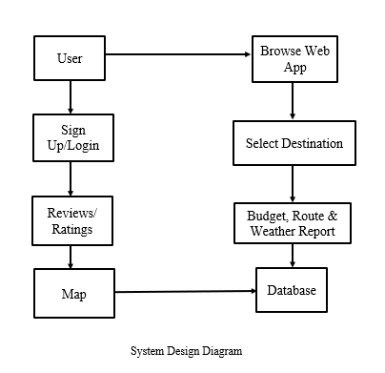

**Figure 4 System Design Diagram**

**Use-Case Diagram**

A use case diagram shows the specification of a use case and a user's interaction with the system. It is generally shown as a graphic depiction of interactions among different elements in a system. An actor could be a person like a client, or a machine such as a server or database.

In our project, User can access to following functionalities:

* Register/Login
* Search Destinations
* Read News
* Book tours

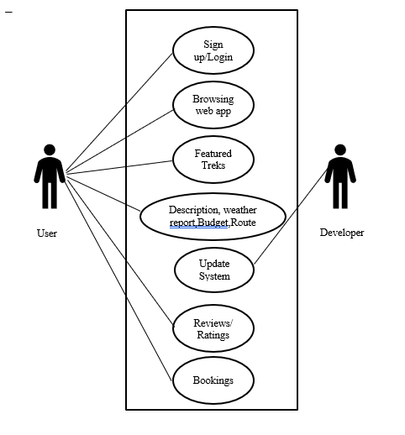

**Figure 5 Use case Diagram**

**Data Flow Diagram**

A Data Flow Diagram (DFD) is a visual representation of how data flows within a system or processed help in understanding the flow of information in a system, making them useful for system analysis, design, and documentation. It demonstrates how data flow from external users and administrators to various processes. The Data Flow Diagram of our project is shown below:

**Shows**

**Create required location**

**account**

User

**Get required**

**information**

**Check News**

**read**

**account**

**db.**

**Figure 6 Data flow Diagram**

.

**System Sequence Diagram**

A sequence diagram is a type of interaction diagram because it describes how—and in what order—a group of objects works together. These diagrams are used by software developers and business professionals to understand requirements for a new system or to document an existing process. The System Sequence Diagram of our project is shown below:

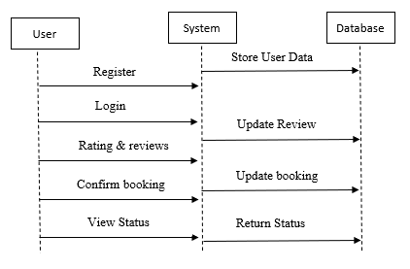

**Figure 7 System Sequence Diagram**

### 

### ER Diagram

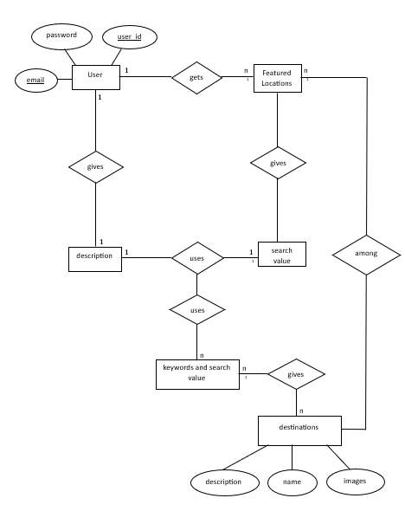The ER Diagram is essentially a database’s structural design. It serves as a framework built with specialized symbols to define the connections between database entities. Entities, attributes and relationships make up the three main parts of an ER diagram. ER diagram of our system is shown below:

### Figure 8 ER Diagram

# CHAPTER 4

# IMPLEMENTATION AND TESTING

## 4.1 IMPLEMENTATION

### 4.1.1 Tools Used

**Hardware and Equipment:**

To develop and test the project a laptop was used as a server to deploy the application on the local network along with client devices for testing purpose.

**Software and Technology:**

To develop this project Visual Studio Code IDE was used along with different dependencies installed. For Database connection Express JS was used and for Database MongoDB was used. The project’s frontend is based on ReactJS and backend is based on NodeJS.

**Communication Tools:**

Microsoft Teams was used for communication among team for planning and requirement analysis. The updated component was uploaded in GITHUB for version control and collaboration of the project among team members.

**Documentation Tools:**

Microsoft Word was used to create System Designs and documentation of this project.

Microsoft Excel was used to create Schedule chart (Gantt Chart).

**Project Management Tools:**

A digital scrum board was used to mark the backlogs, to do list, in progress components and completed components. For monitoring the progress of the project, Gantt chart was used.

**Other Tools & Resources:**

Real-Time data were accessed from different API to increase the functionality of the project.

### 4.1.2 Testing

After the successful development of components, testing was done to ensure QA, termination of possible risk, functionality verification and resources used by component during the test.

**Test Case for Unit Testing**

Individual component or units of code are tested in isolation to ensure they function correctly during unit testing phase for software development. It identifies and fix bugs early, promoting code reliability, and aiding in code maintenance. It involves scope, input, assertion and automation for better software development.

**Test Case for System Testing**

System Testing is a level of testing that validates the complete and fully integrated software product. It ensures that a system meets end-to-end specification and nonfunctional requirement (such as stability and throughput) that have been agreed with its user. It consists bug detection, quality assurance, risk mitigation ultimately contributing to the success trustworthiness of the product.

### 4.1.3 Result Analysis

After different test were conducted, we analyzed the outcome and response to different parameters passed through the system. We validated the system’s functionality with proper analysis of outcome. It helped us to gain valuable insights and also provided information to enhance its future functionality and requirements that user and stakeholders may want in near future.

# CHAPTER 5

# CONCLUSION AND FUTURE RECOMMENDATION

## 5.1 CONCLUSION

In conclusion, the development and implementation of a Trekking Management System (TMS) in Nepal holds tremendous promise for the country's trekking industry, its environmental conservation efforts, and the overall safety and satisfaction of trekkers and mountaineers. Nepal’s natural beauty, diverse landscapes, and rich cultural heritage have made it a cherished destination for adventure enthusiasts and nature lovers. However, the growth in trekking's popularity has brought forth various challenges, including safety concerns, environmental degradation, and logistical issues. These challenges must be addressed to ensure the long-term sustainability of the trekking industry and the preservation of Nepal's unique landscapes.

In conclusion, the Trek’s Mate in Nepal app represents a significant stride toward a safer, more sustainable, and more fulfilling trekking experience. It is a testament to Nepal's dedication to its trekkers, its environment, and its future as a world-renowned trekking destination.

## 5.2 LIMITATION AND FUTURE RECOMMENDATION

**Limitations**

Trek’s Mate is in initial phase of development which provides a basic support for trek enthusiasts leading to a stress-free journey. However, it possesses some limitations too.

* Being a online app, it cannot provide full service on remote trekking regions where access to internet or smartphone is scare.
* The accuracy of real-time data such as weather updates or route conditions can get compromised in remote regions with limited monitoring infrastructures.
* This app is based on English language which can be hindered by language barriers.
* The free API used for retrieving data for weather reports and maps may get expired lacking support.

**Future Recommendations**

The functionality of this project can be improved by following ways:

* + Offline Functionality: Develop offline features in app to ensure usability even in area with poor connectivity.
  + Multilingual Support: Offer the app in multiple languages to cater to the diverse range of trekkers visiting Nepal.
  + Trusted API: Purchase trusted API resource to ensure the functionality of components is always accessible.
  + Feedback Mechanism: Implement a feedback mechanism within the app allowing the users to report issues, provide suggestions and share their experience for further improvement of the application.
  + Integration with other services: Explore opportunities to integrate the application with other travel and emergency services to enhance the overall trekking experience and safety.
  + Constant Updates: Functionalities should be constantly updated and new components should be added as per the need of hour.

# REFERENCES

[1] Over 500,000 tourists visit Nepal in 10 months (2022) <https://myrepublica.nagariknetwork.com/news/over-500-000-tourists-visit-nepal-in-10-months/> . República Nepal (Page no.11)

[2] Shrestha, A. (2022) *Harnessing Tourism to Enhance the Value of Biodiversity and Promote Conservation in Nepal*, *WebBank*. (Page no.12)

[3] Abdulhamid S.M. & Gana U. (2010). Destination Information Management System for Tourist: Computer Science and Telecommunications. Georgian Electronic scientific journal, vol 6(issue 29). (Page no.14)

[4] Zhou F, Zhao M, Sun Z, Zhao J & Gong Z. (2014). *The application of intelligence tourism mobile client based on ontology*. Journal of Chemical and Pharmaceutical Research, Vol. 6(Issue 5), pp 258- 265. (Page no.14)

[5] Rovnaya, A. (2022) Agile Software Development Methodology, Cleve Road.

(Page no.15)

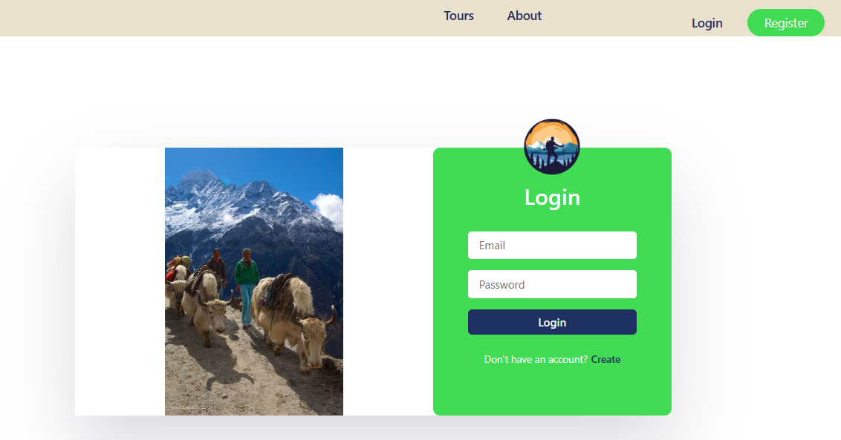**APPENDICES**

**Figure 9 UI Design (Login Page)**

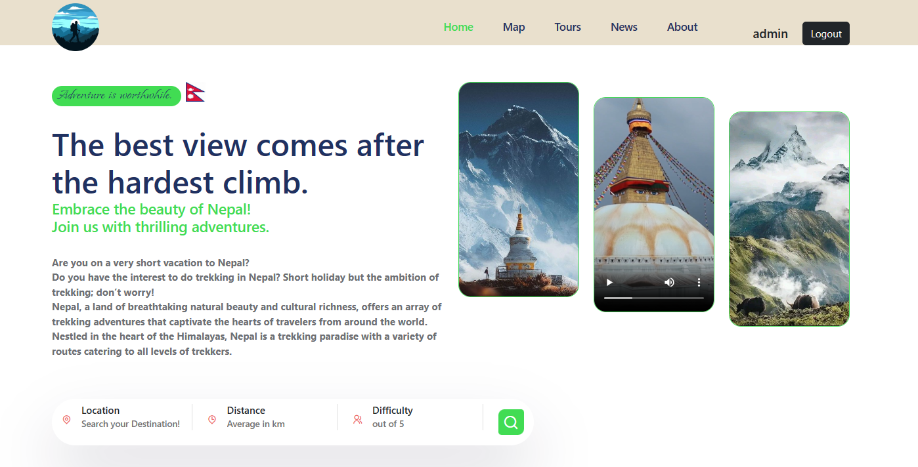

**Figure 10 UI Design (Homepage)**

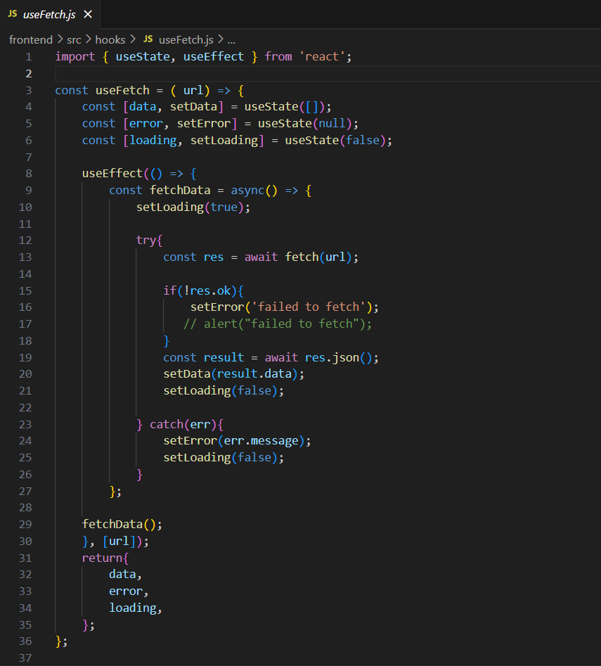**Code Snippets**

**Figure 11 Code Snippets 1**

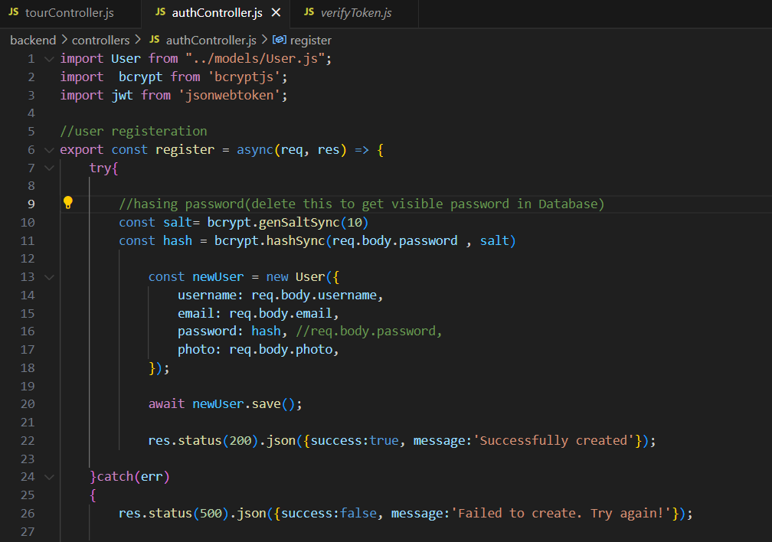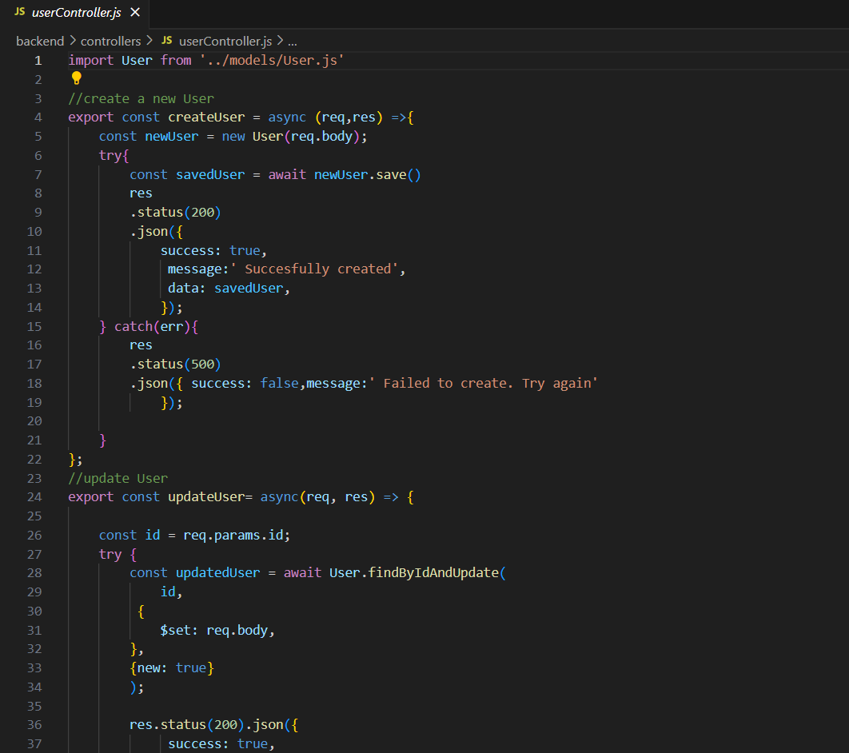**Figure 12 Code Snippets 2**

**Figure 13 Code Snippets 3**