# Standard Operating Procedure – Excel Manager (v1.0.0)

## 1. Purpose

The first and current edition of Excel Manager (1.0.0) was designed to streamline the process of data transfer and collection in Microsoft Excel. Previous to this launch, statisticians would have to manually copy or merge tens of columns of data for analysis, often resulting in transfer errors. Thus, to prevent these errors, Excel Manager was designed to automate this process of data handling.

Excel Manager (1.0.0) was designed as a Windows Application in the C# programming language using the 2013 edition of Visual Studio Code.

## 2. Scope

The initial intended audience for the technologies of Excel Manager (1.0.0) was a group of statisticians and genetic data analysts at the University of Texas at Houston Human Genetics Center, though any person working with data management in Microsoft Excel, especially the transfer of data from file to file or the merging of files may find the application helpful.

## 3. Prerequisites

The user should either have Windows as their operating system, or a version of Windows installed on their device that can run Windows Applications. There are no other prerequisites or third-party software that needs to be downloaded or installed in order to properly run the application, which functions independently.

There are, however, required files that must be present, depending on the action the user wants to execute using the program. This will include the source and/or destination Excel file(s), and occasionally text files that serve as mapping instructions (for insertion functions).

## 4. Responsibilities

The key contributors to the production of the Excel Manager Suite are Edward Ni and Nathan Zheng. Ni was responsible for the early stages of development and setting up the infrastructure needed to navigate and modify Excel file data within the C# language and Visual Studio environment. He played a key role in designing the home page as well as the original merge and duplicate functions.

Following Ni, Zheng took over the rest of the application’s development. With a strong focus on user-friendliness and robust design, he reimplemented portions of Ni’s work with improved error-handling techniques and additional user guidance. The “Merge” and “Find Duplicates” functions were revamped in this manner and two new functions, “Insert to Template” and “Map to Template”, were added. Currently, the “Find Duplicates” function is still under construction and will be ready for use in the next version release. Zheng also developed the installer for Excel Manager (v1.0.0) and any questions regarding program installation and use should be directed toward him. Contact him by e-mail at [nyz3@cornell.edu](mailto:nyz3@cornell.edu) for any further questions and inquiries.

## 5. Procedure

1. **Download and Installation** – If installation permissions are required for third-party installations, please contact the IT Department, or related, for proper installation configurations (if user is within the UTHealth Human Genetics Center, please contact Yun Gong).

After launching the installer (***ExcelManager(v1.0.0)***), the installation process is fairly simple. Upon launch, the following page should appear.

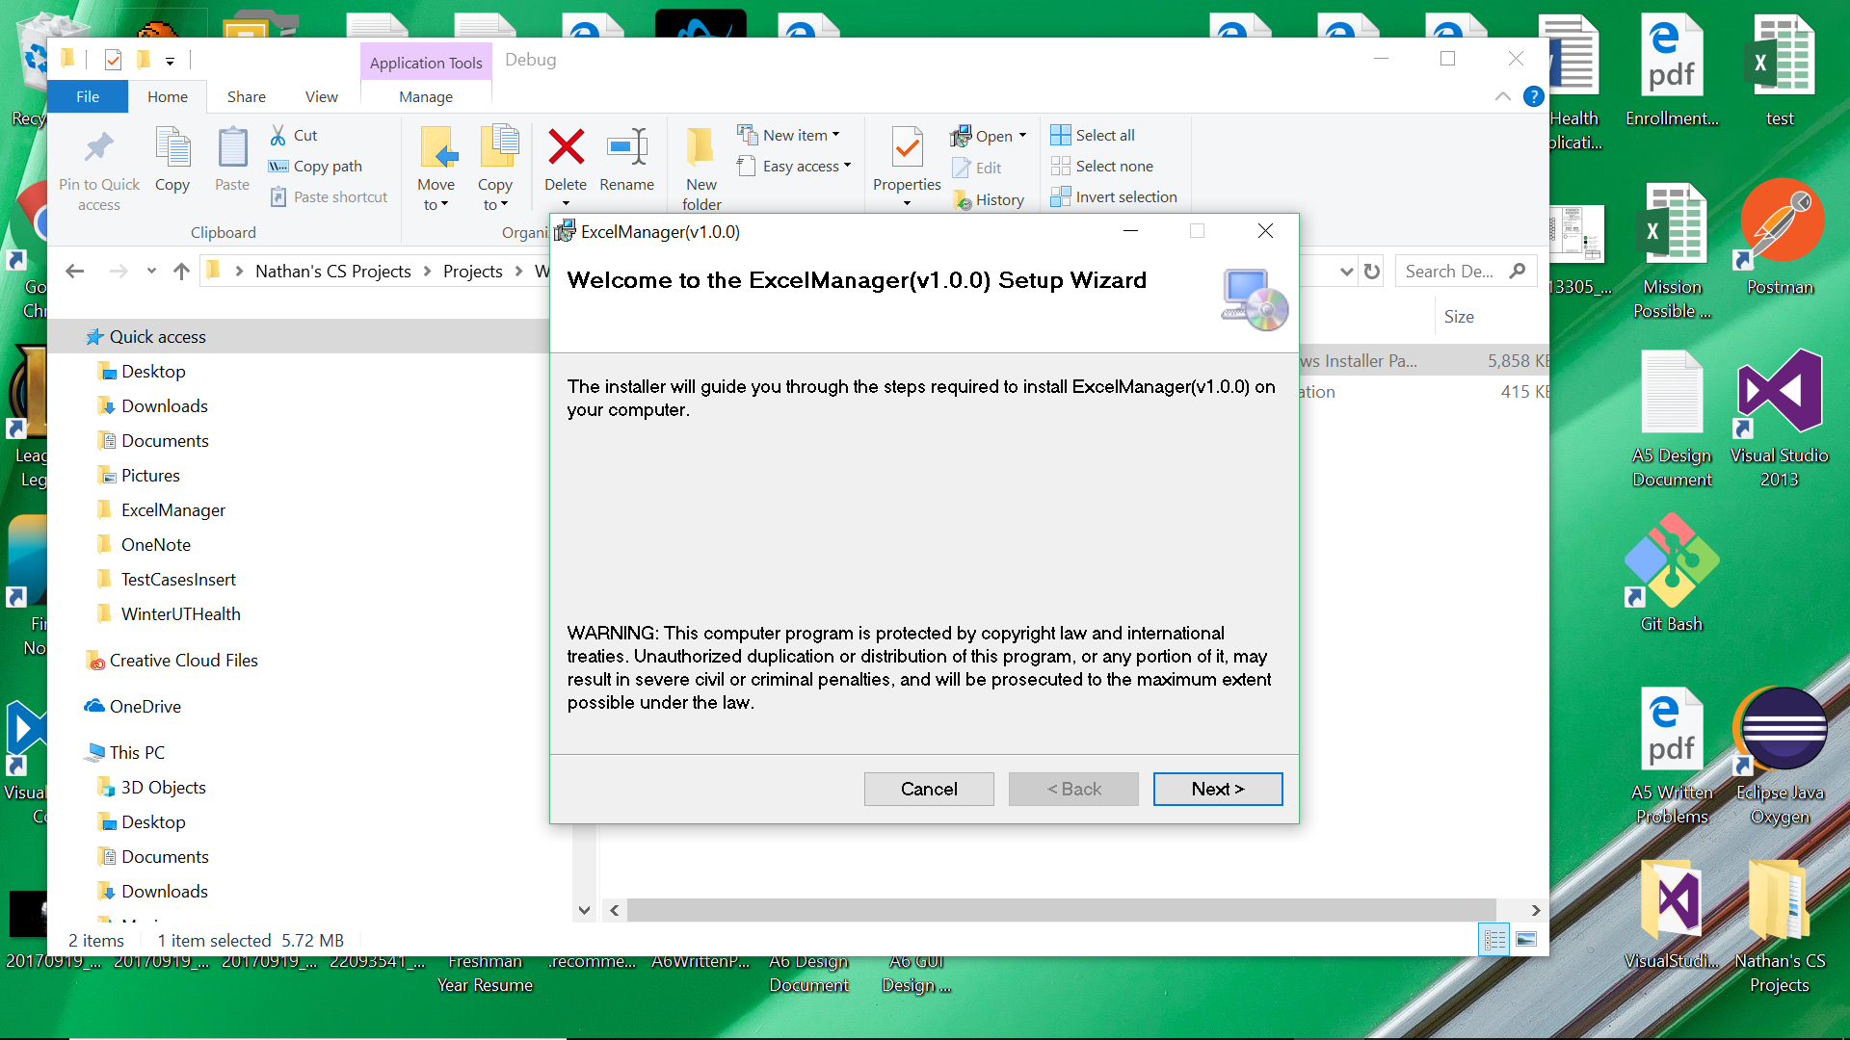

After clicking next to proceed with download, the following page should appear.

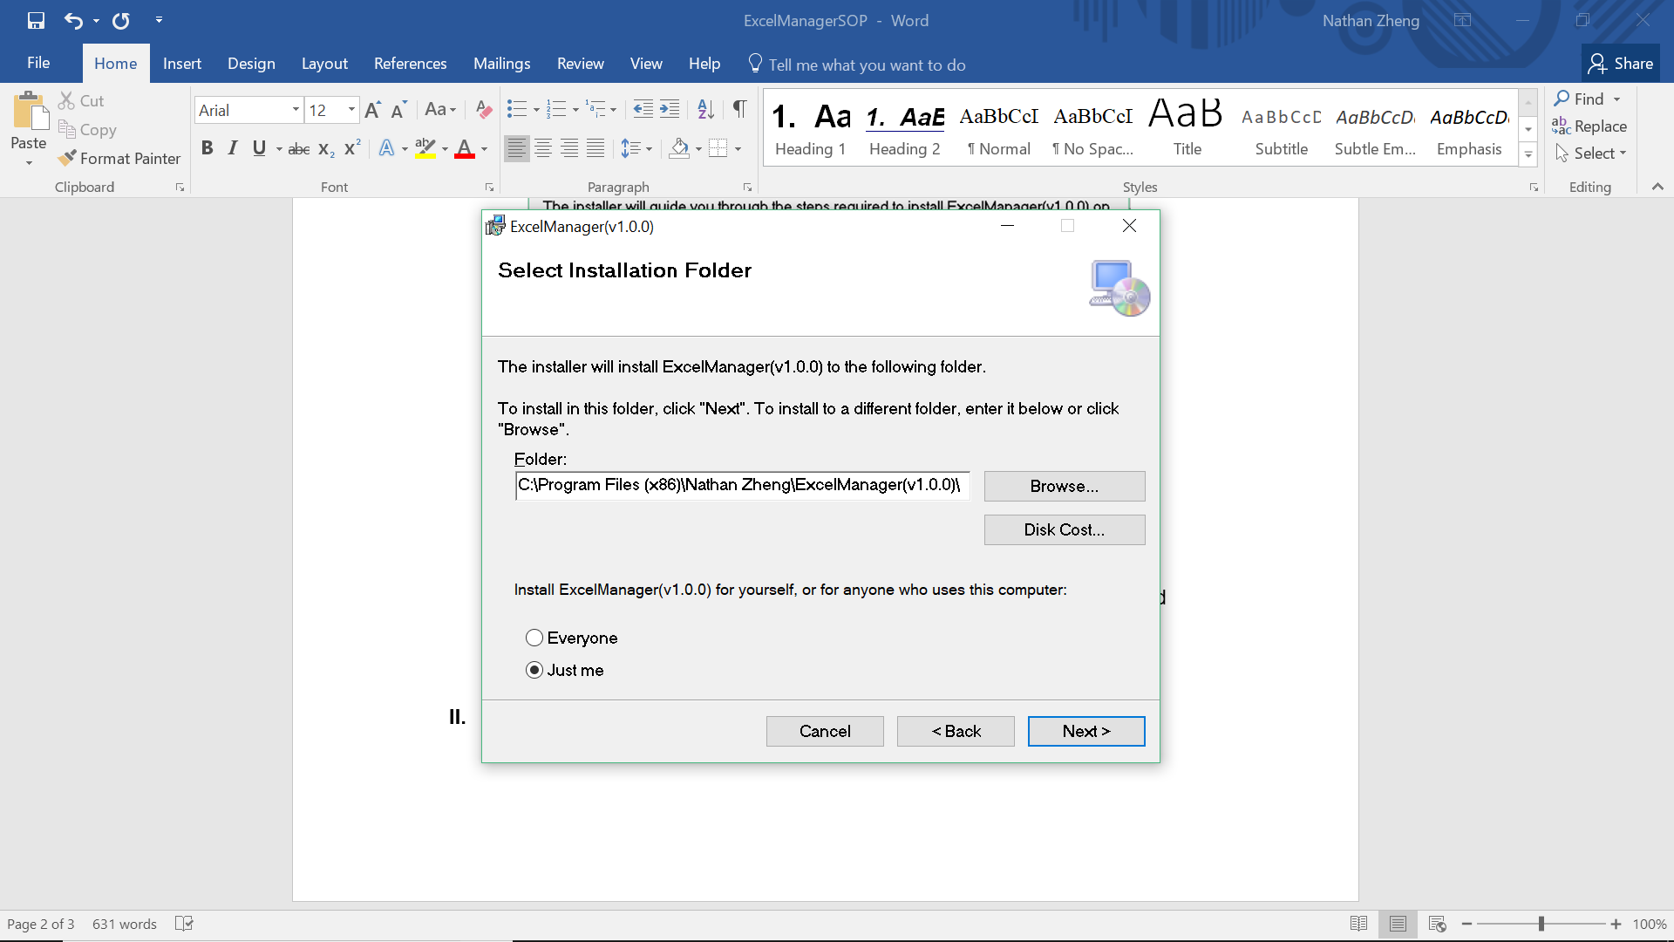

1. **Running the Application / Homepage**
2. **How to Apply Functions (and Descriptions)**

## 6. Definitions

**Visual Studio Code** – A source code editor developed by Microsoft for Windows, Linux, and macOS. It includes support for debugging, embedded Git control, syntax highlighting, intelligent code completion, snippets, and code refactoring. It is also customizable, so users can change the editor’s theme, keyboard shortcuts, and preferences. It is free and open-source, although the official download is under a proprietary license (according to Wikipedia).

**C# (C-Sharp)** – A multi-paradigm programming language encompassing strong typing, imperative, declarative, functional, generic, object-oriented (class-based), and component-oriented programming disciplines. It was developed by Microsoft within its .NET initiative and later approved as a standard by Ecma (ECMA-334) and ISO (ISO/IEC 23270:2006). C# is one of the programming languages designed for the Common Language Infrastructure (according to Wikipedia).