**COMPSYS 302 Group One Project Plan**

Group Background:

Sylvain is in his third year at the University of Auckland, working towards his Computer Systems Engineering degree. From COMPSYS 202, he is familiar with object orientated programming, Eclipse, and C++. Sylvain worked on Chatbot development as part of his practical work experience throughout last summer, actively coding in C# and following object orientated programming principles. He uses Git as a version control system regularly, whether to maintain the websites he created or for organising code-related, university group projects. Sylvain also has a personal interest in game immersion and the factors which impact on and result in a better (or worse!) game immersion.

Mark is studying a conjoint Computer Systems Engineering and Computer Science degree at the University of Auckland. Earlier in the year he worked on a Microsoft Imagine Cup project which consists of a Windows Forms application and a Xamarin cross platform app, both coded in XAML and C#. His team’s extension features for the ELECTENG 209 project last year incorporated a real time graphing Android app, coded in Java. Both projects incorporated Git and object oriented programming. Last summer, Mark undertook a summer studentship for the University of Auckland’s Department of Electrical and Computer Engineering, supervised by Dr Nasser Giacaman. The project involved designing and creating a selection of educational videos, a website, and lab exercises to help future engineering students familiarise themselves with software such as Ubuntu, C++, and Eclipse.

System Outline:

Our game is based on the classic arcade game Warlords. The game will be able to be played by any number of one to four players. Each player will have a stationary base in a corner of the screen, protected by a block wall around it. There will also be a ball on the game screen, which will be continuously moving and bouncing off the sides of the screen and off the block walls. However when the ball bounces off a block in the wall, then that block will be destroyed.

The aim of the game will be to defend your base, using two keys to control a paddle. The paddle will be able to deflect the ball away from your block wall and towards another player’s wall or a side of the screen. If the ball fully penetrates a player’s block wall and hits their base, then that player is defeated. A player wins if all other players are defeated within a certain time frame, or if they have the most blocks in their wall when the time frame expires.

The game will always have four bases, block walls, and paddles. If less than four individuals are playing the game, then an AI will be able to control the remaining bases. This AI will have multiple difficulty levels.

Additional Features:

We want to add the follow additional game features:

* Single player / campaign mode with story, levels, and bosses
* Able to use different classes with different powerups and abilities
* Able to change ball speed
* Able to change paddle speed
* Able to make ball speed up on bounce
* Able to have multiple balls
* Able to enable paddle reverse physics
* Able to have fire balls (penetrate further)
* Able to have huge balls (does damage to multiple blocks)
* Able to have reverse controls
* Able to change have random bounce (and delay on bounce)
* Able to have ball offspring (makes single use bullets on paddle hit)
* Able to use chaotic mode (any selection of the above, or all of the above)

Provisional Schedule:

* Friday Week 4 - Basic mechanics implementation:
  + Moving paddle
  + Moving ball
  + Bouncing ball
  + Wall destruction
* Friday Week 5 - Advanced mechanics and game menus:
  + Classes and players selection
  + Timer and Scoreboard
  + Win conditions
* Friday Week 6 - Additional game features:
  + Custom game options
  + Single player campaign
  + Music and graphics

Foreseen Challenges:

Of the many foreseeable challenges which may be encountered, some of the major ones include the AI implementation in the game, closely following object orientated programming principles and the creation of an original storyline which is appropriate to the game.

AI implementation may get complicated if we want it to be challenging for players of all skill levels, and not simply a basic AI following the ball moving on the screen. We want to implement separate AI for different difficulty levels.

Following object orientated programming principles will be more complex for students than it appears. This is because basic programming papers encourage learning the language and the syntax, rarely focusing on code efficiency and programming standards such as object orientated principles. As a result, students have very few opportunities to practice following these coding principles, which explains why it may be one of the major challenges which will be encountered.

Finally, the creation of an original storyline relevant to the game may prove to be an issue. The game is very specific when it comes to the player number and game mechanics, and the environment never really changes. These are obstacles to creating a credible story which has to encompass all these details. This is will be especially difficult if the story is to be original and captivating to the player, while not reusing too many clichés or the storyline from the original game.

Appendix

*Game Screen Planning*

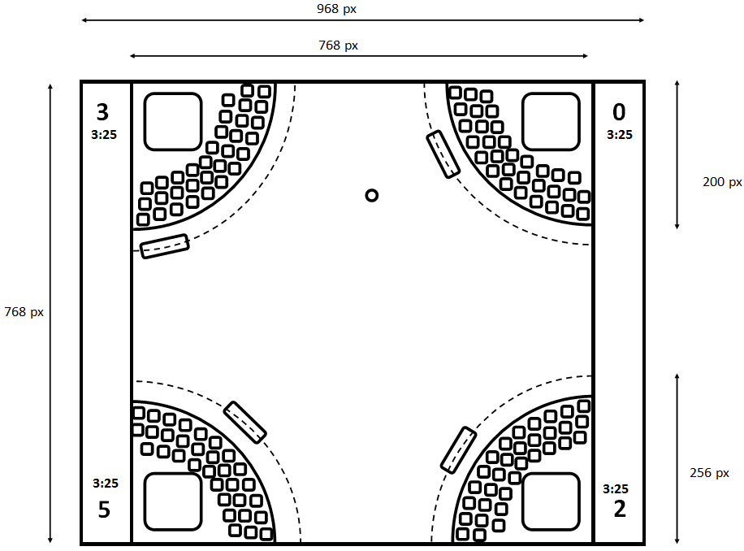

*Software Class Planning*

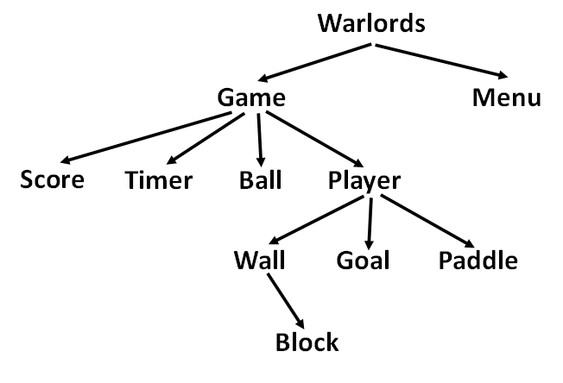

*Menu Planning*

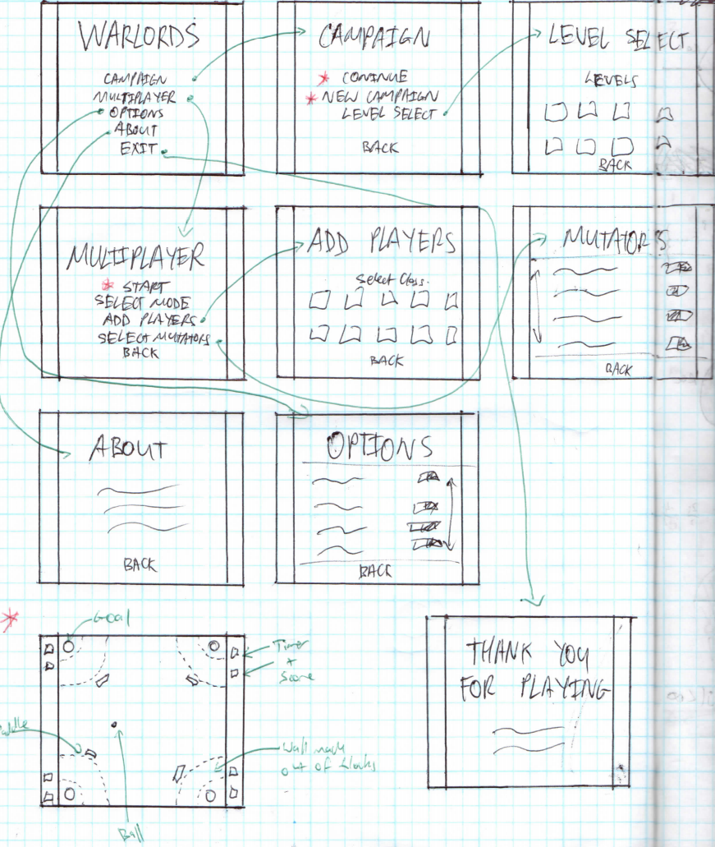

*Player Classes and Abilities*

|  |  |  |  |
| --- | --- | --- | --- |
| Commander | Nation | Ability | Ability Type |
| Sylvain | France | Paddle can move anywhere | Passive |
| Shia | USA | Shoot an extra ball that doesn’t bounce | Cooldown |
| Nigel | Britain | Immunity for a short period of time | Single Use |
| Andrew | New Zealand | Has an extra sheep paddle that wanders randomly | Passive |
| Mark | China | Extra layer of wall | Passive |
| Tony | Australia | Shoot poison spiders that slows other players down | Cooldown |
| Partha | India | Two paddles, slightly smaller, follow one controller | Passive |
| Vladimir | Russia | Steal a random outer block from other players walls | Cooldown |
| Muhammed | Egypt | Paddle turns into a large but stationary pyramid | Cooldown |
| Neymar | Brazil | Paddle can momentarily catch the ball | Passive |