**LINE FOLLOWING ROBOT DATASHEET**

**DESCRIPTION**

The Line Following Robot is a two-wheeled robot that traverses mazes by following lines displayed by an overhead projector. It has two operation modes, level 1 and level 2. The two modes can be switched between using switches on the robot. Level 1 uses a DFS algorithm to traverse every single point on a maze. Level 2 utilises an A* algorithm to traverse the shortest possible path to consume a number of food pellets. To use the robot, it must first be programmed with the map, coordinates of the food pellets, and starting point. The robot is designed to reliably detect lines with thicknesses ranging from 15-20 mm. The robot is designed to detect lines from a projector with a frequency of 120 Hz.

**FEATURES**

* Robot speed between 45 and 69 cms-1
* Wheel speed between 132 and 202.7 rpm
* Powered by six 1.5V AA batteries
* Two operation modes
* Uses A* to find food pellets
* Uses DFS to traverse entire maze
* Has three RF localisation LEDs that allow its position to be tracked. These LEDs can be turned on and off using a switch.
* Uses an array of six light sensors to follow a line and detect corners and intersections.

|  |  |  |  |  |
| --- | --- | --- | --- | --- |
| *Parameter* | *Test Condition* | *MIN* | *MAX* | *UNIT* |
| Operating Voltage Vs |  | 7.8 | 8.3 | V |
| Robot speed | Vs = 8.0 | 45 | 69 | cms-1 |
| Wheel Speed | Vs = 8.0 | 132 | 202.7 | rpm |
| Corner turning speed | Vs = 8.0 | 1.11 | 1.72 | rads-1 |
| Projector frequency | Vs = 8.0 | 120 | 120 | Hz |
| Line thickness | Vs = 8.0 | 15 | 20 | mm  (Tamb = 25 °C) |

**CHARACTERISTICS**

**OPERATIONAL MODES**

Two Operation Modes

Level 1 = DFS, Level 2 = A*

SW2 SW0 Operation mode switches



SW3 SW1

|  |  |  |  |  |
| --- | --- | --- | --- | --- |
| LEVEL | SW0 | SW1 | SW2 | SW3 |
| 1 | 0 | 0 | 0 | 0 |
| 2 | 1 | 0 | 0 | 0 |

**DIMENSIONS (mm)**

FRONT

TOP VIEW

FRONT

SIDE VIEW

00

00

150

120

*Light sensor array*

*LED/ON switches*

*Localisation LEDs*

*Operation mode switches*

90

145

65

**LIGHT SENSOR PERFORMANCE**

**LIGHT SENSOR CIRCUIT**

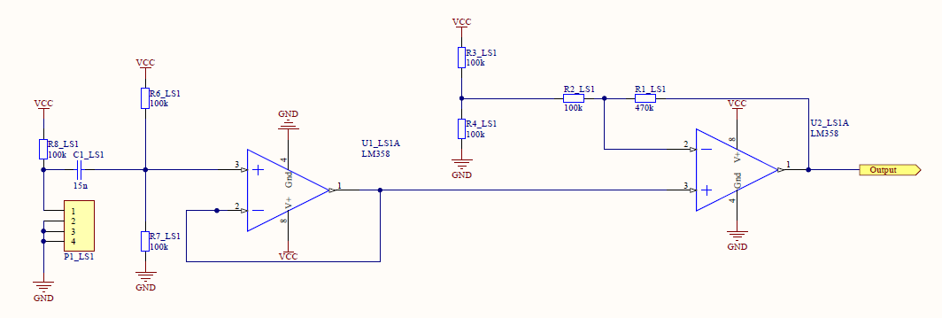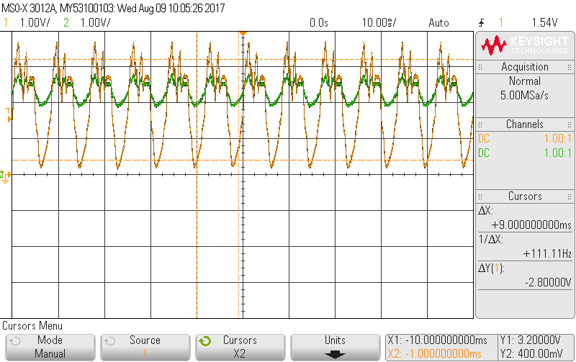

Output when sensor is not under the line

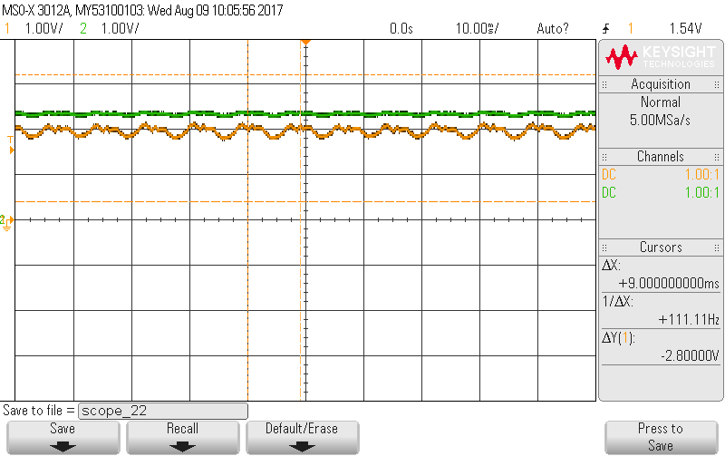

Output when sensor is under the line

Green = Input Orange = Output