Staged Data Demo Deployment

# Before you begin

## Install Docker

Install Docker from: <https://docs.docker.com/docker-for-windows/install/>

## Create a Service Principal for the Azure Deployment

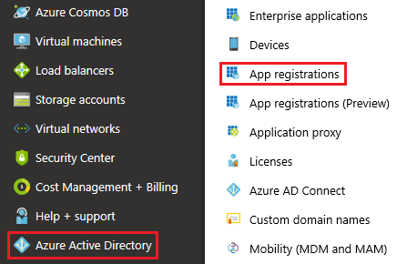

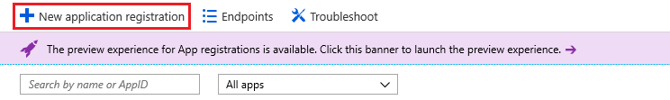

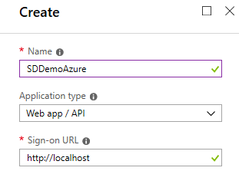

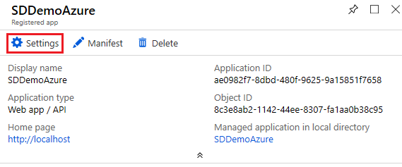

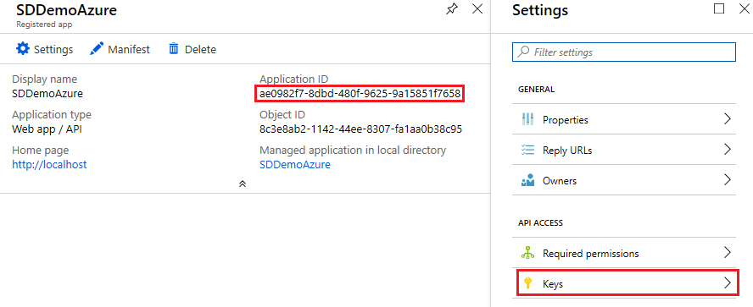

The “**Application ID**” will be used during the deployment as the “**AzureApplicationId**” PowerShell script parameter.

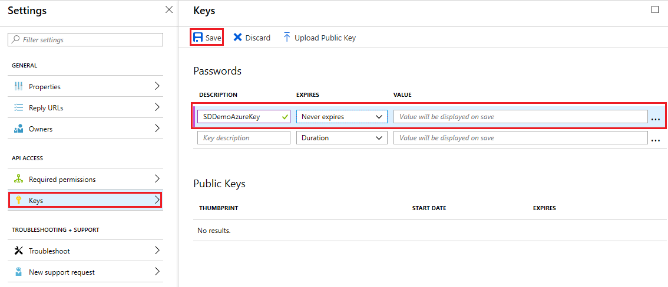

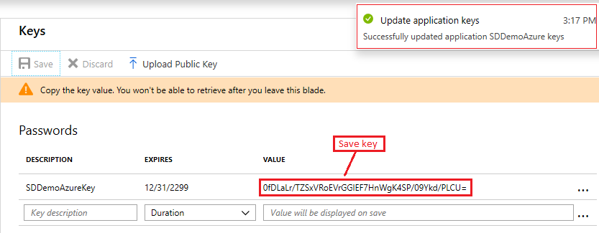

The “**SDDemoAzureKey**” will be used during the deployment as the “**AzureApplicationSecret**” PowerShell script parameter.

## Create a Service Principal for the AzureStack Deployment

Repeat the steps above in Azure for an AzureStack Application ID and Application Secret.

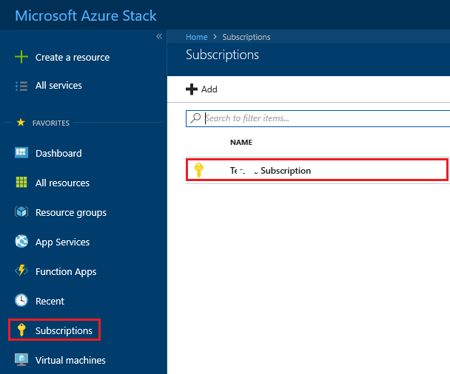

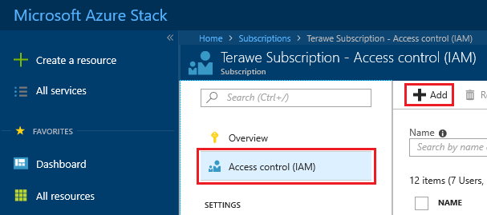

# Install the Demo

1. Create a folder for the Docker Container download

md SDDemo

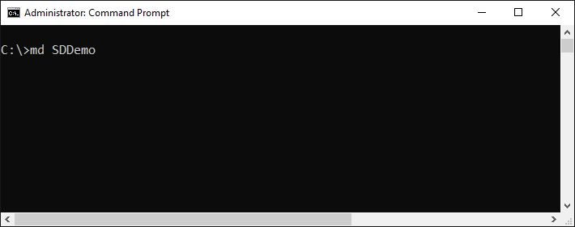

1. Navigate to the folder

cd SDDemo

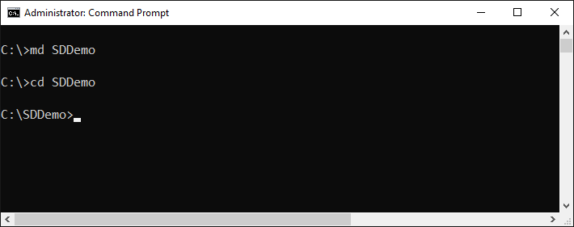

1. Run the following command to download the container

docker pull <dockerAccount>/<dockerRepo>:sd-demo

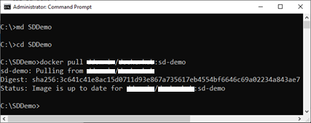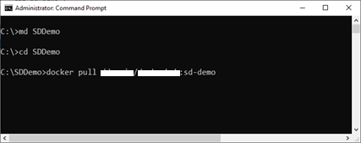

1. Run the docker container

docker run -it <dockerAccount>/<dockerRepo>:sd-demo powershell

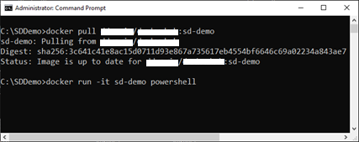

1. Navigate to the sddemo folder

cd .\SDDemo\

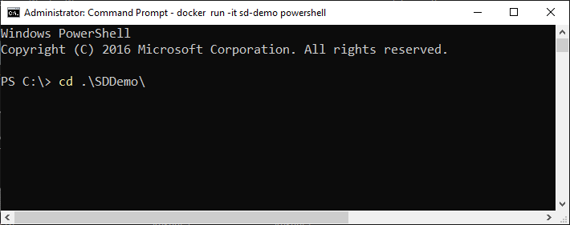

1. Run the deploy script

.\DeploySolution-Azure-AzureStack.ps1

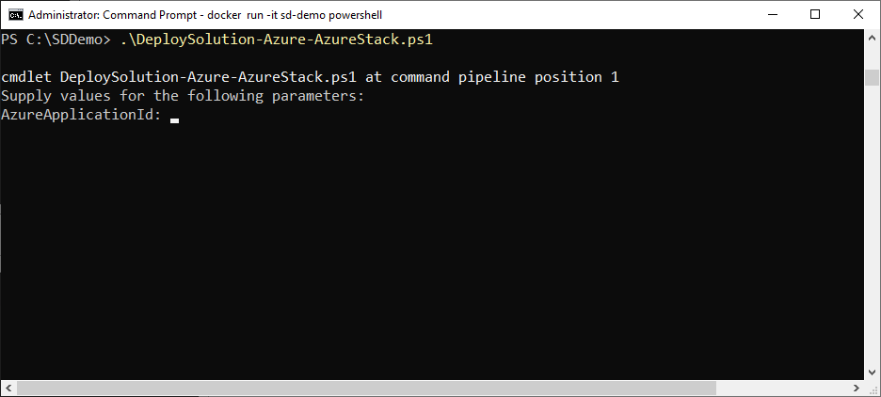

1. Provide all the input parameters

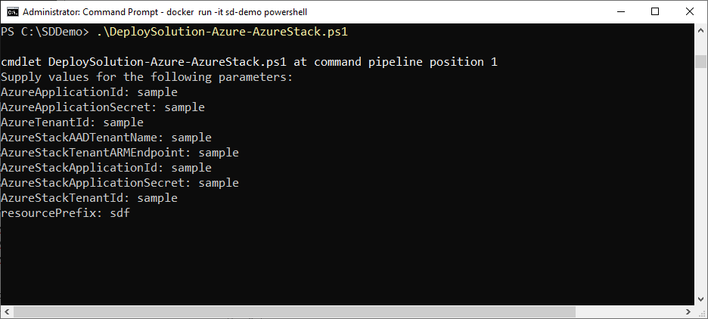

Note: The parameters will be similar to the following:

|  |  |
| --- | --- |
| **AzureApplicationId** | xxxxxxxx-xxxx-xxxx-xxxx-xxxxxxxxxxxx |
| **AzureApplicationSecret** | xxxxxxxxxxxxxxxxxxxxxxxxxxxxxxxxxxxxxxxxxxxx |
| **AzureTenantId** | xxxxxxxx-xxxx-xxxx-xxxx-xxxxxxxxxxxx |
| **AzureStackAADTenantName** | mydomain.onmicrosoft.com |
| **AzureStackTenantARMEndpoint** | https://management.westus.mytenant.com/ |
| **AzureStackcApplicationId** | xxxxxxxx-xxxx-xxxx-xxxx-xxxxxxxxxxxx |
| **AzureStackApplicationSecret** | xxxxxxxxxxxxxxxxxxxxxxxxxxxxxxxxxxxxxxxxxxxx |
| **AzureStackTenantId** | xxxxxxxx-xxxx-xxxx-xxxx-xxxxxxxxxxxx |

1. If prompted; enter the Region for the deployment and Application Insights

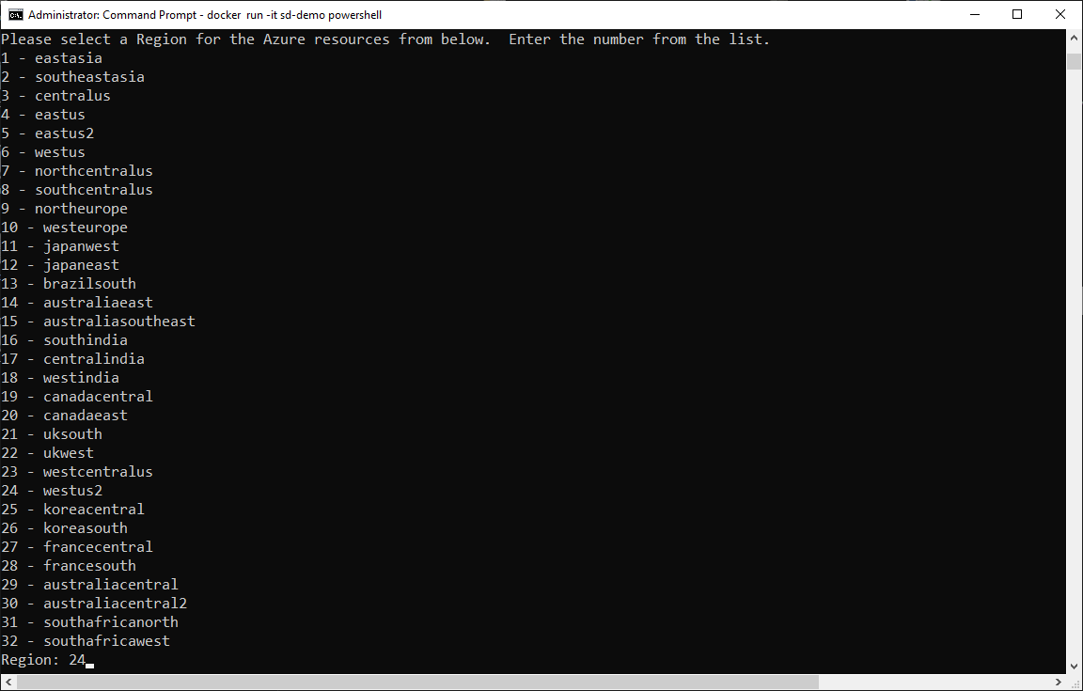

1. Type “Y” to allow the NuGet provider to be installed

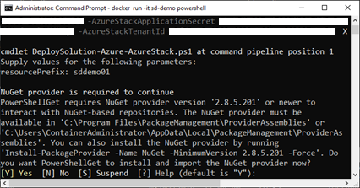

1. Monitor the deployment and wait for it to complete

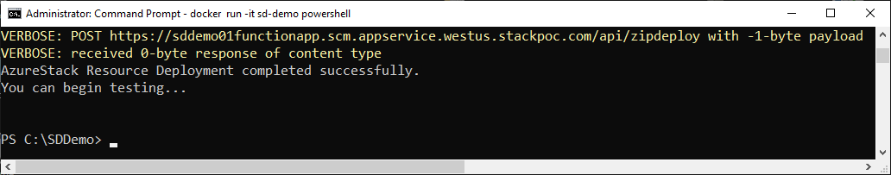

1. Run some tests using the test app

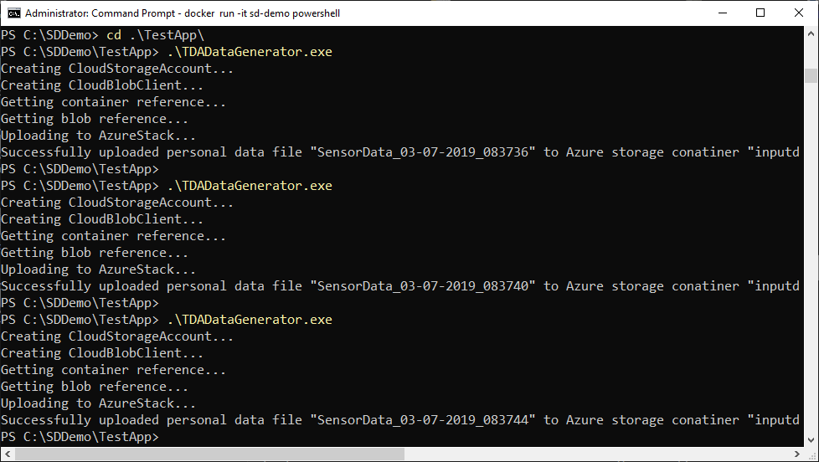

1. Verify the data is available from AzureStack and Azure WebApps

Azure Web App

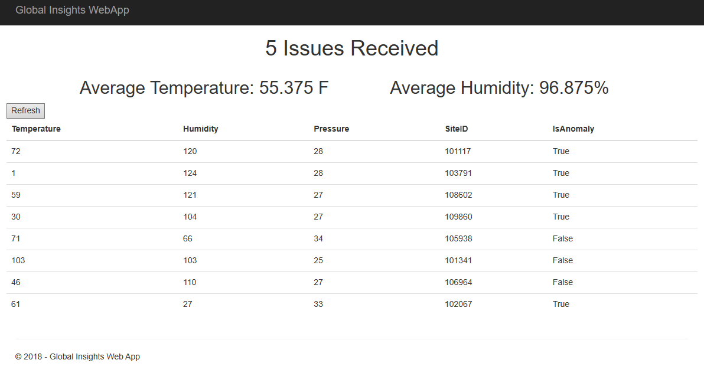

AzureStack Web App

