**FORMAN CHRISTIAN COLLEGE (A CHARTERED UNIVERSITY)**



**Mob App Development (CSCS 468)**

**2024Fall**

**Assignment 3 report**

**Muhammad Umair Shafiq**  **251697475**

**Nida Zafar Khan 251731076**

Objective:

Genius Garden is a mobile app crafted for gardening enthusiasts, offering tools to grow and maintain their gardens effectively. Developed using Kotlin and Android Studio, it features a sleek, user-friendly interface that includes a plant information database, real-time expert consultations, and tailored gardening tips. By connecting casual gardeners with expert guidance, Genius Garden aims to build a supportive gardening community and make expert advice easily accessible.

Target Audience:  
  
Our target audience consists of gardening enthusiasts, ranging from casual hobbyists to experienced gardeners, who seek expert guidance and personalized tips to enhance their gardening experience. This includes individuals interested in growing indoor or outdoor plants, herbs, succulents, or maintaining a thriving garden.

Overview:

Genius Garden is a comprehensive mobile application designed to transform the gardening experience by addressing common challenges like unreliable information and lack of expert guidance. Catering to users of all skill levels, it combines a detailed plant care database with real-time expert consultations and personalized tips, ensuring users receive tailored advice for their specific gardening needs. By fostering a supportive community and promoting environmental sustainability, Genius Garden empowers gardening enthusiasts to nurture thriving plants and enhance their green spaces effectively.

Wireframe Screens

* First page:

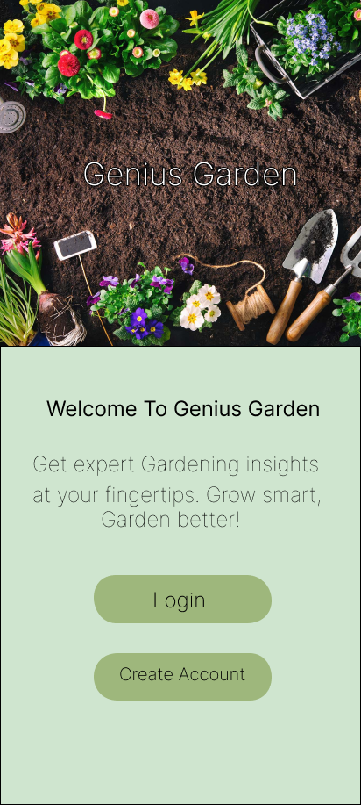

* Login and sign-up pages

Login Page Sign up page

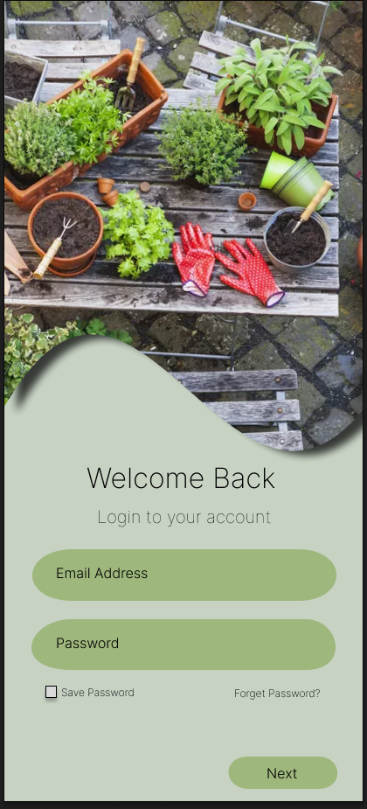 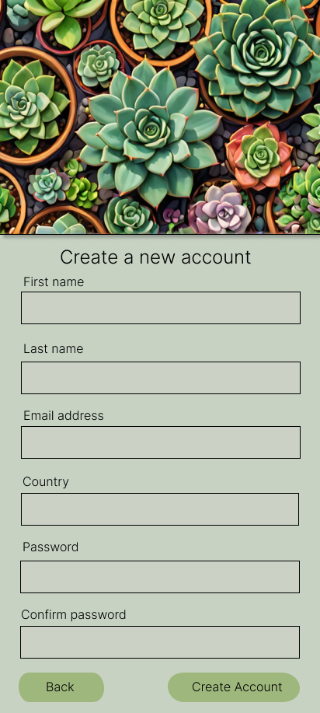

* Home Page

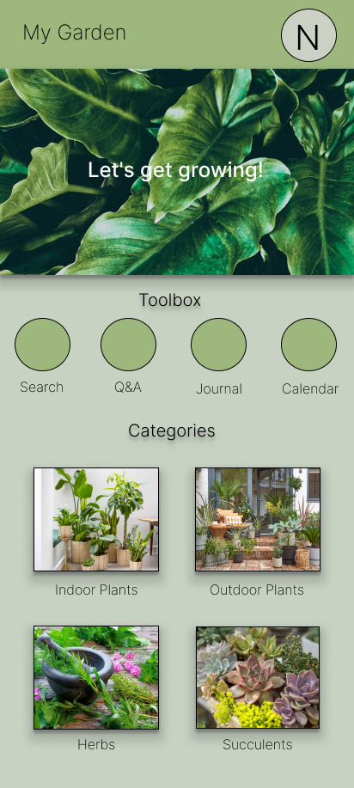

On the **Home Page** of Genius Garden users can seamlessly navigate to three primary functionalities: **Profile**, **Toolbox**, and **Categories**. The **Profile** section allows users to manage their personal information, notifications and security. The **Toolbox** serves as a hub for gardening tools and features, such as search, journal, calendar and expert consultations. Lastly, the **Categories** section provides easy access to organized plant-related information, including indoor plants, outdoor plants, herbs, and succulents, enabling users to explore and manage their gardening interests efficiently.

* Profile page



User can access this page by clicking on the profile picture that is at top right corner of the home page. Here, user can see notifications, can keep check on the security and also on its personal information. User can also make changes in this information.

* Journal page

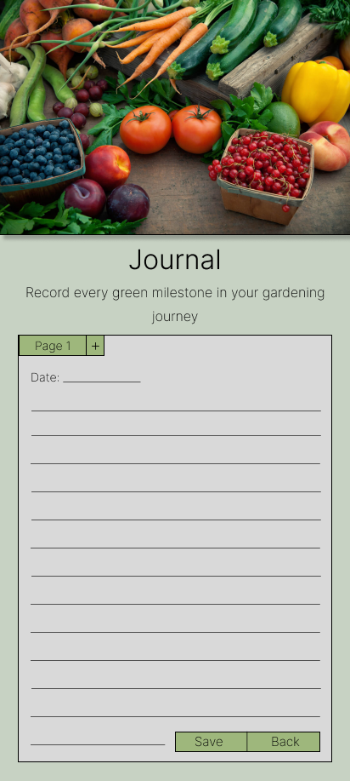

The **Toolbox** on the Home Page of Genius Garden offers four key functionalities to enhance the gardening experience:

1. **Search**: Users can look up any plant in the database, receiving detailed information and care guidelines tailored to their query.
2. **Q&A**: A dedicated section for users to address their gardening challenges by submitting questions or issues, where consultants provide expert answers and solutions.
3. **Journal**: A virtual notepad for users to document daily activities, observations, and progress in their gardening journey.
4. **Calendar**: A scheduling tool designed to help users track important dates, such as planting, watering, fertilizing, and other essential gardening tasks.

* Indoor plants

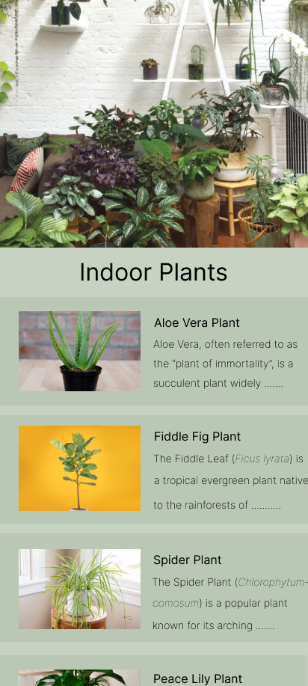

From the home page, it also features a dedicated **Plants** section, where plants are categorized based on their types for easy exploration and accessibility. The categories include **Indoor Plants**, **Outdoor Plants**, **Herbs**, and **Succulents**, allowing users to browse and access specific plant information relevant to their gardening preferences. This organized structure ensures that users can efficiently find detailed care instructions and recommendations tailored to each plant type. Like here, I have selected the indoor plants category and now it is showing me different types of indoor plants.

* Aloe vera (indoor plant)

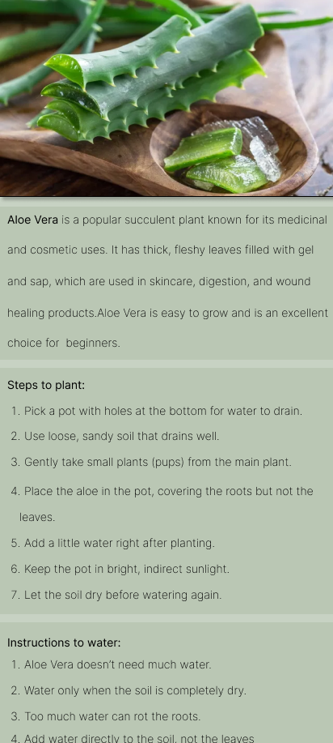

Here, I have selected the plant Aloe vera from indoor plant category. It shows the basic information of the plant, one-by-one steps to plant it and then instructions on how to water it.

The format for each category will be the same.

User flow diagram:

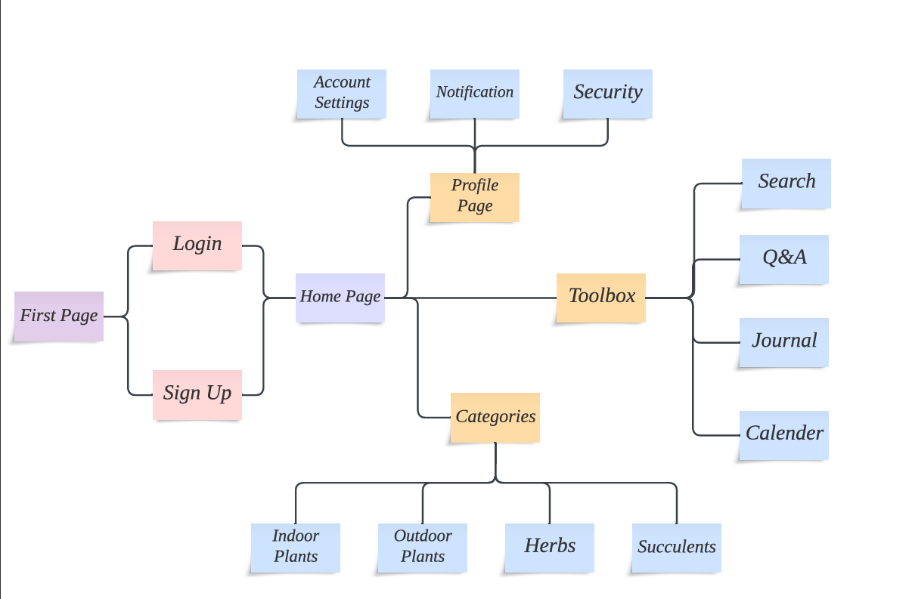

Conclusion:

In conclusion, **Genius Garden** is a thoughtfully designed mobile application that empowers gardening enthusiasts by providing a seamless and personalized gardening experience. With its intuitive navigation, robust features such as the **Toolbox**, categorized **Plants** section, and real-time expert support, the app addresses common gardening challenges and fosters an engaging community for users of all experience levels. By offering tools to plan, track, and enhance plant care, **Genius Garden** not only simplifies gardening but also promotes environmental sustainability and knowledge-sharing among users, making it an indispensable resource for gardeners everywhere.