**A Project Synopsis on**

**VEHICLE DETECTION AND MONITORING USING**

**MAGNETIC FIELD SENSORS**

**Submitted by**

|  |  |
| --- | --- |
| USN | Student Name |
| 1BG10EC058 | Pradeep Kumar. N |
| 1BG10EC054 | Nikunj Tonthanahal |
| 1BG10EC047 | Nafeeya Samar |
| 1BG10EC055 | Noor Zahara |

**Batch No: _________**



B.N.M. Institute of Technology

Banashankari II Stage, Bangalore – 560 070

**Department of Electronics & Communication Engineering**

**February 2014**

|  |  |
| --- | --- |
| Batch Number  ( To be provided by Dept ) |  |
| Project Title: | Vehicle Detection and Monitoring using Magnetic Field Sensors |
| Place where project is being carried out : | Bharat Electronics Limited |
| External Guide:  Contact Details: | Ravi Kumar +919980263340 |
| Name and signature of the Internal guide: | Anuradha V. Rao |
| Date of submission: | 25/01/2014 |

|  |  |  |  |  |
| --- | --- | --- | --- | --- |
| USN | Name | Contact Number | Email Id | Signature |
| 1BG10EC058 | Pradeep Kumar. N | +919663890585 | pradeepkumar.email@gmail.com |  |
| 1BG10EC054 | Nikunj Tonthanahal | +919686574731 | nikunj888@gmail.com |  |
| 1BG10EC047 | Nafeeya Samar | +919900913623 | nafeeya@yahoo.com |  |
| 1BG10EC055 | Noor Zahara | +919008407608 | noor91zahara@gmail.com |  |

**Project coordinator HOD, ECE**

**Introduction**

Maximizing the efficiency and capacity of existing transportation networks is vital because of the continued increase in traffic volume and the limited construction of new highway facilities in urban, intercity, and rural areas. Even when additional facilities are built to ease congestion and promote the use of multiple occupancy vehicles, the cost is often quite high. An alternative to expensive new highway construction is the implementation of strategies that promote more efficient utilization of current road, rail, air, and water transportation facilities. Efficient control requires cost-efficient and accurate estimation of traffic parameters, such as the number of vehicles passing a certain point per unit time, the current speed of vehicles, and their types. The estimation can be based on data collected from magnetic sensors placed close to the road or induction loops buried into the road surface.

A vehicle is built up of several types of magnetic materials; soft magnetic materials with no residual magnetization and hard magnetic materials with high residual magnetization. All of these materials in the vehicle create a disturbance in the earth magnetic field when the vehicle passes a specific region. When we place a magnetic sensor system with a high field sensitivity and resolution in this region, it is possible to detect the vehicle. Two wheelers tend to produce a single peak in the disturbance curve due to their relatively small size. In four wheelers, the front and rear axles create relatively large disturbance in the earth magnetic field due to their proximity to the ground resulting in two peaks in the disturbance curve. The distance between the peaks can be used to distinguish between cars and heavy motor vehicles such as trucks. Thus these magnetic sensor systems can be used for classification of vehicles into different types such as motorcycles, cars and trucks. Alternately, simple induction loops can be used when mere detection of vehicles is sufficient.

The data thus acquired can be used in Intelligent Transportation Systems (ITS), roadway and transit programs that have among their goals reducing travel time, easing delay and congestion, improving safety, and reducing pollutant emissions.

**Motivation**

Traffic congestion and associated effects such as air pollution pose major concerns to the public. Congestion has increased dramatically during the past 20 years in all the major Indian cities. Congestion is an outcome of twin factors, (a) growth in number of vehicles on road,

(b) limitations to expansion of road space. While the road length in urban areas was only 7 per cent of the total road length in India, in 2002, the number of registered motor vehicles in the 23 largest cities alone was 30 per cent of the total registered motor vehicles in the country. Thus, urban congestion is a serious problem and has severely constrained mobility.

Traffic congestion may be alleviated by improving the efficiency of the current transportation system through the implementation of advanced technologies. Real-time traffic surveillance is one of the most important components of such an approach, and real-time travel information is useful for advanced travel advisory systems. Emergency management agencies such as police, fire stations, and ambulance dispatchers may also benefit from real-time traffic information in routing their vehicles through the transportation network to save lives. Roadway safety and efficiency will be significantly enhanced by employing remote sensing and communication technologies capable of providing low-cost, scalable, and distributed data acquisition of road conditions. Such Intelligent Transportation System (ITS) applications require distributed acquisition of different traffic metrics such as traffic speed, volume, and density which can be obtained using magnetic sensors and induction loops.

**Objective and Scope**

The objective of the project is to develop a traffic monitoring and classification system using low power, low cost magnetic sensors and induction loops. The data acquired from this system can be used to increase the efficiency of the existing roadways and to enhance the capacity of transportation networks at locations where the traffic densities are large.

The system can be made more effective and accurate by using auxiliary sensors such as optical, infrared, ultrasonic, triboelectric and seismic sensors. The samples from these sensors can be used when the data acquired by the primary system is ambiguous due to errors during acquisition.

**Description of the project work**

* **Technical details and block diagram**

An induction loop detector provides a low cost method for detection of vehicles.

The system consists of a loop of wire (typically 2 or 3 turns) buried approximately 50 mm below the road surface. The ends of the loop are returned, via a twisted pair, to the vehicle detector usually housed some distance away in the controller cabinet. A decrease in the inductance of the loop occurs when a vehicle is positioned over it. This decrease is sensed by the vehicle detector that outputs a signal to indicate the presence of a vehicle. Changes in inductance of less than 0.02% have to be detected whilst changes of more than 10% can occur.

The controller comprises of a microcomputer which monitors the oscillator frequency and controls the switching of the capacitors to periodically return the frequency to a predetermined value. A vehicle is detected when the monitored frequency alters by more than a predetermined amount, representing a decrease in the inductance of the loop. However these induction loops can be used only for detection of vehicles and not for classification.

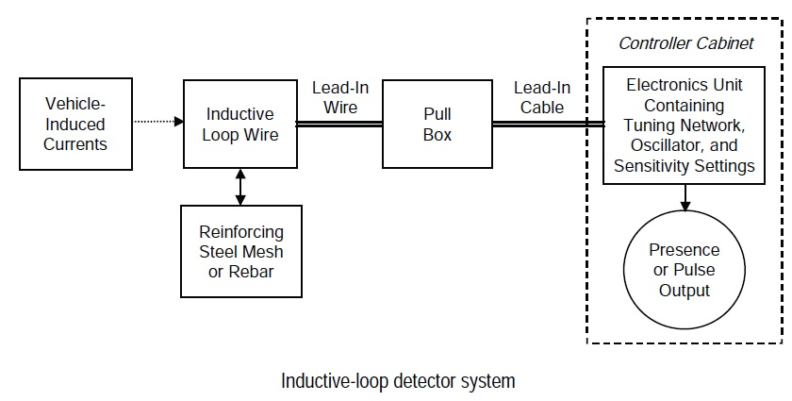

For vehicle classification, a core module and a vehicle detection module containing magnetic sensors are used. The iSense Core Module is based on a Jennic JN5148 wireless microcontroller, a chip that combines the controller and the wireless communication transceiver in a single housing. The controller provides 32 bit RISC computation, runs at a software-scalable frequency from 4 to 32 MHz and comprises 128kbytes of memory that are shared by program code and data. The radio part complies with the IEEE 802.15.4 standard. It achieves a data rate of 250kBit/s, provides hardware AES encryption and is ZigBee-ready. It supports distance measurements to neighboring devices using time of flight ranging.

The iSense Vehicle Detection Module (VDM10) is intended for detection of dynamic magnetic fields. The VDM10 is based on the two-axis anisotropic magneto-resistive (AMR) sensor Phillips KMZ52. The module also provides a de-gaussing circuitry and static magnetic field offset compensation. All three are controlled via I2C commands.

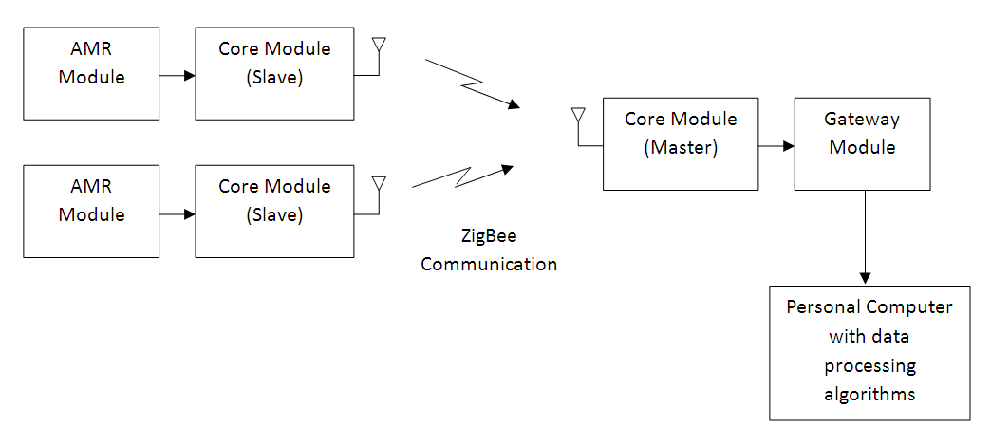

* **Innovativeness and usefulness**

The data acquired from the traffic monitoring and classification system can be used to improve the effectiveness of the existing transport networks and provides an alternative to expensive new roadway construction.

**Market Potential & Competitive advantage:**

The inductive-loop detector is, by far, the most widely used sensor in modern traffic control systems. They provide a simple and low cost solution when detection of vehicles is sufficient.

Video image processing is widely used for vehicle classification. However, this method suffers from disadvantages such as installation and maintenance including periodic lens cleaning. The performance is also affected by inclement weather such as fog, rain, and snow; vehicle shadows, vehicle projection into adjacent lanes, occlusion, day-to-night transition, vehicle/road contrast, and water, salt grime, icicles, and cobwebs on camera lens.

Thus magnetic sensor based classification systems offer an attractive alternative for vehicle classification since it is immune to most of the aforementioned problems.

**Tools**

* **Hardware:**
* iSense Core Module (DS_CM30X)
* iSense Vehicle Detection Module (VDM10)
* iSense Gateway Module (UG_GM10X)
* Induction loops
* **Software:**
* Cygwin
* iSense API
* iShell
* Eclipse (C++)
* LT Spice

**Conclusion**

The proposed traffic detection and classification system provides a low power, low cost solution for traffic monitoring. It can be used to create a dynamic database which can be utilized to promote effective usage of existing roadways and provide an alternative for expensive highway and freeway construction.

**List of publications on which project work is being proposed**

[1] Ravneet Bajwa, Ram Rajagopal, Pravin Varaiya and Robert Kavaler. In-Pavement Wireless Sensor Network for Vehicle Classification.

[2] Sing Yiu Cheung, Sinem Coleri Ergen and Pravin Varaiya. Traffic Surveillance with Wireless Magnetic Sensors.

[3] Farshad Ahdi, Mehdi Kalantari Khandani, Masoud Hamedi, Ali Haghani.

Traffic data collection and anonymous vehicle detection using wireless sensor networks.

**References**

[1] Traffic Detector Handbook: Third Edition—Volume I. Publication No. FHWA-HRT-06-108.

[2] S. Y. Cheung, S. Coleri, B. Dundar, S. Ganesh, C.-W.Tan, and P. Varaiya. Traffic measurement and vehicle classification with single magnetic sensor.

Transportation Research Record: Journal of the Transportation Research Board, 1917:173-181, 2006.

[3] L. E. Y. Mimbela and L. A. Klein. A summary of vehicle detection and surveillance technologies used in intelligent transportation systems.

Technical report, New Mexico State University, 2000.

[4] Honeywell International Inc., “Application Note Vehicle Detection Using AMR Sensors,” available at http://www.magneticsensors.com/datasheets/an218.pdf .

[5] *Traffic Signal Detector Loop Location Design Installation.* Illinois Department of Transportation, District 6, Springfield, IL. 1988.

[6] Courage, K.G., et al. *Inductive Loop Detector Configuration Study—Final Report*, transportation Research Center, prepared by University of Florida. Florida Department of Transportation, Tallahassee, FL. 1985.

[7] Jun Xing, Qi Zeng. A Model Based Vehicle Detection and Classification Using Magnetic Sensor Data. *Department of Signals and Systems,* Chalmers University of Technology, Sweden, 2007.