# Chapter 1: Introduction to Wireless power and Data Transfer

# Chapter 2: Model for the inductively coupled system

## Circuit Model

## Electromagnetic model

# Chapter 3: Electromagnetic simulation and Verifying Models

# Chapter 4: Transceiver for Power and Data transfer

# Chapter 5: Test Results

# Chapter 6: Conclusion

# By Nazia Zannat September 23rd, 2018

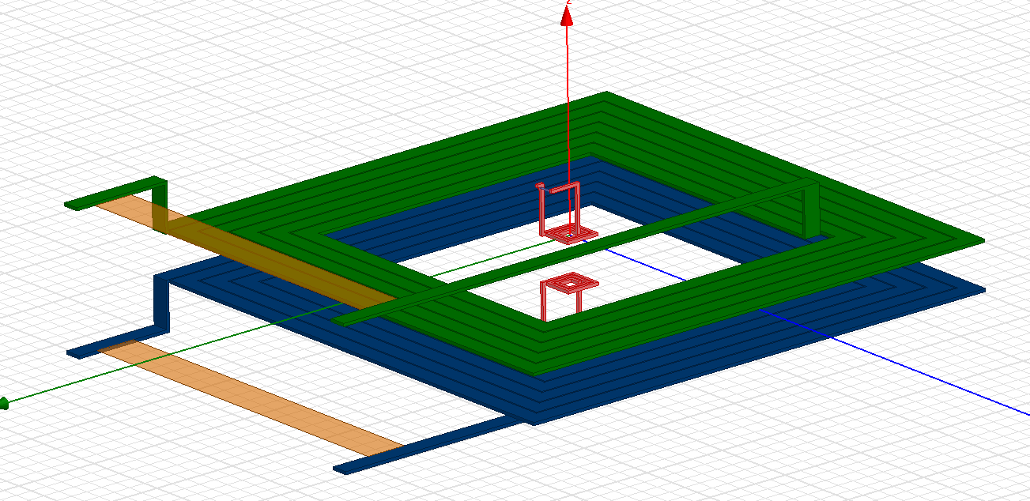

Is any ground layer needed?

Does developing this total system make a PhD topic?

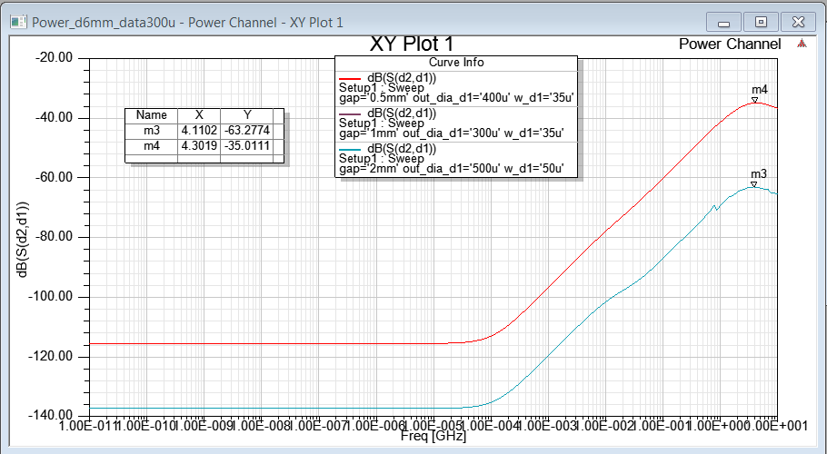

Fig: Data channel incorporated S21 of Data Channel

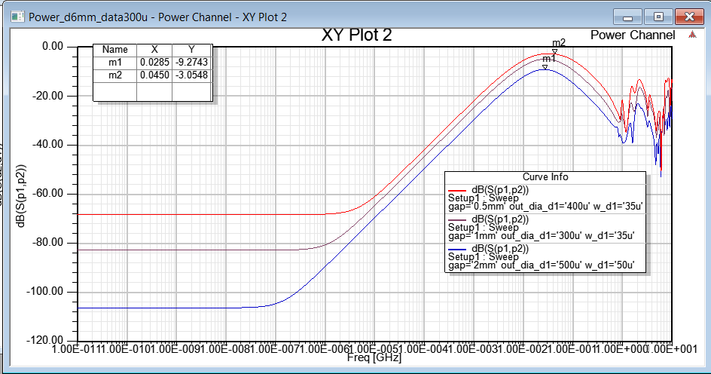

Fig: S21 of Power channel.

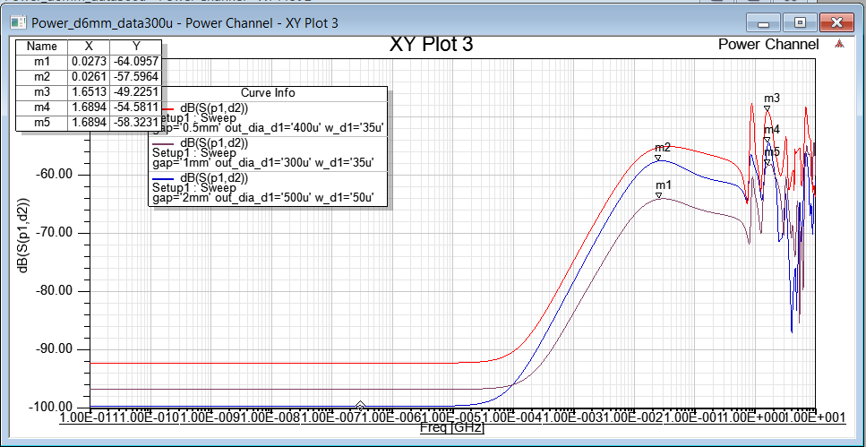

Xtalk between power and data channel

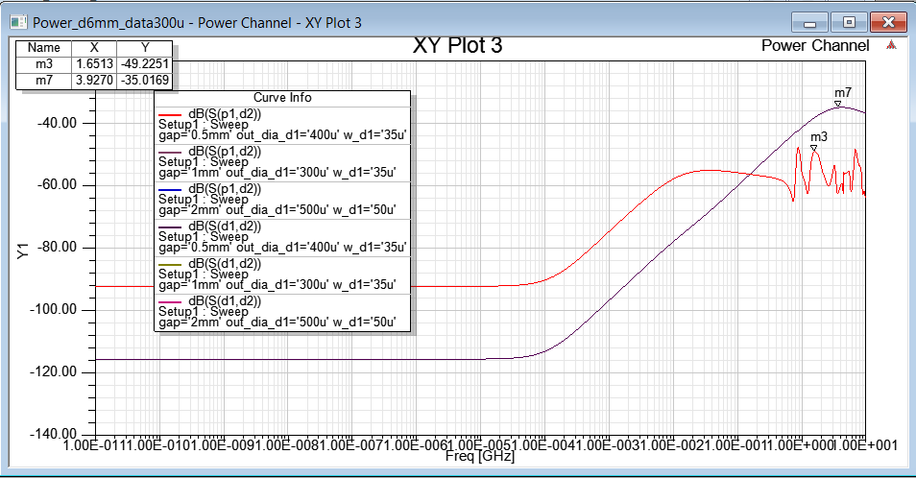

Power channel and data channel both received on Secondary data Channel