Increased rate of large vessel occlusive stroke following the Christchurch terror attack

|  |
| --- |
| Teddy Wu, MD, FRACP1, Daniel J. Myall, PhD1, & Campbell Le Heron, PhD, MD, FRACP1,2 |
| 1 Department of Neurology, Christchurch Hospital, Christchurch, New Zealand |
| 2 New Zealand Brain Research Institute, 66 Stewart St, Christchurch, New Zealand |
|  |

# Author note

Correspondence concerning this article should be addressed to Teddy Wu, MD, FRACP, 66 Stewart St, Christchurch 8011, New Zealand. E-mail: [Teddy.Wu@cdhb.health.nz](mailto:Teddy.Wu@cdhb.health.nz)

Abstract

**Abstract:** Abstract goes here

*Keywords:* Stroke, terror attack

Word count: Abstract: xx, main body: xx

Increased rate of large vessel occlusive stroke following the Christchurch terror attack

# Introduction

# Methods

## Sample

Christchurch hospital admits all people with stroke in Christchurch a city of 390 000, and provides endovascular thrombectomy for the South Island of New Zealand, population 4.8 million. Counts of ischemic stroke admissions, the numbers of patients with intracranial LVO, and the numbers who underwent reperfusion therapy (intravenous thrombolysis and/or endovascular thrombectomy) were collected for the week following the terror attack and from 1st January 2018 until 21st April 2019. These counts were repeated for the rest of New Zealand with the Christchurch data omitted.

## Analyses

Data for each measure, and by Christchurch and nationally, were fit with Bayesian Poisson models, using the R1 package *brms*.2 Parameters were given default weakly-informative priors. Four chains of 5000 iterations each were run. The probability of the rate observed in the week following the terror attack being higher than the background rate was calculated for each measure, with a probability higher than 0.99 providing strong evidence of an effect.

## Reproducibility

The code and the anonymised dataset used to conduct the analyses and generate this manuscript are available at <https://github.com/nzbri/terror-attack-stroke>.

# Results

In the week following the 15th March 2019 terror attack there was no evidence of difference in the number of ischemic stroke admissions (Figure 1 top left, mean rate = 27, probability of an increse after the terror attack P = 39%), but an increase in those receiving reperfusion therapy (Figure 1 bottom left, mean rate= 2.6, probability P = 99.9%). Over the same periods in the rest of New Zealand, there was no evidence of a difference in the number of ischemic stroke admissions (Figure 1 top right, mean rate = 105, P = 80%) nor strong evidence of an increase in the numbers of people treated with reperfusion treatments (Figure 1 bottom left, mean rate= 14, P = 96%).

Examining the type of strokes, in Christchurch there was an increase in the number of patients with Thrombectomys (Figure 2, left, mean rate = 1.4, P = 99.7%), intracranial LVOs (Figure 2 centre, mean rate = 2.4, P = 100.0%), and Thrombolysis strokes (Figure 2 right, mean rate = 1.9, P = 99.6%).

# Discusion

# Figure National

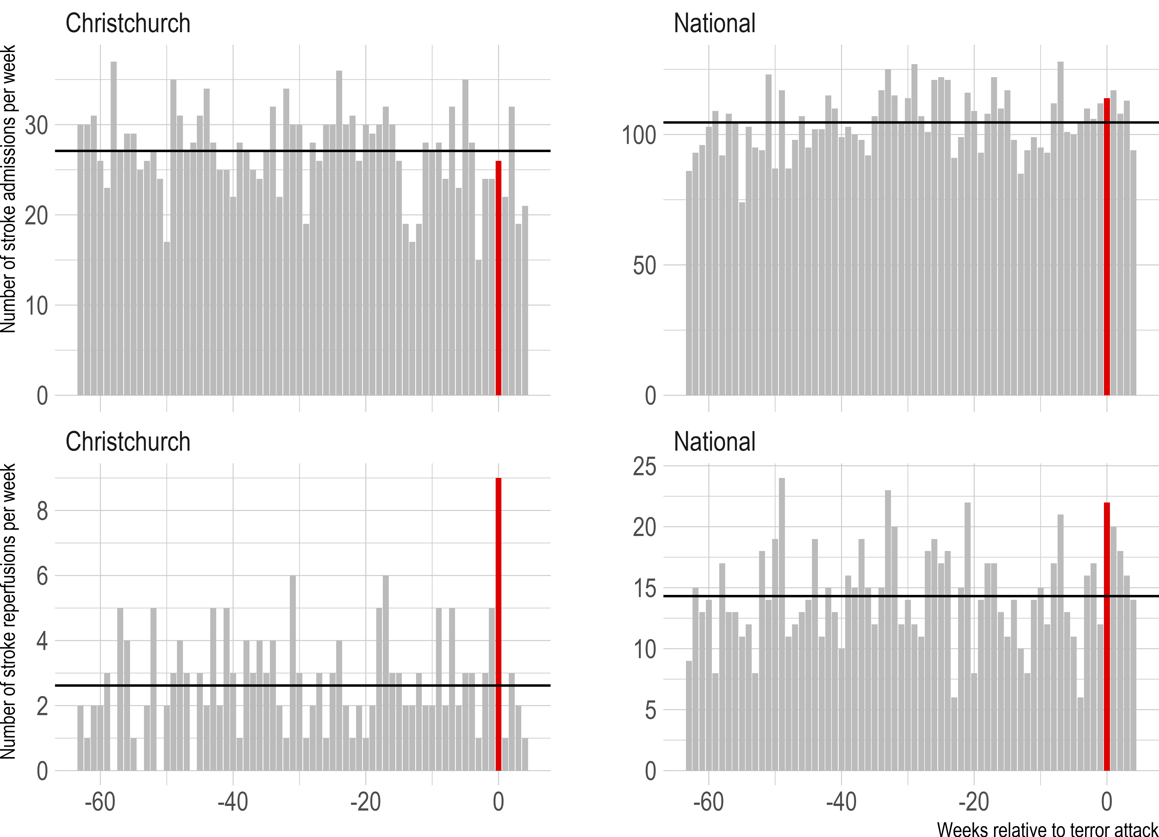

Figure 1: Number of stroke admissions (top row) and stroke reperfusions (bottom row) per week for Christchurch Hospital and nationally (excluding Christchurch Hospital). The week starting on Monday, following the stroke attack, is highlighted as week 0. The average number of admissions or strokes per week is shown by the black horizontal line. Figure by Myall (2020), distributed at <https://doi.org/10.6084/xx> under an open CC-BY 4.0 license.

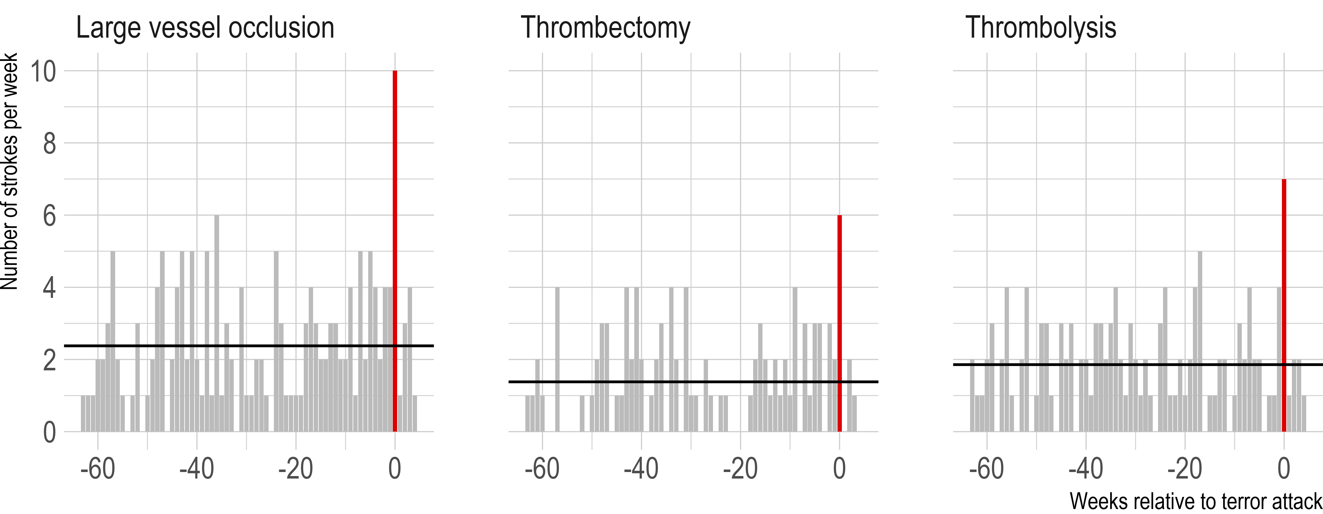

Figure 2: Number of strokes per week by type at Christchurch Hospital, with the week starting on Monday following the terror attack highlighted at week 0. The average number of strokes per week is shown by the black horizontal line. Figure by Myall (2020), distributed at <https://doi.org/10.6084/xx> under an open CC-BY 4.0 license.

# References

1. R Development Core Team. *R: A language and environment for statistical computing*. R Foundation for Statistical Computing, Vienna, Austria, <http://www.R-project.org> (2019).

2. Bürkner P-C. Brms: An R package for Bayesian multilevel models using Stan. *J Stat Soft* 2017; 80: 1–28.

1. R Development Core Team. *R: A language and environment for statistical computing*. R Foundation for Statistical Computing, Vienna, Austria, <http://www.R-project.org> (2019).

2. Bürkner P-C. Brms: An R package for Bayesian multilevel models using Stan. *J Stat Soft* 2017; 80: 1–28.