CareerIntelligence2026: A 2026 US Analyst Job Market Analysis
by
Dr. Ifunanya Grace Nze

Project Overview
As a Clinical Veterinarian switching into data analytics, I built this project to answer a practical question for my own job search: which industries and skills should I focus on to maximize my chances of landing a remote Analyst role in 2026?
CareerIntelligence2026 analyzes real, current US job postings for Analyst roles: Data Analyst, Business Analyst, Sales Analyst, Health Data Analyst, and related titles across three industries: SaaS, Healthcare, and Sales. The project covers the full analytics lifecycle: data extraction from a live API, cleaning and modeling in Python and SQL, and interactive dashboards in Power BI.

Dataset Summary
- Data source: Adzuna API (developer.adzuna.com), live US job postings, queried across 17 role/industry search combinations
- Raw postings collected: 2,168
- Final cleaned dataset: 2,018 rows (150 duplicates removed)
- Industries: SaaS, Healthcare, Sales
- Key fields: job title, company, industry, city/state, min/max/average salary, salary estimation flag, contract type, work arrangement, date posted, skills

Data Quality Issues Identified
- Adzuna's free-tier API truncates job descriptions to exactly 500 characters, even when requesting the full-description parameter, this limited downstream skill and work-arrangement detection
- Approximately 76% of postings had Adzuna-estimated salaries rather than employer-stated figures (flagged via an is_estimated column throughout)
- Some narrow role/industry search terms (e.g. "Sales Operations Analyst SaaS") returned very few or zero results due to literal keyword matching
- ~81% of postings did not explicitly mention a work arrangement (remote/hybrid/on-site) within the available text

Data Pipeline (Python)
I built a modular Python pipeline rather than a single script, so each stage could be tested and re-run independently.
- Extraction (extract_adzuna.py): pulled paginated job data from the Adzuna API for each role/industry search, tagging every record with its industry at the source, and saving raw JSON before any transformation
- Transform (transform.py): flattened nested JSON responses into a single tabular CSV
- Clean (clean.py): removed duplicate postings, calculated average salary from min/max, labeled estimated vs. employer-stated salaries, standardized missing location and date fields
- Skills extraction (extract_skills.py): scanned job description text for a defined list of relevant tools and skills (SQL, Python, Power BI, Excel, Tableau, AWS, and more), producing a normalized job-to-skill mapping table
- Work arrangement classification: keyword-matched job titles and descriptions to flag Remote / Hybrid / On-site postings
- SQL loading (load_to_sql.py): loaded the cleaned dataset into SQL Server via SQLAlchemy for relational analysis
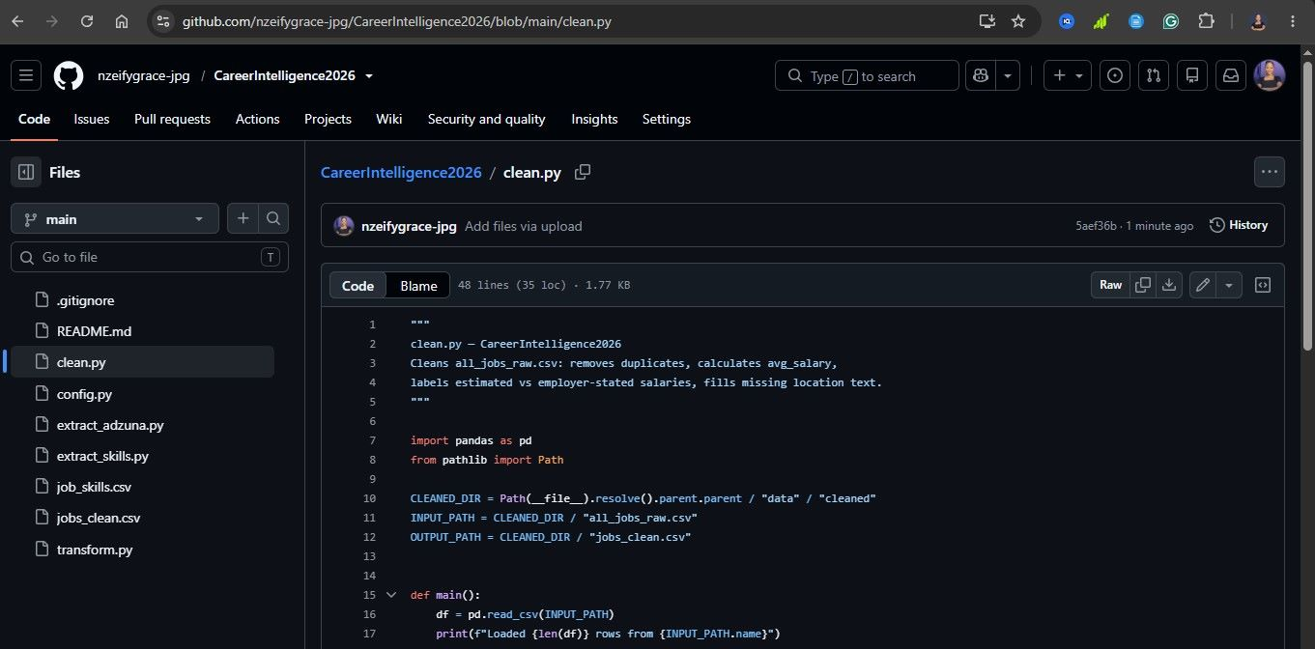

Relational Modeling & Analysis (SQL Server)
Rather than working from a single flat CSV, I modeled the data relationally in SQL Server: a jobs table holding one row per posting, and a normalized job_skills table holding one row per job-skill pair. This structure made real analytical queries (top skills, salary by skill, skill co-occurrence) straightforward via JOINS instead of parsing text.

Example analysis performed in SQL
- Total postings and average/median salary, overall and by industry
- Top hiring companies and states by posting volume
- Salary comparison between employer-stated and Adzuna-estimated postings
- Most in-demand skills, and average salary associated with each skill
- Skill co-occurrence — which tools tend to appear together in the same posting (via a dedicated SQL view)
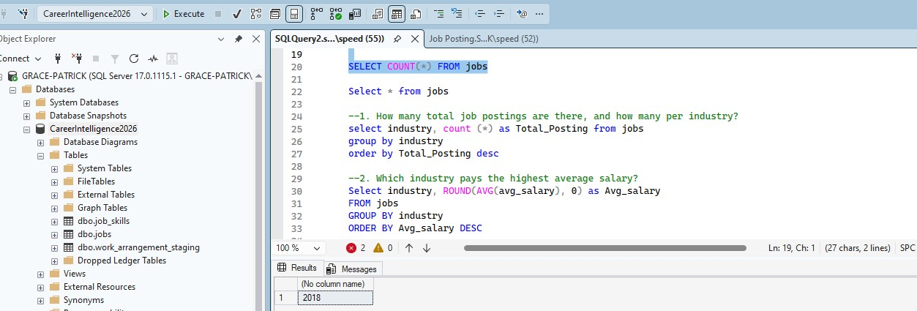

Dashboards in Power BI
I connected Power BI directly to the SQL Server database and built three focused dashboards, mirroring how a real analytics team might separate executive, compensation, and workforce-skills reporting.

Page 1: Executive Overview
Total postings, Average and Median salary, Percentage of postings marked Remote, Postings by Industry, Top 10 hiring companies, Top states by posting volume, and a Work-arrangement breakdown.

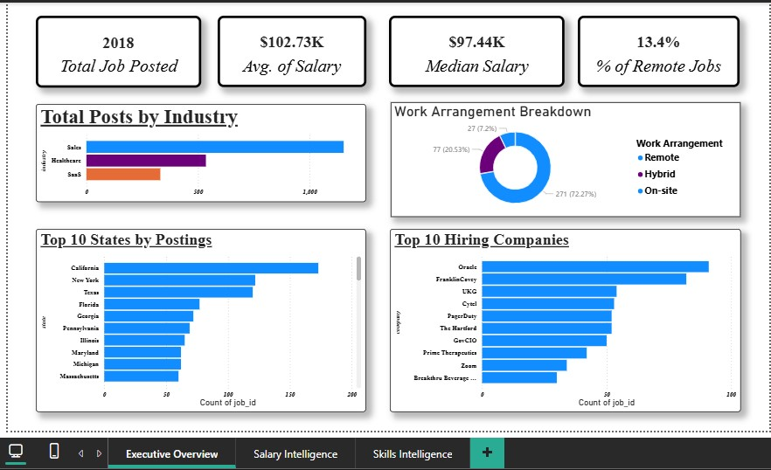

Page 2: Salary Intelligence
Average salary by Industry, Top paying job titles and states (filtered to titles/states with at least 3 postings to avoid single-outlier distortion), a Salary distribution histogram by band, and a comparison of Employer-stated vs. Adzuna-estimated salaries.

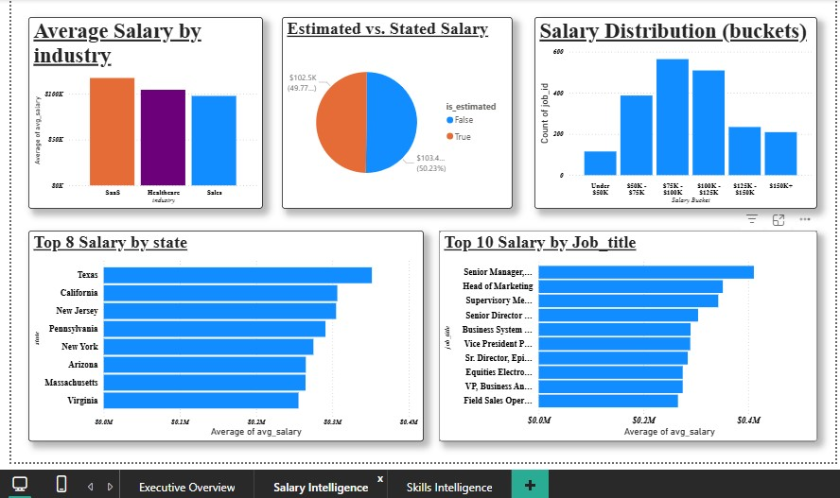

Page 3: Skills Intelligence
Top in-demand skills, Average salary by skill, Skills broken down by industry, and a Skill co-occurrence table showing which tools most often appear together in the same posting.

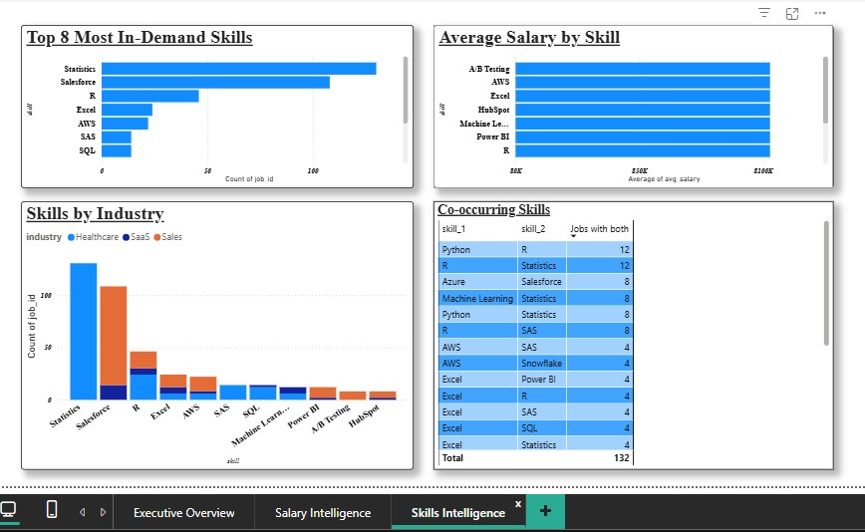

Key Findings
- SaaS postings show the highest average salary among the three industries, followed by Healthcare and Sales
- Adzuna's estimated salaries closely track employer-stated ones (within roughly $1K on average), lending reasonable confidence to using estimated figures where real ones are unavailable
- Statistics and Salesforce were the most frequently mentioned skills across postings, though overall skill-mention volume was limited by the description-truncation issue noted above
- Only a small share of postings explicitly mention remote work in the available text, likely an undercount rather than a true reflection of remote availability

Reflection & Next Steps
This project reflects the full, sometimes messy reality of working with a live API rather than a pre-cleaned Kaggle dataset, including diagnosing a hard data-source limitation (description truncation) using evidence rather than assumption, and making a deliberate, documented decision about how to handle estimated vs. real salary data rather than quietly treating all figures as equally reliable.
Future iterations could address the description-truncation constraint by pulling full postings from an alternate source, expand the skill keyword list, and add month-over-month tracking to observe how salary and skill demand shift over time.

