A Model for Melting Ablation in Hypersonic Heating

T. F. Zien, Ph.D
Senior Research Scientist
Naval Surface Warfare Center, Dahlgren Division
Dahlgren, Virginia 22448, U. S. A.

Abstract

We will present some recent research in the mathematical modeling of melting ablation in hypersonic flows. Emphasis will be placed on the case where a melt-layer of the indigenous ablative material is formed in the ablation process. A simple mathematical model will be presented for the analysis and computation of steady ablation in the neighborhood of the stagnation point of a blunt-nosed body in hypersonic flight. The model consists of an inviscid flow downstream of the bow shock, a viscous boundary-layer of the hot gas, a melt layer and an ablating solid. All these regions are properly coupled through appropriate boundary conditions on the interfaces. A class of similarity-type solutions is constructed on the basis of the model, and the solutions of the fully coupled ablation problem will be presented. These solutions include the velocity and temperature distributions in the melt layer, the effectiveness of the melt layer as a heat shield and the ablation speed in terms of the freestream conditions, material properties and the thermal conditions of the ablating solid. The analytical nature of the approach allows the characteristic parameters of the physical problem to be easily identified, and the parametric dependence of the solution appears explicitly. We will then describe an extended model for hypersonic ablation with sparse particles/droplets in the gas stream, and some preliminary results of the thermal effects of these particles on ablation will be presented. Some suggestions for future research in this direction will be included in the concluding remarks.

- Introduction

An understanding of the aerodynamic ablation phenomena is essential to the optimal design of thermal protection systems for various operations in ultra high-temperature environments. Examples of such severe thermal environments include those encountered by spacecrafts during reentry into the earth atmosphere, reentry missiles, vertical launcher systems used for missiles, space vehicles, etc., to name only a few. However, aerodynamic ablation has long been recognized as one of the most challenging problems in aerodynamic heating. Experimentally, it is difficult to simulate the phenomena in a ground testing facility, and flight test for such phenomena is generally prohibitively expensive. The problem is difficult also from a theoretical standpoint because of its inherent complexities that include phase changes of materials involved, moving interfaces, various physical/chemical reactions and the strong coupling of different regions of fluid dynamic and thermal interest.

Some research efforts have been undertaken recently by the present author and C. Y. Wei ⁽¹⁻⁴⁾ in the mathematical modeling of hypersonic ablation, and our research was aimed at understanding the basic aspects of fluid dynamics and heat transfer associated with the physical phenomena. Thus, we proposed a simple model for the study of thermal ablation near the stagnation point of a blunt-nosed body in hypersonic flight. We focused our attention on a restricted class of aerodynamic ablation problems where the phenomena involve the melting of the ablative material, such as the ablation of glassy materials studied earlier by Lees ⁽⁵⁾ , Hidalgo⁽⁶⁾, among others. Here a thin melt layer formed by the molten ablative material plays a critical role in providing a heat shield to the aerodynamic body. Various complicated physical-chemical processes taking place in the ablative material and their interactions with the flow field are not included in the consideration. Our model consists of an inviscid flow downstream of the strong bow shock, a viscous boundary-layer of the hot gas, a melt layer and an ablating solid. All these regions are properly coupled through appropriate boundary conditions on the interfaces. We note that the model studied here has a similar structure to the one used by Roberts⁽⁷⁾ who studied the problem of ice melting in a low-speed airflow.

The mathematical model proposed for the class of hypersonic ablation problems under consideration is amenable to theoretical treatment without the expenditure of an undue amount of computational efforts. Parameters characterizing the fluid dynamics and heat transfer of the model problem can be easily identified, and the parametric dependence of the solution on such parameters will become apparent in the course of the analysis.

The model is easily extendable to include the effects of particles and droplets in the gas stream on hypersonic ablation for the case of sparse particles. The hypersonic ablation in the presence of small particles is also a problem of practical importance (see, for example, Ungar⁽⁸⁾). In a typical reentry body environment, there are often small particles in the form of dust clouds, moisture particles, ice crystals, etc. in the free stream. In certain vertical launcher systems used for missiles, space vehicles, etc., the high-velocity, high-temperature solid rocket motor exhaust often contains aluminum-oxide particles/droplets. These particles carry large thermal and kinetic energies as they enter the thermal protection system, and their effects on the performance of the system are thus expected to be significant. While the study of mechanical effects of the particles on ablation, including erosion, will require a model for material responses and is thus beyond the limit of the present model, their thermal effects can be readily studied approximately within the framework of the present model. It is noted here that in the operation of certain vertical missile launchers, the particle number density is rather high, and the melt layer formed by the aluminum-oxide droplets/particles in the ablation process could become more important than that formed by the indigenous ablative material (see, for example, Lewis and Anderson⁽⁹⁾). A separate model will be necessary to study such problems.

In the present paper, we will briefly review the results of our recent modeling research on hypersonic ablation. The conservation equations for the individual regions of the model will be discussed, and the appropriate boundary conditions on the interfaces will be developed and implemented to provide the proper coupling of these regions. A class of similarity-type solutions of the model problem will be constructed, and the approximate integral solutions and the more exact numerical solutions will be presented for some typical cases. Relevant parameters governing the fluid dynamics and heat transfer of the ablation model are identified and their effects on the ablation are made apparent. We will also present some preliminary results of the thermal effects of particles in the gas stream based on the aforementioned sparse-particle model. Some suggestions for future research in this direction will be discussed in the concluding remarks.

- The Basic Model

The basic model here refers to the particle-free hypersonic ablation model developed and studied by Zien and Wei in Refs.1-3. The flow configuration and the model structure are shown, respectively, in Figs.1 and 2. In brief, the model consists of an inviscid hypersonic flow approaching a circular-nosed body of radius R. In the neighborhood of the stagnation point, the inviscid flow downstream of the normal shock drives the flow in the gas boundary layer (region 1). A melt layer, region 2, that is made up of the molten solid forms underneath the boundary layer, and the two-dimensional motion of the melt allows part of the thermal energy to be convected away from the stagnation-point, thus providing a shielding effect to the ablating solid. The melt layer connects to the ablating solid. Region 3, through the interface, that is, the ablation front, where an additional amount of thermal energy in the melt is consumed as the latent heat of ablation, resulting in a further reduction of the heat flux entering into the solid structure. For convenience in analysis, we will use a coordinate system fixed with the ablation front, which is receding with an unknown, but constant speed W_{m}. In this coordinate system, the ablation front (z=0) appears stationary, and the molten solid is being injected into the melt layer at a velocity equal to W_{m.}.

  - Analysis of the Basic Model

In terms of the coordinate system described above, the analysis of the model is carried out as follows. First of all, the gas is assumed to be calorically perfect for simplicity. The freestream Mach number is assumed to be very large, 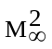 >> 1, so that the shock wave is strong and the hypersonic Newtonian theory can be used to calculate the inviscid surface pressure on the body. The surface pressure distribution is used to determine the inviscid velocity gradient at the stagnation-point. This serves as the starting point of the analysis of the model problem. The surface pressure gradient drives the flow of the hot gas (region 1), and the flow field is modeled as the compressible stagnation-point boundary layer for which similarity solutions exist. However, the classical formulation of the self-similar flows is slightly modified to allow for the (slow) motion of the gas-melt interface, z=z*, whose location and velocity are both unknown in advance, and are to be determined by matching the boundary-layer flow and the flow of the melt in the melt layer. The flow in the thin melt layer is assumed to be viscous and incompressible. While the melt flow is necessarily two-dimensional, the temperature variation in the layer is expected to be mostly in the normal direction. The ratio of the heat flux leaving the melt layer to that entering the layer, which is a measure of the effectiveness of the melt layer as a heat shield to the solid structure, can be easily expressed in terms of the solution of the melt-layer flow. Finally, the heat flow in the “moving” ablating solid (region 3) is assumed to be one-dimensional. Appropriate boundary conditions on the two interfaces, i.e., between regions 1 and 2, and between regions 2 and 3, will be developed and applied to complete the formulation of the fully coupled model problem. It is noted here that in the present analysis, evaporation of the melt is not considered, so that the boundary conditions on the gas-melt interface are much simplified. Many details are omitted here but appear in Refs. 2 and 3.

A. Inviscid Flow

We consider the limit of Newtonian flow in hypersonic aerodynamics^{(10,11)} , i.e., >>1 and 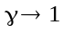 such that N 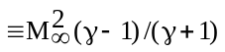= 0 (1). In this limit, the surface pressure near the stagnation-point of the circular-nosed body of radius R is given by the following simple expression:

P_{b}(x) 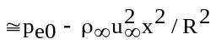 (1)

where p_{e0} is the stagnation-point pressure. We note that 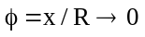and also 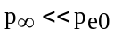 in this limit. Note that the inviscid surface pressure as given above is equal to the pressure on the gas-melt interface, 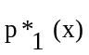, in the boundary-layer approximation.

The inviscid velocity gradient at the stagnation point, (du/dx)₀, is related to the surface pressure gradient by the inviscid momentum equation and is evaluated as (see Ref. (1))

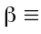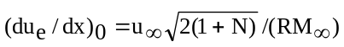. (2)

B. Stagnation-Point Boundary Layer (Region 1)

We will use the subscript 1 to denote conditions in this region and the superscript * to denote conditions at the interface. Also, in trying to seek similarity solutions for the model problem, we will assume that the gas velocity at the interface is ( u*, w*) = 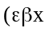, 0) so that the similarity structure of the boundary layer is preserved. Here, is an unknown constant that must be determined as part of the solution. It measures the speed of the melt motion relative to that of the gas flow in the boundary layer and is expected to be small.

We will use the following modified similarity variables⁽⁷⁾ :

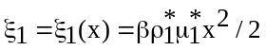 (3a)

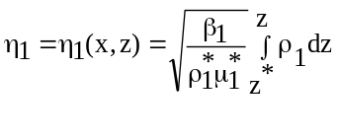 (3b)

where standard notations are used. Note that 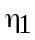= 0 at the gas-melt interface.

The momentum and energy equations pertaining to the self-similar, hypersonic stagnation-point boundary layers can be reduced to the following set of coupled ordinary differential equations for
(Ref.12):

(Cf₁’’)’ + f₁ f₁’’ + g₁ – (f₁’)² = 0 (4)

g₁’’ + (Pr₁ / C) f₁ g₁’ = 0 (5)

where f₁(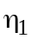) is related to a stream function such that

u = 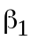x f₁’() (6)

and g₁() is the nondimensional temperature, that is,

T/T_{e} = g₁() (7)

where T_{e} is the temperature in the external inviscid flow. The appropriate boundary conditions for f₁ and g₁ are

f₁(0) = 0, f₁’(0) = , f₁’() = 1 (8a)

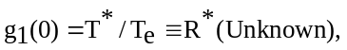 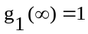 (8b)

In the derivation of the above set of equations, we have used the standard viscosity-temperature relation, that is, 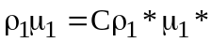, and the Prandtl number of the gas, Pr₁, is assumed to be constant (=0.7).

It is obvious from the system of equations, Eqs.( 4, 5, 8), that the two unknown constants, and R*, determine the boundary-layer flow. These two parameters must, in turn, be determined when the boundary-layer solution is coupled to the melt-layer solution. Solutions of f₁(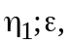R* ) and g₁(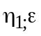,R*)
are easily obtained either numerically by a fourth-order Runge-Kutta shooting method or by a Karman-Pohlhausen (KP) type of integral method for given values of (,R*). We note that the shear stress and the heat flux at z=z*, 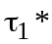 and , respectively, will be used later in the coupling, and they are given below:
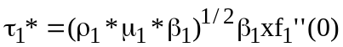; (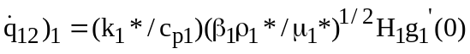, (9a,b)
where H₁ is the total enthalpy of the external inviscid stream.

In the integral solutions, we assume the following forms for the solutions of f₁ and g₁ that satisfy the boundary conditions.

f₁() = 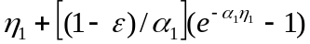, 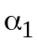>0 (10a)

g₁() = 1 – (1 – R*) e⁻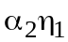, 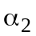>0 (10b)

where and are two profile parameters to be determined. The quantities of particular interest to our problem, f₁’’(0) and g₁’(0), are given as functions of 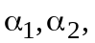R* and :

f₁’’(0)=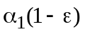; g₁’(0)=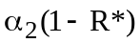 (11a,b)
Some typical solutions are given in Zien and Wei⁽²⁾ where the accuracy of the KP solutions is also discussed. Solutions of the boundary-layer flow for the fully coupled problem will be discussed in Sec. 1.4.

C. Melt Layer (Region 2)

The flow in this region is assumed to be viscous and incompressible, and the conservation equations for mass, momentum and energy are, respectively, given in the following :

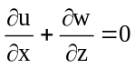 (12)

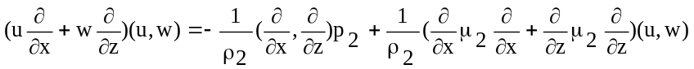 (13)

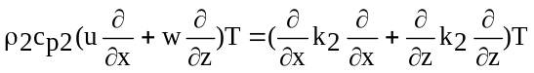 (14)

where the notations are standard and the subscript 2 is used to denote quantities in this region. The boundary conditions are

z = 0: u = 0, w = W_{m,}, T =T_{m} (15)

z = z*: u =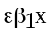 w = 0, T = T* (16)

where T_{m} is the constant melting temperature of the solid. T* is equal to the gas temperature at the interface between regions 1 and 2, and W_{m} is the unknown ablation speed. Here we have made the approximation that the density of the melt is the same as that of the solid. The boundary conditions above imply the continuity of (u, w, T) across the interface, and they are appropriate if no phase change of the melt takes place at the interface.

Again, in seeking similarity solutions, we assume the following forms for the velocity (u, w):

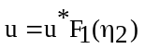 (17)

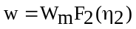 (18)

In the preceding equations, u* is the gas speed at the interface, i.e.,

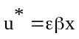 (19)

and 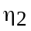is the similarity variable in region 2, defined as

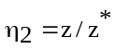 (20)

where z* is the unknown melt-layer thickness.

The above forms of the solutions allow the matching conditions, Eqs.( 15) and (16) to be satisfied.

The continuity equation then gives a relationship between F₁ and F_{2,}

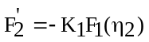 (21)

where the constant parameter K₁ is defined as

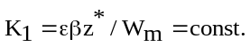 (22)

As was noted in Refs. (1-3), the continuity equation also gives the important and interesting result that for the case of steady ablation, W_{m} = const., under consideration, the melt-layer thickness is constant, i.e., z*=const.

It is shown in Zien and Wei⁽²⁾ that the momentum equations can be reduced to a single fourth-order, nonlinear ordinary differential equation for F₂( ), and the pressure distribution in the melt layer can be expressed in term of F₂(). The results are as follows:

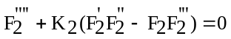 (23)

(24)

In the above equations, another important dimensionless parameter, K₂, is introduced and it is defined as

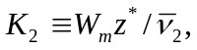 (25)

where

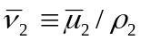 (26)

is an average kinematic viscosity of the melt in the melt layer. It is used in the analysis strictly for simplicity. Note that K₂ so defined is a Reynolds number for the melt-layer flow. In addition, the non-dimensional pressure, 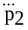, and the non-dimensional coordinate, , are defined, respectively, as

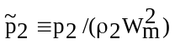 (27)

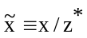 (28)

The boundary conditions for Eq. (23) can be easily derived from Eqs. (16, 17, 21) as

F₂(0) = 1, F₂(1) = 0, 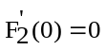, 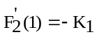 (29)

The constant, , that appears in the pressure distribution, Eq. (24), is defined as

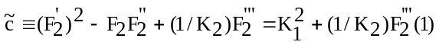 (30)

(see Zien and Wei⁽²⁾).

We note particularly the results of the pressure and the shear stress, respectively, at the gas-melt interface ( =1), 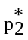 and 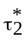, as follows:

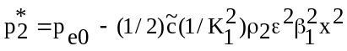 (31)

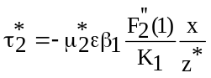 (32)
as they will be used later in the coupling.

Eqs. (23) and (29) determine the solution of the velocity (u, w) in the melt layer for a given set of values (K₁, K₂). They are easily solved numerically by a fourth-order Runge-Kutta shooting method, and some typical solutions are given in Refs. (2, 3). They can also be solved approximately by a KP type integral method, and the integral solutions can be used effectively to simplify the implementation of the coupling procedure to obtain the coupled solutions of the complete model problem (see Ref.(2)). For a KP solution, the following polynomial profile is used⁽²⁾:

(33)

The energy equation, Eq. (14) can be rewritten as

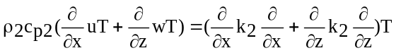 (34)

In this form, the effect of convection in the melt layer on the heat fluxes in and out of the region can be made apparent by integrating the equation across the melt layer. We introduce a non-dimensional temperature, 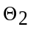, defined as

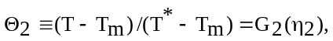 (35)

where T_{m} is the melting temperature of the ablative material, and it is also the temperature at the ablation surface. Next, we assume that is only weakly dependent on x, that is, the thin melt-layer approximation. The assumption is reasonable also because of the significant temperature drop across the melt layer as required by the boundary condition.

Integrating Eq. (35) across the entire melt layer and using the appropriate boundary conditions on u, w, and T as given by Eqs. (15) and (16), we obtain

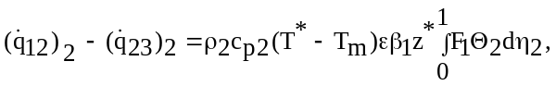 (36)

In Eq. (36), 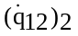 and 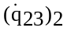are, respectively, the heat fluxes into and out of the melt layer (see Fig. 2):

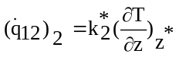 (37a)

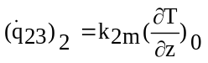, (37b)

where the subscript m denotes conditions atr the ablation front, z = 0, and the superscript * denote conditions at z = z*, as before. It is, thus, apparent from Eq. (36) that the convection current accounts for the reduction of heat flow into the solid.

For simplicity, we will use an average thermal conductivity 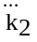for the melt to account for the effect of significant temperature variations anticipated in the melt layer. Thus, we write Eq. (14) in non-dimensional form as follows:

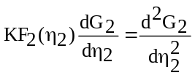 (38)

where another dimensionless parameter K is introduced, and it is an effective Peclet number of the melt defined by

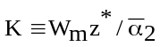 (39)

with 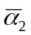 denoting the effective thermal diffusivity, 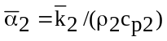. The boundary condition for
Eq. (38) are

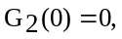 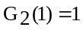. (40)

The solution of 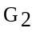is easily obtained as

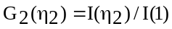 (41)

where

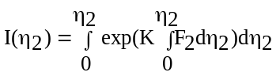 (42a)

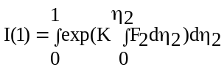 . (42b)

It then follows that

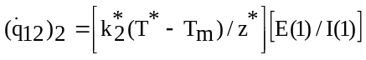 (43a)

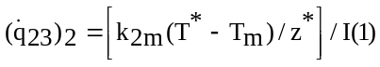 (43b)

where

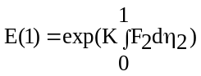 (44)

The shielding factor r defined as

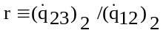 (45)

is given by

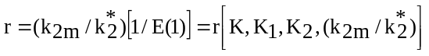. (46)

In the derivation of this result, the ratio k_{2m}/k₂* appears naturally, although some average value of the thermal conductivity was used in the solution of the energy equation. It is clear from Eq. (46) that r < 1, as expected. Solutions of Eq. (46) have been computed and given in Ref. (2) for some typical values of the parameters, K, K₂ and k_{2m} = k₂* as a function of K₁. The results of the particular case where K₂=1 and Pr₂=5 are reproduced here in Fig. (3). From Eqs. (22) and (25), we have

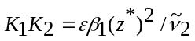, (47)

Therefore, for a given K₂, 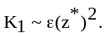 It is seen in Fig. (3) that r decreases as or 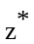 increases, which is also intuitively expected. It is clear from Eqs. (44) and (46) that the melt layer provides a better heat shield to the solid if the molten ablative material has lower thermal diffusivity, that is, larger Prandtl number (hence larger K).

Of course, K₁ and K₂ are functions of the flow parameters in the melt region, and, as such, they must be related to those of regions 1 and 3 through coupling for the complete solution of the coupled model ablation problem under consideration.

D. Ablating Solid

In the coordinate system used here, the solid is moving in the z-direction with a constant velocity W_{m}, and the heat conduction appears steady and is assumed one-dimensional. The equation and boundary conditions are as follows:

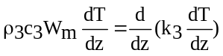 (48)

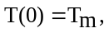 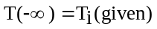 (49)

where T_{i} is the temperature of the solid far away from the ablating front

The solution for the temperature is easily obtained as

(50)

where, as in Section 2.1C, an average value of thermal conductivity, 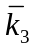, is used to simplify the result, and the thermal diffusivity of the solid, 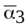, is thus assumed constant.

At the ablation front, z = 0, the heat balance requires that
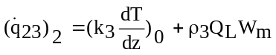 (51)
where Q_{L} is the latent heat of ablation per unit mass of the solid. It is clear from Eq. (51) that the ablation process consumes an additional amount of heat flux leaving the melt region so that the heat flux entering the solid, (k₃ dT/dz )₀, is further reduced. Upon substitution of the solution of the temperature, Eq. (50), into Eq. (51), we have

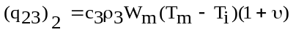 (52)
where

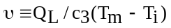 (53)

is an ablation parameter (see, e.g., Zien⁽¹³⁾).

1.2. Coupling

The solutions for different regions of the model, present in Sec. 2.1, must be coupled to form a complete solution for the physical problem of hypersonic ablation under consideration. The coupling is accomplished by appropriate boundary conditions on the interfaces. Details of implementing the coupling based on integral solutions of regions 1 and 2, and also on the numerical solutions of these regions appear, respectively, in Ref. (2) and ref. (3), and an assessment of the approximate solutions based on the coupling of integral solutions is also available in Ref. (3). Suffice it to say here that the integral solutions are found to be reasonably accurate for the cases computed.

A. Gas-Melt Interface (z = z*)

The interface boundary conditions here are continuity of velocity, (u, w), and temperature, which have already been incorporated into the formulation of the problem. The following additional boundary conditions are required:

- Continuity of heat flux

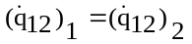 (54)

because no phase changes or chemical reactions on the interface are considered in the present model.

(2) Continuity of normal stress is required. Because the viscous normal stress is expected to be small
compared to the pressure in the hypersonic environments, the pressure is required to be continuous across the interface:

p₁* (x) = p₂* (x) (55)

Using Eqs. (1) and (31) for p₁*(x) and p₂*(x), respectively, we see that the pressure matching is possible because the pressures on both sides of the interface have the same x-dependence. The matching gives the following equation relating the parameter of region 1 to the parameters of the melt layer, and K₁:

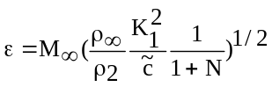 (56)

after Eq. (2) is used for . In a typical hypersonic ablation case where 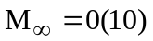 and 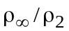=0(10⁻⁴) , Eq. (55) gives = 0 (10⁻¹), which is indeed small.

(3) Continuity of shear stress is required. Here, we require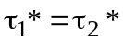. Eqs. (9a) and (32) then give the following relation between the melt-layer thickness and the flow parameters in the gas boundary layer:

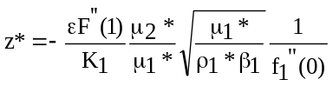 (57)

- Melt–Solid interface (z = 0)

The heat balance equation, Eq. (51), couples the melt region to the ablating solid, and the continuity of velocity at the interface, (u, w) = (0, W_{m}), is already accounted for in the formulation of the flow problem in region 2.

- Summary of Results of Coupling

Combining Eqs. (9b), (43a) and (54), we get

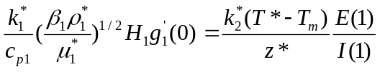 (58)

Combining Eqs. (43b) and (52), we get

. (59)

Eqs.(22), (25), (30) and (56-59) form a system of seven equations for the seven unknowns, 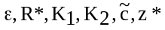 and W_{m},, in terms of the given conditions of the freestream and the material properties involved.

  - Length and Velocity Scales

It is convenient to present and discuss results in a nondimensional form. To do this, we will first
introduce the following length and velocity scales:

= 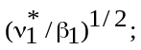 V = (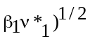 (60a,b)

where 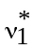 is the kinematic viscosity of the gas at T = T*. Note that is a measure of the thickness of the gas boundary layer of region 1, and V is a typical normal velocity of the boundary-layer flow. Using l and V, we define dimensionless z* and W_{m} as follows:

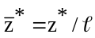 , 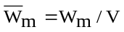 (61a,b)

The system of equations listed in Sec. 2.2C can be easily cast into dimensionless form using the above dimensionless quantities (see Refs. 2-3).

  - Solutions

As discussed in Refs. (2) and (3), it is convenient to use the inverse approach to solve the above
system of equations for the fully coupled model problem. In this approach, we specify the values of the parameters (, R*) that characterize the gas boundary-layer flow in region 1, and determine the nondimensional parameters Acp and B* that describe, respectively, the freestream energy level of the gas and the thermal conditions of the ablating solid. The nondimensional parameters are defined as

Acp = (C_{p2}/C_{p1}) (T* - T_{m}) / T_{e0} (62)

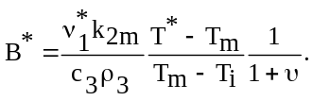 (63)
This approach is convenient because using the given values of 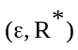 allows the differential equations for the boundary-layer flow, Eqs. (4, 5, 8), to be solved independently of the other equations, and the various boundary derivatives of the functions f₁ and g₁ needed in the coupling can be calculated explicitly. This will greatly facilitate the iteration process necessary for the solution of the system of equations for the coupled problem, Eqs. (22, 25, 30, 56-59).

Details of the solution process are available in Ref. (2) where the KP solutions for the regions 1 and 2 are used in the coupling, and in Ref. (3) where the numerical solutions for the two regions are used. Rresults of the computation of some typical cases are also presented in the above references. In brief, the prescribed values of are used to obtain the corresponding values of the parameters 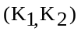 through a proper iterative procedure of solving the system of equations for the coupled problem, given the material properties involved and certain freestream conditions. This crucial step establishes the coupling of the boundary-layer flow and the melt layer, as the parameters 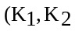) completely determine the melt-layer flow. In the course of the solution, two convenient nondimensional parameters, m and N_{m}, are introduced, and they are defined as

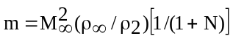 (64)

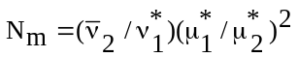, (65)

These parameters roughly describe the freestream conditions and the material properties in regions 1 and 2 of the model, and they are used in the presentation of results. We will only present some representative results in this paper. Figs. (4a,b) show the results of K₁ and K₂ , respectively, as functions of N_{m} for (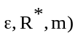= (0.2, 0.4, 0.1). Both the results of the coupling of the numerical solutions and those of the coupling of the KP solutions are included for comparison. The corresponding profiles of the velocity components and temperature in the melt layer for the particular value of N_{m}= 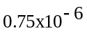 and 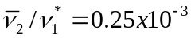are shown in Fig. 5. Also, for this particular case, the solutions for the important quantities, 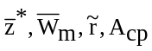and B* are shown, respectively, in Figs. (6a-e) which again include both the coupling of integral solutions and coupling of the numerical solutions. An example was given in Ref. (2) to illustrate the use of the general results presented above. Efforts are still continuing to search for the thermodynamic and thermophysical properties of materials used in practical thermal protection systems, so that realistic applications of the present models can be made.

1.5 Discussion

The validity of the ablation model and its analysis presented here are limited to the class of problems where a melt layer of the ablative material forms in the process. The purpose of the research is to provide some understanding of the basic aspects of fluid dynamics and heat transfer pertaining to the complex, but important, phenomena of thermal ablation in high-speed flight. The configuration of ablation near a stagnation point is chosen for the model primarily for its practical importance in aerodynamic heating. The nature of the flow in this region admits a class of similarity solutions that greatly simplify the analysis and computation of the fully coupled model problem. For some special cases with specific values of the relevant parameters of the model, we have successfully constructed and computed such solutions both by numerically and approximately by an integral method. While a general proof of the existence of such similarity solutions will be extremely difficult and beyond the scope of the present research, we hope that the success in constructing and computing these solutions reported here will serve as an indication that they do indeed exist, at least for the range of the parameter space considered in Refs. (2) and (3). Of course, the ultimate validation of the model and the solutions must await careful experimentation.

- The Sparse-Particle Model

In this section, we will briefly describe an extension of the basic hypersonic ablation model to include the effects of particle or droplets in the gas stream. Aerodynamic ablation in the presence of particles/droplets occurs in many cases of operation of thermal protection systems, as discussed in Section 1 of the paper. An immediate, and also the most straightforward, extension will be to consider the case of sparse particles. Here we refer to the case where the particles have sufficiently low number density so that their presence will not alter the ablation field of the basic model to the first order of approximation. The dynamics and the thermal effects of these particles on ablation will then be analyzed as they travel through the ablation field given by the solutions of the basic model problem. As a first attempt, we will focus our attention on the dynamic and thermal behavior of the particle as it travels through the melt layer after leaving the gas stream, because this is the region where significant changes of the momentum and energy of the particle will take place. The particle is assumed to enter the melt layer at a given temperature and at a given (high) velocity, and it is reasonable to assume that it is in thermal equilibrium with the carrier gas at entry, and thus has a temperature equal to T *, and its entry velocity is approximately equal to that of the freestream, as suggested by Ungar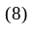. The particle will be decelerated subsequently due to the drag force of the melt it experiences. Also, the hot particle, as it travels through the melt layer with a decreasing temperature field (region 2 of the basic model), will release a certain amount of heat to the surrounding melt, thus directly affecting the performance of the thermal protection system. The dynamic effects of the particles on the ablative material, including the complex phenomena of mechanical erosion, will not be considered here. Only the thermal effects of the particles are studied, as the basic particle-free ablation model can be readily used for this purpose, and some preliminary results have been obtained. We will only briefly present the results here and refer the interested readers to Ref. (4) for details.

  - Particle Dynamics

We will consider only small, spherical particles for simplicity. The particle has a radius a, and a<<z*
so that the particle is small compared to the relevant dimension of the melt-layer. This assumption is made to simplify the subsequent heat transfer analysis of the particle. Also, we will consider vertical entry first, and to the order of approximation of the present analysis, the particle will follow a vertical trajectory which is in the direction of the established temperature gradient of the melt-layer^{(1-3)..} The generalization to the case of oblique entry should cause little difficulty. Note that the magnitude of the melt-flow velocity is much smaller than the particle velocity in the model considered, it will be neglected in the analysis of the particle dynamics.

We will use the coordinate to measure the distance traveled by the particle from its entry at the gas-melt interface. Thus, we have
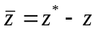 (66)

where z=0 represents the melt-solid interface.

The dynamics of the particle that travels at a very high velocity through the melt layer will be inertia-dominated, and as such, the drag force D on the particle can be approximately estimated by the Newtonian impact theory (see Ungar⁽⁸⁾ and Anderson⁽¹⁰⁾):

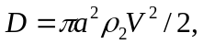 (67)

where 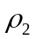 is the melt density and V is the instantaneous particle velocity in the direction (downward).
Neglecting the viscous drag, we get the following solution for the velocity of othe particle as a function of :

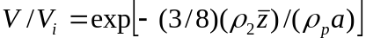 (68)

where 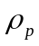denotes the particle density.

The terminal (impact) velocity, V_{f}, of the particle is easily obtained by setting 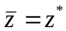, i.e.,

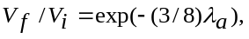 (69)

where we have introduced the deceleration parameter, 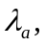 of the particle dynamics defined as

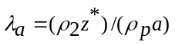. (70)

Note that, in general, V_{f}>0.

Integrating Eq. (68) with respect to t gives the particle trajectory 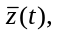with the initial condition, 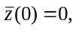
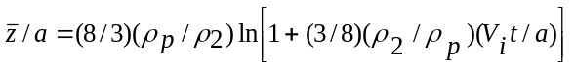. (71)

Finally, the total time of travel of the particle in the melt layer, t_{f}, is given by

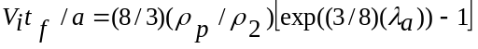, (72)

which will be later in calculating the total heat released by the particle during its travel in the melt layer. In terms of the non-dimensional time defined as 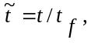 the particle trajectory given by Eq. (71) can be rewritten in the following convenient form:

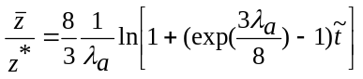 (73)

The results are shown in Fig. (7), with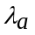as a parameter. Note that for the limiting case of 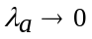which corresponds to the case of very small density ratio, 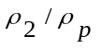, and hence vanishing drag, Eq. (73) gives
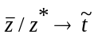, i..e., the particle travels at a constant velocity equal to V_{i}, as expected.

  - Particle Heat Transfer

The particle passes through a non-uniform temperature field in the melt layer across which considerable temperature drop, (T*- T_{m}), occurs, Fig. (2). Heat transfer from the hot particle to the relatively cold melt will take place, and it amounts to an external heating of the melt layer, and thus affecting the performance of the thermal protection system. This heating by the particle represents the thermal effects of the particle.

In Ref. (4), the present author presents a formulation of the heat transfer problem along with some preliminary results. We will briefly summarize the results here.

We use a one-dimensional (spherical symmetric) transient heat conduction model inside the particle with the origin of the spherical coordinate system fixed at the center of the moving particle. In this coordinate system, the particle experiences a varying ambient temperature of the melt passing by at a rate given by the particle velocity, i.e., Eqs (68) and (71).We assume that the particle is initially at a uniform temperature, say, T*, at the entry of the melt layer, t=0. Heat transfer by convection takes place through the particle surface for t>0. The surface boundary condition for the heat conduction equation then couples the conduction inside the particle and the convection in the melt field. As a first attempt at evaluating the thermal effects of the particles, we will make a crude approximation that at any instant of time, the ambient temperature that the particle experiences is represented by the temperature of the melt field at the location of the center of the particle, and that the convection can be expressed by an average heat transfer coefficient over the entire surface of the particle. Such simplifying assumptions should be reasonable for particles whose sizes are small compared to the melt-layer thickness.

The heat conduction equation and the appropriate boundary conditions for the particle are as follows:

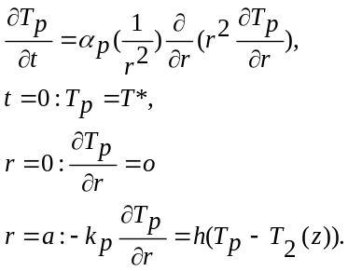 (74a,b,c,d)

In the above system, T_{p} is the particle temperature distribution, k_{p} is the thermal conductivity of the particle, h is the “average” heat transfer coefficient which is assumed to be constant and T₂(z) is the temperature field of the melt layer of the basic particle-free ablation model. We note here that z is related to t through the particle trajectory given by Eqs. (66) and (71).

The rate of heat loss to the melt field, , is given by

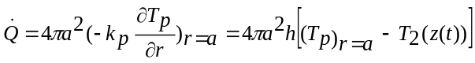 , (75)
and the total heat loss to the melt layer by the particle during its passage, Q, is simply

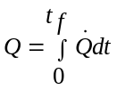. (76)

The following dimensionless quantities are introduced:

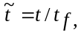 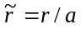, 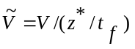, 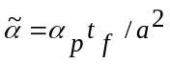, 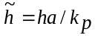, (77a)

and

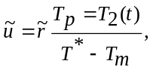 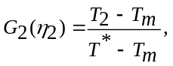 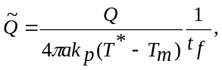 (77b)
where is known as the Biot number and 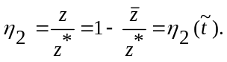

Eqs. (74) can be written in terms of the above dimensionless quantities. We will solve the system of equations approximately by the KP-type integral method, also known as the heat balance integral (HBI) method. Thus we assume the following 2nd degree polynomial for the temperature profile,

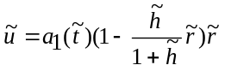 (78)

where 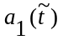 is the profile parameter to be determined by satisfying the integrated form of the partial differential equation. We note that a more appropriate choice of the profile would be a higher degree polynomial to ensure that 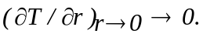 The details of the solution process are available in Ref. (4), and we will simply give the results in the following:

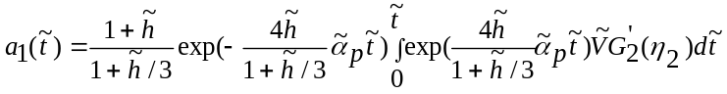, (79)
and

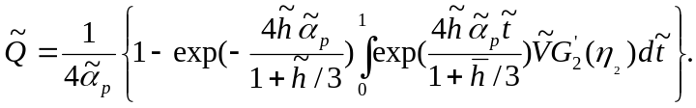 (80)

For a given melt-layer solution, G₂ is known. Also, the deceleration parameter is known for a given particle in a given melt-layer flow, and it relates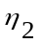and through the particle trajectory, Eq.(73). Therefore, the total heat given to the melt layer by the particle can be calculated by using Eq. (80). Note the results in Eq. (80) can be conveniently written symbolically as

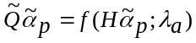 (81)

for a given melt-layer solution. Here for brevity, we have introduced H defined as

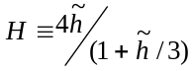. (82)
Fig. (8) shows the result of a particular case which corresponds to the solution of the coupled ablation problem for (see Refs. (2) and (3)). The results show that for given values of (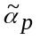, ), the total heat released by the particle, , increases with increasing values of the coefficient of convection heat transfer, (and hence H), and also, for given values of 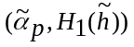, increases with increasing values of , corresponding to longer travel times. These results appear to be intuitively correct.

  - Discussion

Admittedly, the simple model used here in the analysis of the thermal effects of the particle is crude, and the method of solution used is approximate. The calculation of the particle drag did not include the viscous effects, and the model for heat transfer can certainly be improved to account for local variations of the thermal conditions on the surface of the particle. However, such improvements will necessarily complicate the analysis, and the results will not exhibit so clearly the parametric dependence of the solution. It is therefore felt that the preliminary results presented here are perhaps useful as a guide for future refinement. Obviously, more accurate solutions of the heat conduction equation can easily be obtained. The study of dynamic effects of the particles on ablation will require a separate model for material responses to particle impact, and the impact velocity of the particles as estimated in Sec. 2.1 may be used as a starting point for this more difficult study. The early work by Ungar⁽⁸⁾, and more recently the work by Cheung, et al⁽¹⁴⁾ will serve as useful reference for future research on this subject.

- Concluding Remarks

The research presented in this paper represents an attempt at understanding the basic aspects of the challenging problems of aerodynamic ablation. It is hoped that the approach used in the research, namely, the analytical methods of modeling and computing, will find broader applications than the specific problem of hypersonic ablation chosen for consideration here. The model that is presented in the paper is, of course, highly idealized, and its applications to practical problems would not be immediate. However, the study of an idealized, but appropriate, model often helps to reveal the basic characteristics of a complicated physical phenomenon, which would otherwise be obscured in a realistic model that would necessarily require a much more elaborate and complex method of analysis. It is encouraging that the simple KP integral method which is well-known to the fluid dynamics and heat transfer community can actually provide reasonably accurate results for the model problem of hypersonic ablation, and its analytical nature serves well the purpose of bringing out the parametric dependence of the solution without an undue amount of computational labor. Its potential utility as an analytical tool for future research in related problems of aerodynamic ablation thus appears promising.

It will be useful to calculate the results of some realistic cases based on the solutions of the present model. To do this, it will be necessary to find the transport and thermodynamic properties of the materials used in practical thermal protection systems. The theoretical solutions can then be compare with available data from careful experiments. The comparison will hopefully serve to assess the validity of the model and establish the range of its applicability.

Some meaningful and feasible extensions of the present model can also be investigated. For example, evaporation of the molten ablative material on the interface between the melt layer and the gas boundary-layer may become important for certain materials under a range of operating conditions, and its inclusion will require a modification of the interface boundary conditions. The extension of the sparse-particle model to allow for phase changes of the particle/droplet during its passage in the melt-layer is another interesting and important subject of research. Some preliminary results of such studies have been reported by the present author in Refs. (15, 16) where the classical HBI method was again used, but with a 3rd degree polynomial temperature profile that satisfies symmetry condition at the center of the droplet, i.e.,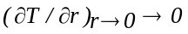. Also the incorporation of some material response models for the study of dynamic effects of particles on ablation/erosion warrants a serious consideration in future research, to name only a few.

Acknowledgment

The research reported in this paper was supported by the Naval Surface Warfare Center, Dahlgren Division’s In-house Laboratory Independent Research (ILIR) Program. The author also acknowledges the significant contributions of Dr. C. Y. Wei of the National Cheng-Kung University in Tainan, Taiwan to the research reported here.

References

1. Zien, T. F., “Effects of Melt layer on Steady Ablation in Hypersonic Flow”, Proceedings of AIAA 8th International Space Planes and Hypersonic Systems Technologies Conference, Apr. 1998, pp.391-400. Also, AIAA Paper 98-1580.
2 Zien, T. F. and Wei, C. Y., “Heat Transfer in the Melt Layer of a Simple Ablation Model”, Journal of
Thermophysics and Heat Transfer, Vol. 13, No. 4, Oct.-Dec. 1999, pp. 450-459.
- Wei, C. Y. and Zien, T. F., “Integral Calculations of Melt-Layer Hear Transfer in Aerodynamic Ablation”, Journal of Thermophysics and Heat Transfer, Vol.15, No.1, Jan.-Mar. 2001, pp. 116-124.
- Zien, T. F., “Thermal Effects of Particles on Hypersonic Ablation”, Journal of Thermophysics and Heat Transfer, Vol. 16, No. 2, 2002, pp. 285-288. Also AIAA Paper 2001-2833, AIAA 35th Thermophysics Conference, 11-14 June 2001, Anaheim, CA.
- Lees, L., “Similarity Parameters for Surface Melting of Blunt Nosed Body in High Velocity Gas Stream”, ARS Journal, Vol. 29, No. 5, May 1959, pp. 345-354.
- Hidalgo, H., “Ablation of Glassy Material Around Blunt Bodies of Revolution”, ARS Journal, Vol. 30, No. 9, Sept. 1960, pp. 806-814.
- Roberts, L., “On the Model of a Semi-Infinite Body of Ice Placed in a Hot Stream of Air”, Journal of Fluid Mechanics, Vol. 4, 1958, pp.505-528.
- Ungar, E. W., “Particle Impacts on the Melt Layer of an Ablating Body”, ARS Journal, Vol. 30, No. 9, Sept. 1960, pp. 799-805.
- Lewis, D. and Anderson, L., “Effects of Melt-Layer Formation on Ablative Materials Exposed to Highly Aluminized Rocket Motor Plumes”, AIAA Paper 98-0872, Jan. 1998.
- Anderson, J. D., Hypersonic and High-Temperature Gas Dynamics, McGraw-Hill, New York, 1989, Chaps. 3 and 9.
- Rasmussen, M., Hypersonic Flow, Wiley, New York, 1994, Chap. 9.
- Zien, T. F., “Fundamentals of Hypersonic Aerodynamics, Part II: Advanced Topics and Real Gas Effects”, Inst. Aeronautics and Astronautics, Publ. No. 45, National Cheng-Kung Univ., Tainan, Taiwan, ROC, 1988.
- Zien, T. F., “Integral Solutions of Ablation Problems with Time-Dependent Heat Flux”, AIAA Journal, Vol. 16, No. 12, Dec. 1978, pp. 1287-1295.
- Cheung, F. B., Yang, B. C., Burch, R. L., and Koo, J. H., “Effect of Melt Layer Formation on Thermo-mechanical Erosion of High-Temperature Ablative Materials”, Proceedings of 1st Pacific International Conference on Aerospace Science and Technology, 1993, pp. 302-309.
- Zien, T. F., “Effects of Particles and Droplets on Hypersonic Ablation in Thermal Protection Systems”, AIAA Paper 2002-5159, 11th AIAA/AAAF International Conference on Space Planes and Hypersonic Systems and Technologies, Sept. 29 – Oct. 4, 2002, Orleans, France.
- Zien, T. F., “Application of Heat Balance Integral Method to Droplet Freezing in Melting Ablation”, AIAA Paper 2004-0167, 42nd AIAA Aerospace Sciences Meeting and Exhibit, 5-8 January 2004, Reno, Nevada.

Figure Captions:

Fig. 1 Flow configuration and inviscid flowfield.
Fig. 2 Model Structure (coordinate system fixed on ablation front).
Fig. 3 Shielding factor, 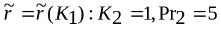
Fig. 4 Coupled solution of model ablation problem: 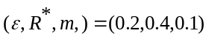, (a) K₁(N_{m}); (b) K₂(N_{m})
Fig. 5 Melt-layer profiles for coupled solution:
Fig. 6 Solutions of coupled problem: 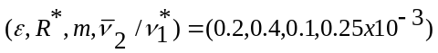; 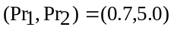
.
Fig. 7 Particle trajectory in melt layer
Fig. 8 Total heat released by particle to melt layer
