**Goal:** To get acquainted with Unity and implement a simple art design and menu feature.

**Task Listing:**

* As a developer, I want to get acquainted with Unity in order to create a mobile game --- (21)
  + Getting acquainted with Unity (20 hours)
* As a developer, I want to implement a simple art design and menu feature to build the framework of the game --- (8)
  + Making a character design (6 hours)
  + Making obstacle design (6 hours)

**Team Roles**:

* Nick Zhang (Product Owner)
* Andres Segundo (Scrum Master)
* Ellie Lin (Developer)
* David Munoz (Developer)
* Brian De Guzman (Developer)

**Initial Task Assignments:**

* Nick Zhang - getting acquainted with Unity
* Andres Segundo - getting acquainted with Unity
* Ellie Lin - getting acquainted with Unity
* David Munoz - getting acquainted with Unity
* Brian De Guzman - getting acquainted with Unity

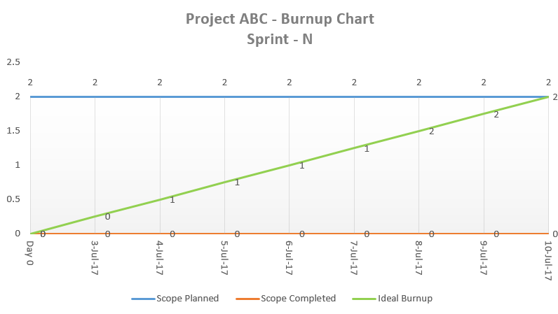

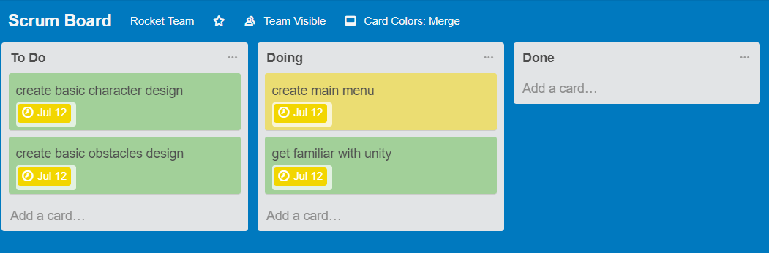

**Meeting Times:**

Tuesday, Friday, and Saturdays in BE lobby