Western Governors University (WGU)

Data Analytics Graduate Capstone — D214
Task 3: Presentation of Findings

Natallia Zimnitskaya | ID: 012247127
Master of Science, Data Analytics

Decoding Fashion Feedback: A Structured Data Approach in Women’s Clothing Using the k-Nearest Neighbors Method.

Executive Summary

Statement of the Problem and Hypothesis
This project addresses the research question: “How can leveraging structured data from Amazon customer reviews through the KNN model provide actionable insights for businesses to enhance product recommendations, customer satisfaction, and sales performance in the women’s clothing sector?”

The null hypothesis asserts that structured data features are not significant predictors of product recommendations. Conversely, the alternative hypothesis posits that features such as ratings, feedback metrics, and customer demographics significantly influence product recommendation likelihood.

Summary of the Data-Analysis Process
The dataset, titled Amazon Reviews on Women Dresses (23K Datapoints), was sourced from Kaggle (Amazon Reviews on Women Dresses (23K Datapoints), 2022). It contains 23000 records with information on demographics, product details, and feedback metrics.
- Feedback metrics include customer ratings and alike_feedback_count, representing the number of helpful votes a review received.
- Product details cover variables such as division_name, department_name, and class_name, offering insights into product hierarchies.
- Demographics include age, allowing for analysis of key customer groups.
- Textual variables include review_text and title, which provide customer opinions in written form.
The dataset underwent the following transformations and analysis:
- Preprocessing: Irrelevant columns (e.g., textual reviews) were excluded, missing values were dropped, and outliers were managed via Z-score normalization. Categorical variables such as division_name, department_name, and class_name were converted into numerical features using one-hot encoding. Numerical features, including age, alike_feedback_count, and rating, were scaled using MinMaxScaler to ensure compatibility with the distance-based KNN model.
- Feature engineering: Predictors such as rating, alike_feedback_count, class_name_Jeans, class_name_Lounge, class_name_Sweaters, age, and department_name_Tops were identified as significant using SelectKBest.
- Modeling: The KNN classifier was optimized with k = 36 using GridSearchCV. An 80/20 train/test split ensured robust model evaluation and minimized overfitting risks.

Findings
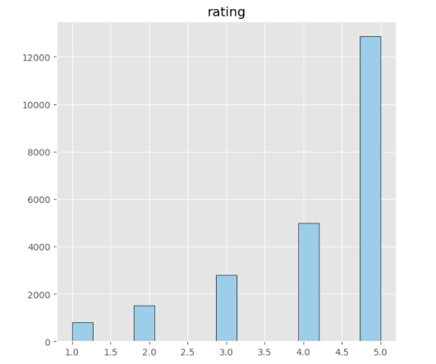
The analysis leveraged several visualizations to uncover key insights from the dataset:
- Rating Distribution: This histogram illustrated that ratings clustered around 4.5, indicating high overall customer satisfaction and the predominance of positive feedback.

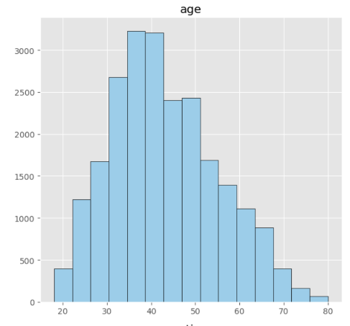
- Age Distribution: The box plot showed that most customers fell within the 30–40 age range, identifying a critical demographic for targeted marketing.

- Recommendation Distribution: The pie chart revealed that 82.4% of products were recommended, confirming the dataset's positive customer sentiment trend. 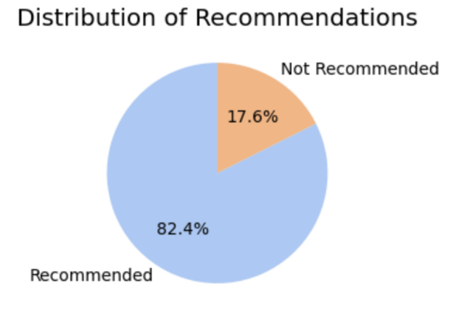
- Division and Department Trends: Charts for division_name and department_name emphasized that the General and General Petite divisions were dominant, with Tops and Dresses emerging as the most significant categories in sales and recommendations.
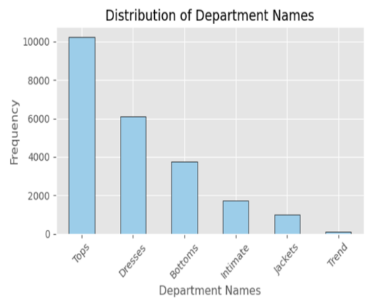
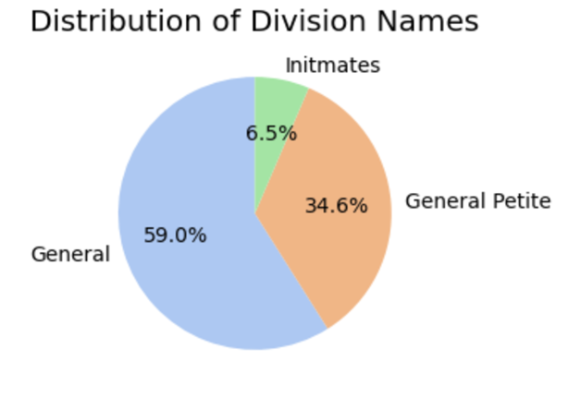

The KNN model delivered strong performance across multiple evaluation metrics:
- Overall accuracy: 93.79%
- AUC score of 0.97 indicates a highly effective model for distinguishing between recommended and not recommended products.
- Precision and recall:
- Class 1 (recommended): Precision = 98%, Recall = 95%.
- Class 0 (not recommended): Precision = 78%, Recall = 89%.
- The confusion matrix indicates strong model reliability, with minimal misclassifications (88 false positives, 197 false negatives) compared to correct classifications (3,585 true positives and 719 true negatives). This high reliability reduces the risk of recommending poorly rated products, enabling more accurate and customer-focused decisions.
- The k-NN graphs illustrate how varying the number of neighbors (k) impacts the model's performance.
- The training accuracy gradually decreases as the value of k increases. This indicates that the model becomes less focused on specific data points, reducing overfitting.
- The testing accuracy initially improves with increasing k, stabilizing as k approaches an optimal value. This stabilization reflects the model's ability to generalize well to unseen data.
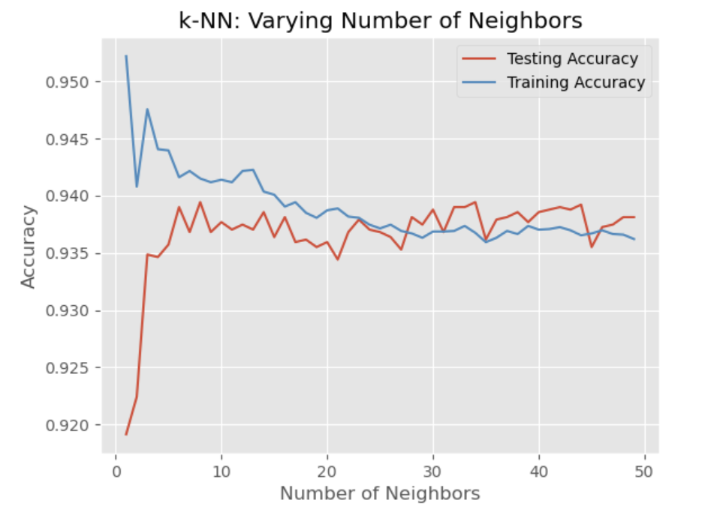
- Significant predictors included higher ratings, higher alike_feedback_count (helpful votes), and specific product classes such as Jeans, Lounge, and Sweaters, confirming their relationship to recommendation likelihood.

Limitations of Techniques and Tools
Several limitations were identified during the analysis:
- KNN depends on feature scaling and can be computationally demanding, adding workflow complexity when working with large or high-dimensional data.
- The static nature of the dataset may not reflect real-time trends or evolving customer behaviors.
- The current analysis did not include textual reviews, leaving room for further exploration using NLP.
- As dataset size increases, the computational demands of KNN can grow significantly, potentially requiring more efficient models or dimensionality reduction techniques to maintain performance.

Summary of Proposed Actions
To leverage these findings, businesses are encouraged to:
- Promote High-Rated Products: Focus marketing efforts on items with strong ratings and frequent recommendations to attract customers to the most popular and well-reviewed products.
- Target Key Demographics: Design campaigns tailored to the most active customer group aged 30–40, which represents a significant portion of shoppers
- Utilize NLP for Deeper Insights: Incorporate natural language processing (NLP) techniques to analyze written customer reviews, uncovering valuable feedback and sentiment patterns beyond structured data.
- Optimize Inventory Management: Prioritize popular categories like Dresses, Tops, and Sweaters while addressing niche categories like Lounge and Jeans to meet diverse customer needs.

Expected Benefits
Implementing these proposed actions is anticipated to deliver measurable and impactful outcomes:
- Maintain High Accuracy: Sustain or improve the recommendation accuracy of 93.79%, ensuring reliable and relevant product suggestions for customers.
- Boost Sales and Customer Satisfaction: Drive higher sales by focusing on the 30–40 age group and promoting top-rated items in the most popular product categories, increasing customer satisfaction and loyalty.
- Unlock Deeper Customer Insights: By analyzing written reviews using NLP, businesses can better understand customer preferences and sentiments, enabling real-time adaptability and more personalized recommendations.
- Strengthen Inventory Efficiency: Aligning inventory with demand will minimize overstocking and shortages, reduce costs, and increase operational efficiency.
- Long-Term Competitive Edge: Equip businesses to adapt quickly to changing customer behaviors and stay ahead in the competitive women’s clothing market.

These benefits highlight the significant business value and competitive advantage that can be achieved by acting on the insights provided by this study.

Sources:
Amazon reviews on Women's dresses (23K Datapoints). (2022, June 14). Kaggle. https://www.kaggle.com/datasets/surajjha101/myntra-reviews-on-women-dresses-comprehensive/data

Panopto Presentation can be found here.

