Western Governors University (WGU)

Data Mining II – D212
Task 3: Association Rules and Lift Analysis

Natallia Zimnitskaya | ID: 012247127
Master of Science, Data Analytics

Part I:

A1: "What are the most common medication combinations prescribed to patients that could indicate potential co-occurring conditions or treatment plans?" This question is relevant to a real-world organizational situation because it aims to identify frequent patterns in medication prescriptions, which can help understand patient characteristics and treatment strategies.

A2: Understanding which drugs are commonly prescribed and spotting trends in patient behavior or treatment outcomes are two applications of market basket analysis in the healthcare industry (Amruta, 2024). This analysis aims to identify the most frequent medication combinations prescribed to patients, enabling the hospital to understand common co-occurring conditions, optimize treatment plans, and improve patient care management. By achieving this goal, the hospital can gain insights into common treatment patterns, which can help tailor patient care plans based on prevalent medication combinations, optimize inventory management for frequently prescribed medications, and identify potential areas for intervention or preventive care based on common co-occurring conditions. The hospital can leverage these insights for better business and strategic decision-making by performing a market basket analysis to analyze patient data.

Part II:

B1: Machine learning methods, including Market Basket Analysis (MBA), have become invaluable for making informed decisions in the retail business by predicting sales performance and identifying customer purchasing behaviors (Kamara, n.d.). MBA examines lists of items within a dataset full of transactions to determine “association rules” regarding the co-occurrence of certain items. For example, in a hospital pharmacy, a patient prescribed carvedilol might also likely be prescribed another medication, such as lisinopril or glipizide.
MBA works by sifting through every transaction in a database and calculating various statistics on how frequently carvedilol is prescribed alongside other medications like lisinopril or glipizide. For example, my results show that carvedilol and lisinopril often co-occur, forming a rule: “If carvedilol, then lisinopril.” This indicates that the carvedilol prescription increases the likelihood of prescribing lisinopril in the same transaction. In this scenario, carvedilol is the antecedent (it comes first), and lisinopril is the consequent. Multiple rules can be formed, sharing either antecedents (e.g., carvedilol => lisinopril and carvedilol => glipizide) or consequents (e.g., glipizide => carvedilol). Rules may also have multiple antecedents or consequents (e.g., carvedilol => lisinopril, glipizide).
The Apriori algorithm is used in MBA to identify frequently occurring item sets and generate association rules. It starts by finding individual items that appear often enough, known as meeting a “minimum support threshold.” Once it finds these frequent items, it looks for larger combinations that meet the criteria.
This process is repeated each time, building on the previous results but only keeping the combinations that are frequent enough. By iteratively and efficiently pruning out the less significant item sets, the algorithm has a set of strong association rules. These rules reveal the relationships between items in the dataset, helping us understand which items tend to occur together.
Expected outcomes include identifying common medication combinations, understanding co-occurrence patterns, improving inventory management, enhancing treatment plans, implementing informed marketing strategies, and ultimately providing better patient care. The analysis may also uncover new association rules that lead to further research and a deeper understanding of treatment practices. Hospitals can make informed decisions to optimize inventory management, devise effective treatment plans, and improve patient care by achieving these outcomes.

B2: An example of a transaction from my dataset:
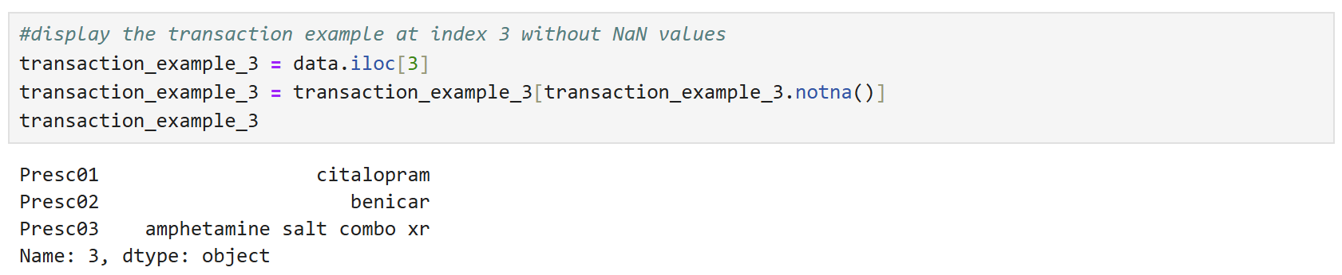
Transaction 3 contains 3 prescriptions: citalopram, Benicar, and amphetamine salt combo XR.

B3: MBA relies on the assumption that certain products are frequently bought together because they share some underlying relationship or association. It assumes that identifiable patterns within the transaction data reveal how specific products co-occur in shopping baskets. By uncovering these associations, MBA helps businesses understand purchasing behavior and develop effective cross-selling strategies, ultimately aiming to enhance customer satisfaction and boost sales. In the pharmaceutical and bioinformatics fields, MBA can be used to discover co-occurrence relationships among diagnoses and pharmaceutical active ingredients prescribed to different patient groups (Smartbridge, 2024).

Part III:

C1: The data transformation and association rule generation steps were adapted from the code provided by Dr. Kamara in his Panopto series (Kamara, n.d.-a)
.

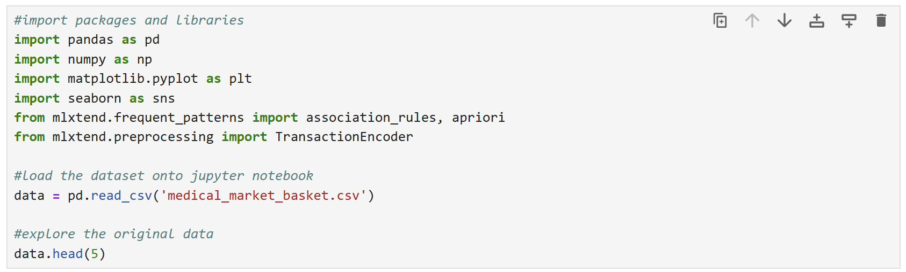
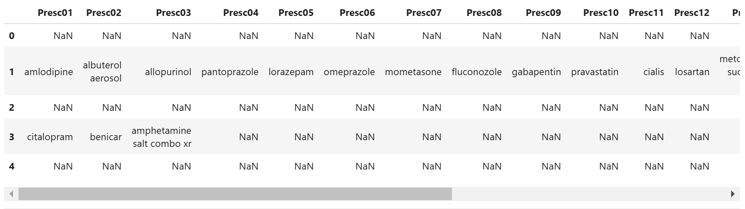
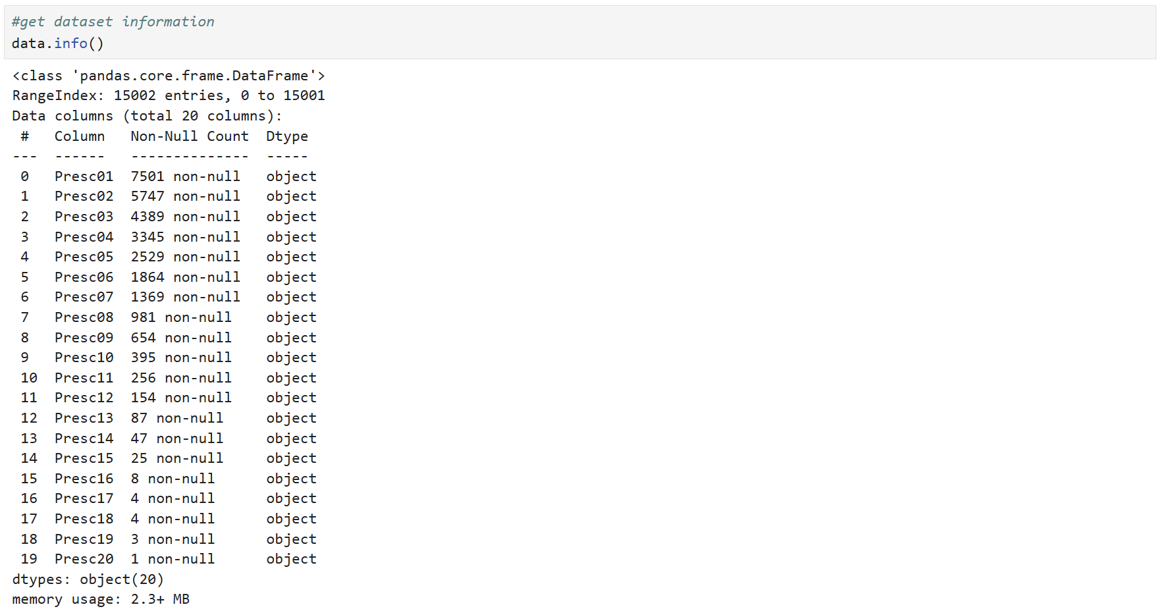
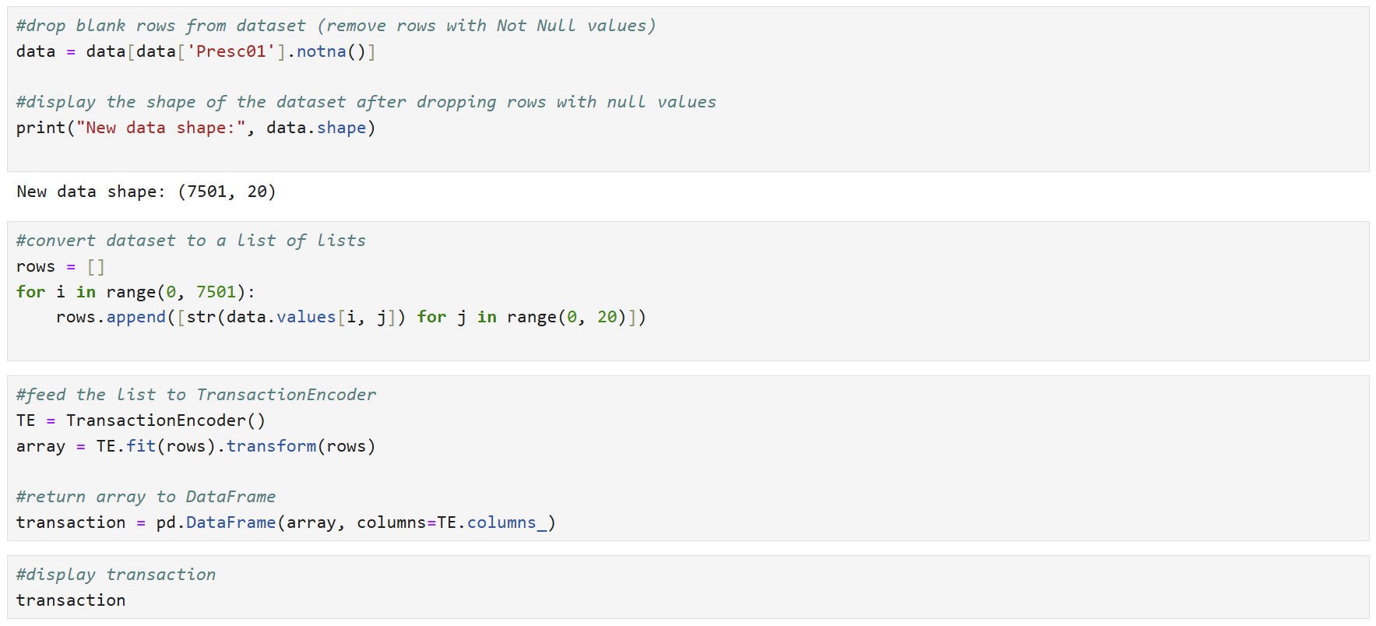
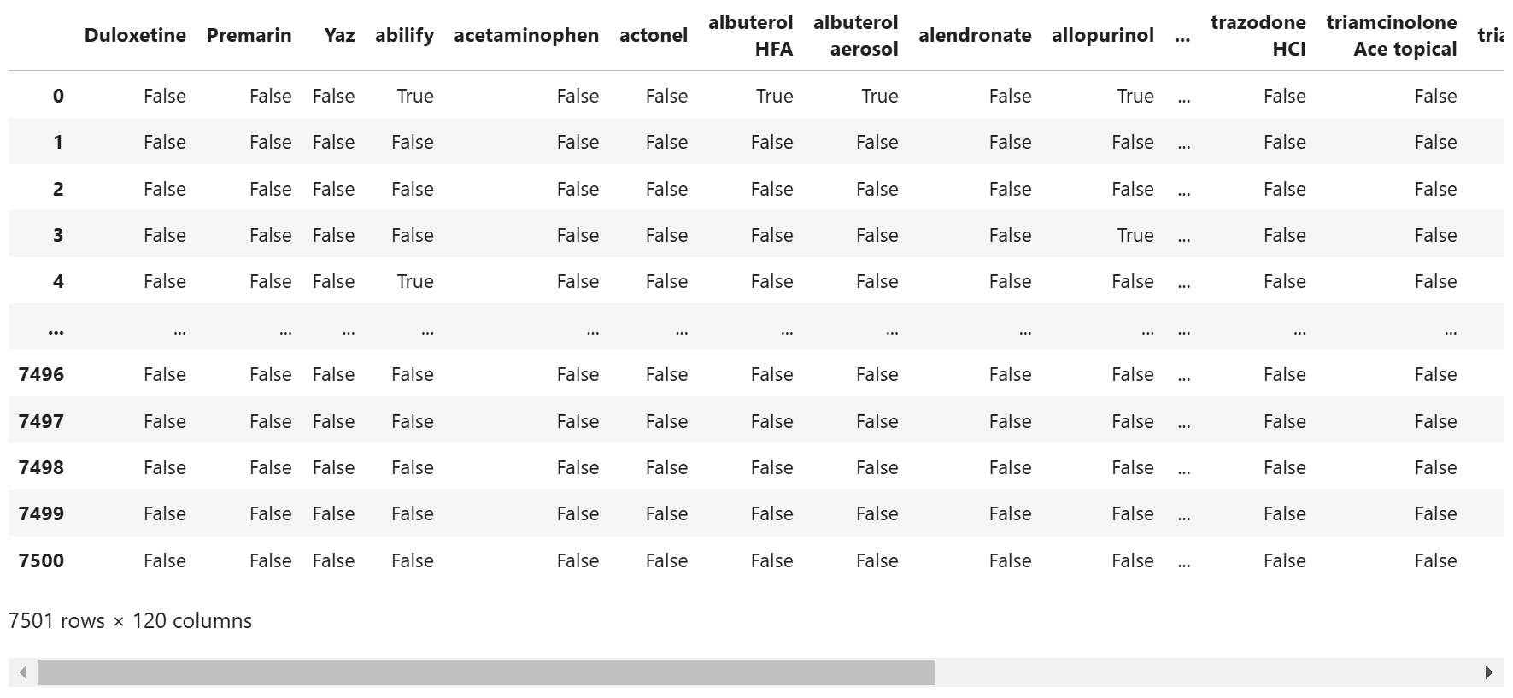
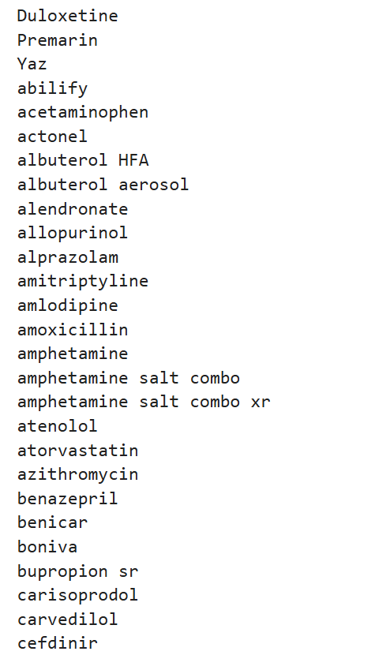
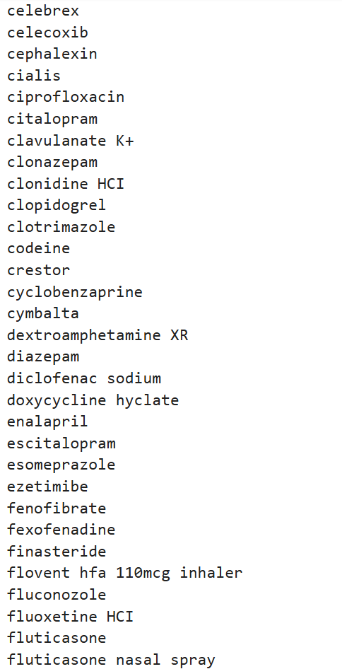
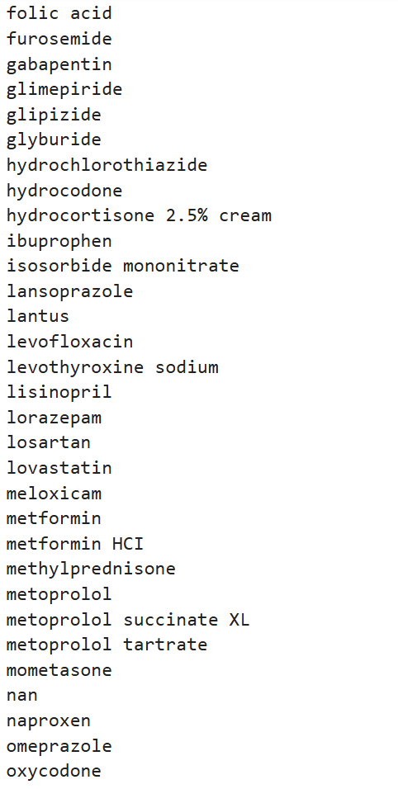
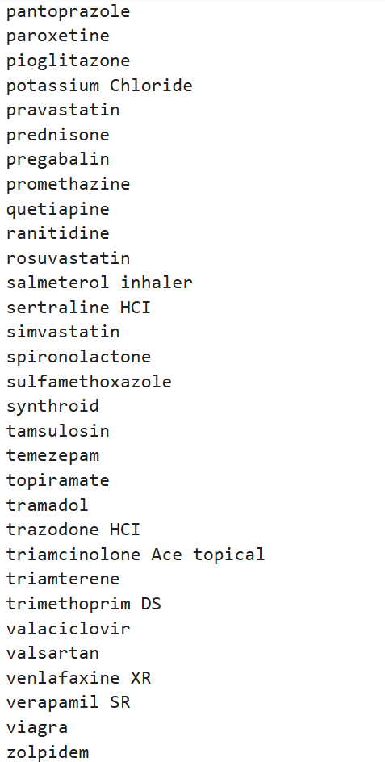
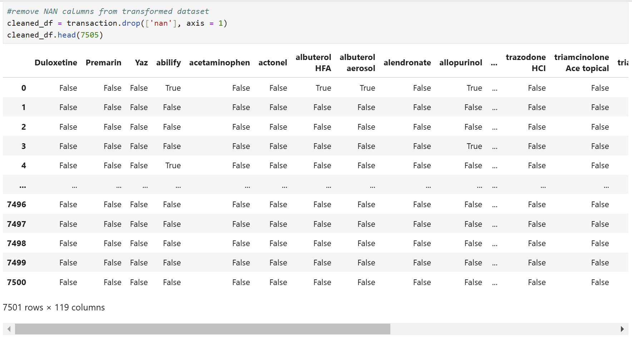

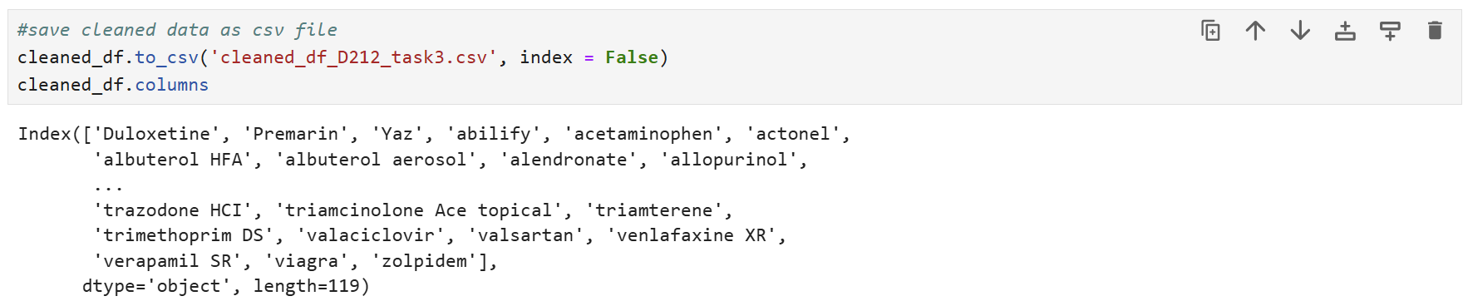
Each prescription in the dataset has been converted into a separate column, resulting in 119 columns.
The cleaned dataset “cleaned_df_D212_task3.csv” is attached to the submission.

C2: The generation of association rules is achieved through two main functions. First, the ‘apriori’ function is utilized to identify all associations that meet a specified minimum support threshold of 0.02. Following this, the ‘association_rules’ function is applied to develop these rules further, using an additional threshold to refine them. Before applying the ‘apriori’ algorithm, I aim to identify the 20 most popular prescriptions in the transformed dataset.
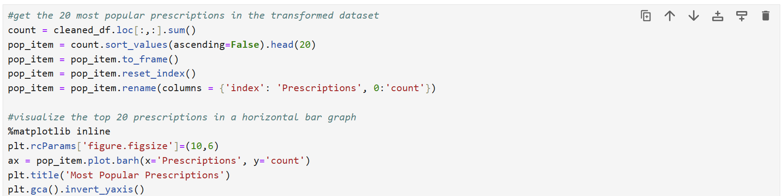
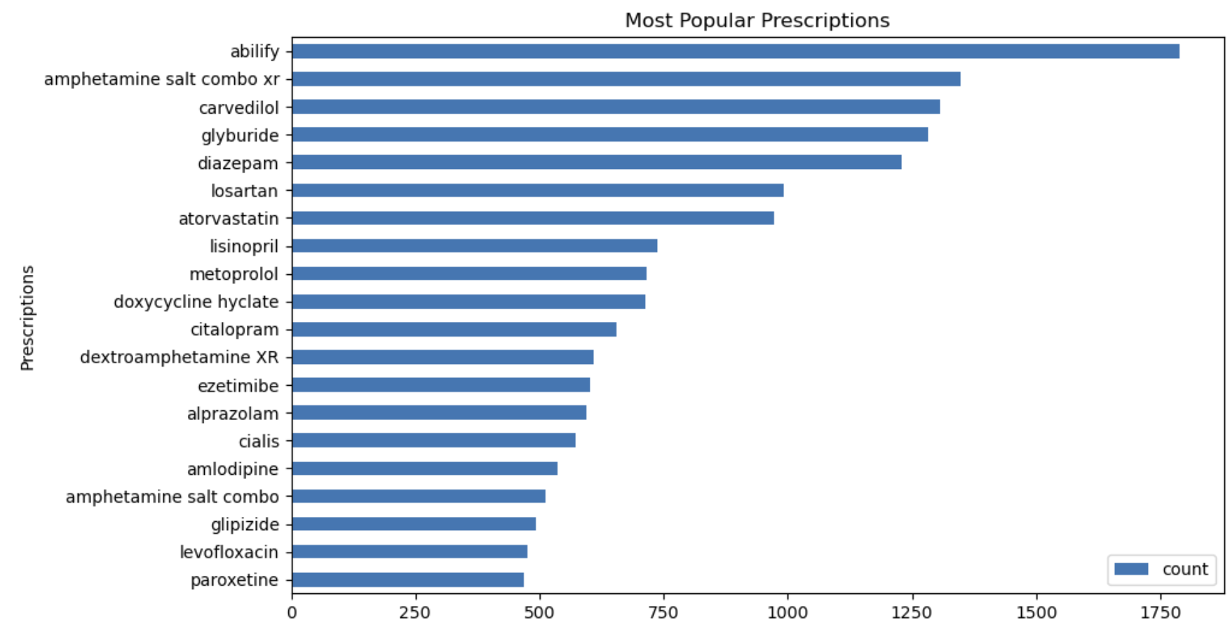

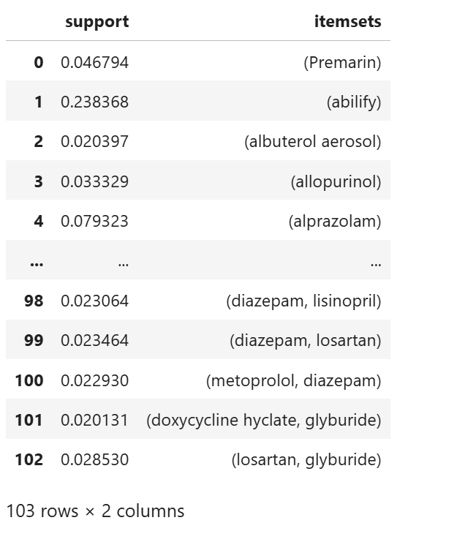

C3: The rules table is created using the ‘association_rules’. This table is generated based on the lift metric for each rule, with the output ordered in descending value for lift. It applies a minimum threshold of 1, meaning it contains only items whose lift value is 1 or higher. This ensures that the table includes only the most significant and impactful associations, highlighting the most substantial relationships between medications in the dataset. Here is a screenshot of the Rules Table, complete with support, confidence, and lift values.
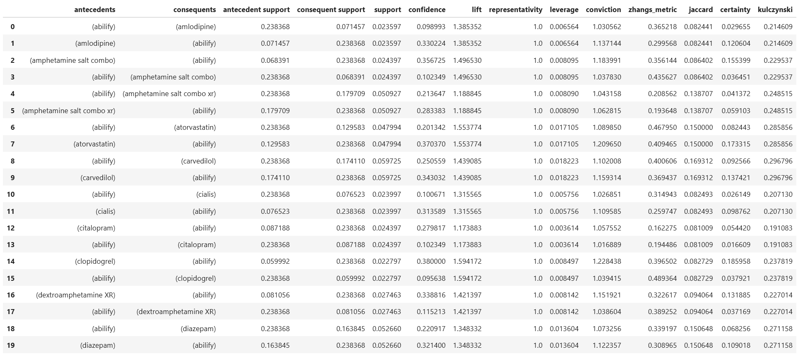

C4: I decided to sort the rules by different metrics—lift, confidence, and support—because each metric provides unique insights into the strength and significance of medication associations. Support tracks how often items appear; confidence reveals the probability of purchasing one given another; and lift highlights the relationship between items (Deniran, 2023). Sorting by these metrics ensures a comprehensive analysis, revealing the most impactful and relevant rules from multiple perspectives. Together, these metrics provide a wealth of strategic insights.
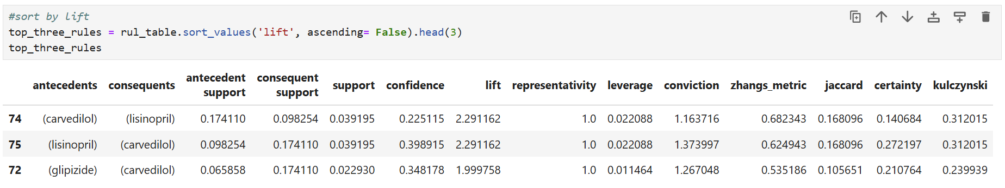
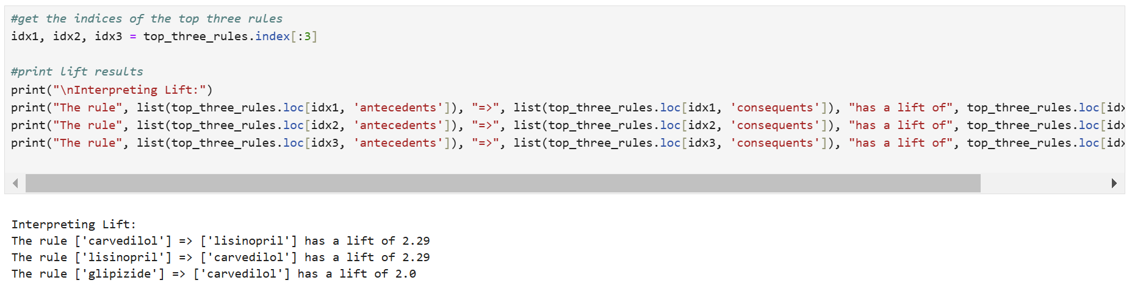
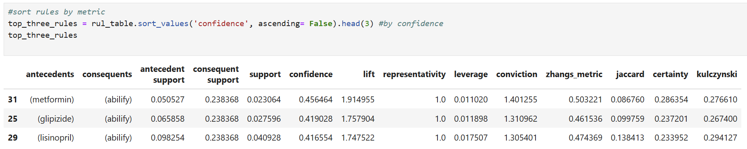
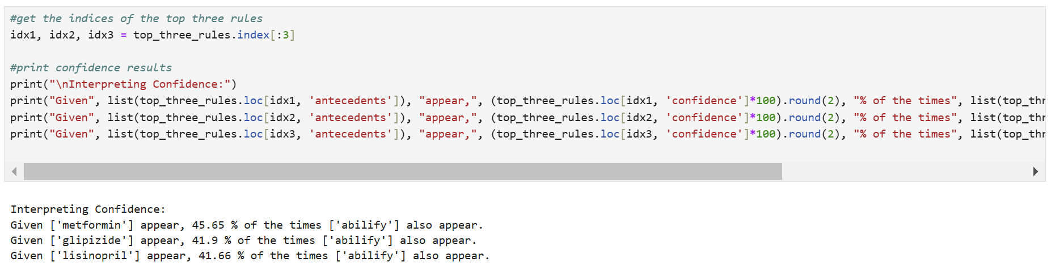
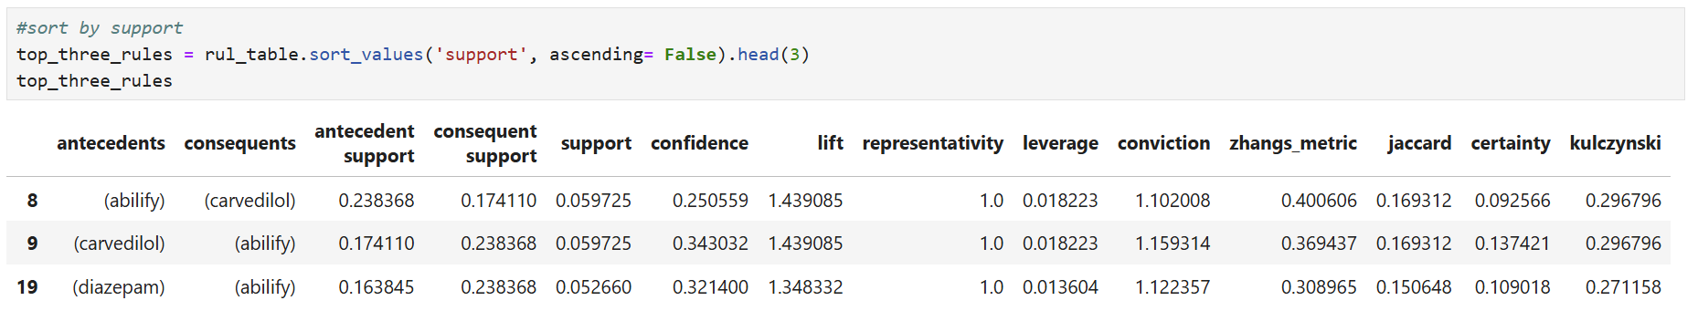
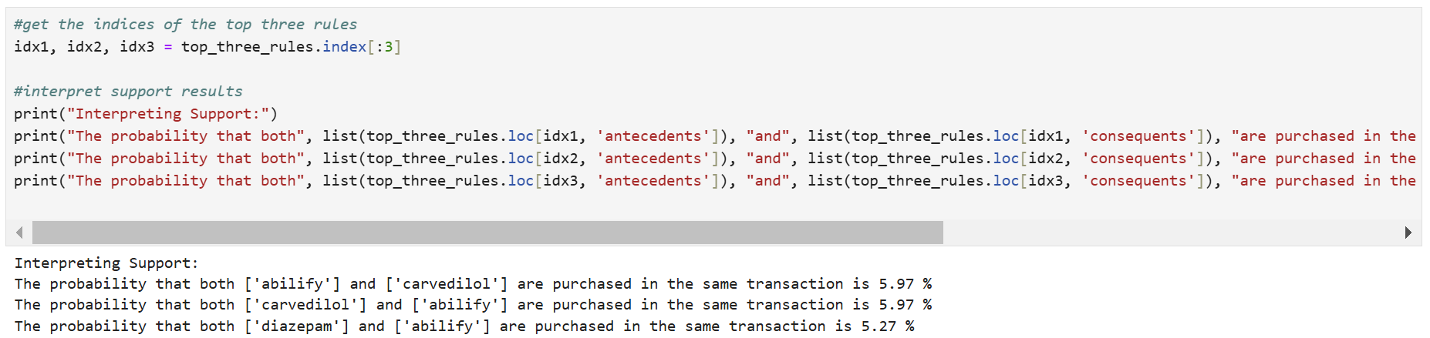

Part IV:

D1: Support measures how frequently an item set appears in the dataset. It is crucial as it helps identify the commonality of a particular combination. For example, a high support value indicates that the combination of medications appears frequently in the dataset, implying that this combination is common among patients.
The first rule, carvedilol => Abilify, has a support value of 5.97%, indicating that this combination appears in 5.97% of all transactions, making it a common co-prescription.
- The second rule, Abilify => carvedilol, also has a support value of 5.97%, reinforcing the frequent occurrence of this medication pair.
- The third rule, Abilify => diazepam, with a support value of 5.27%, shows that this combination appears in 5.27% of transactions.

Lift indicates the strength of the association between the items in the rule. It is the ratio of the observed support to the expected support if the items were independent. A lift value greater than 1 suggests a strong association between the items, while a value equal to or less than 1 indicates a weaker or no association. Lift helps prioritize the most significant and impactful rules.
- The first rule, carvedilol => lisinopril, has a lift value of 2.29, indicating that the presence of carvedilol increases the likelihood of prescribing lisinopril by more than twice compared to if they were independent.
- The second rule, lisinopril => carvedilol, also has a lift value of 2.29, reinforcing the strong bidirectional relationship between these two medications.
- The third rule, glipizide => carvedilol, with a lift value of 2.0, shows that the occurrence of glipizide nearly doubles the likelihood of prescribing carvedilol.

Confidence measures the likelihood that the consequent is present in transactions that contain the antecedent. It provides insight into the reliability of the rule. Higher confidence means that the presence of the antecedent strongly suggests the presence of the consequent. This helps in understanding the reliability and predictability of the association.
- The first rule, metformin => Abilify, has a confidence value of 45.65%, indicating that when metformin appears in a transaction, there is a 45.65% chance that Abilify will also be present.
- The second rule, glipizide => Abilify, with a confidence value of 41.90%, shows that when glipizide appears, Abilify is also included 41.90% of the time.
- The third rule, lisinopril => Abilify, has a confidence value of 41.66%, meaning that Abilify is present in 41.66% of transactions that include lisinopril.

D2: The analysis, sorted by lift, confidence, and support, reveals key insights into the associations between medications in the dataset. The highest lift values highlight strong associations, such as carvedilol => lisinopril and lisinopril => carvedilol, where one medication significantly increases the likelihood of the other being prescribed, suggesting important co-prescription patterns.
Sorting by confidence showcases reliable rules, with metformin => Abilify showing a high probability (45.65%) that Abilify will be prescribed when metformin is present. This high confidence indicates strong predictability in these relationships.
Lastly, sorting by support identifies the most frequently co-occurring medications, such as Abilify => carvedilol, with a support value of 5.97%, underscoring common treatment combinations. Together, these metrics provide a comprehensive understanding of prevalent, strong, and reliable medication associations, offering valuable insights for optimizing treatment plans, inventory management, and patient care strategies. This comprehensive analysis aids in identifying prevalent, strong, and reliable medication associations, offering valuable insights that can be leveraged for optimizing treatment plans, enhancing inventory management, and improving overall patient care strategies.

D3: Based on the analysis, it is recommended that the hospital take the following actions:
- Optimize Inventory Management: Ensure that medications with high co-occurrence are well-stocked to prevent shortages and delays in treatment. This will enhance patient satisfaction and care efficiency.
- Develop Targeted Treatment Plans: Utilize the identified medication combinations to create or refine treatment protocols for patients with common co-occurring conditions. This can lead to more personalized and effective care plans.
- Implement Preventive Measures: Design preventive care initiatives based on frequent medication associations to address potential health issues before they escalate, thus improving overall patient outcomes.
- Enhance Training for Healthcare Providers: Educate healthcare providers on the common medication combinations and their implications, enabling them to make informed decisions in patient care.
These actions will help the hospital leverage the insights from the market basket analysis for better strategic decision-making, ultimately improving patient care and operational efficiency.

Part V:

E. Link to the Panopto video recording:
https://wgu.hosted.panopto.com/Panopto/Pages/Viewer.aspx?id=9fb699bc-1f27-4014-96d1-b27200118a9a

F. Third-party code
Kamara, K. (n.d.-a). Market basket analysis in Python [Video]. https://wgu.hosted.panopto.com/. Retrieved December 15, 2024, from https://wgu.hosted.panopto.com/Panopto/Pages/Viewer.aspx?id=db85c4f1-0da5-4bde-a1a4-b07c0019d46d

G. Sources
Amruta. (2024, December 1). Market Basket Analysis: A Comprehensive guide for businesses. Analytics Vidhya. https://www.analyticsvidhya.com/blog/2021/10/a-comprehensive-guide-on-market-basket-analysis/
Deniran, O. H. (2023, November 27). Boosting Sales with Data: The Power of Market Basket Analysis in Retail. Medium. https://medium.com/@chemistry8526/boosting-sales-with-data-the-power-of-market-basket-analysis-in-retail-c79cc10a14df#:~:text=Transaction%20Independence%3A%20It%20is%20assumed,item%20associations%20within%20individual%20transactions
Kamara, K. (n.d.-b). Market basket analysis in theory [Video]. wgu.hosted.panopto.com. Retrieved December 15, 2024, from https://wgu.hosted.panopto.com/Panopto/Pages/Viewer.aspx?id=9541a29b-2f14-4c5d-9d86-af030005bcf6
Smartbridge. (2024, January 29). Market Basket Analysis 101: Anticipating Customer Behavior. Smartbridge. https://smartbridge.com/market-basket-analysis-101/

