**Define the number of clusters**

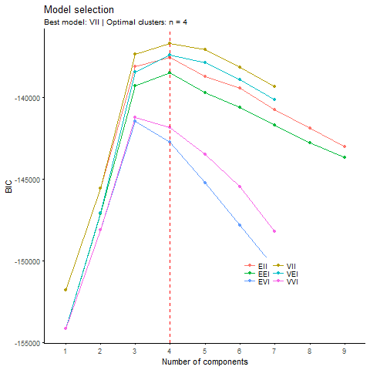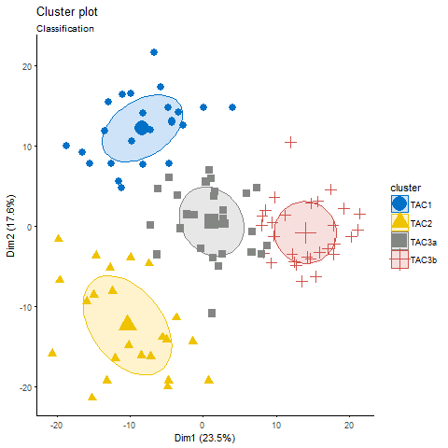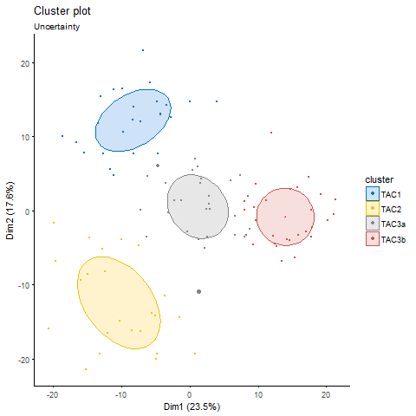

**Discriminative features:**

**Between Four Classes:**

|  |  |  |  |  |  |  |
| --- | --- | --- | --- | --- | --- | --- |
|  | f.test | kruskal.test | component boosting | random Forest | Fold Change | sum |
| CCNYL1 | 1 | 1 | 0 | 0 | 0.824561404 | 2 |
| OR2A7 | 1 | 1 | 0 | 0 | 0.824561404 | 2 |
| CPA3 | 1 | 0 | 0 | 0 | -1.212765957 | 1 |
| FCER1A | 0 | 1 | 0 | 0 | -1.212765957 | 1 |
| CD207 | 1 | 0 | 0 | 0 | -1.212765957 | 1 |
| IL18R1 | 0 | 1 | 0 | 0 | -1.212765957 | 1 |
| DNAJB1 | 1 | 0 | 0 | 0 | -1.212765957 | 1 |
| STX7 | 0 | 1 | 0 | 0 | 0.824561404 | 1 |
| ARPC3 | 1 | 0 | 0 | 0 | 0.824561404 | 1 |
| TRAM1 | 1 | 0 | 0 | 0 | 0.824561404 | 1 |
| ETS2 | 1 | 0 | 0 | 0 | -1.212765957 | 1 |
| FCF1 | 0 | 1 | 0 | 0 | 0.824561404 | 1 |
| ERN1 | 0 | 1 | 0 | 0 | -1.212765957 | 1 |
| RNF135 | 1 | 0 | 0 | 0 | 0.824561404 | 1 |
| PDIA6 | 0 | 1 | 0 | 0 | 0.824561404 | 1 |
| FCGR3B | 1 | 0 | 0 | 0 | 0.824561404 | 1 |
| FCGR1B | 0 | 1 | 0 | 0 | 0.824561404 | 1 |
| NR4A1 | 1 | 0 | 0 | 0 | -1.212765957 | 1 |
| GIMAP4 | 1 | 0 | 0 | 0 | 0.824561404 | 1 |
| NFKBID | 0 | 1 | 0 | 0 | -1.212765957 | 1 |
| UBE2D1 | 0 | 1 | 0 | 0 | -1.212765957 | 1 |
| SBF2 | 0 | 1 | 0 | 0 | 0.824561404 | 1 |
| ARHGEF3 | 0 | 1 | 0 | 0 | 0.824561404 | 1 |
| OLIG2 | 0 | 1 | 0 | 0 | -1.212765957 | 1 |
| CASP5 | 1 | 0 | 0 | 0 | -1.212765957 | 1 |
| CARD16 | 0 | 0 | 1 | 0 | -1.212765957 | 1 |
| NT5DC1 | 1 | 0 | 0 | 0 | 0.824561404 | 1 |
| RNF149 | 0 | 1 | 0 | 0 | -1.212765957 | 1 |
| CDC73 | 0 | 1 | 0 | 0 | 0.824561404 | 1 |
| IFIH1 | 1 | 0 | 0 | 0 | -1.212765957 | 1 |
| OAS1 | 0 | 0 | 1 | 0 | 0.824561404 | 1 |
| UTP11L | 1 | 0 | 0 | 0 | 0.824561404 | 1 |
| GZMB | 0 | 1 | 0 | 0 | -1.212765957 | 1 |
| PRF1 | 0 | 1 | 0 | 0 | -1.212765957 | 1 |
| LINC01366 | 0 | 0 | 1 | 0 | -1.212765957 | 1 |
| TSPAN2 | 0 | 1 | 0 | 0 | -1.212765957 | 1 |
| SNX30 | 0 | 1 | 0 | 0 | 0.824561404 | 1 |
| NSL1 | 0 | 1 | 0 | 0 | 0.824561404 | 1 |
| NCR3LG1 | 1 | 0 | 0 | 0 | -1.212765957 | 1 |
| RRAS2 | 0 | 1 | 0 | 0 | 0.824561404 | 1 |
| AMFR | 1 | 0 | 0 | 0 | 0.824561404 | 1 |
| KRT23 | 1 | 0 | 0 | 0 | -1.212765957 | 1 |
| ADM | 0 | 1 | 0 | 0 | -1.212765957 | 1 |
| NOLC1 | 0 | 1 | 0 | 0 | 0.824561404 | 1 |
| TNFAIP3 | 0 | 1 | 0 | 0 | -1.212765957 | 1 |
| PLK3 | 1 | 0 | 0 | 0 | -1.212765957 | 1 |
| MRPS33 | 1 | 0 | 0 | 0 | 0.824561404 | 1 |

**Between TAC3a and TAC3b:**

|  |  |  |  |  |  |  |  |  |  |
| --- | --- | --- | --- | --- | --- | --- | --- | --- | --- |
|  | t.test | welch.test | kruskal.test | rfe | rf | lasso | elasticnet | foldChange | sum |
| LCP2 | 0 | 0 | 1 | 0 | 0 | 1 | 1 | 0.070676 | 5 |
| CPA3 | 1 | 1 | 0 | 0 | 0 | 0 | 0 | -2.48654 | 4 |
| ATG2A | 1 | 1 | 1 | 0 | 0 | 0 | 0 | -0.01543 | 4 |
| ZKSCAN8 | 1 | 1 | 0 | 0 | 0 | 0 | 0 | 2.297125 | 4 |
| FTSJ2 | 1 | 1 | 0 | 0 | 0 | 0 | 0 | 7.360166 | 4 |
| TGOLN2 | 0 | 0 | 0 | 0 | 0 | 1 | 1 | -4.17153 | 3 |
| ARHGAP1 | 1 | 0 | 0 | 0 | 0 | 0 | 0 | -1.12318 | 2 |
| GGT5 | 1 | 0 | 0 | 0 | 0 | 0 | 0 | -0.1919 | 2 |
| SCARB2 | 1 | 0 | 0 | 0 | 0 | 0 | 0 | -8.96869 | 2 |
| UMPS | 0 | 0 | 1 | 0 | 0 | 0 | 0 | 0.679818 | 2 |
| ADAM10 | 0 | 0 | 1 | 0 | 0 | 0 | 0 | 2.44524 | 2 |
| FLOT1 | 0 | 0 | 1 | 0 | 0 | 0 | 0 | -0.43086 | 2 |
| MGAM | 1 | 0 | 0 | 0 | 0 | 0 | 0 | -0.96917 | 2 |
| LINC01002 | 0 | 0 | 0 | 0 | 0 | 0 | 1 | 0.31538 | 2 |
| PPFIBP2 | 0 | 0 | 1 | 0 | 0 | 0 | 0 | 1.06133 | 2 |
| IL1RL1 | 0 | 0 | 0 | 0 | 0 | 0 | 0 | -1.11874 | 1 |
| GATA2 | 0 | 0 | 0 | 0 | 0 | 0 | 0 | -0.49547 | 1 |
| BIRC3 | 0 | 0 | 0 | 0 | 0 | 0 | 0 | -8.86015 | 1 |
| RNF146 | 0 | 0 | 0 | 0 | 0 | 0 | 0 | -3.51611 | 1 |
| TLR7 | 0 | 0 | 1 | 0 | 0 | 0 | 0 | 1.616064 | 1 |
| UTRN | 0 | 0 | 0 | 0 | 0 | 0 | 0 | -0.09813 | 1 |
| GTF2H2B | 0 | 1 | 0 | 0 | 0 | 0 | 0 | -4.10763 | 1 |
| SCOC | 0 | 0 | 0 | 0 | 0 | 0 | 0 | 1.982288 | 1 |
| DNAJB1 | 0 | 0 | 0 | 0 | 0 | 0 | 0 | -0.37063 | 1 |
| PLBD1 | 0 | 0 | 0 | 0 | 0 | 0 | 0 | 3.70161 | 1 |
| PQLC3 | 0 | 0 | 0 | 0 | 0 | 0 | 0 | 1.419889 | 1 |
| SIGLEC7 | 0 | 0 | 0 | 0 | 0 | 0 | 0 | 0.837903 | 1 |
| BANK1 | 0 | 0 | 1 | 0 | 0 | 0 | 0 | 0.172962 | 1 |
| HN1 | 0 | 1 | 0 | 0 | 0 | 0 | 0 | 0.311273 | 1 |
| BTG1 | 0 | 0 | 0 | 0 | 0 | 0 | 0 | 0.212585 | 1 |
| FCGR1B | 0 | 0 | 0 | 0 | 0 | 0 | 0 | 0.49851 | 1 |
| MARCKSL1 | 0 | 0 | 0 | 0 | 0 | 0 | 0 | -0.64897 | 1 |
| GTPBP10 | 0 | 0 | 1 | 0 | 0 | 0 | 0 | 8.368588 | 1 |
| SLC25A37 | 0 | 1 | 0 | 0 | 0 | 0 | 0 | 0.285616 | 1 |
| SAMSN1 | 0 | 0 | 0 | 0 | 0 | 0 | 0 | 0.041328 | 1 |
| GNG2 | 0 | 0 | 0 | 0 | 0 | 0 | 0 | -0.25842 | 1 |
| FAM65B | 0 | 0 | 0 | 0 | 0 | 0 | 0 | 0.612149 | 1 |
| ATP1B1 | 0 | 0 | 0 | 0 | 0 | 0 | 0 | 4.324306 | 1 |
| FAM162A | 0 | 0 | 0 | 0 | 0 | 0 | 0 | 11.2957 | 1 |
| HLA-DMB | 0 | 0 | 0 | 0 | 0 | 0 | 0 | 3.850917 | 1 |
| MRPL57 | 0 | 0 | 0 | 0 | 0 | 0 | 0 | 1.410857 | 1 |

**Box Plots for Clinical Data:**

**Between Four classes:**

**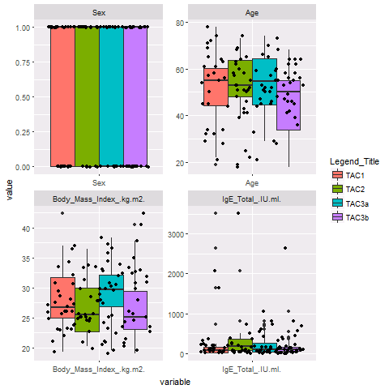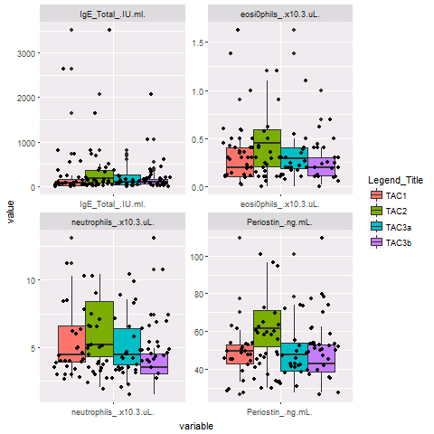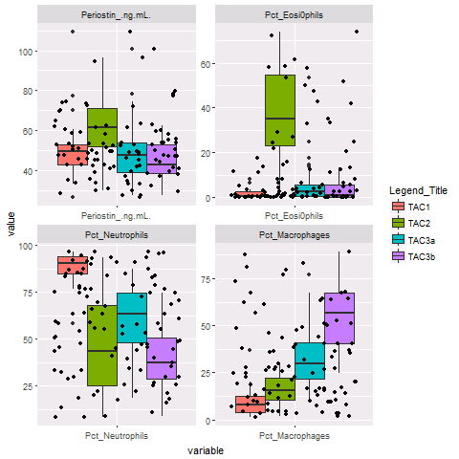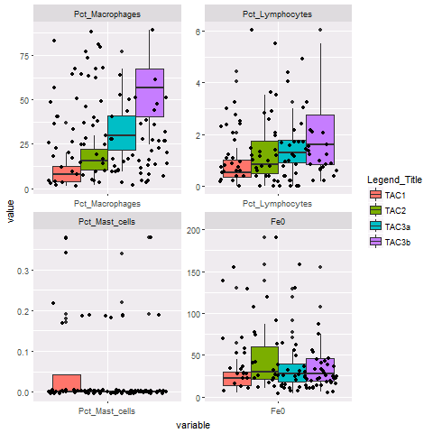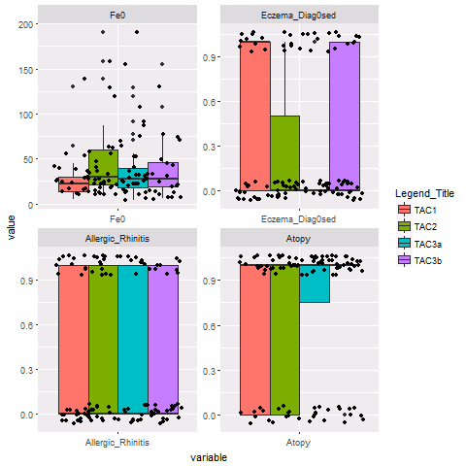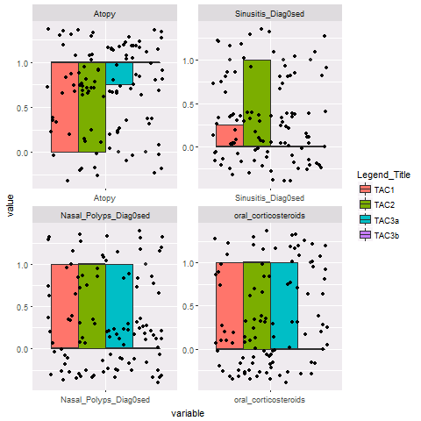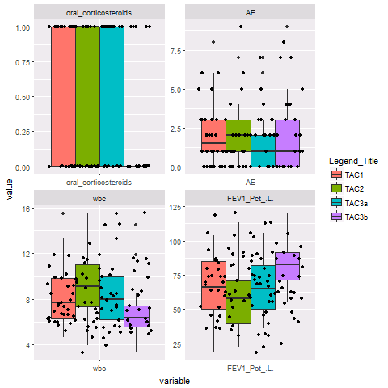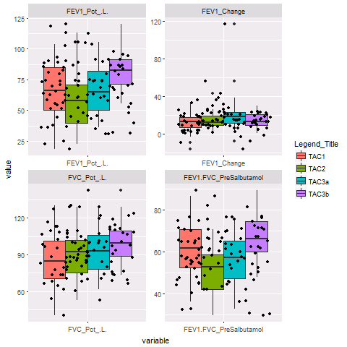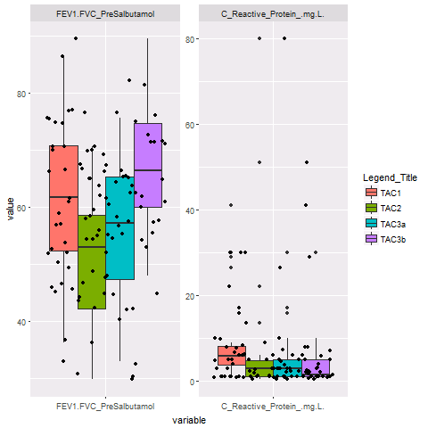**

**Boxplots to show differences between TAC1 and TAC2 (merged) against TAC3a,b (merged)**

**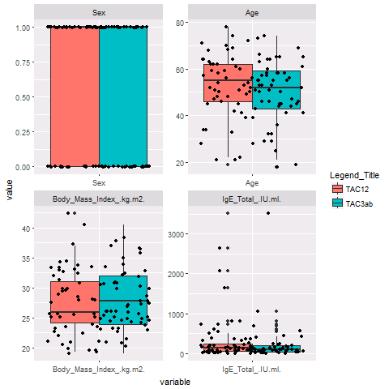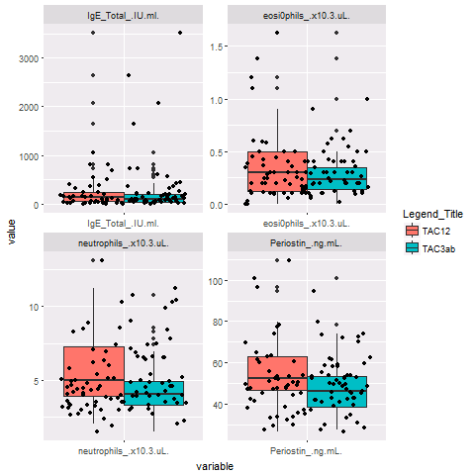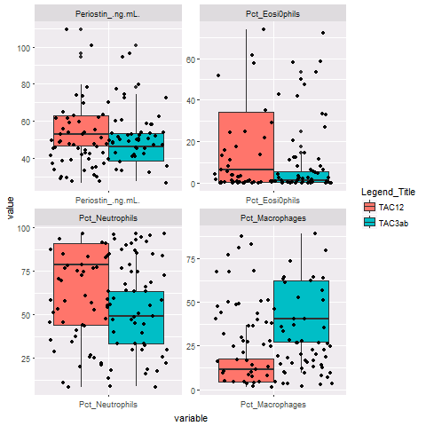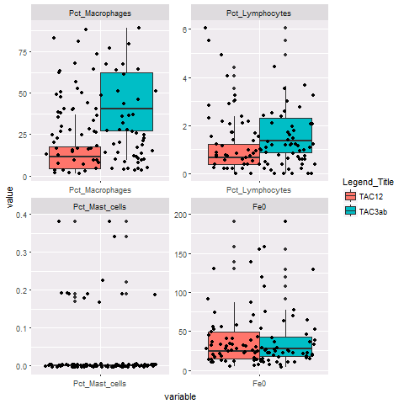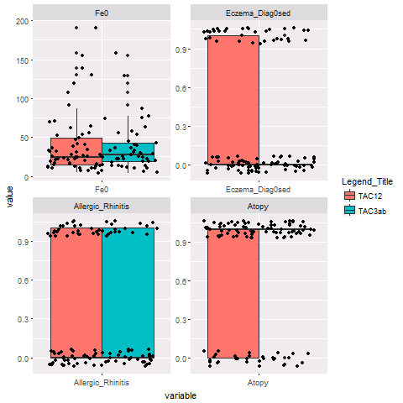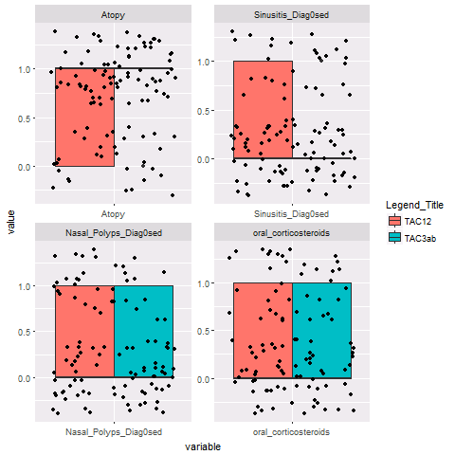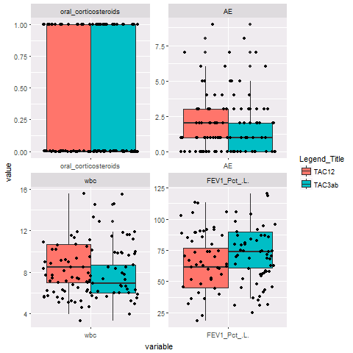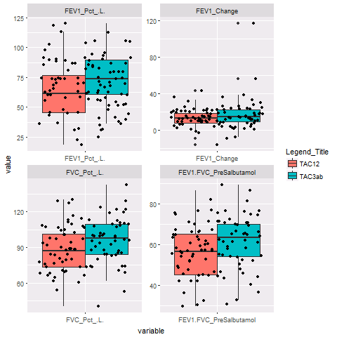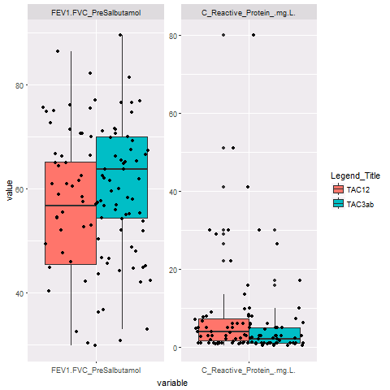**

**Boxplots to depict clinical differences for TAC3a and TAC3b**

**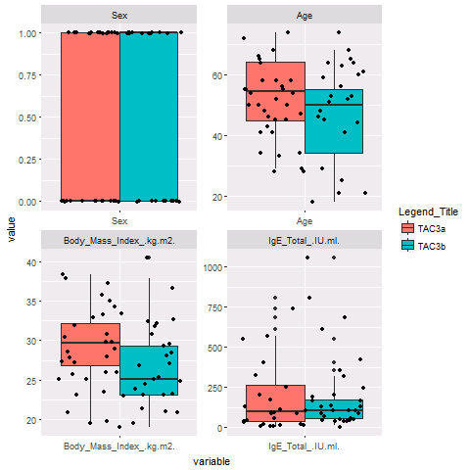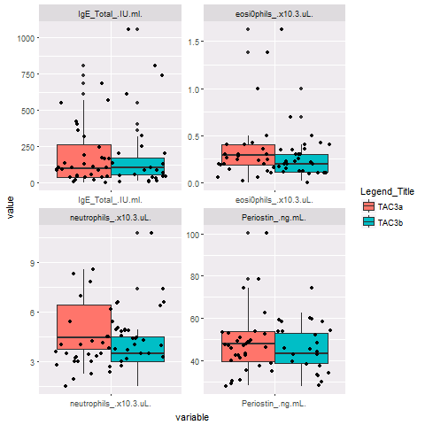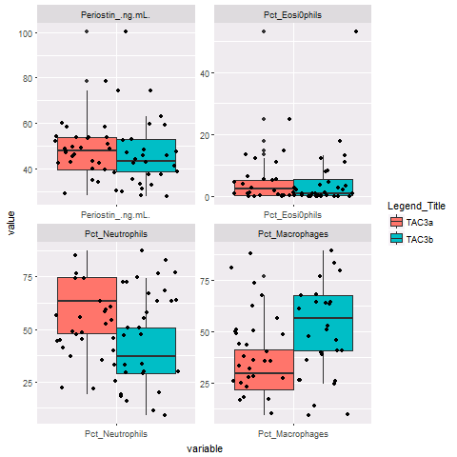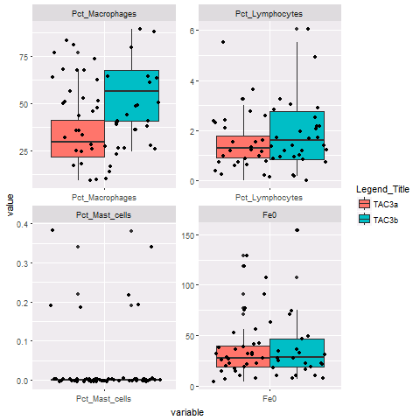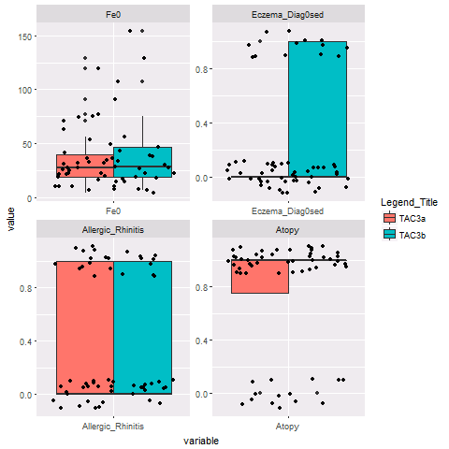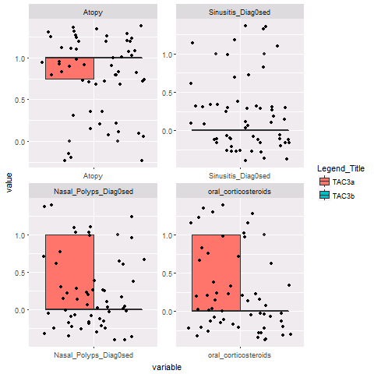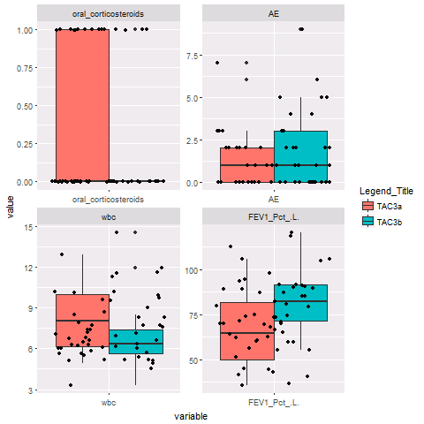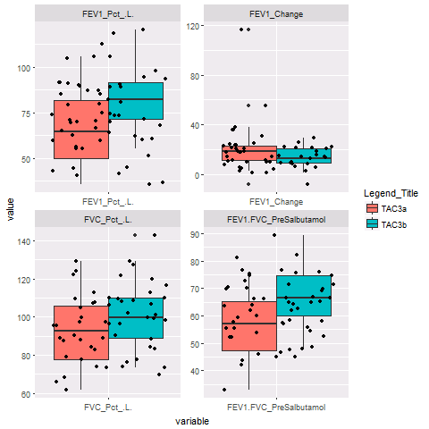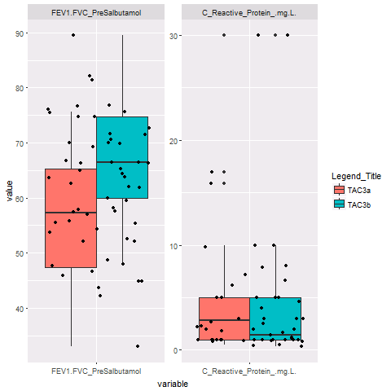**

**Gene Expression between TAG3a and TAG3b (70 most relevant genes)**

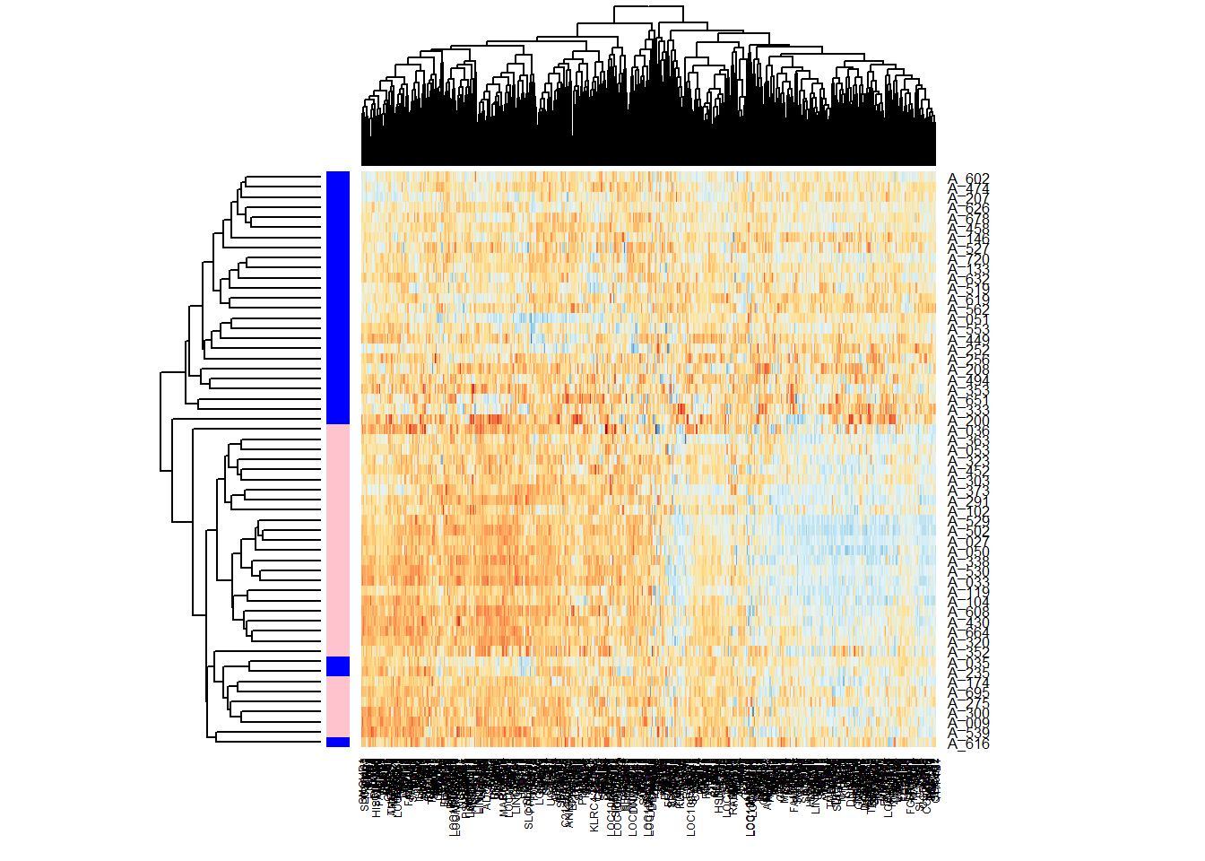

**Gene Expression between all TAGs (all genes)**

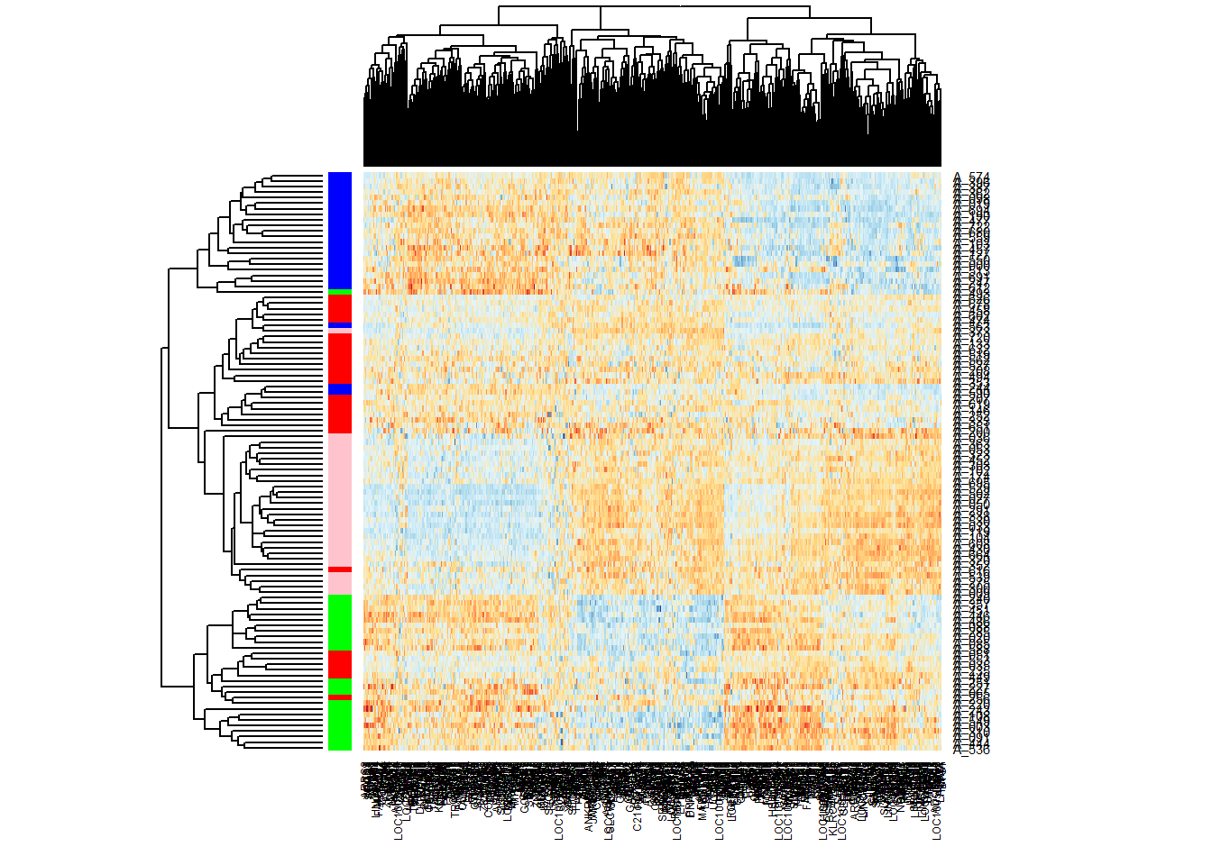

(Homo sapiens)Pathways from KEGG

• [hsa00010 Glycolysis / Gluconeogenesis - Homo sapiens (human)](http://www.genome.jp/kegg-bin/show_pathway?151816330557022/hsa00010.args" \t "_map) ([7](javascript:display('hsa00010')))

• [hsa01100 Metabolic pathways - Homo sapiens (human)](http://www.genome.jp/kegg-bin/show_pathway?151816330557022/hsa01100.args" \t "_map) ([7](javascript:display('hsa01100')))

• [hsa01200 Carbon metabolism - Homo sapiens (human)](http://www.genome.jp/kegg-bin/show_pathway?151816330557022/hsa01200.args" \t "_map) ([6](javascript:display('hsa01200')))

• [hsa01230 Biosynthesis of amino acids - Homo sapiens (human)](http://www.genome.jp/kegg-bin/show_pathway?151816330557022/hsa01230.args" \t "_map) ([5](javascript:display('hsa01230')))

• [hsa00030 Pentose phosphate pathway - Homo sapiens (human)](http://www.genome.jp/kegg-bin/show_pathway?151816330557022/hsa00030.args" \t "_map) ([3](javascript:display('hsa00030')))

• [hsa00051 Fructose and mannose metabolism - Homo sapiens (human)](http://www.genome.jp/kegg-bin/show_pathway?151816330557022/hsa00051.args" \t "_map) ([3](javascript:display('hsa00051')))

• [hsa04066 HIF-1 signaling pathway - Homo sapiens (human)](http://www.genome.jp/kegg-bin/show_pathway?151816330557022/hsa04066.args" \t "_map) ([2](javascript:display('hsa04066')))

• [hsa00562 Inositol phosphate metabolism - Homo sapiens (human)](http://www.genome.jp/kegg-bin/show_pathway?151816330557022/hsa00562.args" \t "_map) ([2](javascript:display('hsa00562')))

• [hsa00900 Terpenoid backbone biosynthesis - Homo sapiens (human)](http://www.genome.jp/kegg-bin/show_pathway?151816330557022/hsa00900.args" \t "_map) ([1](javascript:display('hsa00900')))

• [hsa00500 Starch and sucrose metabolism - Homo sapiens (human)](http://www.genome.jp/kegg-bin/show_pathway?151816330557022/hsa00500.args" \t "_map) ([1](javascript:display('hsa00500')))

• [hsa00052 Galactose metabolism - Homo sapiens (human)](http://www.genome.jp/kegg-bin/show_pathway?151816330557022/hsa00052.args" \t "_map) ([1](javascript:display('hsa00052')))

• [hsa00750 Vitamin B6 metabolism - Homo sapiens (human)](http://www.genome.jp/kegg-bin/show_pathway?151816330557022/hsa00750.args" \t "_map) ([1](javascript:display('hsa00750')))

• [hsa00730 Thiamine metabolism - Homo sapiens (human)](http://www.genome.jp/kegg-bin/show_pathway?151816330557022/hsa00730.args" \t "_map) ([1](javascript:display('hsa00730')))

• [hsa05010 Alzheimer's disease - Homo sapiens (human)](http://www.genome.jp/kegg-bin/show_pathway?151816330557022/hsa05010.args" \t "_map) ([1](javascript:display('hsa05010')))

• [hsa00520 Amino sugar and nucleotide sugar metabolism - Homo sapiens (human)](http://www.genome.jp/kegg-bin/show_pathway?151816330557022/hsa00520.args" \t "_map) ([1](javascript:display('hsa00520')))

**Glucose and pyruvate metabolism in severe chronic obstructive pulmonary disease**

[Christina C. Kao](https://www.ncbi.nlm.nih.gov/pubmed/?term=Kao%20CC%5BAuthor%5D&cauthor=true&cauthor_uid=22016370),corresponding author1,2 [Jean W.-C. Hsu](https://www.ncbi.nlm.nih.gov/pubmed/?term=Hsu%20JW%5BAuthor%5D&cauthor=true&cauthor_uid=22016370),2 [Venkata Bandi](https://www.ncbi.nlm.nih.gov/pubmed/?term=Bandi%20V%5BAuthor%5D&cauthor=true&cauthor_uid=22016370),1 [Nicola A. Hanania](https://www.ncbi.nlm.nih.gov/pubmed/?term=Hanania%20NA%5BAuthor%5D&cauthor=true&cauthor_uid=22016370),1 [Farrah Kheradmand](https://www.ncbi.nlm.nih.gov/pubmed/?term=Kheradmand%20F%5BAuthor%5D&cauthor=true&cauthor_uid=22016370),1 and [Farook Jahoor](https://www.ncbi.nlm.nih.gov/pubmed/?term=Jahoor%20F%5BAuthor%5D&cauthor=true&cauthor_uid=22016370)2

[Author information ►](https://www.ncbi.nlm.nih.gov/pmc/articles/PMC3290418/) [Article notes ►](https://www.ncbi.nlm.nih.gov/pmc/articles/PMC3290418/) [Copyright and License information ►](https://www.ncbi.nlm.nih.gov/pmc/articles/PMC3290418/)

This article has been [cited by](https://www.ncbi.nlm.nih.gov/pmc/articles/PMC3290418/citedby/) other articles in PMC.

[Go to:](https://www.ncbi.nlm.nih.gov/pmc/articles/PMC3290418/)

**Abstract**

## Abstract

The mechanisms leading to weight loss in patients with chronic obstructive pulmonary disease (COPD) are poorly understood but may involve alterations in macronutrient metabolism. Changes in muscle oxidative capacity and lactate production during exercise suggest glucose metabolism may be altered in COPD subjects. The objective of this study was to determine differences in the rates of glucose production and clearance, the rate of glycolysis (pyruvate production), and oxidative and nonoxidative pyruvate disposal in subjects with severe COPD compared with healthy controls. The in vivo rates of glucose production and clearance were measured in 14 stable outpatients with severe COPD (seven with low and seven with preserved body mass indexes) and 7 healthy controls using an intravenous infusion of [2H2]glucose. Additionally, pyruvate production and oxidative and non-oxidative pyruvate disposal were measured using intravenous infusions of [13C]bicarbonate and [13C]pyruvate. Endogenous glucose flux and glucose clearance were significantly faster in the combined COPD subjects (P = 0.002 and P < 0.001, respectively). This difference remained significant when COPD subjects were separated by body mass index. Pyruvate flux and oxidation were significantly higher in the combined COPD subjects than controls (P = 0.02 for both), but there was no difference in nonoxidative pyruvate disposal or plasma lactate concentrations between the two groups. In subjects with severe COPD, there are alterations in glucose metabolism leading to increased glucose production and faster glucose metabolism by glycolysis and oxidation compared with controls. However, no difference in glucose conversion to lactate via pyruvate reduction is observed

The mechanisms leading to weight loss in patients with chronic obstructive pulmonary disease (COPD) are poorly understood but may involve alterations in macronutrient metabolism. Changes in muscle oxidative capacity and lactate production during exercise suggest glucose metabolism may be altered in COPD subjects. The objective of this study was to determine differences in the rates of glucose production and clearance, the rate of glycolysis (pyruvate production), and oxidative and nonoxidative pyruvate disposal in subjects with severe COPD compared with healthy controls. The in vivo rates of glucose production and clearance were measured in 14 stable outpatients with severe COPD (seven with low and seven with preserved body mass indexes) and 7 healthy controls using an intravenous infusion of [2H2]glucose. Additionally, pyruvate production and oxidative and non-oxidative pyruvate disposal were measured using intravenous infusions of [13C]bicarbonate and [13C]pyruvate. Endogenous glucose flux and glucose clearance were significantly faster in the combined COPD subjects (*P* = 0.002 and *P* < 0.001, respectively). This difference remained significant when COPD subjects were separated by body mass index. Pyruvate flux and oxidation were significantly higher in the combined COPD subjects than controls (*P* = 0.02 for both), but there was no difference in nonoxidative pyruvate disposal or plasma lactate concentrations between the two groups. In subjects with severe COPD, there are alterations in glucose metabolism leading to increased glucose production and faster glucose metabolism by glycolysis and oxidation compared with controls. However, no difference in glucose conversion to lactate via pyruvate reduction is observed.