**AMERPSOFT Themes (New Format IDEMPIERE-4421)**

Idempiere Plugin: **org.amerpsoft.com.zk_themes**

AMERPSOFT Themes is a collection of themes from different sources and contributors. Joining on a single fragment plugin. Tested on idempiere versions since 8.2.

Use this version for idempiere 8.2 or Latest.

Based on IDEMPIERE-4421, Some Theme Migration Notes:

*Theme resources reside at “src/web/theme/<theme_name>” instead of “/theme/<theme_name”*

*Within the theme folder, reference to other theme resources must use full path (with “~./” prefix) instead of relative path. For e.g, at “theme/default/zul/login/login-left.zul”, the macroURI value is change from "vendor-logo.zul" to "~./theme/default/zul/login/vendor-logo.zul".*

*Same goes for resource reference at *.css.dsp. For e.g, at theme/default/css/fragment/grid.css.dsp, “background-image: url(${c:encodeURL('/theme/default/images/EditRecord16.png')})” is replace with “background-image: url(${c:encodeURL('~./theme/default/images/EditRecord16.png')})”. Note the added “~./” prefix.*

*For versioning, add a dummy javascript-module entry to src/metainfo/zk/lang-addon.xml (see the example entry for default theme. naming of the dummy js is arbitrary but it is probably easier to just use the pattern of idempiere.theme.<theme_name>). For external theme, you can use the same src/metainfo/zk/lang-addon.xml approach (at the src folder of your external theme plugin).*

Feature: Font Icons are supported and tested

Developer: Heng Sin Low

Description:

iDempiere can use now font icons.

Configuration is simply to set the System Configurator flag **ZK_THEME_USE_FONT_ICON_FOR_IMAGE** = **Y**, and then execute a Cache Reset.

After that windows will look like:

**Amtheme**: Standard Theme similar to ferrythem.

See FerryTheme from Hiep LQ on:

<http://wiki.idempiere.org/en/Plugin:_Theme_ferrytheme>

**Amthemeblu**: Blue Theme, Bigger Icons.

**Ksys**:

Maintainer: [Ken_longnan](http://wiki.idempiere.org/w-en/index.php?title=User:Ken_longnan&action=edit&redlink=1) - [ken.longnan@gmail.com]

Status: Beta, up to date with release 8.2

License: [GPLv2](http://www.gnu.org/licenses/gpl-2.0.html)

Sources: [ksys-idempiere-theme](https://bitbucket.org/longnan/ksys-idempiere-theme)

**BusinessTeam and BusinessTeamBlue:**

Maintainer: [User: PabloValdivia](http://wiki.idempiere.org/en/User:PabloValdivia)

Main Copyright: Pablo Valdivia, EGS GROUP, Lima, PERU,

**Iceblue Theme (iceblue_c):**

Mantainer: Heng Sin

**Content:**

1. **SysConfig Considerations.**
2. **Sysconfig Configurable Values**
3. **Install Binaries**
4. **Install from sources**

**Appendix 1:**

1. **SysConfig Considerations.**

There are four undocumented variables in ***ZK_ family***, that can be configured using SysConfig. In Class ***‘ThemeManager.java’*** these values are assigned using getValue Method:

***‘ThemeManager.java’ (part)***

/**

* **@return** url for large logo

*/

**public** **static** String getLargeLogo() {

String theme = *getTheme*();

String def =ITheme.***THEME_PATH_PREFIX***+theme+ITheme.***LOGIN_LOGO_IMAGE;***

**return** MSysConfig.*getValue*(MSysConfig.***ZK_LOGO_LARGE***, def);

}

/**

* **@return** url for small logo

*/

**public** **static** String getSmallLogo() {

String theme = *getTheme*();

String def = ITheme.***THEME_PATH_PREFIX***+theme+ITheme.***HEADER_LOGO_IMAGE***;

String url = MSysConfig.*getValue*(MSysConfig.***ZK_LOGO_SMALL***, **null**);

**if** (url == **null**)

url = MSysConfig.*getValue*(MSysConfig.***WEBUI_LOGOURL***, def);

**return** url;

}

/**

* **@return** name of active theme

*/

**public** **static** String getTheme() {

String theme = System.*getProperty*(MSysConfig.***ZK_THEME***);

**return** Util.*isEmpty*(theme) ? MSysConfig.*getValue*(MSysConfig.***ZK_THEME***, ITheme.***ZK_THEME_DEFAULT***) : theme;

}

/**

* **@return** url for browser icon

*/

**public** **static** String getBrowserIcon() {

String theme = *getTheme*();

String def = ITheme.***THEME_PATH_PREFIX*** + theme + ITheme.***BROWSER_ICON_IMAGE***;

**return** MSysConfig.*getValue*(MSysConfig.***ZK_BROWSER_ICON***, def);

}

Default values are assigned on ‘***ITheme.java’*** interface.

//default theme

**public** **static** **final** String ***ZK_THEME_DEFAULT*** = "default";

//logo

**public** **static** **final** String ***LOGIN_LOGO_IMAGE*** = "/images/login-logo.png";

**public** **static** **final** String ***HEADER_LOGO_IMAGE*** = "/images/header-logo.png";

**public** **static** **final** String ***BROWSER_ICON_IMAGE***= "/images/icon.png";

//theme resource url prefix

**public** **static** **final** String ***THEME_PATH_PREFIX*** = "/theme/";

1. **Sysconfig Configurable Values.**

**ZK_LOGO_LARGE**

This is the image that is shown when User Log in.

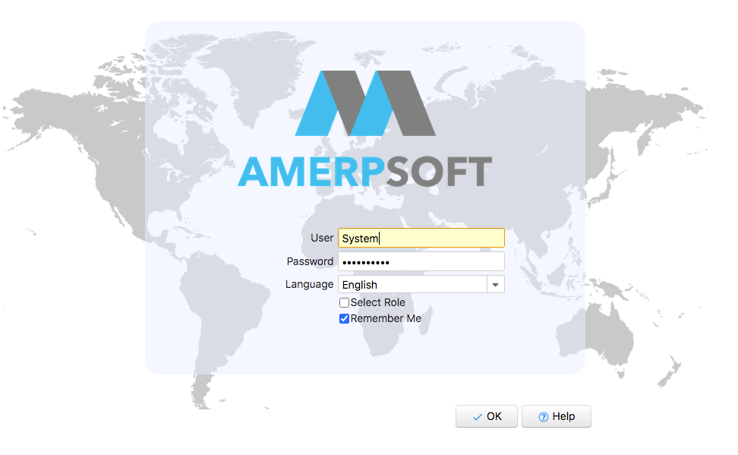

Sample Configuration:

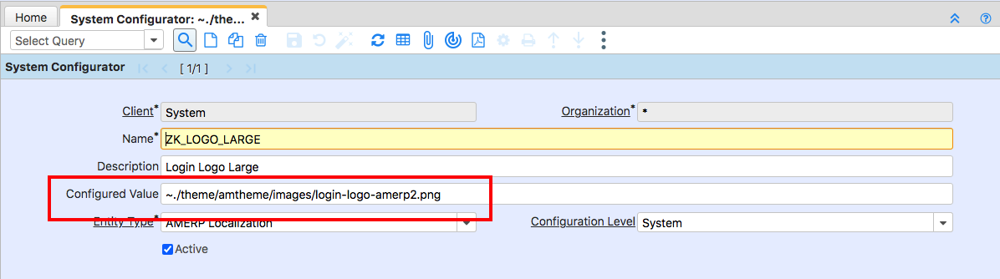

**ZK_LOGO_SMALL**

Default Value for image on upper left corner where search field and menu button is located.

It can’t be modified by each Client, in order to have information on what client user is working.

It has to be very small graphic file, otherwise may override main search field and menu button.

See included **header-logo-amerp.png** ( 3 KB) sample on documentation folder.

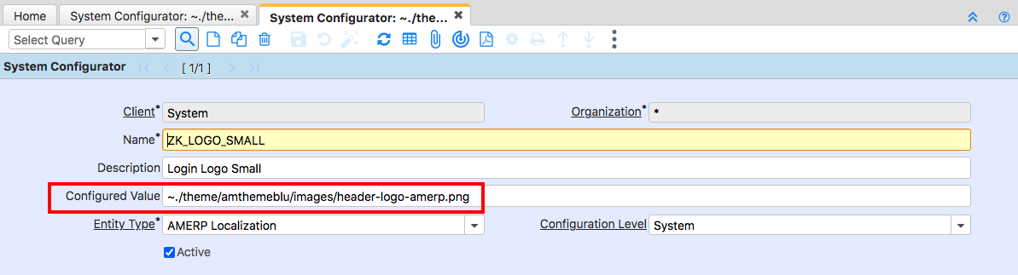

**ZK_BROWSER _ICON**

This is icon image locate at the top of navigator:

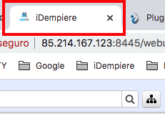

Is similar to default value: ***BROWSER_ICON_IMAGE.***

Configured Value: */theme/amtheme/images/icon-amerp.png*

theme: SIMILAR Default ***THEME_PATH_PREFIX.***

amtheme: Theme’s name.

**ZK_THEME**

This Variable is already configured on iDempiere.

Option Values:

Configured Value: *default*

When using this Plugin, user can select between Themes defined:

**Values for plugin Themes:**

***default***

***amtheme***

***amthemeblu***

***ksys***

***businessteam***

***businessTeamBlue***

***iceblue_c***

***optumTheme***

**Sample THEMES.**

***businessteam***

***Login including image:***

***Sample screen:***

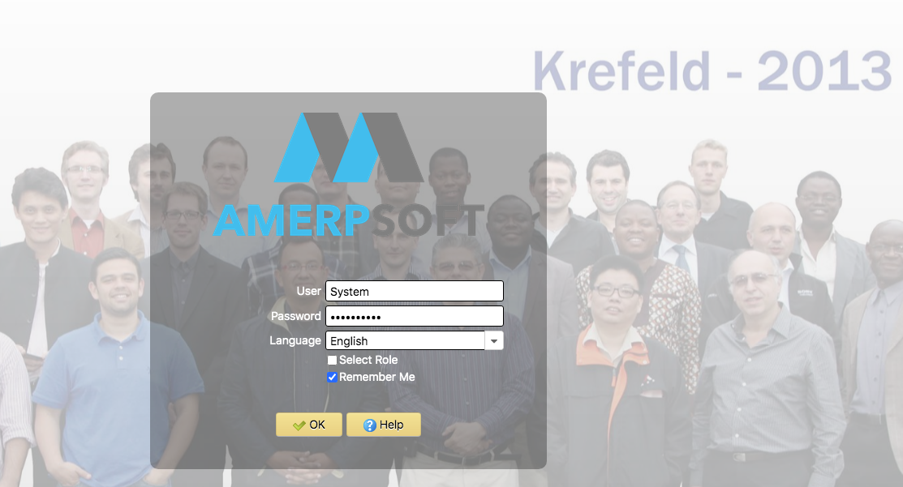

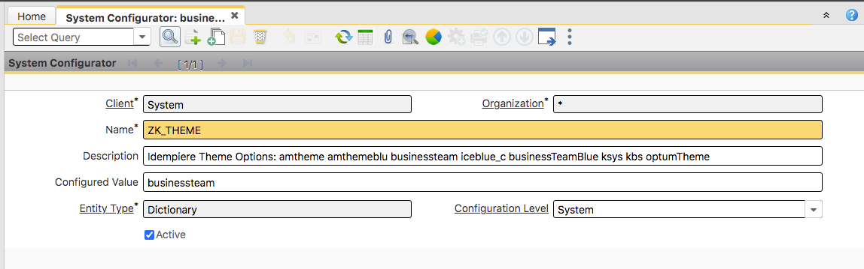

***businessTeamBlue***

***Sample screen:***

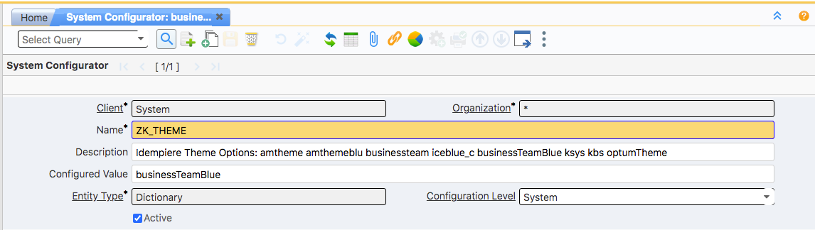

***amthemeblu:***

***Sample screen:***

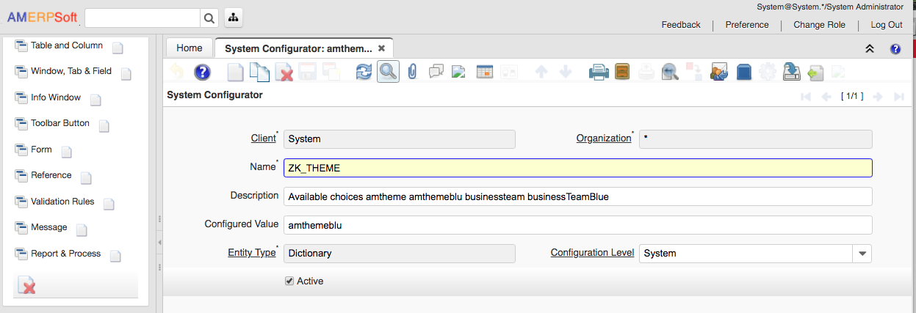

***ksys:***

***sample Screen:***

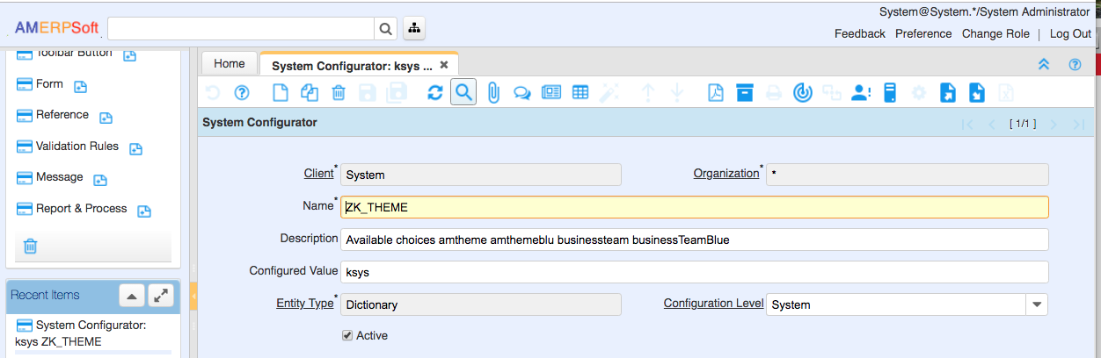

***iceblue_c:***

***sample screen.***

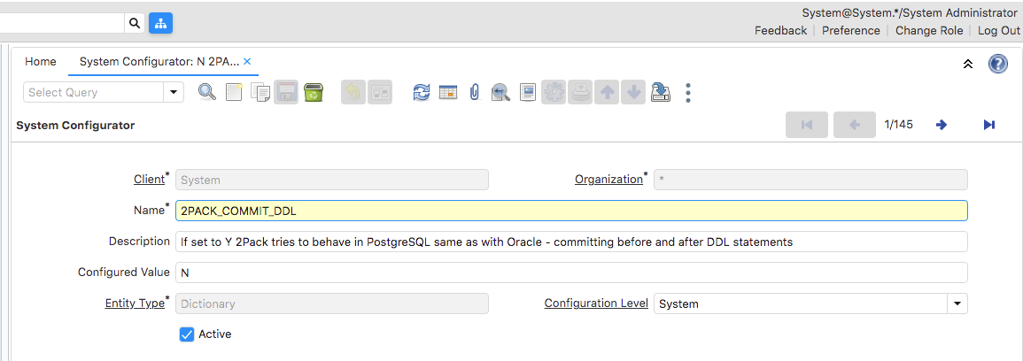

1. **Install Binaries**

Download plugin:

**https://github.com/luisamesty/Amerpsoft-iDempiere-community/blob/master/build.plugins/org.amerpsoft.com.idempiere.zk_themes_8.2.0.202102152245.jar**

(*) Version may be different

Install Using Apache Felix Web Console:

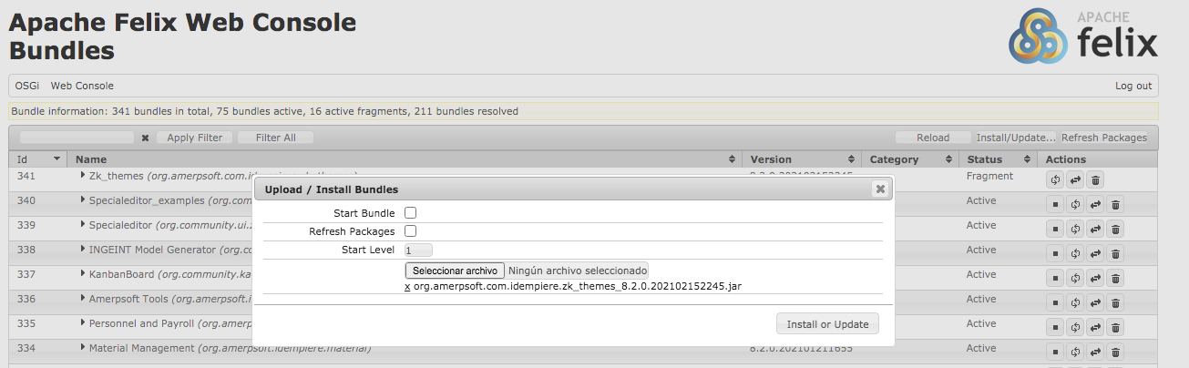

Using System Configuration Window, edit values for:

**ZK_LOGO_LARGE**

**ZK_LOGO_SMALL**

**ZK_BROWSER _ICON**

**ZK_THEME**

1. **Install from sources**

Clone repository:

[**https://github.com/luisamesty/Amerpsoft-iDempiere-community**](https://github.com/luisamesty/Amerpsoft-iDempiere-community)

With maven and eclipse, generate plugin.

See wiki reference for more information.

<https://wiki.idempiere.org/en/Building_iDempiere_Plugins_with_Maven>

Linux Commands (Generates all plugins):

$ cd sources/myexperiment/Amerpsoft-iDempiere-community

**\*\* See build.sh for information on changes**

$ sh build.sh

Plugins are generated on:

sources/myexperiment/Amerpsoft-iDempiere-community/org.amerpsoft.idempiere.p2.site/target/repository/plugins

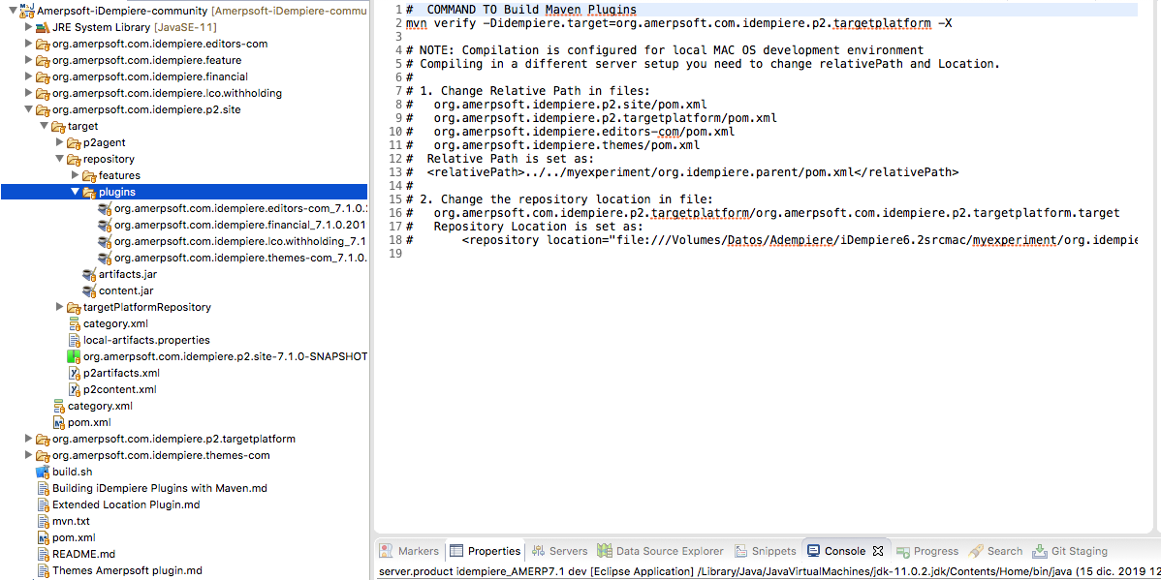

1. **Appendix 1:**

Base on **CARLOS RUIZ** contribution, Logo on header panel by client

Sample HeaderPanel Extends

**https://groups.google.com/forum/#!searchin/idempiere/client$20logo$20carlos$20ruiz%7Csort:date/idempiere/mRhPxhL5seQ/JsVsecCHAQAJ**

What I have done is to include a class in my theme plugin.   
A local HeaderPanel extending org.adempiere.webui.panel.HeaderPanel   
and overwriting this method like:   
  
 @Override

**protected** **void** onCreate() {

//log.warning("...onCreate...AMHeaderPanel..");

**super**.onCreate();

Image image = (Image) getFellow("logo");

**if** (image != **null**) {

**try** {

org.zkoss.image.Image logo = ThemeManager.*getClientWebLogo*();

**if** (logo != **null**) {

image.setContent(logo);

} **else** {

image.setSrc(ThemeManager.*getSmallLogo*());

}

image.setVisible(**true**);

} **catch** (IOException e) {

// **TODO** Auto-generated catch block

e.printStackTrace();

}

}

}

Then you can use the desktop-header class and the client logo image in   
your theme header.zul file. Also desktop.zul file must contain include header.zul.  
  
Here the code I tested, include in amerpsoft themes sources (**AMHeaderPanel.java class**):

package org.amerpsoft.themes.panel;

import java.io.IOException;

import org.adempiere.webui.panel.HeaderPanel;

import org.adempiere.webui.theme.ThemeManager;

import org.compiere.util.CLogger;

import org.zkoss.zul.Image;

public class AMHeaderPanel extends HeaderPanel {

/**

*

*/

private static final long serialVersionUID = 6442750584675935215L;

static CLogger log = CLogger.getCLogger(AMHeaderPanel.class);

@Override

protected void onCreate() {

//log.warning("...onCreate...AMHeaderPanel..");

super.onCreate();

Image image = (Image) getFellow("logo");

if (image != null) {

try {

org.zkoss.image.Image logo = ThemeManager.getClientWebLogo();

if (logo != null) {

image.setContent(logo);

} else {

image.setSrc(ThemeManager.getSmallLogo());

}

image.setVisible(true);

} catch (IOException e) {

// TODO Auto-generated catch block

e.printStackTrace();

}

}

}

}

Background-World Options:

There are two options for Background World on businessTeam, ksys and kbs.

Standard Version: (../images/background-world.png)

GMT Version: (../images/background-world-gmt.png)

***Change login.css.dsp if you are on Western hemisphere or Eastern hemisphere..***

.login-window .z-window-content {

background-image: url(../images/background-world-gmt.png) !important;

background-position: center;

/*background-attachment: scroll;*/

background-repeat: no-repeat;

}