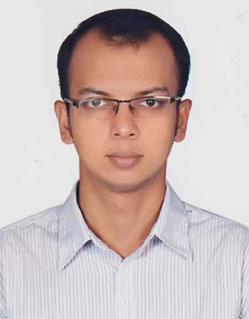**Name:** Md. Nazmus Sakib

**Contact:** 01917169307

**E-mail:** sakib.ewu@gmail.com

**Birth Date:** 13 November, 1992

**Current Address:** 164/B, Khilgaon, Chowdhury Para, Matir Masjid, Dhaka-1219

**Online portfolio link:** https://github.com/nzsakib

**Career Objective:**

For a profitable and successful career, I seek a challenging job and healthy environment where I can utilize my skill and communicate with people efficiently to create great product to help people.

**Why I want to work in Japan?**

I want to gain experience by working in different culture and challenging environment. I want to meet people with different perspective and culture to make a stronger career. Japan is a developed and advanced country and I want to utilize the technology to develop interesting product and build my career.

**Academic Background:**

**Degree:** BSc. in Computer Science and Engineering

**University Name:** East West University

**Duration:** 2013 - 2017

**Passing Date:** November, 2017

**Result:** 2.86

**Employment Experience:**

**Company Name:** Small Success LLC (www.smallsuccess.com)

**Job Title:** Junior Fullstack Web Developer

**Job Responsibilities:** Implement new feature on backend and frontend using Laravel and VueJS, fixing bugs and co-ordinate with other team members.

**Duration:** 11/2017 – 11/2018

**Technical Skills:**

**A = Team Lead or Managerial Level experience, B = Professional project Experience, C = Personal / Academic Project Experience, D = Theoretical Knowledge**

|  |  |  |  |  |  |
| --- | --- | --- | --- | --- | --- |
| **Skills** | **Level** | **Skills** | **Level** | **Skills** | **Level** |
| PHP | B | Docker | D |  |  |
| JavaScript | C | VueJS | C |  |  |
| Laravel | C | Bootstrap | B |  |  |
| Linux | B | Git | B |  |  |

**Professional Project Experience:**

|  |  |  |  |
| --- | --- | --- | --- |
| **Duration** | **Project Details** | **Technology Used** | **Your Role**  **(Part of Project)** |
| 11/2017 – 11/2018  (1 Year) | **Project Title:** Jack Westin **-** MCAT Cars Tutor  **Project Summary:** Online tutor site for Critical analysis and reasoning skills and medical admission in US and Canada.  **Project Link:** https://www.jackwestin.com/ | PHP, JS, VueJS, Laravel, Bootstrap, Mysql, Docker, Git, AWS, Stripe | **Total Number of Members:** 8  **Part of Project:**  Frontend and Backend  **Your Role:**  Fixing bugs, Implement new features and Frontend design |

**Academic or Personal Project Experience:**

|  |  |  |  |
| --- | --- | --- | --- |
| **Duration** | **Project Details** | **Technology Used** | **Your Role**  **(Part of Project)** |
| 06/2017 – 08/2017  (3 Months) | **Project Title:** Online Restaurant Review  **Project Summary:**  Get review of nearest restaurants, detecting ingredients from food photos using artificial intelligence, produce recipe from given ingredients. We used external api to do the AI stuff.  **Project Link:** https://github.com/nzsakib/foodnetwork | PHP, Laravel, Javascript, Spoonacular [Food API], Clarifai [Image API], Google maps API | **Total Number of Members: 2**  **Part of Project:**  Frontend and backend  **Your Role:**  Design frontend and implement new feature with help of team member. |

**Language Skills:**

|  |  |  |  |  |
| --- | --- | --- | --- | --- |
| **Language** | **Reading** | **Writing** | **Listening** | **Speaking** |
| English | Excellent | Good | Excellent | Good |
|  |  |  |  |  |