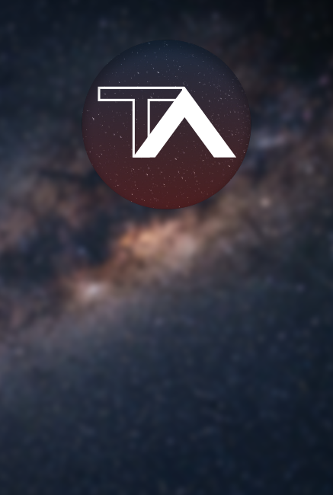

Documentation by The Astronauts



Table of Contents

Project information and plan 3

Team information 4

Introduction 5

Realisation 6

# **Project information and plan**

• We created our word game using C++, in a span of 30 days.



# 

# **Team information**

|  |  |
| --- | --- |
| № | Roles in the team |
| 1 | Nikolay Stoyanov – Scrum Trainer |
| 2 | Vicho Vichev – Backend Developer |
| 3 | Dimitar Byandov – Backend Developer |
| 4 | Martin Nenkov – QA Engineer |

# **Introduction**

|  |  |
| --- | --- |
| № | Introduction |
| 1 | **What is the final product?**  The finished product is a word game. And we used C++. |
| 2 | **How can u access the game?**  You can access the game through our GitHub project’s repository files. |
| 3 | **How did we communicate?**  For communication we used MS Teams so we can screenshare, chat and discuss everything related to the project. |
| 4 | **What programs were used?**  We used GitHub as our main collaborative work, Visual Studio Code for coding and editing, MS Teams for communication, MS PowerPoint for our presentation and MS Word for the documentation. |



# 

# **Realisation**

|  |  |
| --- | --- |
| № | How did we do it? |
| 1 | **Task Management**  The tasks were distributed through MS Teams/GitHub Issues. And whenever a task is done we notify eachother to stay in touch. |
| 2 | **Deadlines**  Whenever we had a meeting we would put our own deadlines for certain tasks to help us with organisation and bring out the finished product in time. |