Nicholas Zubrycki
MA 346
Programming Project 1

I pledge my honor that I have abided by the Stevens Honor System.

1) Use the routines you have implemented to find the natural cubic spline and interpolating polynomial for the data.

Spline: aj + bj(x-xj) + cj(x-xj)^2 + dj(x-xj)^3

using j=3

S3(x) = 59 - .6804(x-3) -.4804(x-3)^2 + .0107(x-3)^3

Interpolating Polynomial: F0,0 + ΣFi,i * Π(x-xj)

Based on the program I created...

Pn(x) = 58 + 5(x-1) + 3(x-2) + 1.83(x-3) + .75(x-4) + .2167(x-5) + .05(x-6) + .0105(x-7) + .0022(x-8) + .0004795(x-9) + .000097277(x-10) + .000017612(x-11) + 000017612(x-12)

2) Compare results by plotting both interpolants and the original data

Created in 'runProject.m', they look extremely similar to the graph of the data.
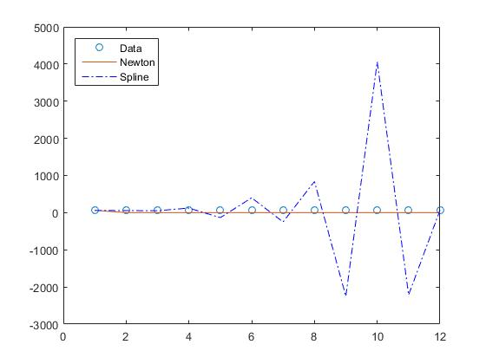

3) Which interpolant seems to give more reasonable values between the given data points?

Spline makes much more sense to me. The values that are used in the creating of the spline actually make sense, unlike the Newton values (all 0's). They are negative when the data decreases and are positive when it increases. The spline is also more 'curvy' than the newton, which to me means that it is closer to the natural data. There are parts in the graph of the newton interpolant that look like flat lines, which means that it closer to the original data and less like a polynomial representation.

4) ~72 – Still high, but I think I know where the error is coming from.

