Assignment 1

Q1.

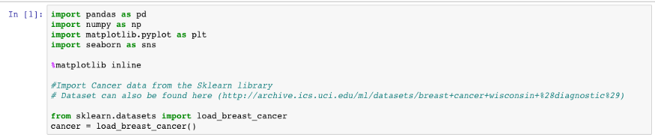

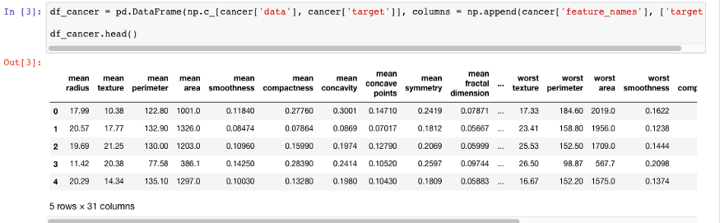

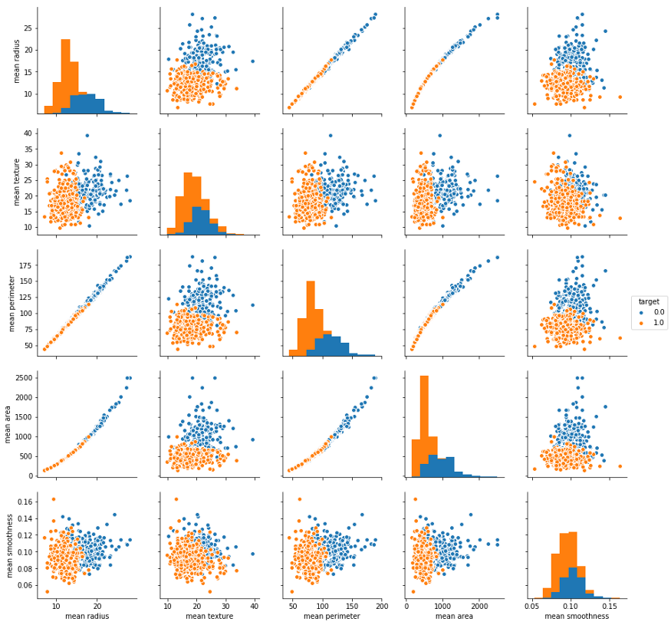

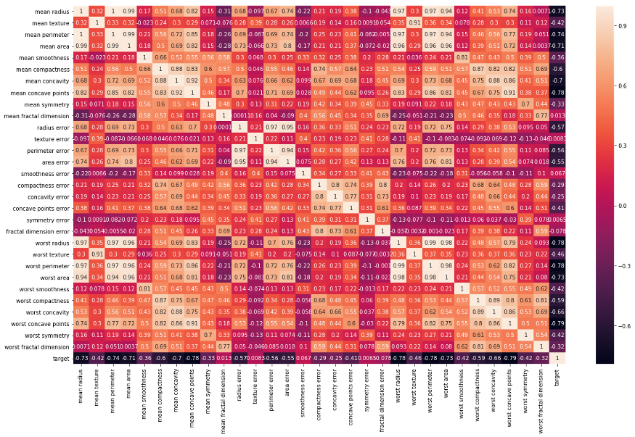

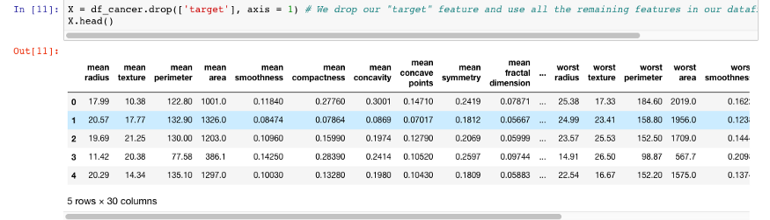

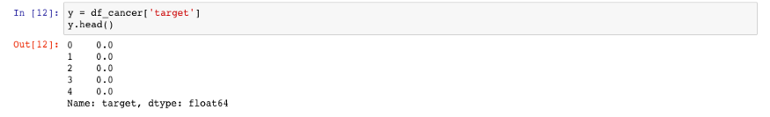

https://miro.medium.com/max/875/1*JFpwHz00VnxzBN0yjqFlJA.png

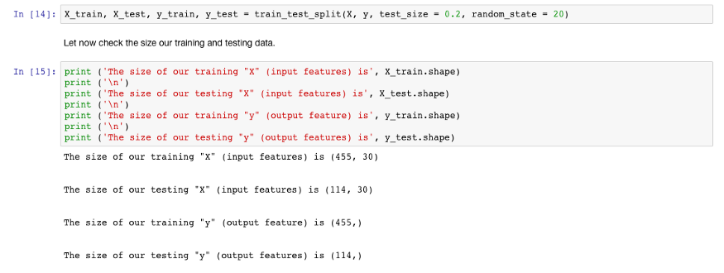



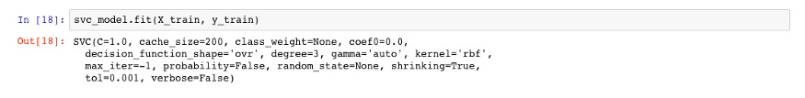

https://miro.medium.com/max/875/1*2xteBfna1URrrMp8ea2EBQ.png

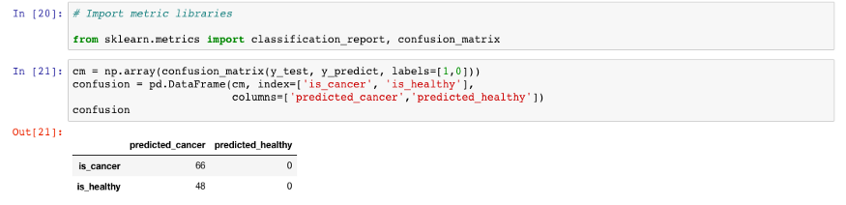

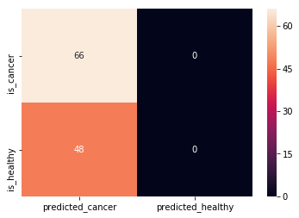

# performing linear algebra

import numpy as np

# data processing

import pandas as pd

# visualisation

import matplotlib.pyplot as plt

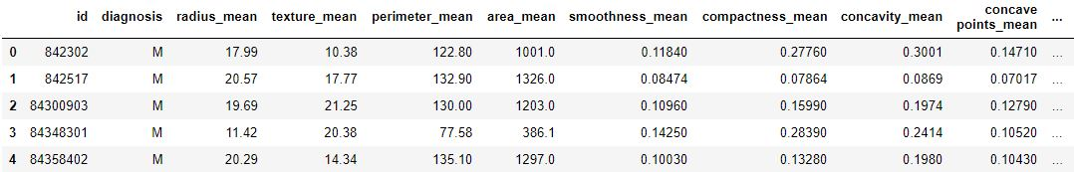

sns.lmplot(x = 'radius_mean', y = 'texture_mean', hue = 'diagnosis', data = df)

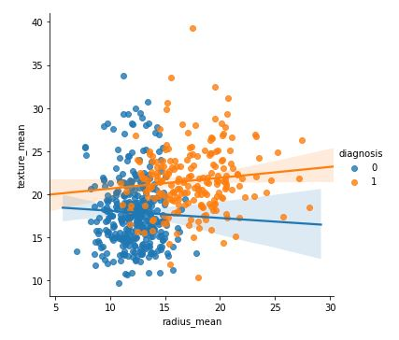

from sklearn.model_selection import train_test_split

X_train, X_test, y_train, y_test = train_test_split(

X, y, test_size = 0.33, random_state = 42)

knn = KNeighborsClassifier(n_neighbors = 13)

knn.fit(X_train, y_train)

knn.score(X_test, y_test)

neighbors = []

cv_scores = []

from sklearn.model_selection import cross_val_score

# perform 10 fold cross validation

for k in range(1, 51, 2):

neighbors.append(k)

knn = KNeighborsClassifier(n_neighbors = k)

scores = cross_val_score(

knn, X_train, y_train, cv = 10, scoring = 'accuracy')

cv_scores.append(scores.mean())

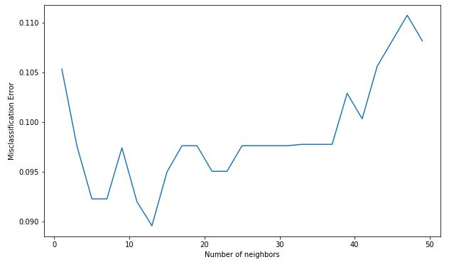

**import** numpy **as** np

**import** pandas **as** pd

**from** sklearn.datasets **import** load_breast_cancer;

cancer **=** load_breast_cancer();

X **=** cancer**.**data;

y **=** cancer**.**target;

*#data = np.c_[cancer.data, cancer.target];*

*#columns = np.append(cancer.feature_names, ["target"]);*

*#cancer.df = pd.DataFrame(data, columns = columns);*

*#print(cancer.df.head());*

*#print("\ncancer.df.shape = ",cancer.df.shape);*

**1. Divide the data into train (80%) and test (20%)**

In [3]:

**from** sklearn.model_selection **import** train_test_split;

X_train , X_test, y_train, y_test **=** train_test_split(X,

y,

test_size **=** 0.2,

random_state **=** 0);

print(X_train**.**shape);

print(y_train**.**shape);

print("\r\n");

print(X_test**.**shape);

print(y_test**.**shape);

(455, 30)

(455,)

(114, 30)

(114,)

**2. *Decision Tree Classifier* using all the features of the data. Model tested on the test data**

In [4]:

**from** sklearn.tree **import** DecisionTreeClassifier;

tree **=** DecisionTreeClassifier(criterion **=** 'entropy',

max_depth **=** 3,

random_state **=** 0 );

tree**.**fit(X_train, y_train)

Out[4]:

DecisionTreeClassifier(ccp_alpha=0.0, class_weight=None, criterion='entropy',

max_depth=3, max_features=None, max_leaf_nodes=None,

min_impurity_decrease=0.0, min_impurity_split=None,

min_samples_leaf=1, min_samples_split=2,

min_weight_fraction_leaf=0.0, presort='deprecated',

random_state=0, splitter='best')

In [5]:

**from** sklearn.tree **import** plot_tree;

plot_tree(tree,

feature_names **=** cancer**.**feature_names,

fontsize **=** 7 )

Out[5]:

[Text(193.15384615384616, 190.26, 'worst concave points <= 0.142\nentropy = 0.945\nsamples = 455\nvalue = [165, 290]'),

Text(103.01538461538462, 135.9, 'worst perimeter <= 107.75\nentropy = 0.399\nsamples = 303\nvalue = [24, 279]'),

Text(51.50769230769231, 81.53999999999999, 'symmetry error <= 0.016\nentropy = 0.133\nsamples = 269\nvalue = [5, 264]'),

Text(25.753846153846155, 27.180000000000007, 'entropy = 0.337\nsamples = 80\nvalue = [5, 75]'),

Text(77.26153846153846, 27.180000000000007, 'entropy = 0.0\nsamples = 189\nvalue = [0, 189]'),

Text(154.52307692307693, 81.53999999999999, 'worst texture <= 20.22\nentropy = 0.99\nsamples = 34\nvalue = [19, 15]'),

Text(128.76923076923077, 27.180000000000007, 'entropy = 0.0\nsamples = 11\nvalue = [0, 11]'),

Text(180.27692307692308, 27.180000000000007, 'entropy = 0.667\nsamples = 23\nvalue = [19, 4]'),

Text(283.2923076923077, 135.9, 'worst perimeter <= 112.8\nentropy = 0.375\nsamples = 152\nvalue = [141, 11]'),

Text(257.53846153846155, 81.53999999999999, 'worst texture <= 27.575\nentropy = 0.948\nsamples = 30\nvalue = [19, 11]'),

Text(231.7846153846154, 27.180000000000007, 'entropy = 0.964\nsamples = 18\nvalue = [7, 11]'),

Text(283.2923076923077, 27.180000000000007, 'entropy = 0.0\nsamples = 12\nvalue = [12, 0]'),

Text(309.04615384615386, 81.53999999999999, 'entropy = 0.0\nsamples = 122\nvalue = [122, 0]')]

In [6]:

**from** sklearn.metrics **import** accuracy_score;

y_pred_train **=** tree**.**predict(X_train);

print("Train Set Accuracy : ", accuracy_score(y_train, y_pred_train))

y_pred_test **=** tree**.**predict(X_test);

print("Test Set Accuracy : ", accuracy_score(y_test, y_pred_test))

Train Set Accuracy : 0.9648351648351648

Test Set Accuracy : 0.9473684210526315

**3. Model Run for trees of *depth 1, 2, 3, 4, 5, and 6* and for the *Gini Impurity* and *Entropy impurity* measures for each tree depth.**

**3.1 Depth = 1**

In [7]:

*# GINI IMPURITY*

tree_gin_d1 **=** DecisionTreeClassifier(criterion **=** 'gini',

max_depth **=** 1,

random_state **=** 0 );

tree_gin_d1**.**fit(X_train, y_train)

y_pred_train_gin_d1 **=** tree_gin_d1**.**predict(X_train);

y_pred_test_gin_d1 **=** tree_gin_d1**.**predict(X_test);

*# ENTROPY IMPURITY*

tree_ent_d1 **=** DecisionTreeClassifier(criterion **=** 'entropy',

max_depth **=** 1,

random_state **=** 0 );

tree_ent_d1**.**fit(X_train, y_train)

y_pred_train_ent_d1 **=** tree_ent_d1**.**predict(X_train);

y_pred_test_ent_d1 **=** tree_ent_d1**.**predict(X_test);

**3.2 Depth = 2**

In [8]:

*# GINI IMPURITY*

tree_gin_d2 **=** DecisionTreeClassifier(criterion **=** 'gini',

max_depth **=** 2,

random_state **=** 0);

tree_gin_d2**.**fit(X_train, y_train)

y_pred_train_gin_d2 **=** tree_gin_d2**.**predict(X_train);

y_pred_test_gin_d2 **=** tree_gin_d2**.**predict(X_test);

*# ENTROPY IMPURITY*

tree_ent_d2 **=** DecisionTreeClassifier(criterion **=** 'entropy',

max_depth **=** 2,

random_state **=** 0 );

tree_ent_d2**.**fit(X_train, y_train)

y_pred_train_ent_d2 **=** tree_ent_d2**.**predict(X_train);

y_pred_test_ent_d2 **=** tree_ent_d2**.**predict(X_test);

**3.3 Depth = 3**

In [9]:

*# GINI IMPURITY*

tree_gin_d3 **=** DecisionTreeClassifier(criterion **=** 'gini',

max_depth **=** 3,

random_state **=** 0 );

tree_gin_d3**.**fit(X_train, y_train)

y_pred_train_gin_d3 **=** tree_gin_d3**.**predict(X_train);

y_pred_test_gin_d3 **=** tree_gin_d3**.**predict(X_test);

*# ENTROPY IMPURITY*

tree_ent_d3 **=** DecisionTreeClassifier(criterion **=** 'entropy',

max_depth **=** 3,

random_state **=** 0 );

tree_ent_d3**.**fit(X_train, y_train)

y_pred_train_ent_d3 **=** tree_ent_d3**.**predict(X_train);

y_pred_test_ent_d3 **=** tree_ent_d3**.**predict(X_test);

**3.4 Depth = 4**

In [10]:

*# GINI IMPURITY*

tree_gin_d4 **=** DecisionTreeClassifier(criterion **=** 'gini',

max_depth **=** 4,

random_state **=** 0 );

tree_gin_d4**.**fit(X_train, y_train)

y_pred_train_gin_d4 **=** tree_gin_d4**.**predict(X_train);

y_pred_test_gin_d4 **=** tree_gin_d4**.**predict(X_test);

*# ENTROPY IMPURITY*

tree_ent_d4 **=** DecisionTreeClassifier(criterion **=** 'entropy',

max_depth **=** 4,

random_state **=** 0 );

tree_ent_d4**.**fit(X_train, y_train)

y_pred_train_ent_d4 **=** tree_ent_d4**.**predict(X_train);

y_pred_test_ent_d4 **=** tree_ent_d4**.**predict(X_test);

**3.5 Depth = 5**

In [11]:

*# GINI IMPURITY*

tree_gin_d5 **=** DecisionTreeClassifier(criterion **=** 'gini',

max_depth **=** 5,

random_state **=** 0 );

tree_gin_d5**.**fit(X_train, y_train)

y_pred_train_gin_d5 **=** tree_gin_d5**.**predict(X_train);

y_pred_test_gin_d5 **=** tree_gin_d5**.**predict(X_test);

*# ENTROPY IMPURITY*

tree_ent_d5 **=** DecisionTreeClassifier(criterion **=** 'entropy',

max_depth **=** 5,

random_state **=** 0 );

tree_ent_d5**.**fit(X_train, y_train)

y_pred_train_ent_d5 **=** tree_ent_d5**.**predict(X_train);

y_pred_test_ent_d5 **=** tree_ent_d5**.**predict(X_test);

**3.6 Depth = 6**

In [12]:

*# GINI IMPURITY*

tree_gin_d6 **=** DecisionTreeClassifier(criterion **=** 'gini',

max_depth **=** 6,

random_state **=** 0 );

tree_gin_d6**.**fit(X_train, y_train)

y_pred_train_gin_d6 **=** tree_gin_d6**.**predict(X_train);

y_pred_test_gin_d6 **=** tree_gin_d6**.**predict(X_test);

*# ENTROPY IMPURITY*

tree_ent_d6 **=** DecisionTreeClassifier(criterion **=** 'entropy',

max_depth **=** 6,

random_state **=** 0 );

tree_ent_d6**.**fit(X_train, y_train)

y_pred_train_ent_d6 **=** tree_ent_d6**.**predict(X_train);

y_pred_test_ent_d6 **=** tree_ent_d6**.**predict(X_test);

**3.7 Comparison**

In [13]:

print("\r\nDEPTH = 1");

print("\tGINI : ");

print("\t\tTrain Set Accuracy : ", accuracy_score(y_train, y_pred_train_gin_d1));

print("\t\tTest Set Accuracy : ", accuracy_score(y_test, y_pred_test_gin_d1));

print("\tENTROPY : ");

print("\t\tTrain Set Accuracy : ", accuracy_score(y_train, y_pred_train_ent_d1));

print("\t\tTest Set Accuracy : ", accuracy_score(y_test, y_pred_test_ent_d1));

print("\r\nDEPTH = 2");

print("\tGINI : ");

print("\t\tTrain Set Accuracy : ", accuracy_score(y_train, y_pred_train_gin_d2));

print("\t\tTest Set Accuracy : ", accuracy_score(y_test, y_pred_test_gin_d2));

print("\tENTROPY : ");

print("\t\tTrain Set Accuracy : ", accuracy_score(y_train, y_pred_train_ent_d2));

print("\t\tTest Set Accuracy : ", accuracy_score(y_test, y_pred_test_ent_d2));

print("\r\nDEPTH = 3");

print("\tGINI : ");

print("\t\tTrain Set Accuracy : ", accuracy_score(y_train, y_pred_train_gin_d3));

print("\t\tTest Set Accuracy : ", accuracy_score(y_test, y_pred_test_gin_d3));

print("\tENTROPY : ");

print("\t\tTrain Set Accuracy : ", accuracy_score(y_train, y_pred_train_ent_d3));

print("\t\tTest Set Accuracy : ", accuracy_score(y_test, y_pred_test_ent_d3));

print("\r\nDEPTH = 4");

print("\tGINI : ");

print("\t\tTrain Set Accuracy : ", accuracy_score(y_train, y_pred_train_gin_d4));

print("\t\tTest Set Accuracy : ", accuracy_score(y_test, y_pred_test_gin_d4));

print("\tENTROPY : ");

print("\t\tTrain Set Accuracy : ", accuracy_score(y_train, y_pred_train_ent_d4));

print("\t\tTest Set Accuracy : ", accuracy_score(y_test, y_pred_test_ent_d4));

print("\r\nDEPTH = 5");

print("\tGINI : ");

print("\t\tTrain Set Accuracy : ", accuracy_score(y_train, y_pred_train_gin_d5));

print("\t\tTest Set Accuracy : ", accuracy_score(y_test, y_pred_test_gin_d5));

print("\tENTROPY : ");

print("\t\tTrain Set Accuracy : ", accuracy_score(y_train, y_pred_train_ent_d5));

print("\t\tTest Set Accuracy : ", accuracy_score(y_test, y_pred_test_ent_d5));

print("\r\nDEPTH = 6");

print("\tGINI : ");

print("\t\tTrain Set Accuracy : ", accuracy_score(y_train, y_pred_train_gin_d6));

print("\t\tTest Set Accuracy : ", accuracy_score(y_test, y_pred_test_gin_d6));

print("\tENTROPY : ");

print("\t\tTrain Set Accuracy : ", accuracy_score(y_train, y_pred_train_ent_d6));

print("\t\tTest Set Accuracy : ", accuracy_score(y_test, y_pred_test_ent_d6));

DEPTH = 1

GINI :

Train Set Accuracy : 0.9230769230769231

Test Set Accuracy : 0.9035087719298246

ENTROPY :

Train Set Accuracy : 0.9230769230769231

Test Set Accuracy : 0.9035087719298246

DEPTH = 2

GINI :

Train Set Accuracy : 0.9516483516483516

Test Set Accuracy : 0.9649122807017544

ENTROPY :

Train Set Accuracy : 0.9318681318681319

Test Set Accuracy : 0.9210526315789473

DEPTH = 3

GINI :

Train Set Accuracy : 0.9714285714285714

Test Set Accuracy : 0.9649122807017544

ENTROPY :

Train Set Accuracy : 0.9648351648351648

Test Set Accuracy : 0.9473684210526315

DEPTH = 4

GINI :

Train Set Accuracy : 0.9846153846153847

Test Set Accuracy : 0.956140350877193

ENTROPY :

Train Set Accuracy : 0.9868131868131869

Test Set Accuracy : 0.9385964912280702

DEPTH = 5

GINI :

Train Set Accuracy : 0.989010989010989

Test Set Accuracy : 0.9473684210526315

ENTROPY :

Train Set Accuracy : 0.9912087912087912

Test Set Accuracy : 0.9210526315789473

DEPTH = 6

GINI :

Train Set Accuracy : 0.9934065934065934

Test Set Accuracy : 0.9473684210526315

ENTROPY :

Train Set Accuracy : 0.9934065934065934

Test Set Accuracy : 0.9035087719298246

In [14]:

**%matplotlib** inline

**import** matplotlib.pyplot **as** plt

plt**.**style**.**use("dark_background")

fig **=** plt**.**figure();

ax **=** plt**.**axes();

ax**.**set_xlabel('Depth - 1');

ax**.**set_ylabel('Accuracy');

ax**.**set_title('Accuracy of Test and Train Datasets at Varying Depths');

train_gin_accuracy_lst **=** [accuracy_score(y_train, y_pred_train_gin_d1),

accuracy_score(y_train, y_pred_train_gin_d2),

accuracy_score(y_train, y_pred_train_gin_d3),

accuracy_score(y_train, y_pred_train_gin_d4),

accuracy_score(y_train, y_pred_train_gin_d5),

accuracy_score(y_train, y_pred_train_gin_d6)];

test_gin_accuracy_lst **=** [accuracy_score(y_test, y_pred_test_gin_d1),

accuracy_score(y_test, y_pred_test_gin_d2),

accuracy_score(y_test, y_pred_test_gin_d3),

accuracy_score(y_test, y_pred_test_gin_d4),

accuracy_score(y_test, y_pred_test_gin_d5),

accuracy_score(y_test, y_pred_test_gin_d6)];

train_ent_accuracy_lst **=** [accuracy_score(y_train, y_pred_train_ent_d1),

accuracy_score(y_train, y_pred_train_ent_d2),

accuracy_score(y_train, y_pred_train_ent_d3),

accuracy_score(y_train, y_pred_train_ent_d4),

accuracy_score(y_train, y_pred_train_ent_d5),

accuracy_score(y_train, y_pred_train_ent_d6)];

test_ent_accuracy_lst **=** [accuracy_score(y_test, y_pred_test_ent_d1),

accuracy_score(y_test, y_pred_test_ent_d2),

accuracy_score(y_test, y_pred_test_ent_d3),

accuracy_score(y_test, y_pred_test_ent_d4),

accuracy_score(y_test, y_pred_test_ent_d5),

accuracy_score(y_test, y_pred_test_ent_d6)];

plt**.**plot(train_gin_accuracy_lst, label **=** "Train GINI Accuracies");

plt**.**plot(test_gin_accuracy_lst, label **=** "Test GINI Accuracies");

plt**.**plot(train_ent_accuracy_lst, label **=** "Train ENTROPY Accuracies");

plt**.**plot(test_gin_accuracy_lst, label **=** "Test ENTROPY Accuracies");

plt**.**legend(loc **=** "lower right", frameon **=** **True**);