Nicholas A. Zwan

06/03/19

Web 151 M1HW1

Mr. Kleiner

The app selected for me was the “Stranger Things” mobile game on the google play store. The app was developed by BonusXP Inc and it can be located and downloaded at the following link; <https://play.google.com/store/apps/details?id=com.bonusxp.legend&hl=en_US>. Below is a screenshot of the app in action. 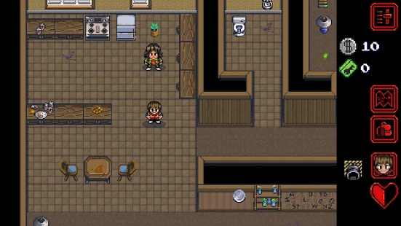

The purpose of this app is to put the world of the hit Netflix series in the palm of the user’s hand. The game itself is fairly straight forward and is reminiscent of older SNES games such as METAL GEAR, Castlevania, or The Legend of Zelda. It is a simple touch screen interface that boasts several playable characters, as well as new abilities. While this game is certainly meant to be pleasing to fans of the series, someone like myself, who is unfamiliar with Stranger Things can still find much to enjoy on this app. While playing this game, I was initially presented with two difficulty levels. The first difficulty is for beginners, while the second is meant for veteran players who like a bit more of an unforgiving experience. I found the game enjoyable despite my lack of knowledge of this universe. The combat is fun and the story is interesting. I definitely felt a brief moment of nostalgia as I played through and thought back to similar experiences.

The app has been fairly well received by the community and currently holds an average score of 4.8 on the google play store. As I have not played many games on the play store I can’t currently say that I would enjoy another app to a greater extent than this one. I would certainly say that this app serves its intended purpose for entertainment to new and returning players.