Game Design Document

Fill up the following document

1. Write the title of your project.

Parkour

1. What is the goal of the game?

Jump from platform to plat form and avoid enemies and collect coins

1. Write a brief story of your game.

You’re tryng to reach the end of a parkour and collect all the coins aswell as avoiding enemies so you don’t loose all your health

1. Which are the playing characters of this game?

* Playing characters are the ones who respond to the user based on the input from the user.
* Cars, monkeys, dinos, wizards, etc., are the playing characters in the game.

|  |  |  |
| --- | --- | --- |
| Number | Character Name | What can this character do? |
| 1 | bartholomew | Jump and move |
| 2 |  |  |
| 3 |  |  |
| 4 |  |  |
| 5 |  |  |
| 6 |  |  |
| 7 |  |  |
| 8 |  |  |

1. Which are the Non-Playing Characters of this game?

* Non-Playing characters are the ones that don't have an action or behavior when the user interacts with the game.
* Hurdles, stones, bananas, coins, etc., are non-playing characters in the game.

|  |  |  |
| --- | --- | --- |
| Number | Character Name | What can this character do? |
| 1 | enemy | Move back and forth and attack players when it touches them |
| 2 |  |  |
| 3 |  |  |
| 4 |  |  |
| 5 |  |  |
| 6 |  |  |
| 7 |  |  |
| 8 |  |  |

Draw your imagination of this game. What does this game look like?

* Draw the game either on your computer or on paper.
* Add images of the game scenes to show each of the playing and non-playing characters at least once.

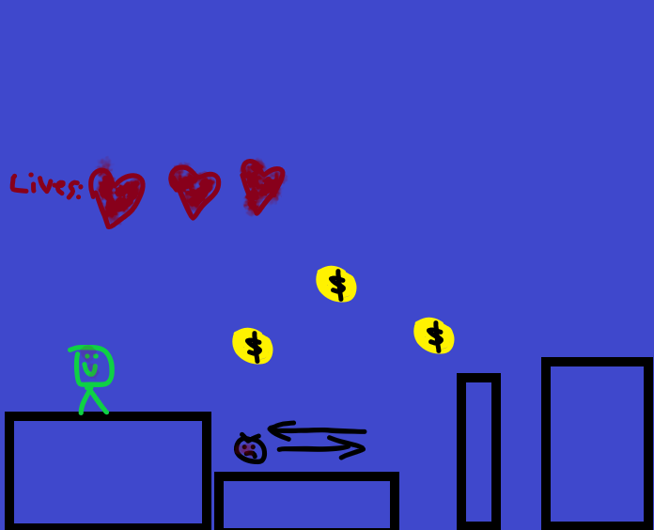

How do you plan to make your game engaging?

Maybe add mutiple levels that get harders as you go