Optimal Controls of Tensegrity Foundation for Moonquake Mitigation

Piero Risi Mortola
Department of Mechanical and Aerospace Engineering
Univeristy of Houston
Houston, Texas
plrisimo@cougarnet.uh.edu

Abstract— This report presents the design of a tensegrity foundation based on hexagonal units and outlines the analysis of its dynamic behavior. An optimal control scheme is proposed to regulate nodal movements, with the framework set up to evaluate system stability and response.

Introduction
In recent years there has been a renewed push to return to the Moon and eventually establish a lunar base. One of the challenges in building a long-term lunar base is the presence of moonquakes. Studies on the moon’s seismic activities reveal that these moonquakes, while typically weaker than earthquakes, can last for hours at a time [1]. While Earth has well-established techniques to build earthquake resistant structures, the same techniques are not suitable for the Moon. Instead the underlying concepts can be adapted for lunar conditions.
Tensegrity structures offer a promising solution. Tensegrity structures are designed to minimize mass for a given loading condition, and as such they are perfect for space applications where mass comes at a premium due to launch costs. However the main advantage in using tensegrity comes from their cable network that allows the structure to be actively controlled. This is done by changing the lengths or tension of the cables, allowing us to change the shape of the structure or change the stiffness of the structure. This ability to control the stiffness is what makes tensegrity structures a compelling solution to moonquakes.

Tensegrity Structures
Tensegrity structures are comprised of compressive members (bars) and tensile members (strings) that maintain their shape through a balance of tension and compression. Unlike traditional rigid frameworks, tensegrities distribute loads efficiently, allowing for high strength-to-weight ratios. This makes them especially well-suited for space applications, where minimizing mass is critical. Fig. 1 shows a simple tensegrity prism and how the strings and bars are connected to hold up the structure.
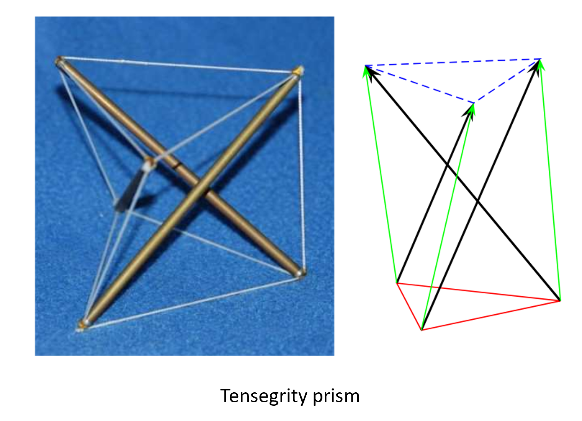
Fig 1. Tensegrity prism using 3 bars and 9 strings [2]
A key feature of tensegrities is their ability to change the stiffness of the structure. The pre-tensioned cable network allows the structure to deform elastically under load without catastrophic failure. Additionally, the cable network can be actively controlled: by adjusting string lengths and string tensions, the global stiffness and shape of the structure can be modified. This property enables tensegrities to function as active systems capable of adapting to their environment, in this case adapting to moonquake conditions. Beyond these advantages, tensegrity structures also provide robustness. In case of one of the members failing, the loads can be redistributed across the other members preventing catastrophic failure.

Structure Concept
The foundation design is based on tessellating a single tensegrity unit across a certain area. A hexagonal unit was chosen because of its symmetry and ease of tessellation. Note, many of the functions used in the code were adjusted from [3].

Hexagonal Unit
The structure, shown in Fig. 2, consists of 24 bars and 60 strings. To control the stiffness of the structure we control the strings of the structure, meaning a unit will have 60 possible control inputs. However, by symmetry, we can easily group similar strings together. While this will decrease the amount of control inputs and thus decreases the structure’s controllability, having such a high number of controllers becomes computationally expensive. Rather than prescribing tensions for individual strings, tensions can be prescribed to groups of strings.
Fig. 3 shows the chosen groups of strings. These groups were chosen during assembling a prototype of the hexagonal unit. The string groups represent just one string that has been weaved through the nodes, as this was how the prototype was built. However, a better approach may be to group strings based on the full, tessellated structure.
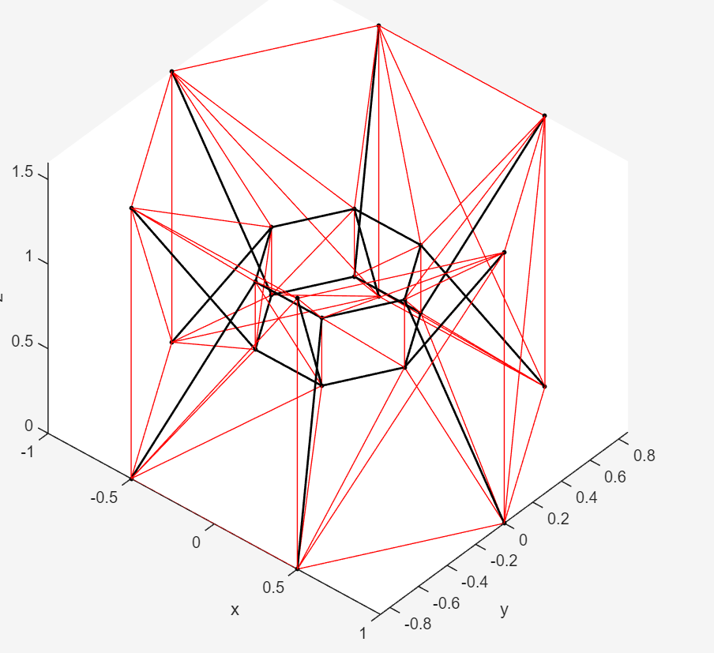
Fig. 2: Hexagonal unit. Red lines are strings, black lines are bars.
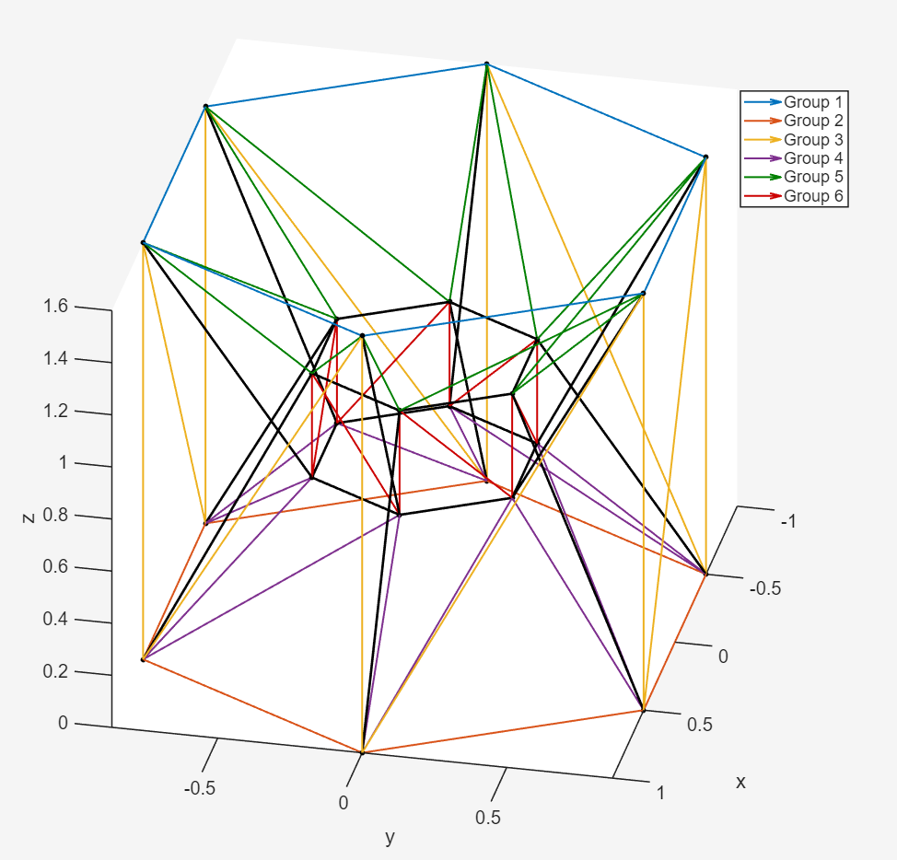
Fig. 3: Grouped strings of hexagonal unit

Tessellating
Using the properties of a hexagon, the tensegrity unit can easily be tessellated to fit the area of need. When performing the tessellation in MATLAB, care needs to be taken to remove repeated nodes or strings. Otherwise, the foundation will not be one structure but a group of individual structures. Because of the large number of nodes, a 2-by-2 foundation was used in modelling, top-view seen in Fig. 4.

Modeling Assumptions
To simplify the calculations the following assumptions were used:
- A 2-by-2 foundation was tested
- Small displacements around the equilibrium position
- Bars and strings are linear elastic
- Only axial members, strings only carry tension
- Mass of the structure concentrated at the nodes
- Ground nodes are pinned

Dynamics Formulation
First we define the material properties of the bars and strings. Table 1 shows the symbols and their definitions.

Symbol | Definition
E_{b}, E_{s} | Bar, string Young’s modulus
A_{b}, A_{s} | Cross-sectional area of bars, strings
Using these material properties and the configuration of the nodes and the elements, the stiffness of an element is defined as:
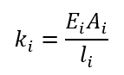 (1)
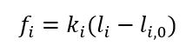 (2)
In (2), l_{i,0} is the resting length of the i’th element. To assemble the global stiffness matrix, K, the local stiffnesses, k_{i}, are transformed from the local axial coordinates to the global nodal coordinates.
With the global stiffness, the structure is modeled using nodal dynamics, similar to what is used in Finite Element Analysis (FEA). Using our linear assumptions and lumped nodal mass assumption, the nodal dynamics is given in (3).
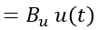 (3)
M is the mass matrix, n is the nodal coordinates, D is the damping matrix, and K is the global stiffness matrix. For simplicity, let D = 0, assuming damping effects are negligible.

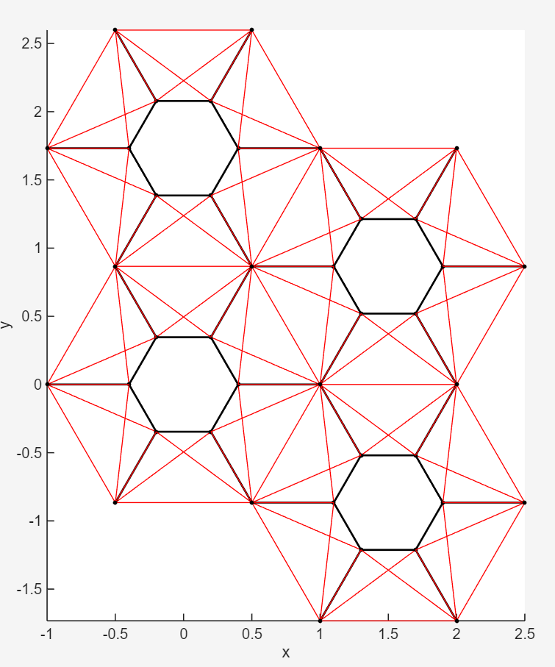
Fig.4: Two-by-two tessellation top view

Optimal Controls
To actively regulate the stiffness of the tensegrity foundation, a linear-quadratic regulator (LQR) is designed based on the linearized state-space model of the structure. The goal of the controller is to minimize the displacement and velocity of the top nodes while also limiting the actuation effort applied to the strings.

State-Space Model
Define the state vector as the nodal positions and nodal velocities:
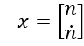
Rewrite (3) using the state x to get the state-space representation of the dynamics:
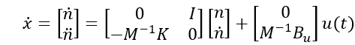 (4)
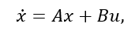
This is the model used for the LQR design. When modeling the moonquake, an extra force is added to (4).

LQR Design
Since the moonquakes can last for hours, we can formulate the problem as an infinite horizon LQR. The cost function is :
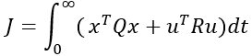
The state-weighting matrix, Q, weighs the top nodes higher since we are trying to minimize movement at the top nodes, and R is the control energy weighting matrix. With these weighting matrices and the state-space model, the optimal feedback gain can be found by solving the algebraic Riccati equation (5) for P and plugging it into (6).

(5)

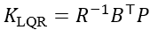 (6)
The resulting controller is then:
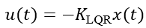 (7)
Further adjustments to Q and R can be made depending on the performance of the simulation results.

Further work
The work presented here outlines the modeling and control framework for a tensegrity-based lunar foundation, but several steps remain to complete the full analysis. The next stage is to finish validating the dynamics model and perform a statics analysis of the foundation for some mass sitting on top. A prescribed prestress to the strings would then need to be applied to counteract the deformation of the platform due to the mass on top. With this new equilibrium found, the LQR gain matrix can be solved using the linearized model. With the controller in place, time-domain simulations will be performed using recorded moonquake data to evaluate how effectively the structure can suppress nodal motion.
In practice, the foundation would rely on seismometers and other sensors rather than full state measurements. For this reason, a more realistic extension is to replace the pure LQR design with a Linear-Quadratic-Gaussian (LQG) controller, combining the LQR feedback law with a Kalman filter for state estimation under sensor noise and incomplete measurements. Additional work includes incorporating damping effects, exploring alternative control strategies, and studying how changes in cable grouping cam influence performance.

References

- C. Nunn, Y. Nakamura, S. Kedar, and M. P. Panning, “A New Archive of Apollo’s Lunar Seismic Data,” Planet. Sci. J., vol. 3, no. 9, p. 219, Sept. 2022, doi: 10.3847/psj/ac87af.J. Clerk Maxwell, A Treatise on Electricity and Magnetism, 3rd ed., vol. 2. Oxford: Clarendon, 1892, pp.68–73.
- M. C. Oliveira and R. E. Skelton, Tensegrity Systems. Springer US, 2009. doi: 10.1007/978-0-387-74242-7.
- S. Ma, M. Chen, and R. E. Skelton, “TsgFEM: Tensegrity Finite Element Method,” JOSS, vol. 7, no. 75, p. 3390, July 2022, doi: 10.21105/joss.03390.

