**Recommendations for Big Mountain Resort**

1. Introduction

Big Mountain Resort, a ski resort located in Montana, offers spectacular views of Glacier National Park and Flathead National Forest, with access to 105 trails, vast bowl, and tree skiing. With these stunning features, BMR hosts about 350,000 people to ski or snowboard every year using 11 lifts, 2 T-bars, and one magic carpet. Big Mountain Resort has recently installed an additional chair lift to help increase the distribution of visitors across the mountain, which has increased their operating costs by $1,540,000 this season. The BMR is looking for a way to increase profitability even though the increased operation expenditure. In this regard, a new ticket price has been offered to BMR by exploring the other resorts’ pricing strategy. Moreover, by examining the effect of various operations on ticket price, some expenditure reduction has been offered to BMR.

1. Materials and method

The available data resource for this purpose was just a CSV file provided by the database manager of BMR. It contains data about total chairs, runs, terrain parks, days open last year, years open, etc. as well as ticket price for both weekdays and weekend days for various resort all around the US. To evaluate the correlation between ticket prices and various features, the provided CSV file has been reviewed for missing values and after modification of the referred dataset, a clean, defectless dataset has been passed to “Scikit-learn” machine learning library, in particular random forest regression model to train and test the ml algorithm.

1. Results and discussion

According to the prediction of the developed model, there is a meaningful correlation between the tick price and some features of resorts. Fig. 1 shown the evaluation of the random forest regression algorithm on the importance of features.

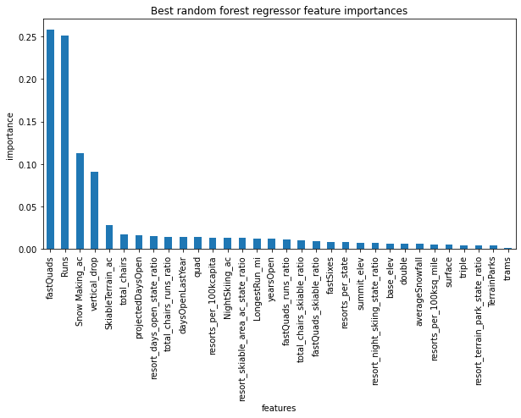

Figure 1. Importance of different features on ticket pricing

Based on the prediction of the model on the important features, some hypotheses have been suggested. Investigating various conditions and hypotheses have revealed that closing the least used run will have no effect on ticket price, but will reduce the maintenance expenditure. Figure 2 shown the effect of number of runs on ticket price and revenue consequently. To check the revenue, it has been considered for each visitor to buy 5 tickets within the season.

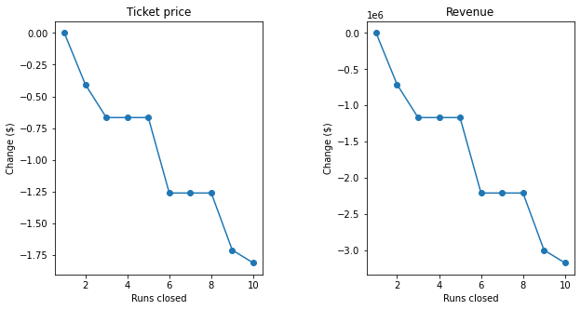

Figure 2. Effect of number of closing on the ticket price (left) and revenue (right)

Comparing the situation of BMR on the desired features with other resorts has proved the premium segment of BMR in the market. Therefore, it is anticipated that the market will tolerate a few premium charges for new installed chair lift. According to the prediction of the model based on the ticketing policy of the other resorts; adding a run, increasing the vertical drop by 150 feet, and installing an additional chair lift supports increasing the ticket price by $1.99 which results in increasing the revenue by $13474638.