A1 documentation.

Resource path- All a1 services are located on */otf/vth/oran/a1/v1*. Action parameter is used to determine which service is used.

Possible actions:

1. Health check – performs health check on a1

Vth parameters:

action: “health_check”

1. List policy- list all registered policy type ids

Vth parameters:

action: “list_policy”

1. Edit policy- edit a specify policy type.

Possible edit types:

1. GET
2. DELETE
3. PUT

Vth parameters:

action: “edit_policy”

policy_type_id: [policy type id]

request_type: [edit type] (**chosen from one of the above possible edit types)

payload: payload for PUT request

1. List policy instance- list all policy instance ids for a specify policy type.

Vth parameters:

Action: “list_policy_instance”

policy_type_id: [policy type id]

1. Edit policy instance- edit a specify policy instance.

Possible edit types:

1. Get
2. Delete
3. Put

Vth parameters:

action: “edit_policy_instance”

policy_type_id: [policy type id]

policy_instance_id: [policy instance id]

request_type: [edit type] (**chosen from one of the above possible edit types)

payload: payload for PUT request

1. Get policy instance status- Retrieve the policy instance status across all handlers of the policy.

VTH parameters:

action: "get_policy_instance_status"

policy_type_id: [policy type id]

policy_instance_id": [policy instance id]

**Sample workflow:**

Parameters for A1-vth in this workflow:

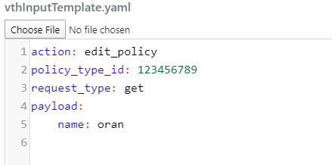

Workflow:

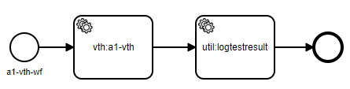

**FYI: when the workflow reaches the a1-vth box, a request is sent to the A1-vth with the provided parameters as stated above.