Policy Manager documentation.

Resource paths:

(POST) /otf/vth/oran/a1/v1/handle_action

(GET) /otf/vth/oran/a1/v1/health

Actions:

Handle Action:

1. Actions – (policies|policy|policy_ids|policy_schema|policy_schemas|policy_status|policy_types|ric|rics|service|services|keepalive|status)

1. Methods: (GET|POST|PUT|DELETE)
2. Auth: can be disabled by env variable
   1. Username
   2. password
3. Action Data (Json Objects that use single quotes if used by Front End):
   1. Query: query params, single level: e.g. {‘key1’:’value1’, ‘key2’:’value2’}
   2. jsonBody: json request passed in body: e.g. {'key':'value', 'key2':{'innerKey': 11}}

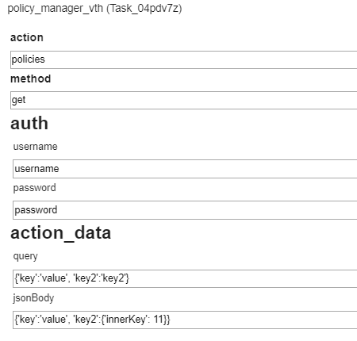

VTH Request Using Frontend

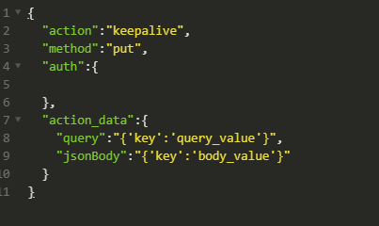

VTH Direct Request Using Insomnia/Postman

**Sample workflow:**

Parameters for one vth in this workflow:



Workflow:

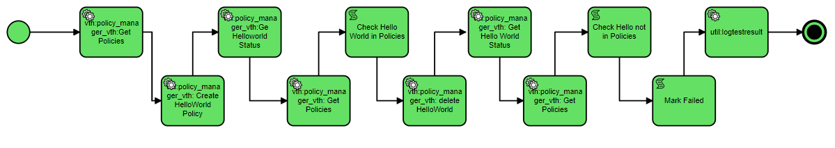

**FYI: when the workflow reaches the vth box, a request is sent to the vth with the provided parameters as stated above. Each vth box contains its own set of parameters.