dMaap VTH

**subscribe option**: subscribes to a dMaap topic

Subscribe parameters:

* topic_name: topic name that you are subscribing to.
* consumer_group: group id.
* consumer_id: consumer id.
* timeout(*optional*): declare an optional timeout(ms) for how long the request should wait for a topic to be publish.

Example vthInputTemplate.yaml from UI:

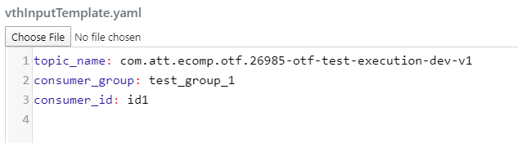

**publish option**: publish a topic to a specific dMaap group

publish parameters

* topic_name: topic that you are publishing message to.
* data: the message that you are publishing.

Example vthInputTemplate.yaml from UI:

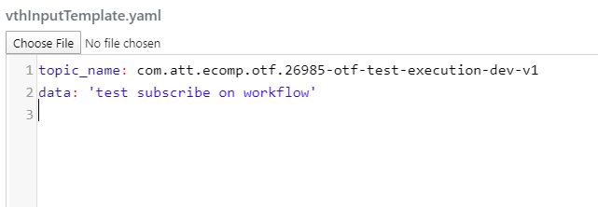

***Sample publish workflow***

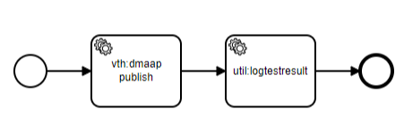

***Sample subscribe workflow***

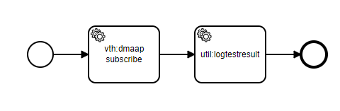

***Sample publish-subscribe workflow***

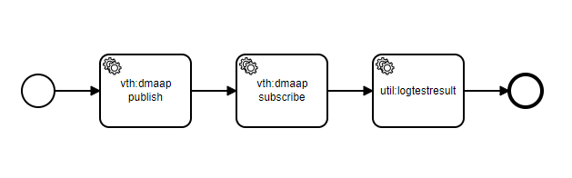

***Sample subscribe-publish-subscribe workflow***

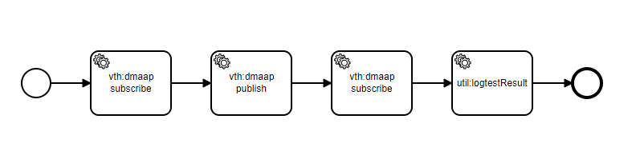

**Important notes:**

1. if you create a new group, you must subscribe to the dMaap topic before you can you receive any messages.
2. published messages will be sent to all groups but only to one consumer id within the group.