SMO VTH Documentation

Resource path: /otf/vth/oran/smo/v1/alarm-list

Parameters: None

Sample workflow:

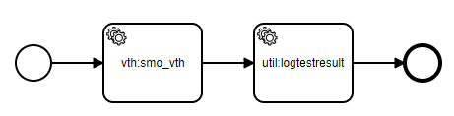

Note- smo_vth only has one route/usage which is get alarm list (named as “Health check” on oran flow#2 and flow #4)