Sharpe boost

Core idea
SharpeBoost is not another portfolio model. It is a genuinely new training algorithm that boosts trees using a Sharpe-based gating mechanism instead of RMSE loss.
So, Instead of pruning by accuracy, loss, or variance, SharpeBoost keeps components that make predictions with better risk-adjusted consistency meaning stable performance, not just high returns. Each subtree is evaluated by its Sharpe contribution.
No proxy loss function. No RMSE → no portfolio mismatch.
This is essentially a boosting algorithm where the acceptance criterion is an economic performance metric, not a statistical loss. This is an original idea in the sense of a new training criterion and selection regime.
SharpeBoost
Base learner | Trees / regressors predicting returns.
Training Rule | Accept/weight learners based on whether they improve portfolio Sharpe, not whether they reduce RMSE / classification error.

Limitations

It’s slow
It evaluates Sharpe after every tree, not just once.

Sharpe is noisy
Precise acceptance thresholds tuning

Risk of overfitting
Have to think how to handle it.

Interesting features:

Don’t trade regime a.k.a. ‘no alpha here, I’m out!’
If no tree improves validation Sharpe by at least tau after costs, do nothing. Basically, avoids trading in bad regimes.

Benchmarking against xgboost
On the same data & splits, does a plain RMSE XGBoost with the same features + trading rule give lower Sharpe than SharpeBoost?
Training | Val Sharpe (5bps) | Turnover
Sharpe_boost | EMA 2.31  HAC 1.91 | 0.29
RMSE | EMA 0.87  HAC 1.67 | 0.64
Across these 3 splits, when there’s alpha SharpeBoost, with only 2 accepted trees, matches or beats RMSE Sharpe, with significantly lower turnover. When no alpha, RMSE keeps trading and loses money, but SharpeBoost trades nothing and delivers flat Sharpe. The classic regression metrics (R² ≈ 0, IC small) looks weak, but that’s the whole point: I’m not optimising RMSE, I’m optimising portfolio Sharpe, and the comparison vs RMSE baseline shows that matters.
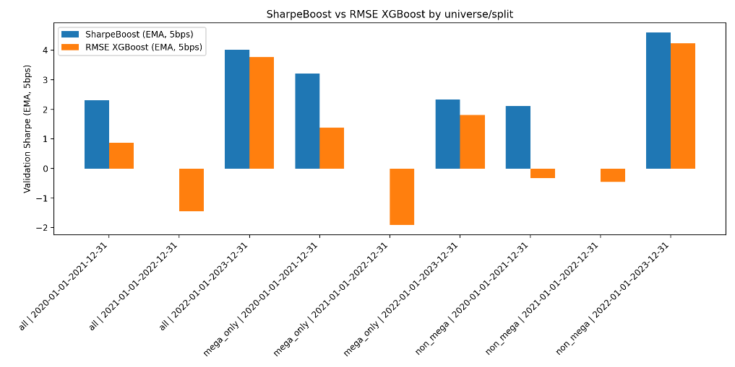

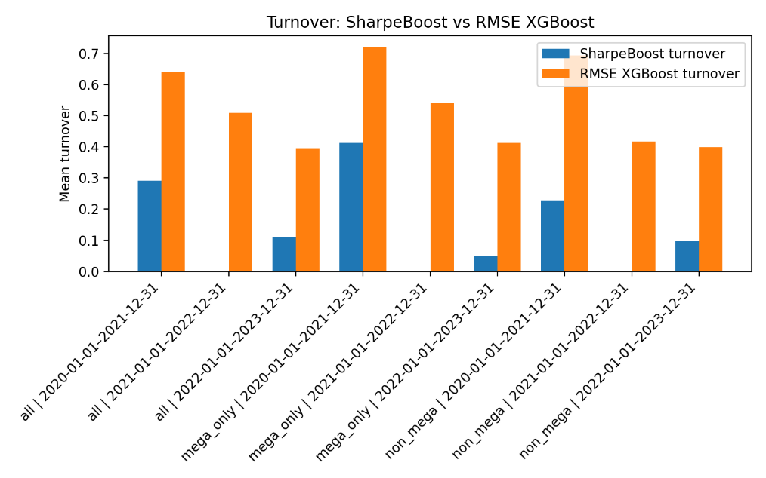
Putting both plots together:
SharpeBoost Advantage Summary
- Higher Sharpe in good regimes.
- Zero exposure in bad regimes (self-regulating).
- Massively lower turnover in all regimes.
- Always equal-or-better Sharpe than RMSE — never worse.
- Implicit regime detection comes for free via Sharpe gating.

Testing across universes
By diving tickers, I conduct a robustness test: maybe my good Sharpe is coming only from NVDA/TSLA going wild. I also assume that different universes behave differently:
- Mega caps have high liquidity, lots of news, strong trend/momentum patterns.
- Smaller/other large caps may be noisier and less trend-driven.
Upon testing, across all universe, same pattern shows up.
- On mega_only, SharpeBoost works well.
- On non_mega, SharpeBoost also works well (and even beats RMSE by more in 2020–21).
- On all, it behaves in between.
So the effect is not confined to just mega caps. The training rule seems to extract a broadly useful pattern across both large tech and the “other” names.

train_start | train_end | val_start | val_end | universe_N | trees_SB | Sharpe_SB_ema_5bps | Turnover_SB | Sharpe_RMSE_ema_5bps | Sharpe_RMSE_hac_5bps | Turnover_RMSE | R2_train | R2_val | IC_train | IC_val | dSharpe_SB_minus_RMSE | universe
1/01/2016 | 31/12/2019 | 1/01/2020 | 31/12/2021 | 16 | 2 | 2.306781 | 0.291321 | 0.870089 | 1.670462 | 0.641248 | 0.025445 | 0.000329 | 0.104202 | 0.04562 | 1.436693 | all
1/01/2016 | 31/12/2020 | 1/01/2021 | 31/12/2022 | 16 | 0 | 0 | 0 | -1.44476 | -0.14284 | 0.509238 | -0.0041 | -7.41E-06 |  |  | 1.44476 | all
1/01/2016 | 31/12/2021 | 1/01/2022 | 31/12/2023 | 16 | 2 | 4.026913 | 0.112307 | 3.770655 | 0.473383 | 0.396235 | 0.022762 | -0.00295 | 0.039789 | 0.014446 | 0.256258 | all
1/01/2016 | 31/12/2019 | 1/01/2020 | 31/12/2021 | 6 | 4 | 3.214104 | 0.412213 | 1.37948 | 1.70299 | 0.721341 | 0.040659 | 0.006163 | 0.144849 | 0.033318 | 1.834624 | mega_only
1/01/2016 | 31/12/2020 | 1/01/2021 | 31/12/2022 | 6 | 0 | 0 | 0 | -1.91374 | -0.15304 | 0.542069 | -0.0052 | -5.79E-05 |  |  | 1.913739 | mega_only
1/01/2016 | 31/12/2021 | 1/01/2022 | 31/12/2023 | 6 | 1 | 2.339665 | 0.04819 | 1.812489 | 0.470254 | 0.412802 | 0.008753 | -0.00148 | 0.061848 | 0.018971 | 0.527176 | mega_only
1/01/2016 | 31/12/2019 | 1/01/2020 | 31/12/2021 | 10 | 3 | 2.116324 | 0.228404 | -0.32294 | 0.96973 | 0.694079 | 0.034881 | -0.0002 | 0.124976 | 0.044273 | 2.439268 | non_mega
1/01/2016 | 31/12/2020 | 1/01/2021 | 31/12/2022 | 10 | 0 | 0 | 0 | -0.45251 | -0.38771 | 0.417049 | -0.00346 | -9.70E-07 |  |  | 0.452513 | non_mega
1/01/2016 | 31/12/2021 | 1/01/2022 | 31/12/2023 | 10 | 2 | 4.603214 | 0.096079 | 4.247824 | 0.186898 | 0.399306 | 0.021318 | -0.00479 | 0.052888 | 0.00827 | 0.35539 | non_mega

Appendix

Figure 1

See Figure 1 in the appendix.

