1. 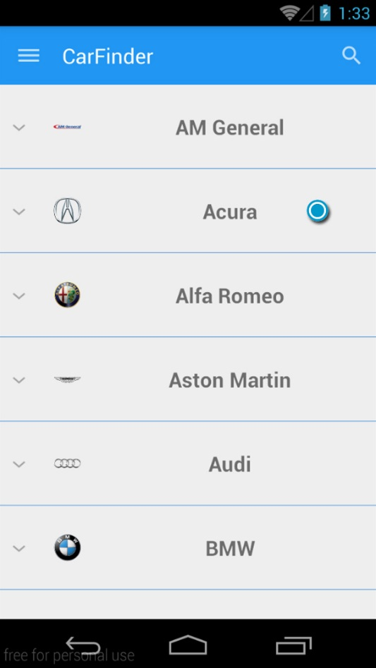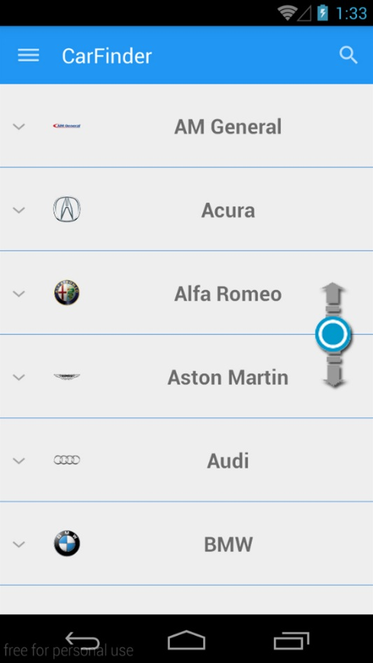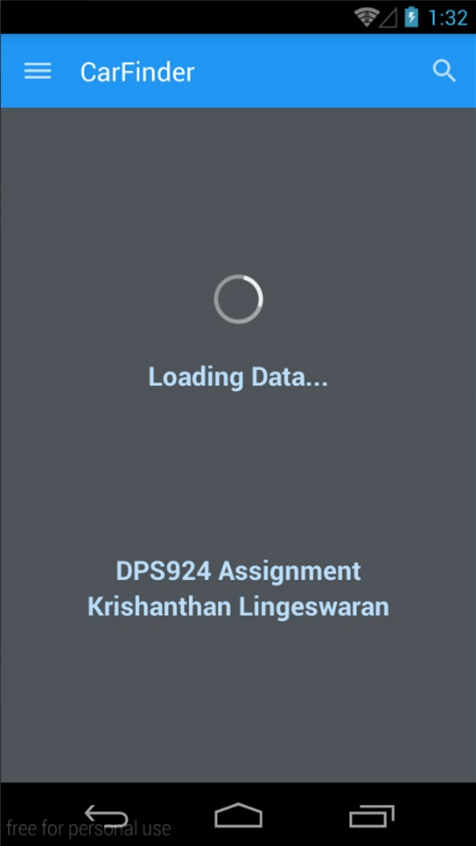First launch the application. When launched you will see the loading screen. Once loaded you will be presented with a list of vehicle makes and models. Models are revealed when a make is clicked.
2. 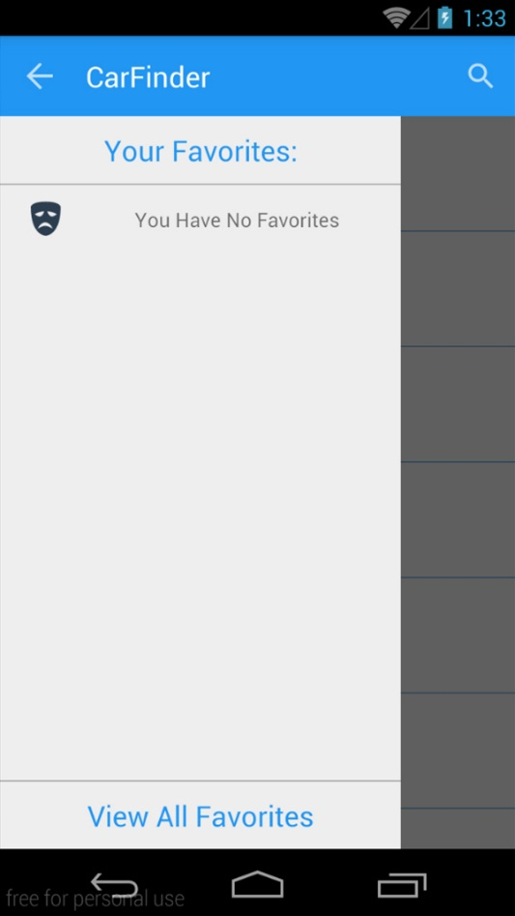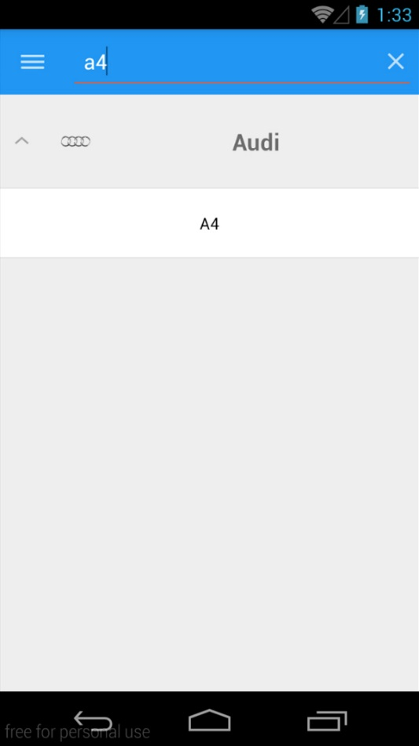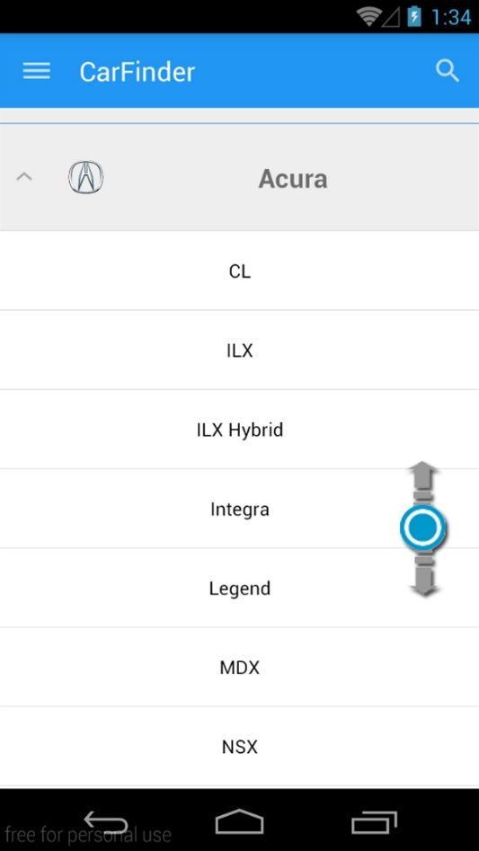In this view you can do many things. Like browse all vehicles and models. Search the list. Open the navigation drawer and view all favorites.
3. You can start of by selecting any model that you want to view. Once clicked, data will load for that model, and once done it will display it accordingly. Details Activity has tabs which contain each year for the model. You can swipe left or right to view the other years, or select the tab.

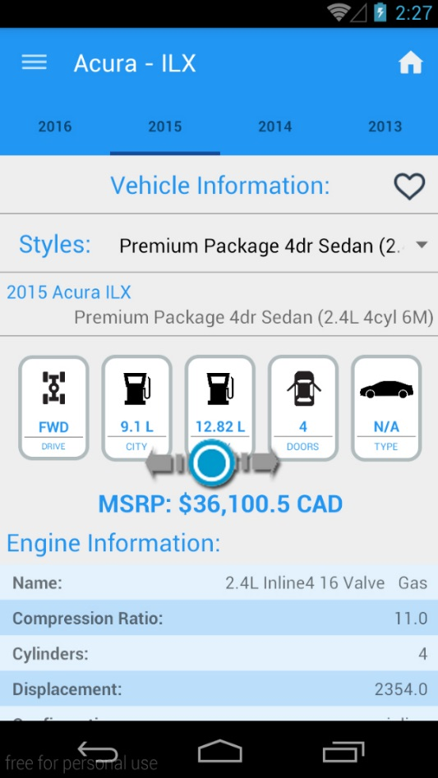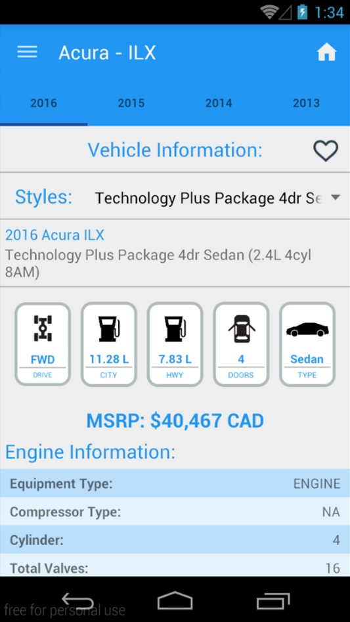

Figure 1: Switch Tabs:

Figure 2: Standard Detail Landing Page

1. 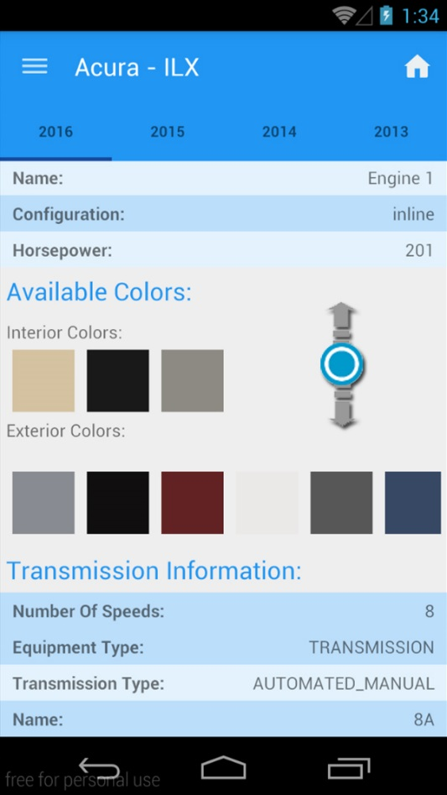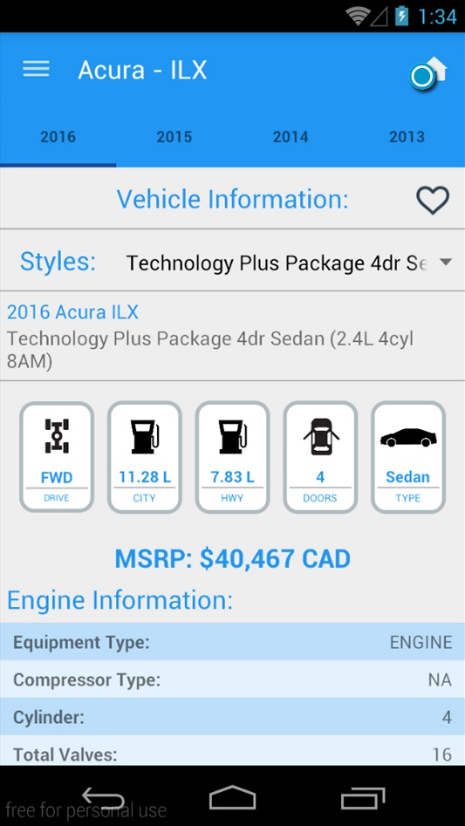In the detail activity, you can do a lot things. Following are the actions that can be done.

Figure 3: Scroll Down for more information

Figure 4: Can go back to the Main Activity.

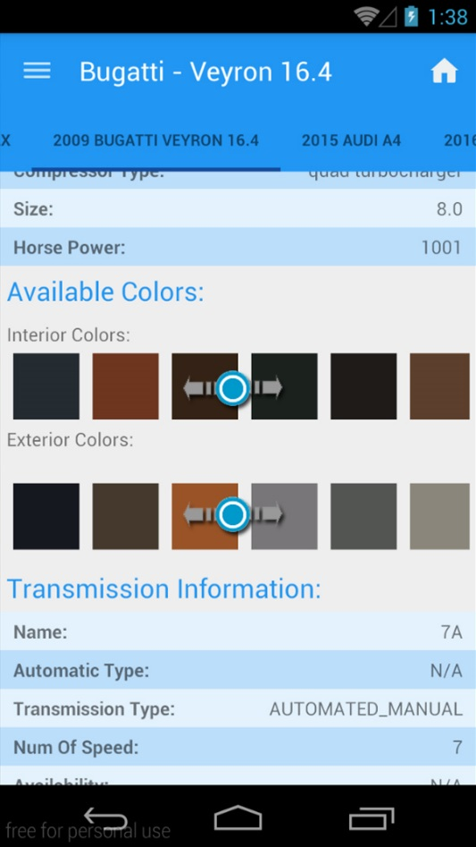

Figure 5: Colors can be scrolled right or left.

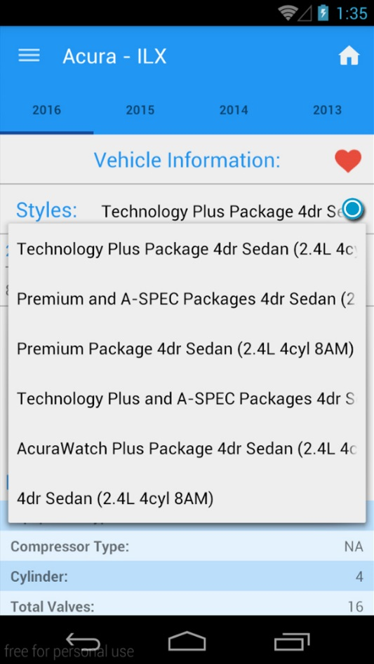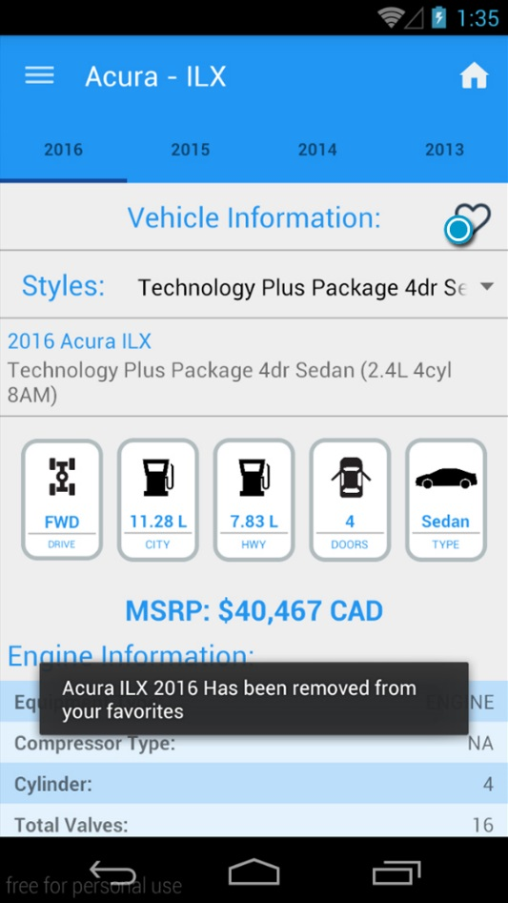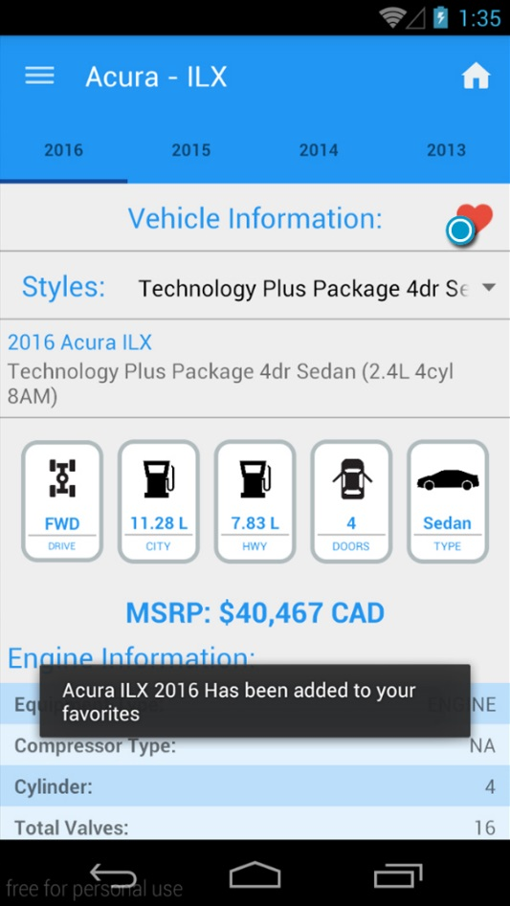

Figure 6: Select Different Styles.

Figure 7: Remove Vehicle From Favorites

Figure 8: Add Vehicle to Favorites

1. You can add as much items to the favorites list. To view the favorites simply open the navigation drawer. You can see all your favorites here. You can also view the details of individual favorite items, or view all together.

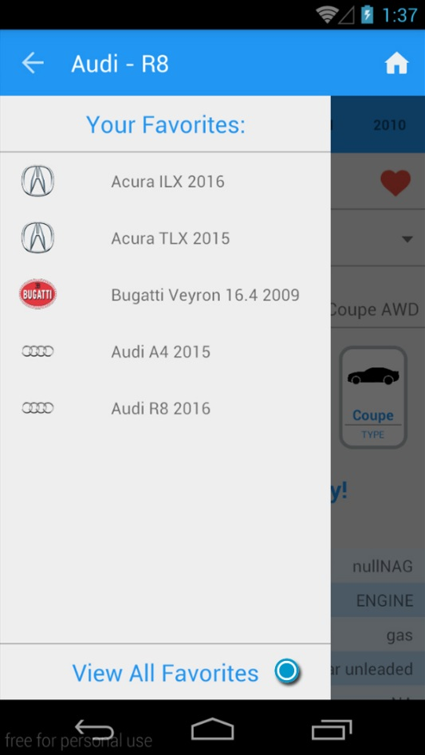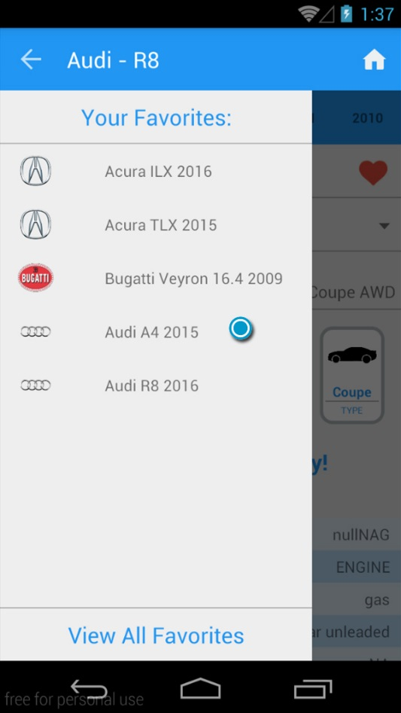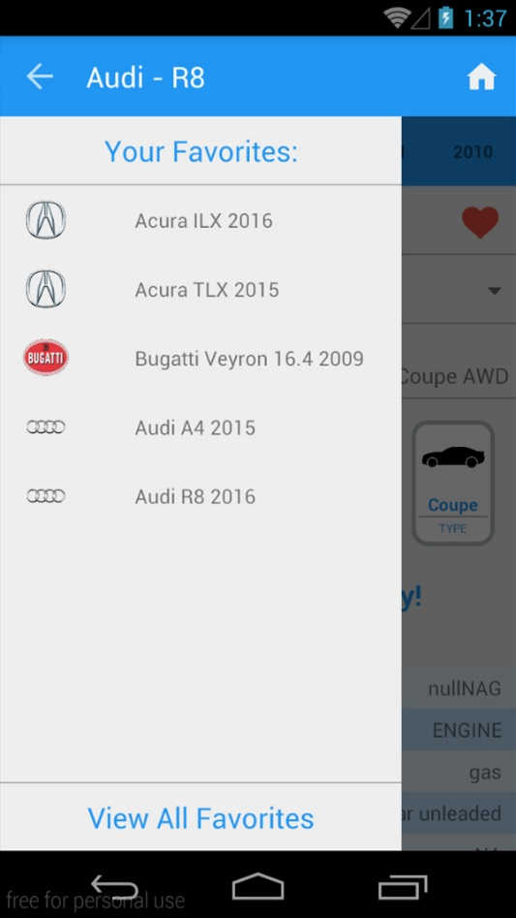

Figure 9: Select all favorites

Figure 10: Select Individual Favorite vehicle

Figure 11: View Favorites

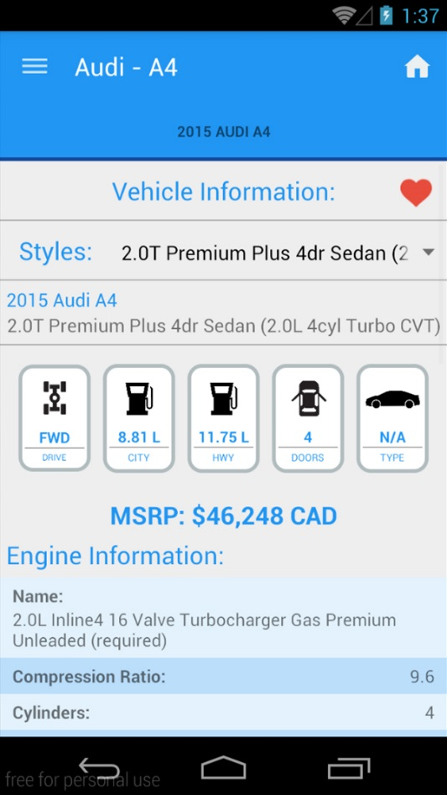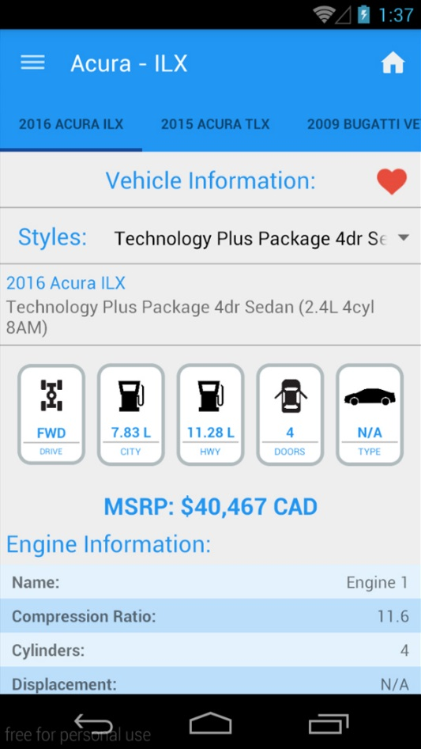

Figure 12: View all Favorite Details

Figure 13: View Specific vehicle Detail.