Individualized Curriculum Design (学程)  
Your Study, You decide!

Marketing Requirements Document

|  |  |  |  |  |  |
| --- | --- | --- | --- | --- | --- |
| Ver. | Date | Author | Description | Approved by | Approval date |
| 0.0 | March | Qin Liu | Proposed Project Content |  |  |
| 0.1 | April 3, 2015 | Q.P. Zhao | The First Written Draft |  |  |
| 0.2 | May 20, 2015 | Q. Liu | Modified Package Features, Management, Performance , Payment, Rating etc. and wording. |  |  |
| 0.3 |  |  |  |  |  |
|  |  |  |  |  |  |

*This document contains* *proprietary and confidential material of CC. Any unauthorized reproduction, use, or disclosure of this material, or any part thereof, is strictly prohibited. This document is solely for the use of CC and authorized CC module attendees.*

Table of Contents

1. Scope 2

1.1 Terms Acronyms and Abbreviations 2

1.2 Applicable Documents 2

2. Required release date 2

3. Description of requirements 2

3.1 General technical requirements 2

3.1.1 Package Management 3

3.1.2 Membership/ Login 5

3.1.3 Module ware Management 5

3.1.4 Payment 5

3.1.5 Assumptions and Dependencies 5

3.1.6 Compatibility 6

3.1.7 Performance 6

3.1.8 Confidentiality and security 6

3.2 Administration 6

3.2.1 Update module s 6

3.2.2 View members 6

3.2.3 Terminate members 6

3.2.4 Language 7

# Scope

Generally, the students have to follow the learning package as soon as they have decided their learning subject. There is little chance for them to study the modules in other subjects. For example, a student in computer science is usually not able to take a module in Arts. In order to improve the situation, the *Individualized Curriculum Design* （学程） is an educational platform for the students to get involved in the construction of the learning package. It provides opportunities on modules for students in different disciplines to select based on their own study status. Currently, the ICD is just designed for students in computer science and Arts. This document specifies the requirements of the ICD.

## Terms Acronyms and Abbreviations

For the purposes of this project, the following abbreviations apply:

|  |  |
| --- | --- |
| IICD | Individualized Curriculum Design |
| IE | Internet Explorer |
| API | Application Programming Interface |
| PC | Personal Computer |
| XP/vista/win7/ win8 | Windows operation systems |
| Mac OS X | Mac operation systems |

## Applicable Documents

[1] See the ICD System Requirements Document for system design requirements (not ready yet)

# Required release date

Three months after system design requirements are confirmed.

# Description of requirements

## General technical requirements

The ICD should provide a login module, a payment module, a module ware management module, together with a package management module (Fig. 1). The scope of the project encompasses both server and client-side functionalities. The students use web browsers to access the package configuration page, and manage the package data through client-side. The lecturer is responsible for the management of module design, for example, insert, delete or modify the module materials by using their browsers on PC to access the website on the web server of the system. It is the similar way to the package owner/admin to manage the package information. So, the lecturers and admins are managing the data through server-side.

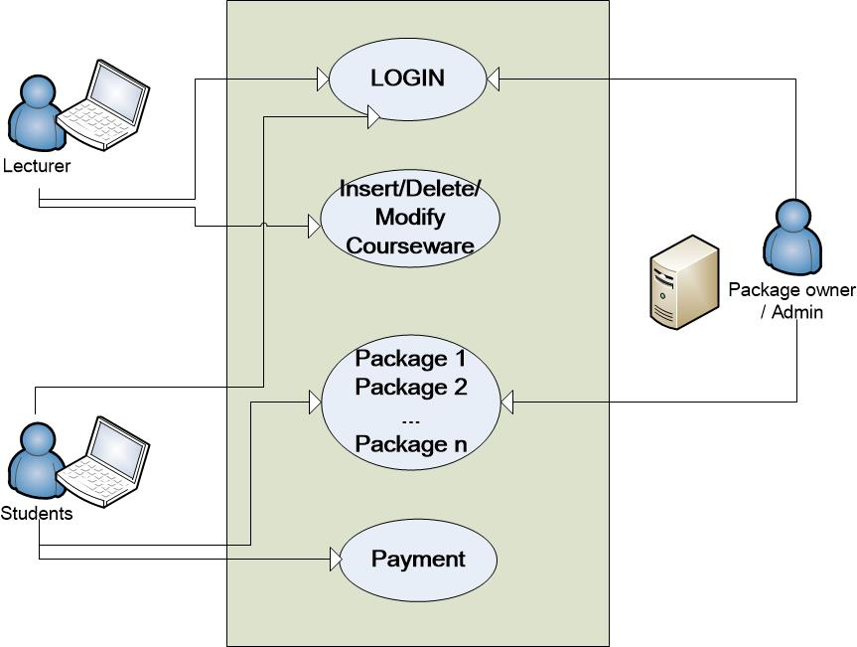

Fig. 1. The framework for the ICD.

### Package Management

The package management module includes two sides; one is the web-side and the server-side. On the web-side, there is the information of the available module s, such as module description, credits; price, correlation between module s etc (see Fig. 2). A recommendation rate of the current module is given to users based on its correlation to other module s.

The module configuration should provide a user-friendly and interactive interface. Therefore, an interactive module configuration interface should be provided. After login, the students can propose a new package consists of modules based on own interests. Students could also configure the modules into different packages (see Fig. 3).

Proposed packages approved by package administrator would be officially open for recruitment. Any open package need to enroll at least 10 students within 3 months would be considered a released package. Package managers’ are responsible to propose and maintain the structure and quality of packages.

When propose a package, the students can select the modules into a shop cart, which the total price and preliminary payment will be displayed. Only the preliminary payment is completed, the students would be considered as registered candidates. If the packaged released successfully, the candidates would be informed to complete remain bill, otherwise the preliminary payment (deposit) would be refunded.

For the server-side, the package owner is able to manage the packages proposed by the students. The package owner is the one who takes care of the module packages. The responsibilities of the package owner could be: checking if the total credits in the package exceed a limit; the payment is done; the package can be open etc.

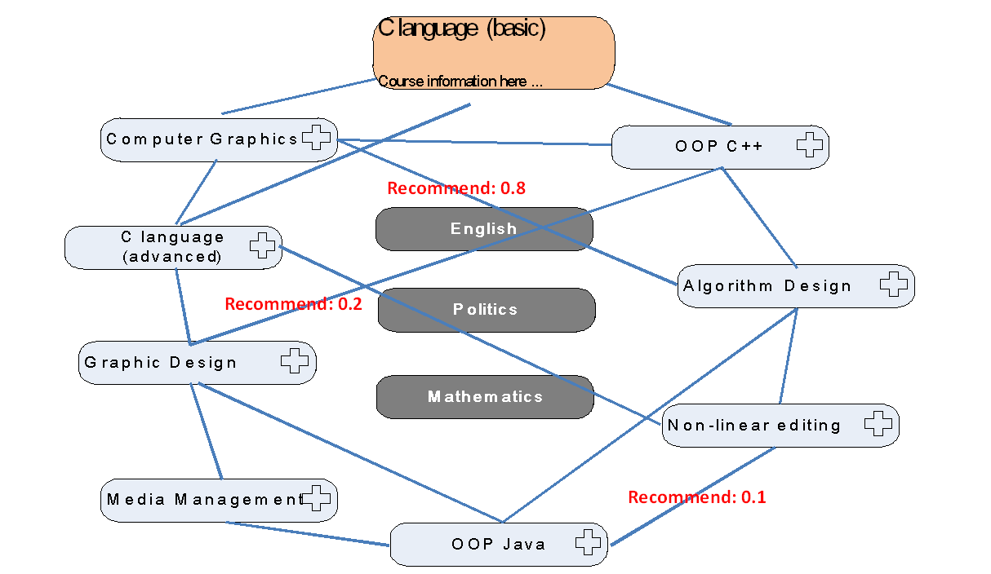

Fig. 2. Module Configuration

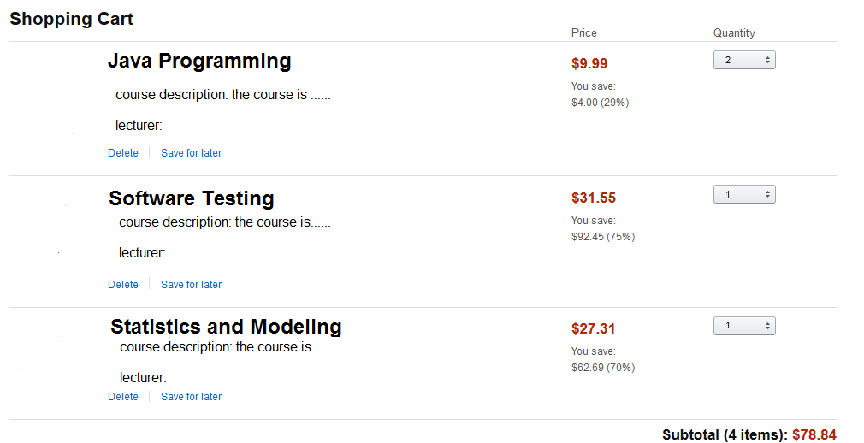

Fig. 3. Module package

### Membership/ Login

The ICD should provide a membership module with basic functions such as registration as a new user, login as an existing user, management of the account, retrieval of passwords etc. The detailed information of the registered user can be found in this module. Only the registered users can access the package management, module ware management and payment modules. Once the user is registered as a student, the configuration option is provided. If the user is registered as a lecturer, he/she can access the module ware management module.

### Module Management

After the lecturer’s login, the module ware management function is enabled. The lecturer can add, remove or modify a module ’s materials. The modification includes the basic information of the module s and the materials such as slides, lecture notes etc.

### Payment

Once a user configures his/her own module list, a payment module is provided. The payment accepts the online payment in the ways of:

* The third-party payment (Alipay, Wechat pay)
* Credit card (Visa, or MasterCard only)
* Debit card (Bank of Communication)

The users will be confirmed by an email or a message in the system after a successful payment. The payment should take use of the APIs from the third party of payment.

Refund service is available for pre-noticed withdrawn.

### Assumptions and Dependencies

Considering the project involves only in two disciplines, software engineering and Arts. The compulsory modules for both of the disciplines are English, Mathematics and Politics. The optional modules in two disciplines are C language (basic & advanced) – 3 credits, Object-oriented programming (C++ & Java) – 3 credits, Computer graphics – 2 credits, Algorithm Design – 2 credits, Graphic design - 2 credits, Non-linear editing – 3 credits, Media management – 2 credits. The module package should contain all of the compulsory modules and 10 credits of optional module s. The structure of the package should be designed by package administrator.

Assume also that each module is ready to open, there is no attendance limit.

The correlation between module s is known by the package owner beforehand.

The payment module depends on the third-party, so the security of the payment depends on the third party.

### Compatibility

The ICD should be compatible on three popular browsers, Firefox, IE, Chrome. It should also be compatible on smart phones and PCs with different operating systems (XP/vista/win7/ win8, Mac OS X).

### Performance

The response time of the webpage from the server side should be controlled in 2-5 seconds. Otherwise, a message should be pop out to inform the user. The system should support 37 universities and their 20-30 disciplines and 3000 students for their individualized curriculum design.

### Confidentiality and security

Since there are membership and payment modules, the confidentiality and security should be assured in the ICD. For protecting users’ information, password setting is necessary. The password should be encrypted by message digest algorithm MD5 to assure the security of the password.

## Administration

### Update module s

On the server side, the module s shown in the module configuration page could be updated. The updates include

* Module addition/removal
* Module description
* Correlation between module s
* Price adjustment
* Module materials: slides, lecture notes etc.

### View members

On the server side, the package owner and the student shall have access to the following information:

* User’s registration information
* Payment information
* Package details

### Terminate members

If an administrator believes that a user is engaged in illegal, inappropriate, or fraudulent use of the ICD, the administrator may terminate the user.

The user shall receive a message that the membership account was terminated for inappropriate activity.

### Language

English is supported as the main language for the ICD.

3.2.5 Rating (feedback) System

Students are offered opportunities to rate or providing feedbacks to each module and package.